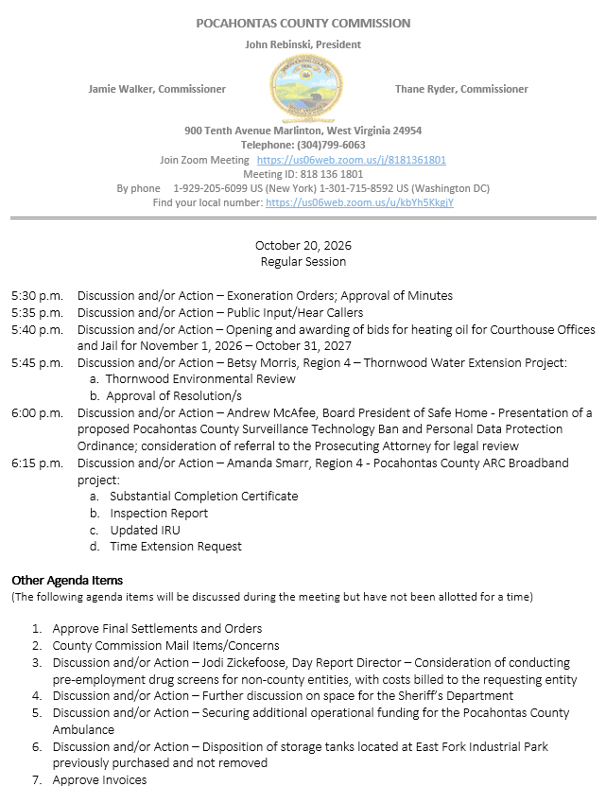

At a Regular Session of the Pocahontas County Commission held at the Courthouse situated in Marlinton, West Virginia, on the 20th day of October, 2026.

PRESENT: John Rebinski, President
Jamie Walker, Commissioner
Thane Ryder, Commissioner

Prior to the beginning of today’s session, the Commission invited all individuals in attendance to stand and recite the Pledge of Allegiance.

IN RE: EXONERATION/APPORTIONED ORDERS APPROVED

None

IN RE: MINUTES APPROVED

A motion was made by Commissioner Ryder to approve the minutes of the last regular session of the Commission held on the 6th day of October, 2026, as presented, and noting no objections, motion carried.
IN RE: FINAL SETTLEMENTS AND ORDERS APPROVED

Commission President John Rebinski reviewed several final settlements and orders pertaining to estates as presented by the County Clerk’s Office and, thereafter, approved same by placing his signature thereto.

IN RE: COUNTY COMMISSION MAIL ITEMS/CONCERNS

Copy – Fraternal Order of Police – Donation request (mailed contribution guidelines)


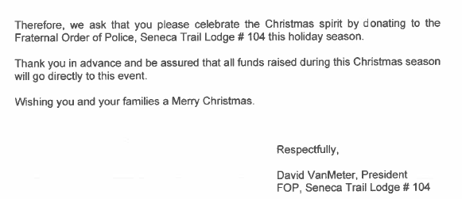
IN RE: JODI ZICKEFOOSE, DAY REPORT DIRECTOR – CONSIDERATION OF CONDUCTING PRE-EMPLOYMENT DRUG SCREENS FOR NON-COUNTY ENTITIES, WITH COSTS BILLED TO THE REQUESTING ENTITY

A motion was made by Commissioner Ryder to approve Day Report to conduct pre-employment drug screens for non-county entities, with costs billed to the requesting entity, and noting no objections, motion carried.

IN RE: SIGN IN SHEET/HEAR CALLERS

See Attached

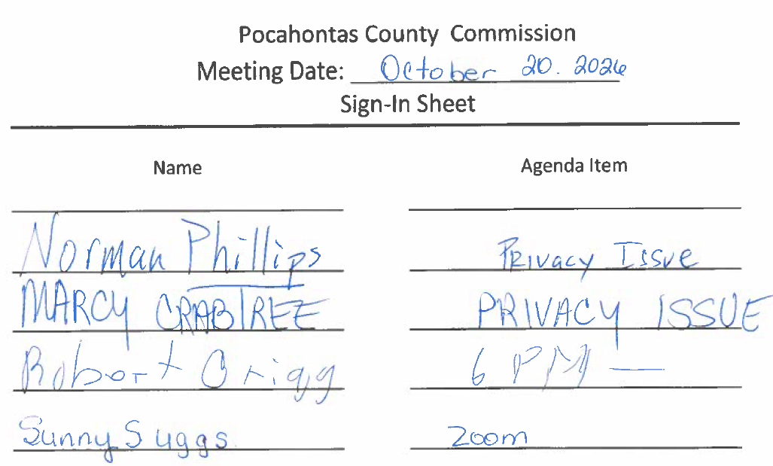

Norman Phillips, Marcy Crabtree, Robert Grigg present, and Sunny Suggs by Zoom all spoke in support of the 6:00 p.m. agenda item Andrew McAfee presentation of a proposed Pocahontas County Surveillance Technology Ban and Personal Data Protection Ordinance.

IN RE: FURTHER DISCUSSION ON SPACE FOR THE SHERIFF’S DEPARTMENT

The County Commission is still working on space options for the Sheriff’s Department. The commission has reviewed several options, but rent and leasing are very expensive. No action was taken on this matter.

IN RE: OPENING AND AWARDING OF BIDS FOR HEATING OIL FOR COURTHOUSE OFFICES AND JAIL FOR NOVEMBER 1, 2026 – OCTOBER 31, 2027

A motion was made by Commissioner Walker to accept the only bid received for heating oil for the Courthouse and Jail buildings in response to an advertisement in the local newspaper for the period of November 1, 2026 to October 31, 2027, that being a bid from Woodford Oil Company as quoted, and noting no objections, motion carried.


IN RE: BETSY MORRIS, REGION 4 – THORNWOOD WATER EXTENSION PROJECT:

A. THORNWOOD ENVIRONMENTAL REVIEW
B. APPROVAL OF RESOLUTION/S

A motion was made by Commissioner Walker to approve the Thornwood Water Extension Project, Thornwood Environmental Review, and Resolution #12 of the Thornwood Water Extension Project, and noting no objections, motion carried.
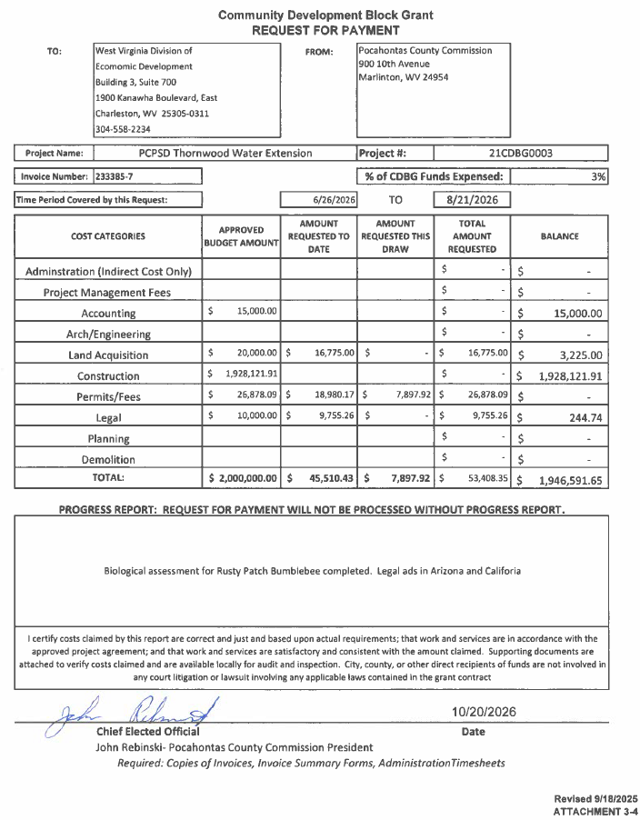
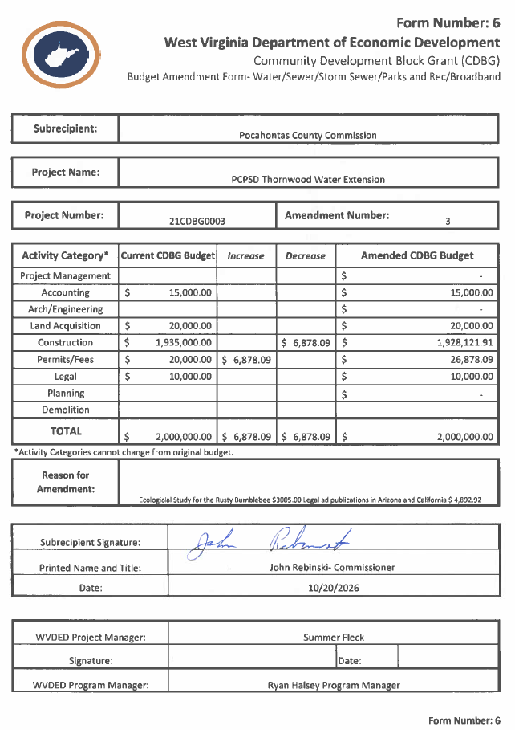
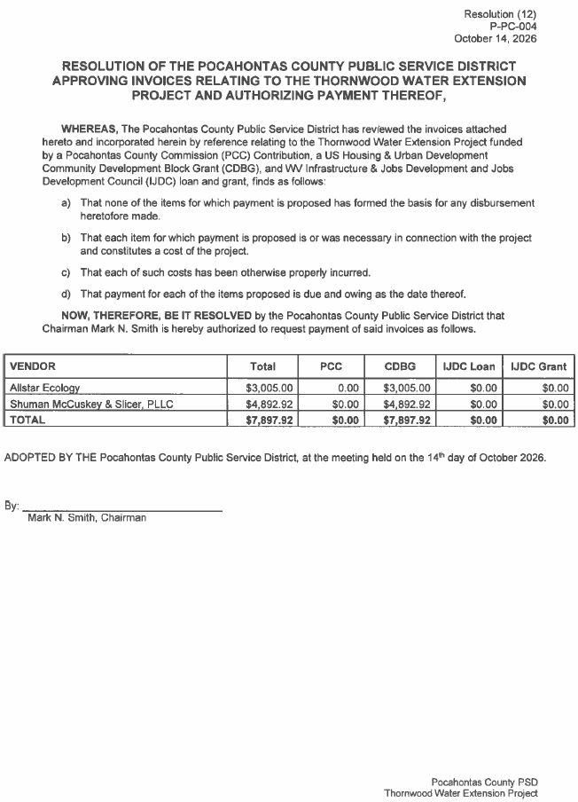
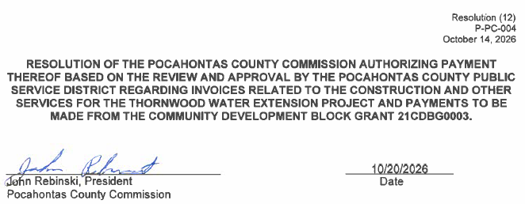
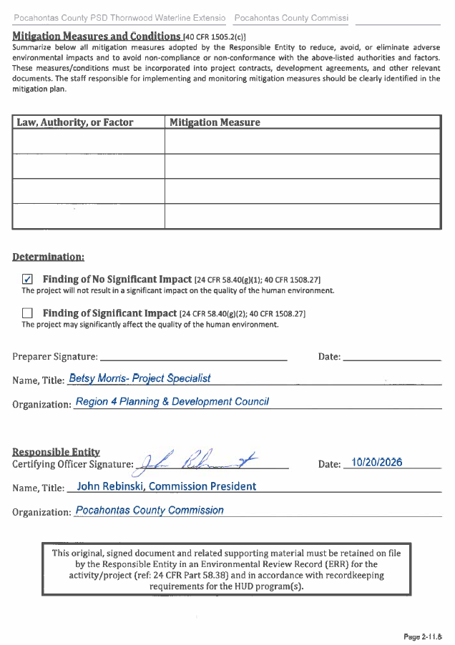

IN RE: ANDREW MCAFEE, BOARD PRESIDENT OF SAFE HOME - PRESENTATION OF A PROPOSED POCAHONTAS COUNTY SURVEILLANCE TECHNOLOGY BAN AND PERSONAL DATA PROTECTION ORDINANCE; CONSIDERATION OF REFERRAL TO THE PROSECUTING ATTORNEY FOR LEGAL REVIEW

Andrew McAfee, Board President of Safe Home, met with the commission with a presentation of a proposed Pocahontas County Surveillance Technology Ban and Personal Data Protection Ordinance; consideration of referral to the Prosecuting Attorney for legal review. There were several community members present in support of the ordinance. The commission took no action on this matter.

IN RE: DISCUSSION AND/OR ACTION – AMANDA SMARR, REGION 4 - POCAHONTAS COUNTY ARC BROADBAND PROJECT:

A. SUBSTANTIAL COMPLETION CERTIFICATE
B. INSPECTION REPORT
C. UPDATED IRU
D. TIME EXTENSION REQUEST

A motion was made by Commissioner Ryder to approve Pocahontas County ARC Broadband Project, Substantial Completion Certificate, Inspection Report and the Time Extension Request as presented, and noting no objections, motion carried. There was no action taken on the updated IRU at this time.


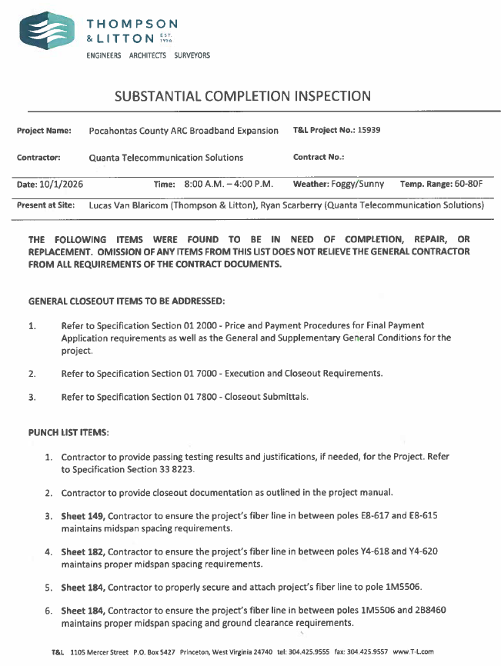
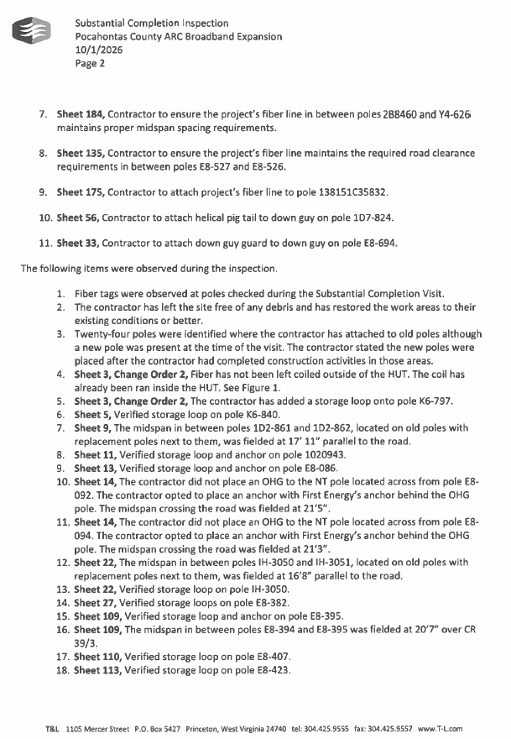
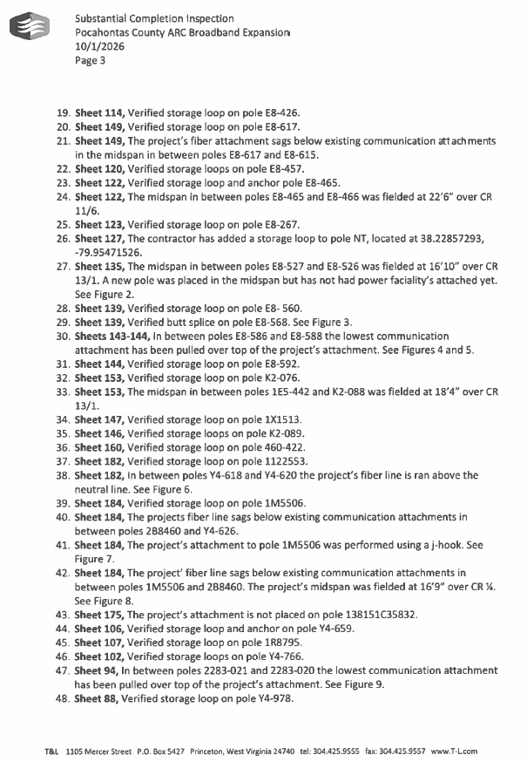
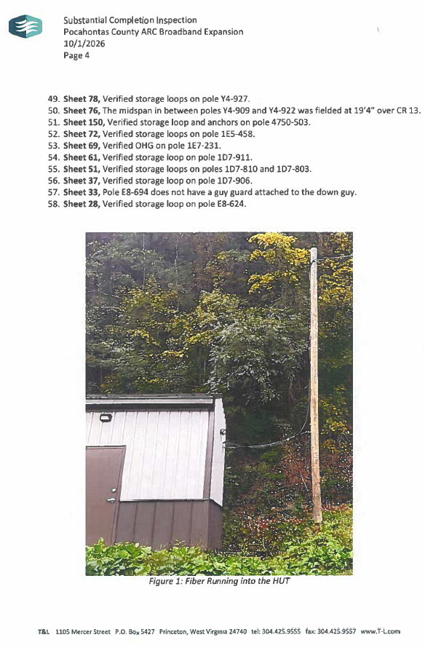
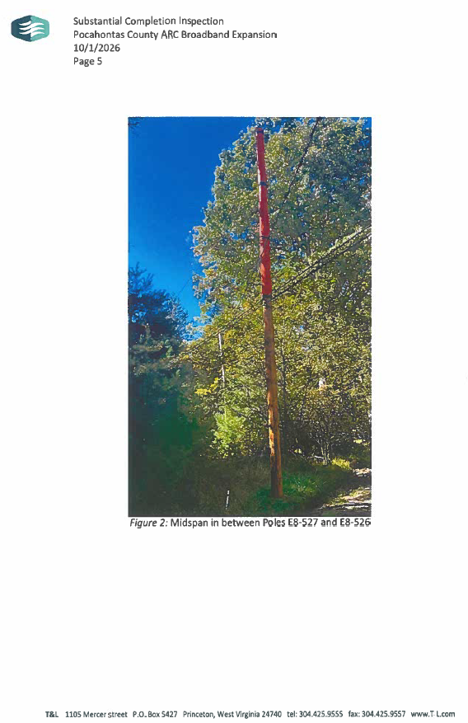
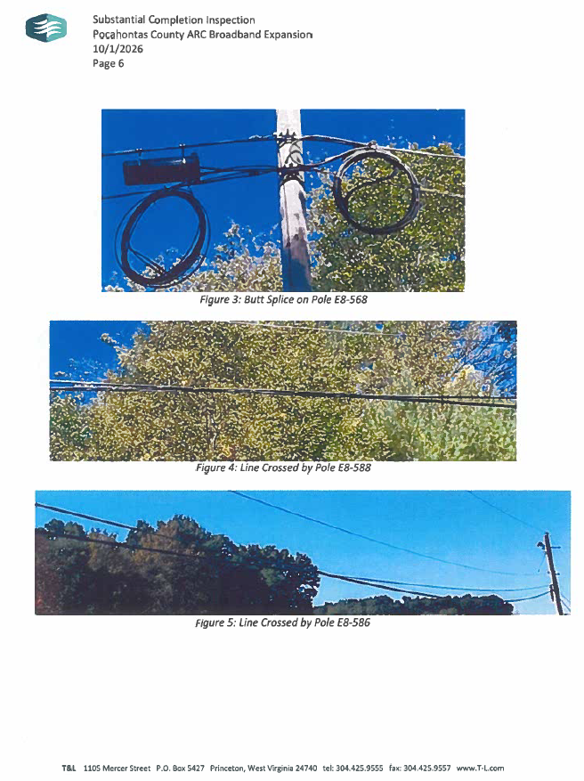
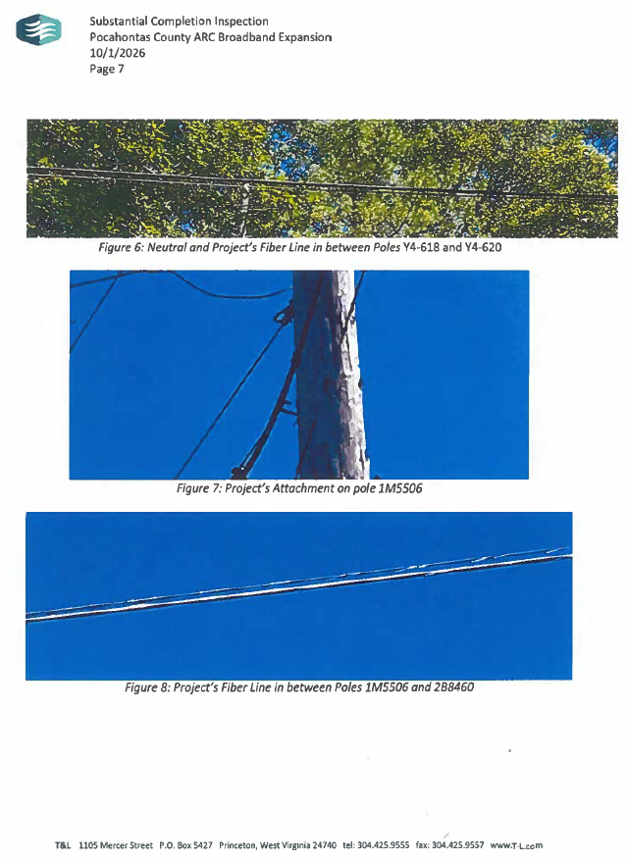
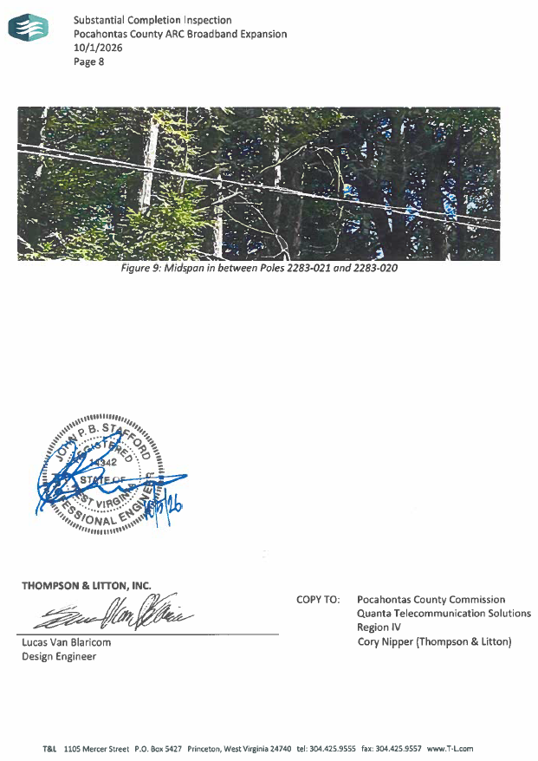

IN RE: SECURING ADDITIONAL OPERATIONAL FUNDING FOR THE POCAHONTAS COUNTY AMBULANCE

Commissioner Rebinski spoke about securing an additional $80,000.00 for operational funding from the Hotel/Motel Occupancy Tax for the Pocahontas County Ambulance, to help in purchasing items like heart monitors and the purchase of another ambulance in the future. Commissioner Ryder would like an update from Chris Lusk, EMS Director, on the ambulance services before making a decision. No action was taken on this matter.

IN RE: DISPOSITION OF STORAGE TANKS LOCATED AT EAST FORK INDUSTRIAL PARK PREVIOUSLY PURCHASED AND NOT REMOVED

The Commission discussed the disposition of storage tanks located at East Fork Industrial Park that were previously purchased by Buster Varner. Before the demolition begins on the tannery buildings, these tanks need to be removed. Mr. Varner said he tried to move the tanks and that the contents inside had solidified and are too heavy to be moved. The suggestion from Commissioner Walker was to have them moved and send the bill to the owner. Commissioner Walker and Commissioner Ryder stated they would get in touch with Mr. Varner. No action was taken on this matter.
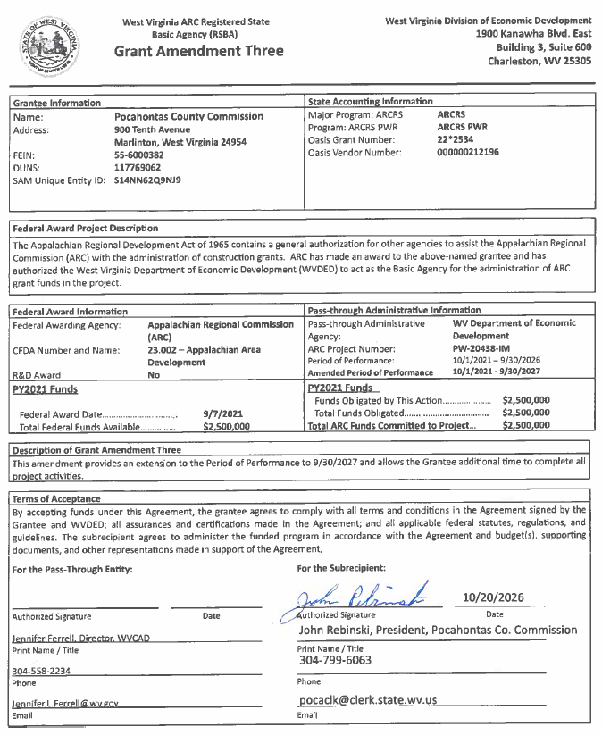

IN RE: INVOICES

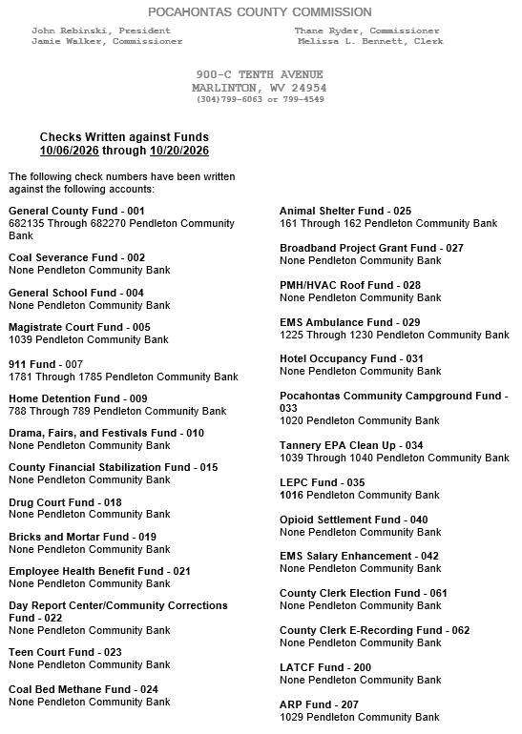

ORDERED THIS MEETING BE ADJOURNED, SINE DIE.

