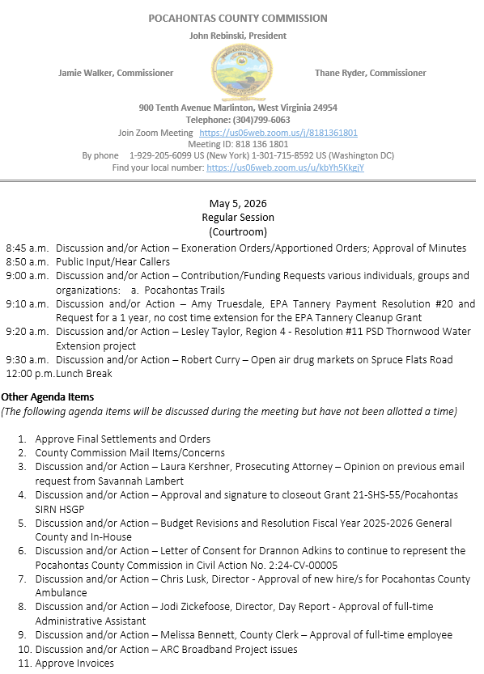

At a Regular Session of the Pocahontas County Commission held at the Courthouse situate in Marlinton, West Virginia, on the 5th day of May, 2026.

PRESENT: John Rebinski, President
Jamie Walker, Commissioner
Thane Ryder, Commissioner

Prior to the beginning of today’s session, the Commission invited all individuals in attendance to stand and recite the Pledge of Allegiance.

IN RE: EXONERATION/APPORTIONED ORDERS APPROVED

None

IN RE: MINUTES APPROVED

A motion was made by Commissioner Ryder to approve the minutes of the last regular session of the Commission held on the 21st day of April, 2026, and noting no objections, motion carried.

IN RE: FINAL SETTLEMENTS AND ORDERS APPROVED

Commission President John Rebinski reviewed several final settlements and orders pertaining to estates as presented by the County Clerk’s Office and, thereafter, approved same by placing his signature thereto.
IN RE: COUNTY COMMISSION MAIL ITEMS/CONCERNS

Letter – Advanced Alarm Technologies – Security Systems bidding interest
Email – West Virginia State Auditor’s Office – County Commission Annual in-service training sign-up.
Email – Katie Broce – Animal Shelter – resignation
Email – David Cain – Mowing at the FEMA Lots in East Cass
Letter - THB Land Management - Jessica Walkup - Land Survey
Letter – Frontier – Noice of Claim Damage

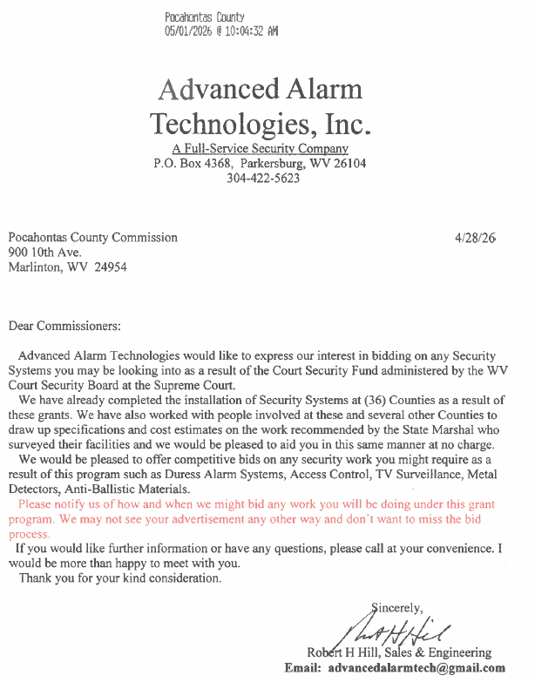
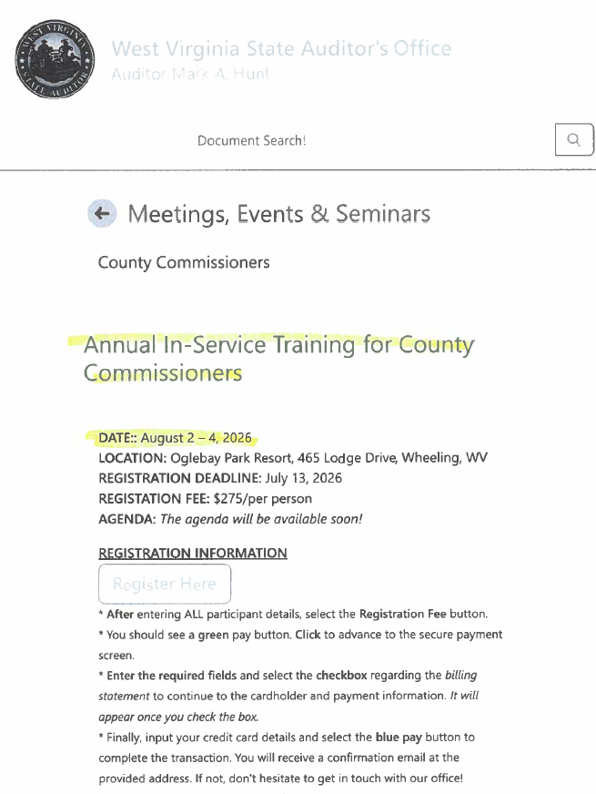
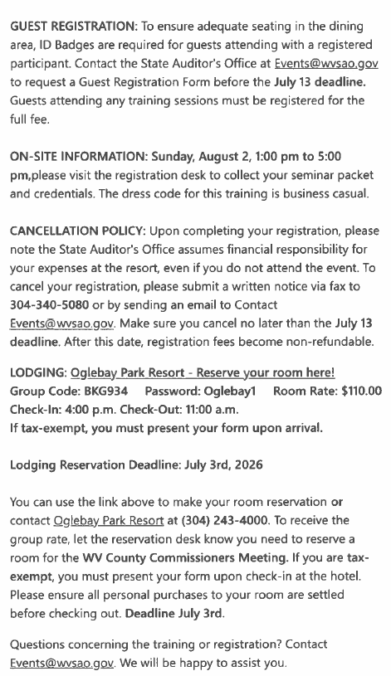
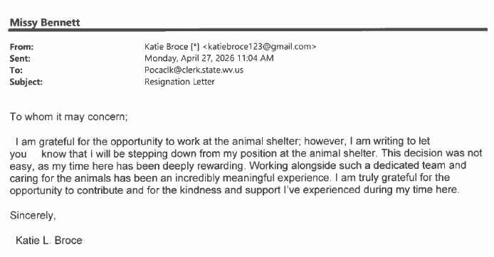
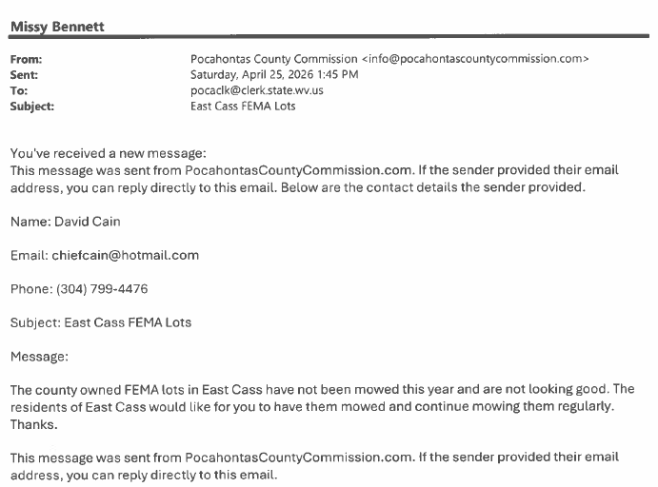
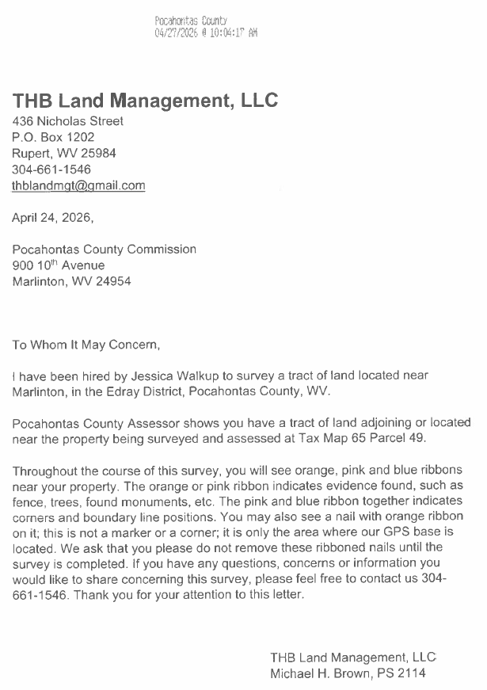

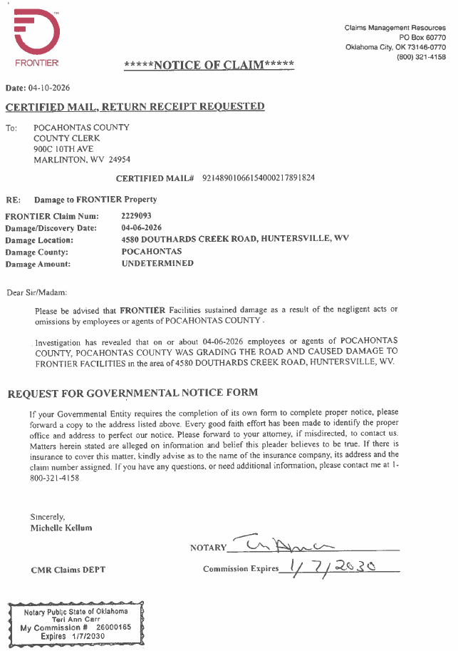

IN RE: SIGN IN SHEET/HEAR CALLERS
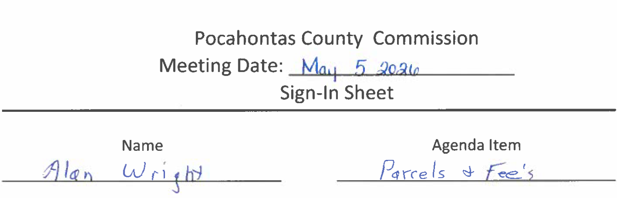

Alan Wright – SWA – Fees set for every land parcel

Alan Wright addressed the commission with the concerns from the April 29, 2026 Pocahontas County Solid Waste meeting at which the fees were suggested to be set for every land parcel and to be charged by the Solid Waste Authority. The Commission advised that they had no intention at this time at setting the fee but in the future if the land fill closes and there are no more green boxes it would fall back to the County Commission or the State and at that time the bill would have to be paid and it would be on the residence to pay. No action was taken on this matter.
IN RE: CONTRIBUTION/FUNDING REQUESTS VARIOUS INDIVIDUALS, GROUPS AND ORGANIZATIONS:

- POCAHONTAS TRAILS

A motion was made by Commissioner Ryder to approve a $2,500.00 contribution request for Pocahontas Trails, and noting no objections, motion carried.

IN RE: AMY TRUESDALE, EPA TANNERY PAYMENT RESOLUTION #20 AND REQUEST FOR A 1 YEAR, NO COST TIME EXTENSION FOR THE EPA TANNERY CLEANUP GRANT

A motion was made by Commissioner Ryder to approve the EPA Tannery payment resolution #20, and noting no objections, motion carried.
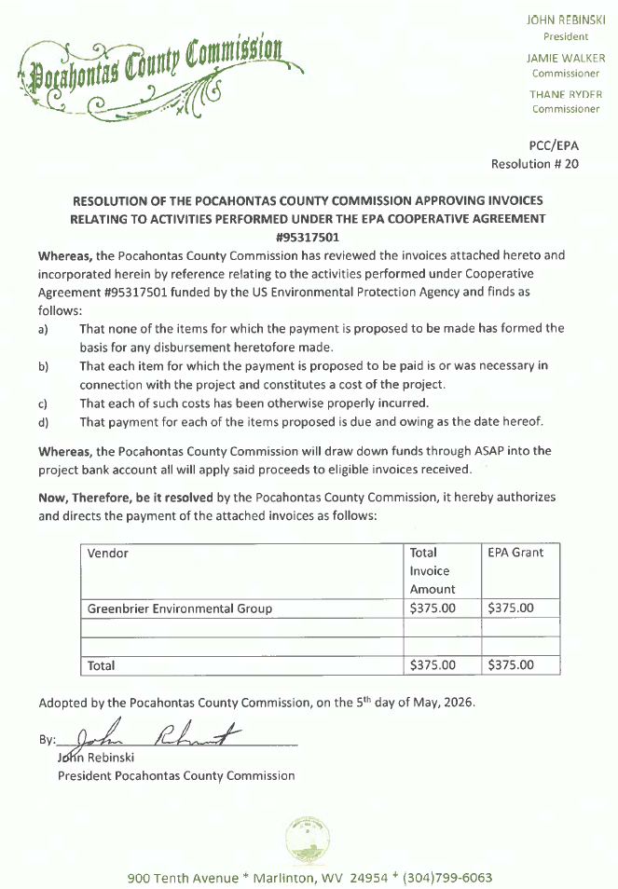
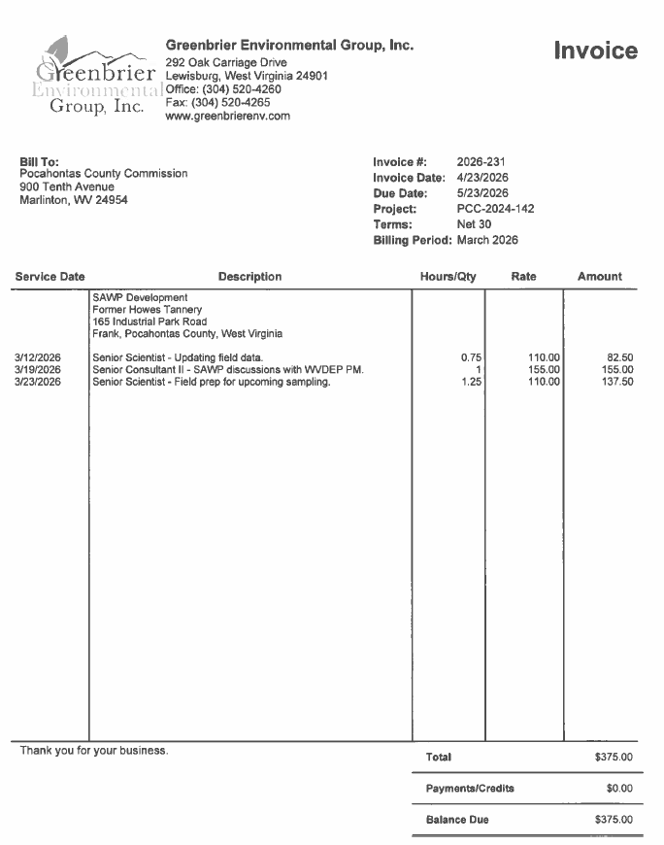

A motion was made by Commissioner Walker to approve a 1 year no cost time extension for the EPA Tannery Cleanup Grant, and noting no objections, motion carried.

IN RE: LESLEY TAYLOR, REGION 4 - RESOLUTION #11 PSD THORNWOOD WATER EXTENSION PROJECT

A motion was made by Commissioner Walker to approve Resolution #11 for the PSD Thornwood Water Extension Project as presented by Lesley Taylor, and noting no objections motion carried.
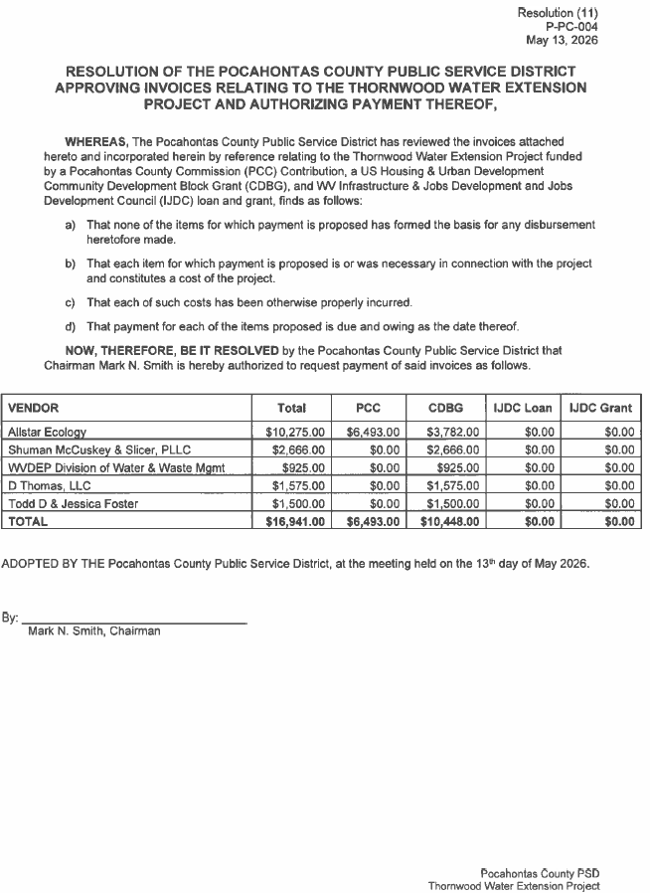
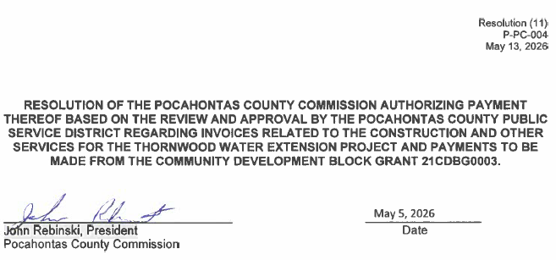
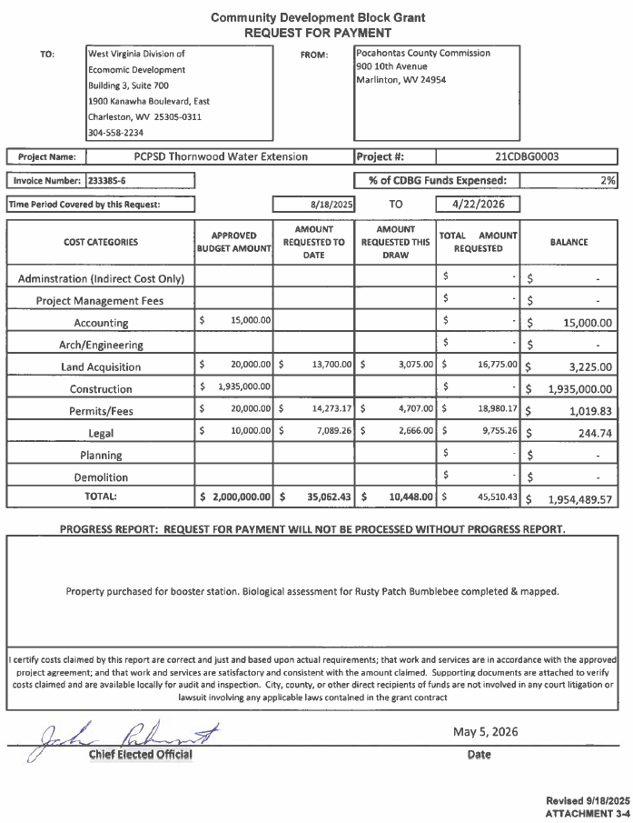

IN RE: LAURA KERSHNER, PROSECUTING ATTORNEY – OPINION ON PREVIOUS EMAIL REQUEST FROM SAVANNAH LAMBERT

Prosecuting Attorney Laura Kershner addressed the commission with an option on previous email request from Savannah Lambert. Mrs. Kershner stated that the code references in the were incorrect as pertaining to the County Commission. No action was taken on this matter.

IN RE: ROBERT CURRY – OPEN AIR DRUG MARKETS ON SPRUCE FLATS ROAD

Robert Curry came before the Commission with a complaint on the Open-Air Drug Markets on Spruce Flats Road. Mr. Curry expressed concerns of the depreciation of his property value due to the conditions and activity from surrounding property owner Lowell Loudermilk. The Commission advised Mr. Curry to speak with the assessor’s office with the concerns of lowering his taxes. No action was taken on this matter.

IN RE: APPROVAL AND SIGNATURE TO CLOSEOUT GRANT 21-SHS-55/ POCAHONTAS SIRN HSGP

A motion was made by Commissioner Walker to approve and sign the Closeout Grant 21-SHS-55 / Pocahontas SIRN HSGP, and noting no objections, motion carried.

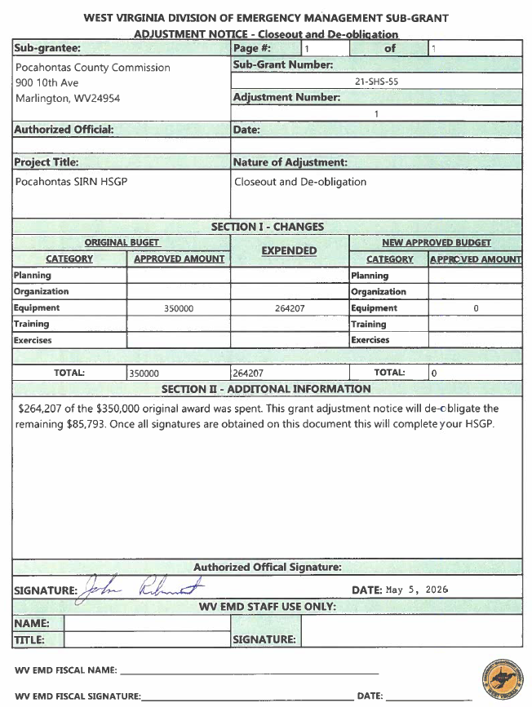

IN RE: BUDGET REVISIONS AND RESOLUTION FISCAL YEAR 2025-2026 GENERAL COUNTY AND IN-HOUSE

A motion was made by Commissioner Walker to approve the Budget Revisions and Resolution for Fiscal Year 2025-2026 General County and In-House, and noting no objections, motion carried.

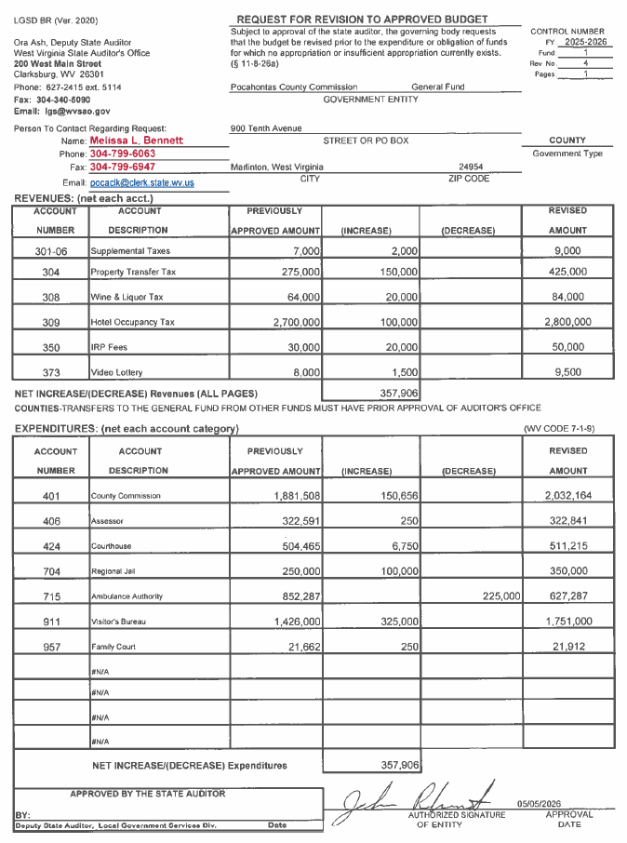
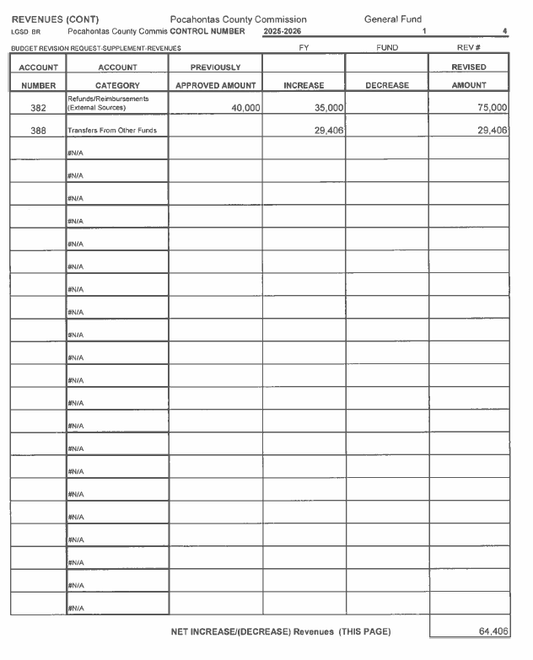
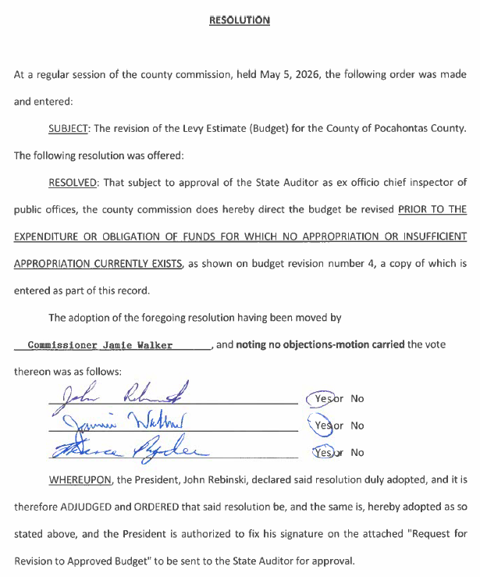

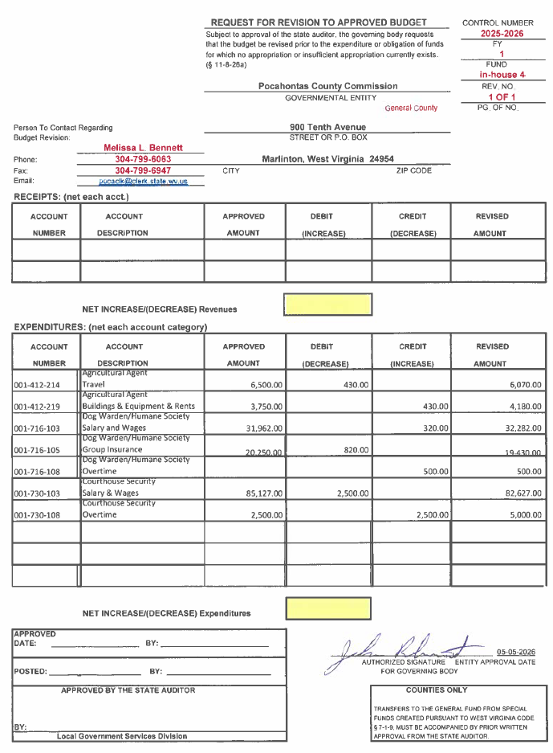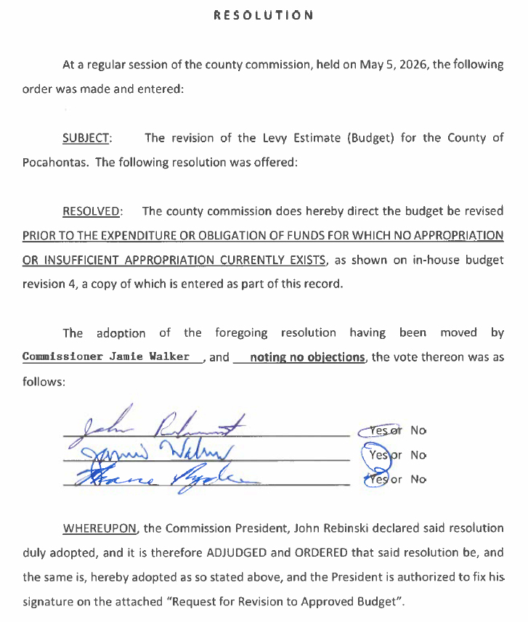
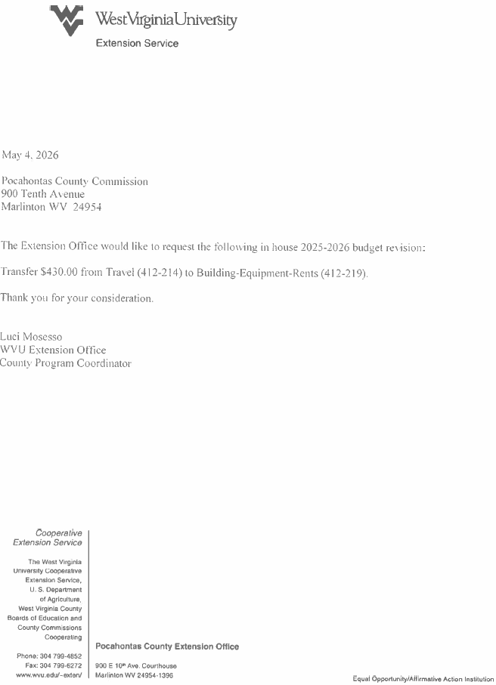
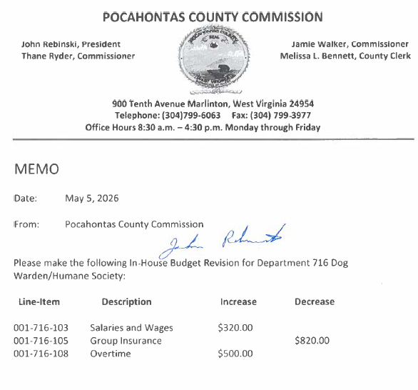
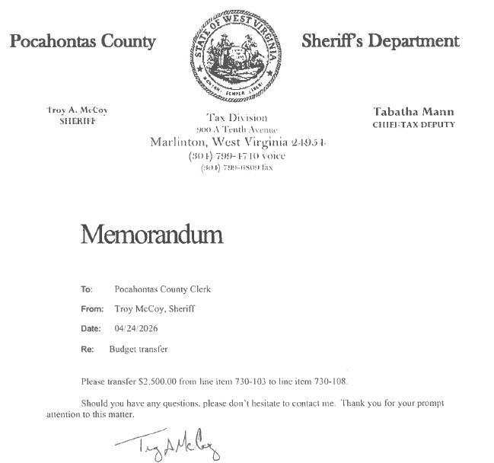
IN RE: LETTER OF CONSENT FOR DRANNON ADKINS TO CONTINUE TO REPRESENT THE POCAHONTAS COUNTY COMMISSION IN CIVIL ACTION NO. 2:24-CV-00005

A motion was made by Commissioner Ryder to approve the letter of consent for Drannon Adkins to continue to represent the Pocahontas County Commission in Civil Action No. 2:24-CV-00005, and noting no objections, motion carried.

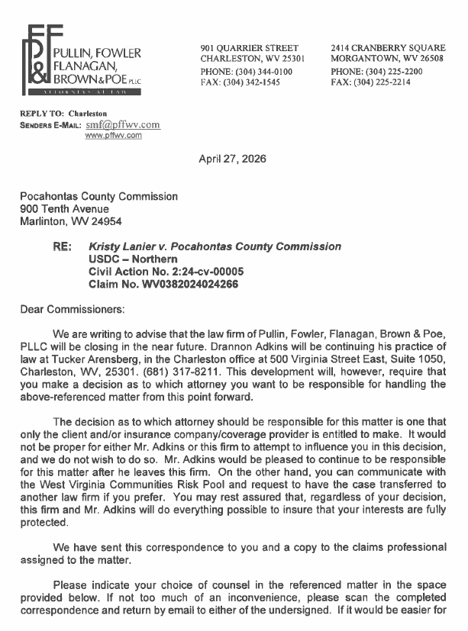
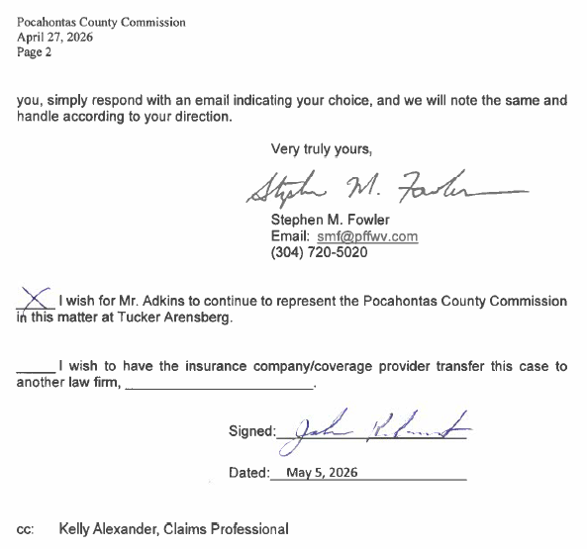

IN RE: CHRIS LUSK, DIRECTOR - APPROVAL OF NEW HIRE/S FOR POCAHONTAS COUNTY AMBULANCE

A motion was made by Commissioner Walker to approve Dakota Pritt as part-time EMT effective May 5, 2026, with a starting salary of $15.00 per hour, and noting no objections, motion carried.

IN RE: JODI ZICKEFOOSE, DIRECTOR, DAY REPORT - APPROVAL OF FULL-TIME ADMINISTRATIVE ASSISTANT

A motion was made by Commissioner Walker to approve Patty McCarty as Administrative Assistant for Day Report effective May 11, 2026, with at starting salary of $16.00 per hour and full benefits, and noting no objections, motion carried.

IN RE: ARC BROADBAND PROJECT ISSUES

Commissioner Rebinski stated that First Energy did receive the letter that was drafted and sent with issues the Commission had on handling the pole attachments and the reimbursement issues. The response was there is some confusion on Pole readiness and they are going to reimburse for the extra expense. Commissioner Walker still thinks the commission should pursue legal action. No action was taken on this matter.

IN RE: MELISSA BENNETT, COUNTY CLERK – APPROVAL OF FULL-TIME EMPLOYEE

At the request of County Clerk, Melissa Bennett to enter into executive session per Open Meeting Act #2A. A motion was made by Commissioner Ryder to enter into executive session, and noting no objections, motion carried. At the end of the executive session a motion was made by Commissioner Ryder to end the session, and noting no objections, motion carried.

A motion was made by Commissioner Ryder to hire Franklin Pennington effective May 11, 2026, with a starting salary of $ 45,000.00 per year, with full benefits, and noting no objections, motion carried.

IN RE: INVOICES

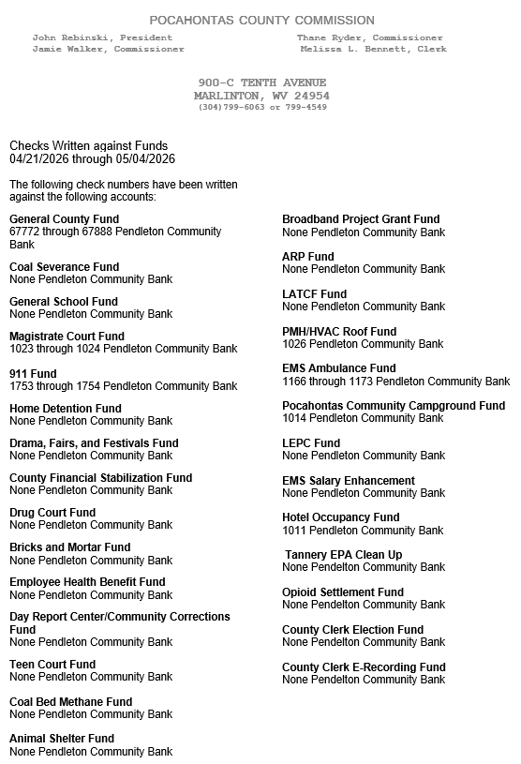

ORDERED THIS MEETING BE ADJOURNED, SINE DIE.

COUTY

