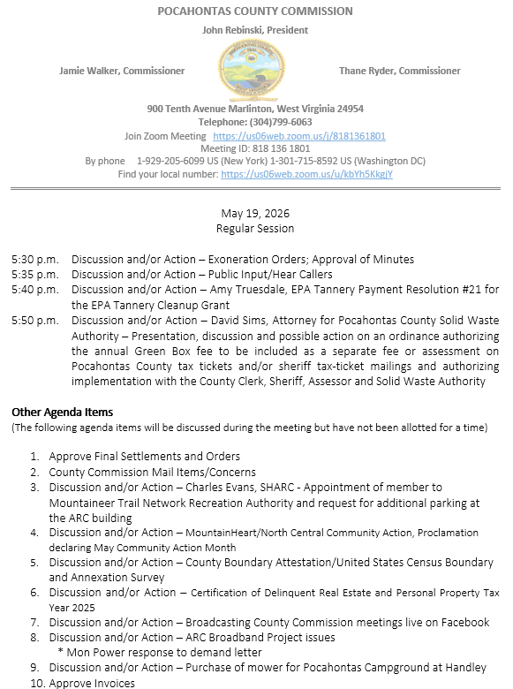

At a Regular Session of the Pocahontas County Commission held at the Courthouse situate in Marlinton, West Virginia, on the 19th day of May, 2026.

PRESENT: John Rebinski, President
Jamie Walker, Commissioner
Thane Ryder, Commissioner

Prior to the beginning of today’s session, the Commission invited all individuals in attendance to stand and recite the Pledge of Allegiance.

IN RE: EXONERATION/APPORTIONED ORDERS APPROVED

None

IN RE: MINUTES APPROVED

A motion was made by Commissioner Ryder to approve the minutes of the last regular session of the Commission held on the 5th day of May, 2026, and noting no objections, motion carried.

IN RE: FINAL SETTLEMENTS AND ORDERS APPROVED

Commission President John Rebinski reviewed several final settlements and orders pertaining to estates as presented by the County Clerk’s Office and, thereafter, approved same by placing his signature thereto.

IN RE: COUNTY COMMISSION MAIL ITEMS/CONCERNS

Email – Sarah E. Hamilton – Pocahontas County Board of Education 2025 Financial Statement.
Email – Teresa Boyd – Green Box fees attachment to property taxes and live streaming.
Copy – Thomas & Litton Engineer’s Field Report Quanta Telecommunications Solutions.
Copy – Sheriffs Monthly Financial Statement April 2026.
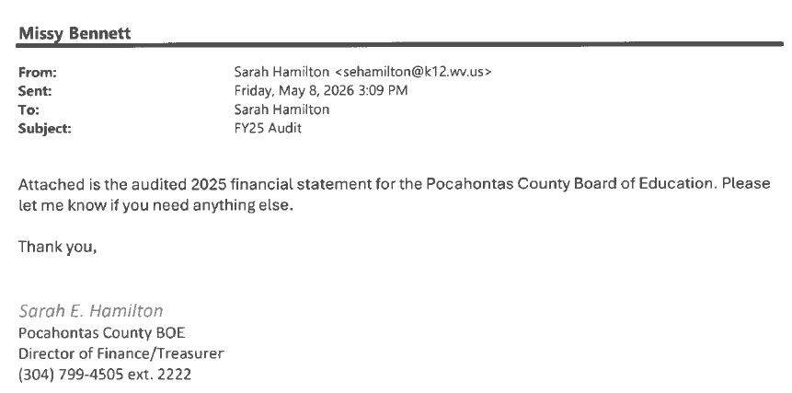

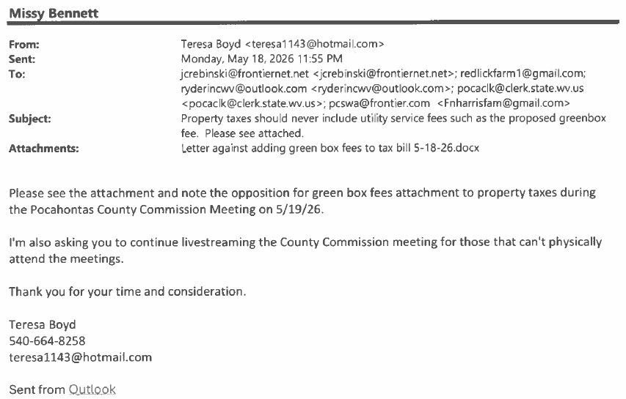

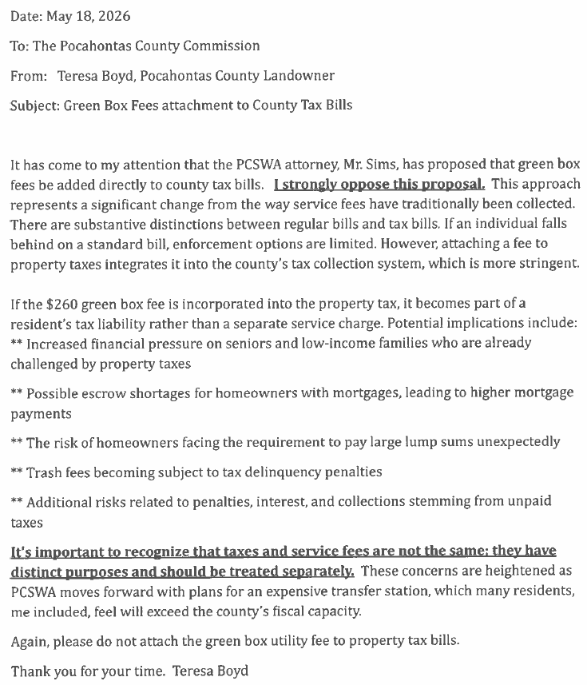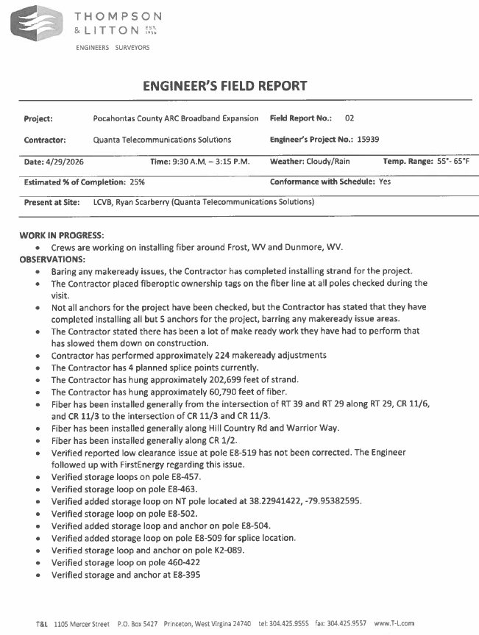
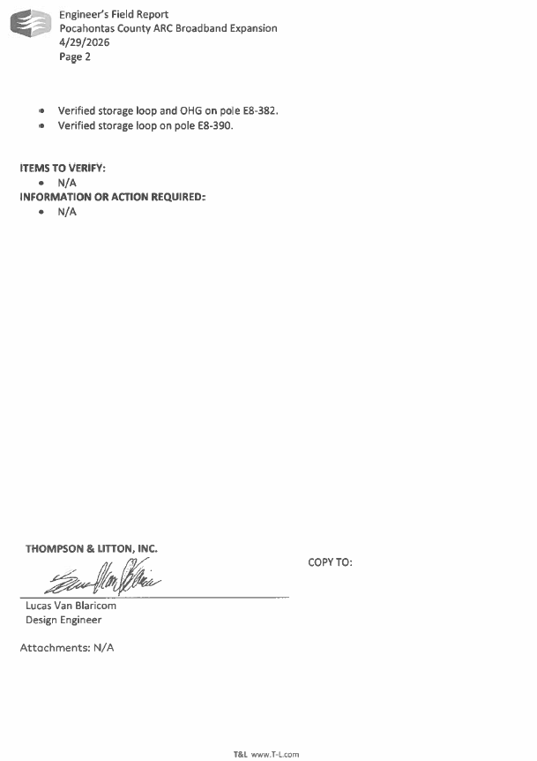
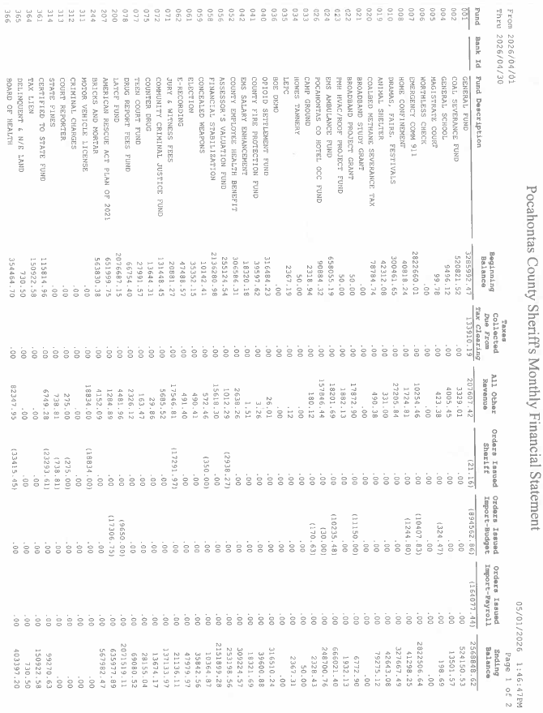
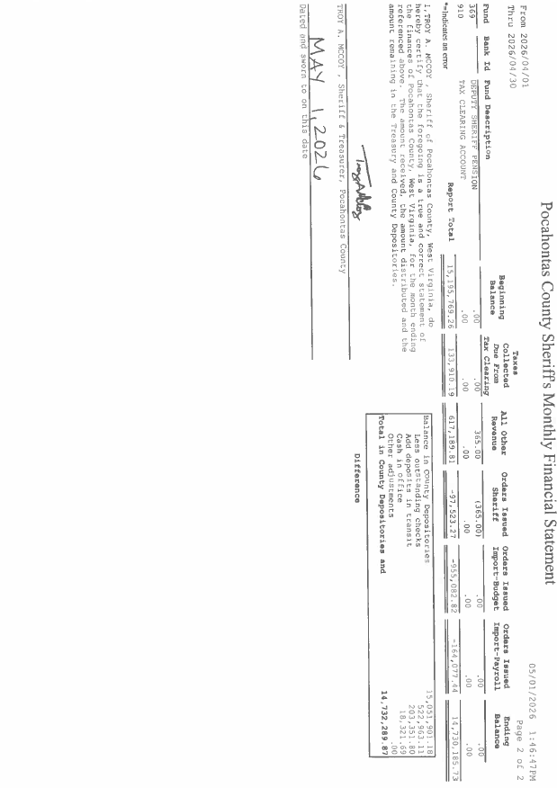

IN RE: SIGN IN SHEET/HEAR CALLERS

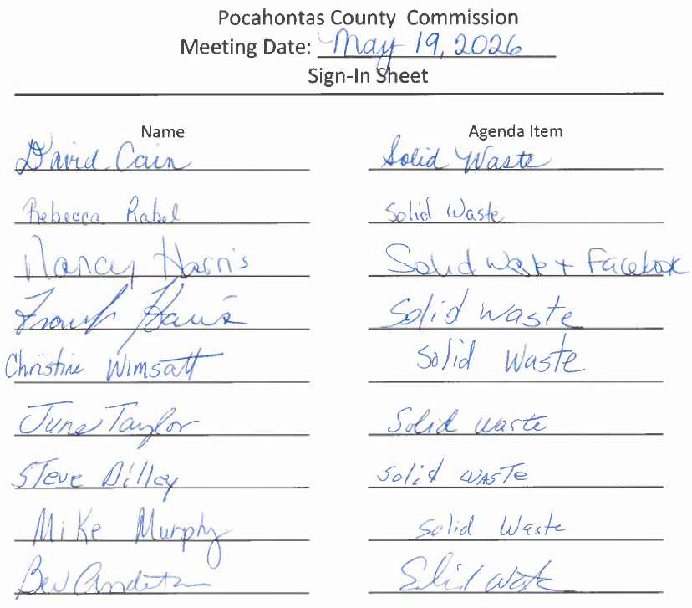

David Cain, Rebecca Rabel, Nancy Harris, Frank Harris, Christine Wimsatt, June Taylor, Steve Dilley, Mike Murphy, Bev Anderton – Solid Waste Authority

Several individuals signed in the Hear Callers sheets to speak on behalf of the 5:50 P.M. Agenda Item.

IN RE: APPOINTMENT OF MEMBER TO MOUNTAINEER TRAIL NETWORK RECREATION AUTHORITY AND REQUEST FOR ADDITIONAL PARKING AT THE ARC BUILDING

A motion was made by Commissioner Ryder to approve the appointment of Zen Clements by recommendation from Charles Evans with SHARC to the Mountaineer Trail Network Recreation Authority for Pocahontas Trails, and noting no objections, motion carried.
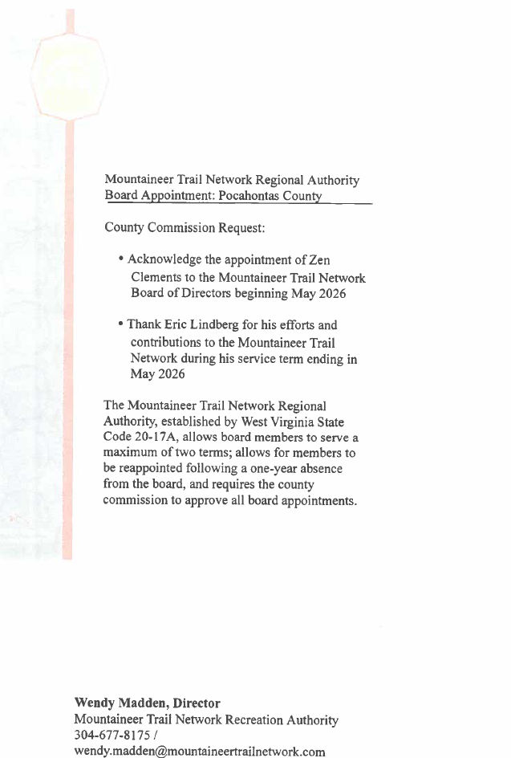

A motion was made by Commissioner Walker to approve the request for additional parking at the ARC Building, and noting no objections, motion carried.

IN RE: EPA TANNERY PAYMENT RESOLUTION #21 FOR THE EPA TANNERY CLEANUP GRANT

A motion was made by Commissioner Walker to approve the EPA Tannery payment resolution #21 for the EPA Tannery Cleanup Grant, and noting no objections, motion carried.
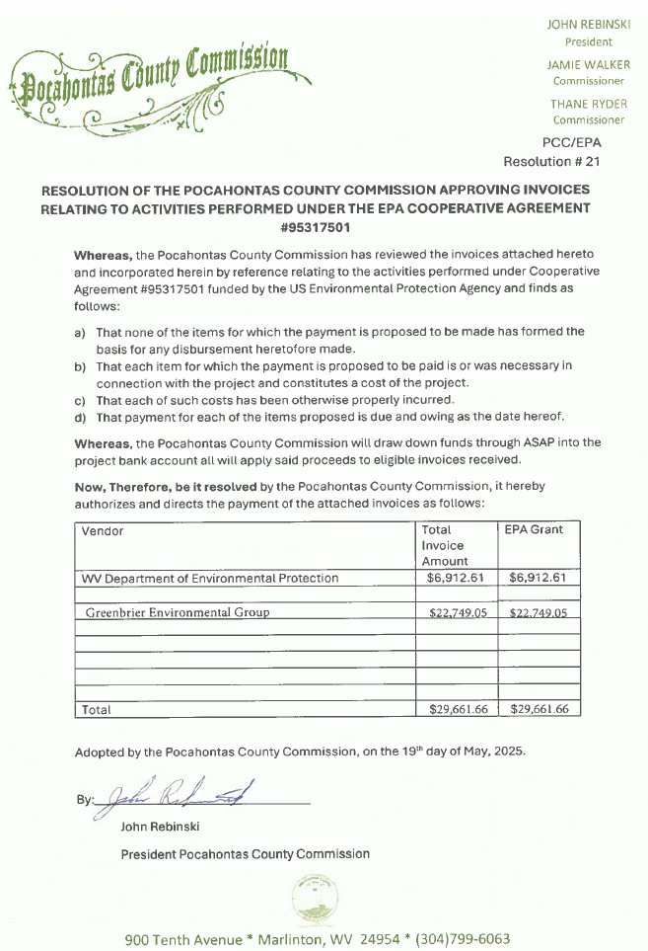

IN RE: MOUNTAIN HEART/NORTH CENTRAL COMMUNITY ACTION, PROCLAMATION DECLARING MAY COMMUNITY ACTION MONTH

A motion was made by Commissioner Walker to approve Mountain Heart/North Central Community Action Proclamation declaring May Community Action Month, and noting no objections motion carried.
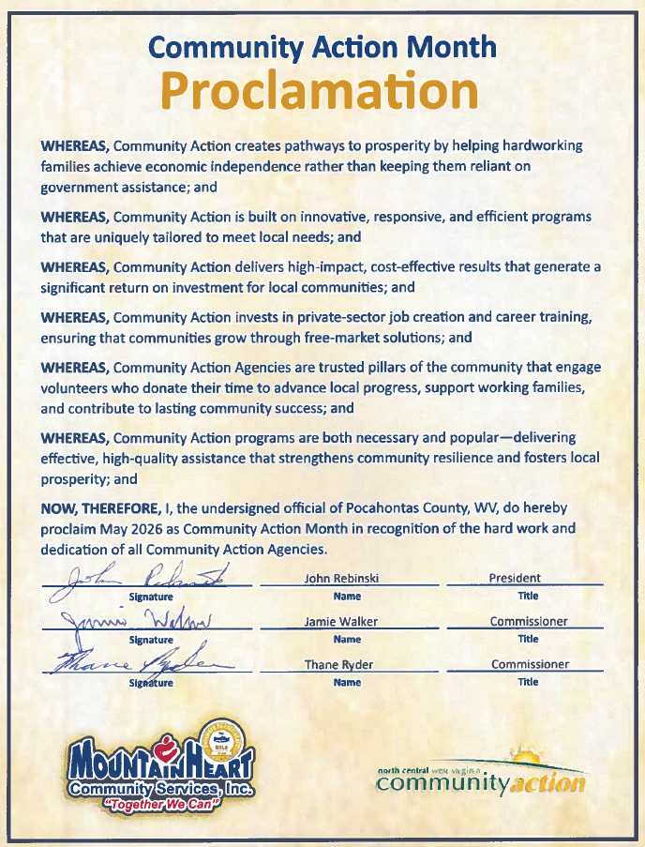

IN RE: COUNTY BOUNDARY ATTESTATION/UNITED STATES CENSUS BOUNDARY AND ANNEXATION SURVEY

A motion was made by Commissioner Walker at approve the County Boundary Attestation/United States Census Boundary and Annexation survey for Durbin and Marlinton, and noting no objections, motion carried.
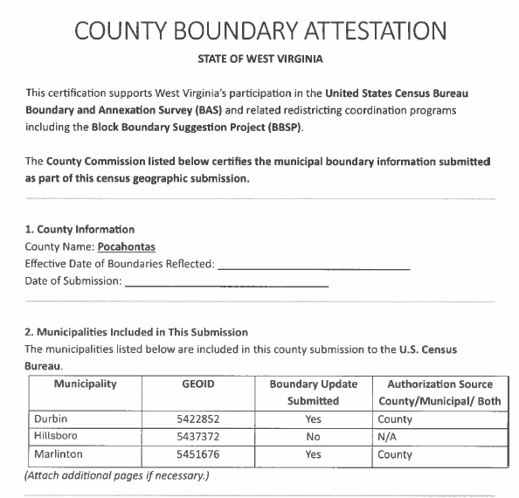
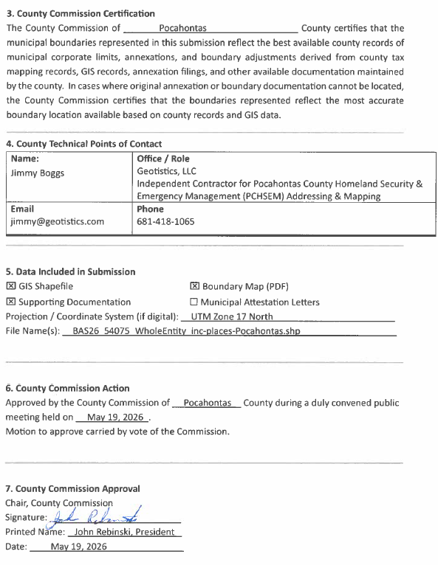
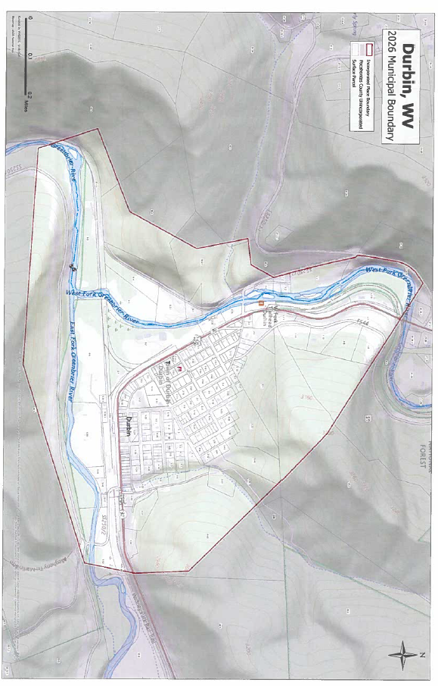

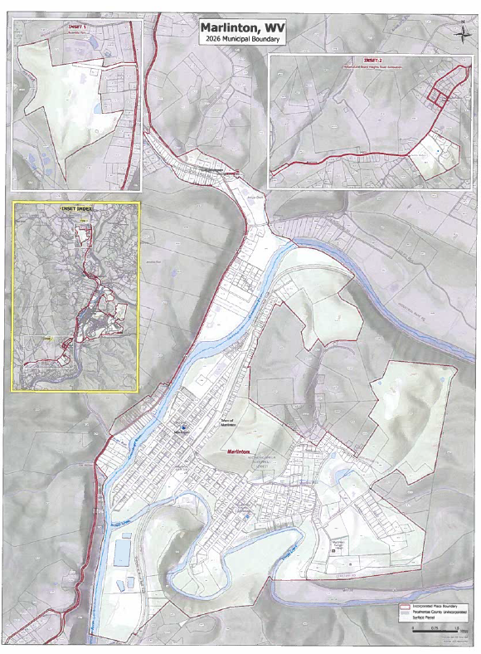

IN RE: CERTIFICATION OF DELINQUENT REAL ESTATE AND PERSONAL PROPERTY TAX YEAR 2025

A motion was made by Commissioner Ryder to approve the Certification of Delinquent Real Estate and Personal Property Tax Year 2025, and noting no objections, motion carried.

IN RE: BROADCASTING COUNTY COMMISSION MEETINGS LIVE ON FACEBOOK

A motion was made by Commissioner Ryder to approve to continue to post zoom meetings to facebook after the meetings, and noting no objections, motion carried.

IN RE: ARC BROADBAND PROJECT ISSUES

Attorney has designated weekly meeting. Three poles demobilized on resolution near future. No action was taken on this matter.

IN RE: PURCHASE OF MOWER FOR POCAHONTAS CAMPGROUND AT HANDLEY

No action was taken on this matter. Tabled until June 2, 2026 County Commission Meeting.

IN RE: PRESENTATION, DISCUSSION AND POSSIBLE ACTION ON AN ORDINANCE AUTHORIZING THE ANNUAL GREEN BOX FEE TO BE INCLUDED AS A SEPARATE FEE OR ASSESSMENT ON POCAHONTAS COUNTY TAX TICKETS AND/OR SHERIFF TAX-TICKET MAILINGS AND AUTHORIZING IMPLEMENTATION WITH THE COUNTY CLERK, SHERIFF, ASSESSOR AND SOLID WASTE AUTHORITY

Several members signed in to hear callers to speak on the behalf of the opposition of the possible ordinance authorizing the annual green box fee be included as a separate fee of assessment on Pocahontas County Tax Tickets mailings and authorizing implementation with the County Clerk, Sheriff, Assessor, and Solid Waste Authority. Commissioner Rebinski stated that the County Commission does not have the authority to add anything to tax tickets without it being voted on in the form of a levy. No Action was taken on this matter.

IN RE: INVOICES

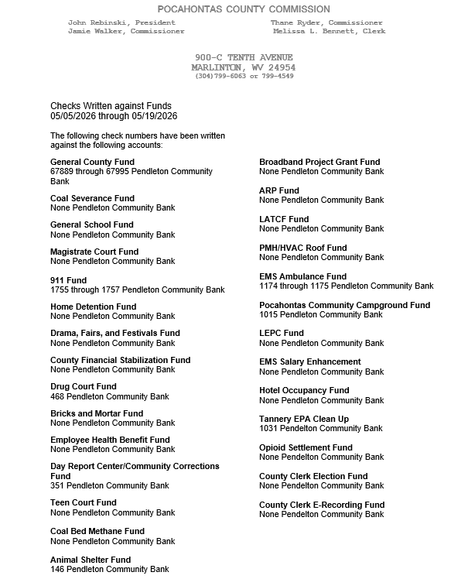

ORDERED THIS MEETING BE ADJOURNED, SINE DIE.

