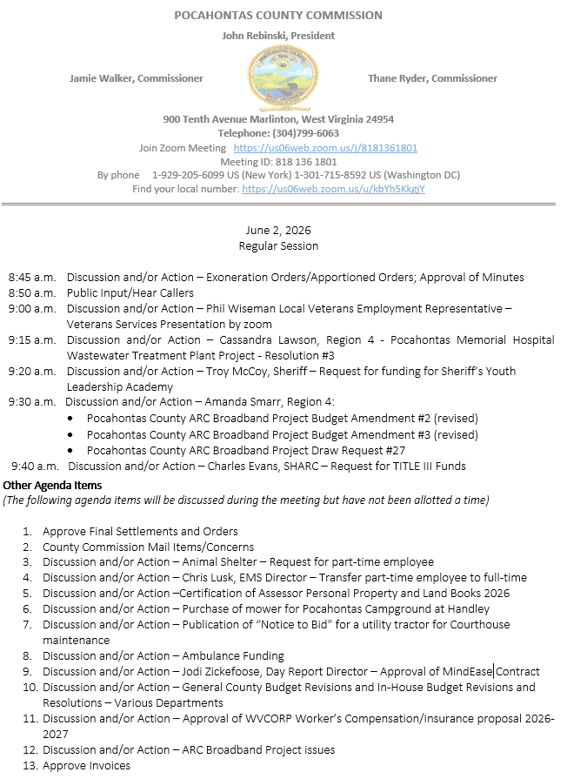

At a Regular Session of the Pocahontas County Commission held at the Courthouse situate in Marlinton, West Virginia, on the 2nd day of June, 2026.

PRESENT: John Rebinski, President
Jamie Walker, Commissioner
Thane Ryder, Commissioner

Prior to the beginning of today’s session, the Commission invited all individuals in attendance to stand and recite the Pledge of Allegiance.

IN RE: EXONERATION/APPORTIONED ORDERS APPROVED

None

IN RE: MINUTES APPROVED

A motion was made by Commissioner Walker to approve the minutes of the last regular session of the Commission held on the 19th day of May, 2026, a Special Session on the 27th day of May, 2026, and Canvass minutes for the Primary 2026 as presented, and noting no objections, motion carried.

IN RE: FINAL SETTLEMENTS AND ORDERS APPROVED

Commission President John Rebinski reviewed several final settlements and orders pertaining to estates as presented by the County Clerk’s Office and, thereafter, approved same by placing his signature thereto.

IN RE: COUNTY COMMISSION MAIL ITEMS/CONCERNS

Phone Message – David Cain – Grass at East Cass Lots.
Letter – FEMA - Extended compliance period until September 2, 2026
Copy – Ethan Burgess – Resignation Pocahontas Community Campground at Handley
Copy - Thompson & Litton Engineer’s Field Report Quanta Telecommunications Solutions
Copy – DEP Tannery Project Deviation from groundwater quality standards. No objections
Copy – DEP Tannery Project No-Cost extension approval

IN RE: SIGN IN SHEET/HEAR CALLERS

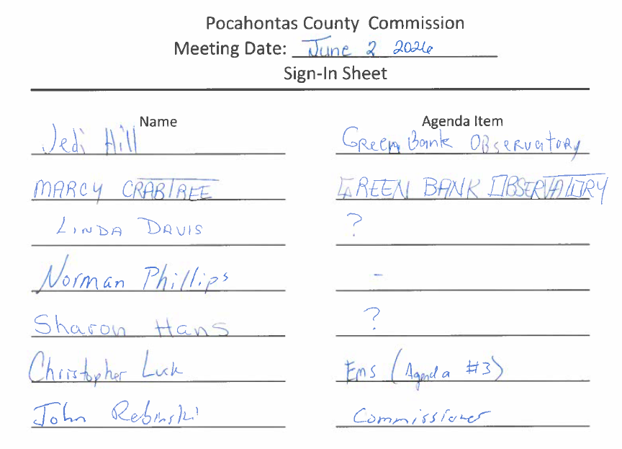

Jedi Hill, Marcy Crabtree, Linda Davis, Norman Phillips, Sharon Hans, Christopher Lusk, John Rebinski

Jedi Hill Marcy Crantree and Sharon Hans signed up to speak on the Green Bank Observatory funding cuts, smart meters and WIFI issues. Linda Davis spoke concerning the solid waste fee increase. Norman Phillips introduced himself as a new member of the County. Christopher Lusk agenda item #3. John Rebinski spoke on accusations with the last SWA meeting and Commission not helping the SWA.

IN RE: PHIL WISEMAN LOCAL VETERANS EMPLOYMENT REPRESENTATIVE – VETERANS SERVICES PRESENTATION BY ZOOM

Phil Wiseman with the Local Veterans Employment Representative met with the Commission with a Veterans Service Presentation by zoom with the program on employer services. No action was taken on this matter.

IN RE: CASSANDRA LAWSON, REGION 4 - POCAHONTAS MEMORIAL HOSPITAL WASTEWATER TREATMENT PLANT PROJECT - RESOLUTION #3

A motion was made by Commissioner Ryder to approve the Pocahontas Memorial Hospital Wastewater Treatment Plant Project - Resolution #3, and noting no objections, motion carried.

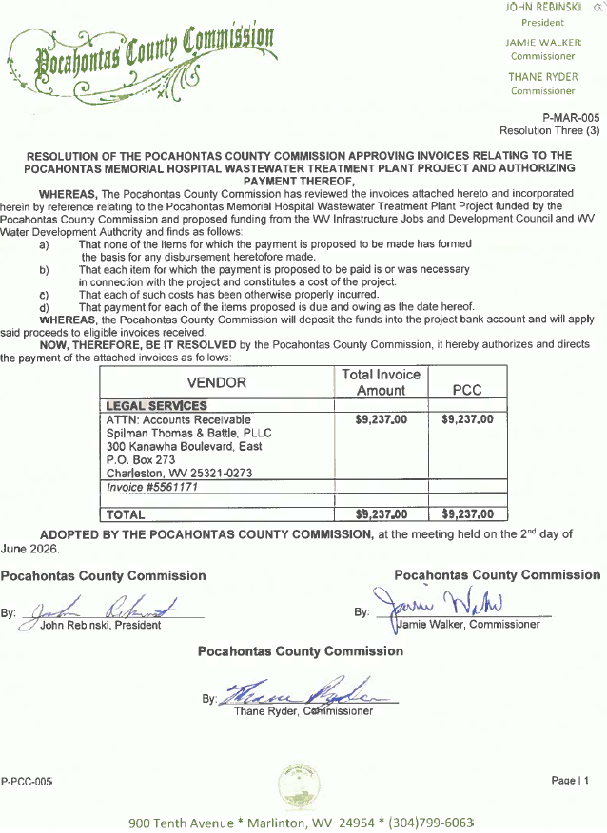

IN RE: TROY MCCOY, SHERIFF – REQUEST FOR FUNDING FOR SHERIFF’S YOUTH LEADERSHIP ACADEMY

A motion was made by Commissioner Rebinski at the request of Sheriff Troy McCoy, to approve a contribution of $2,500.00 for the Youth Leadership Academy, contingent upon receiving itemized statement of what funds are used for, and noting no objections, motion carried.

IN RE: AMANDA SMARR, REGION 4:

- POCAHONTAS COUNTY ARC BROADBAND PROJECT BUDGET AMENDMENT #2 (REVISED)
- POCAHONTAS COUNTY ARC BROADBAND PROJECT BUDGET AMENDMENT #3 (REVISED)
- POCAHONTAS COUNTY ARC BROADBAND PROJECT DRAW REQUEST #27

A motion was made by Commissioner Ryder to approve Pocahontas County ARC Broadband Project Budget Amendment #2 (revised) and Pocahontas County ARC Broadband Project Budget Amendment #3 (revised), and noting no objections, motion carried.

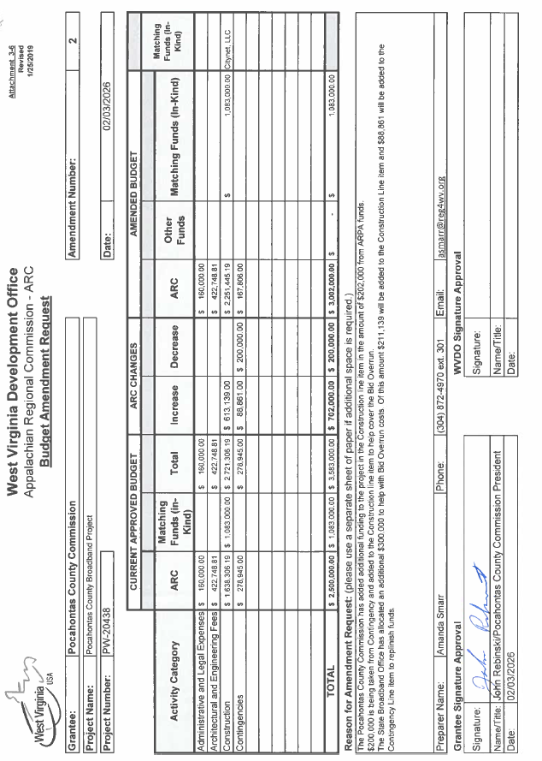
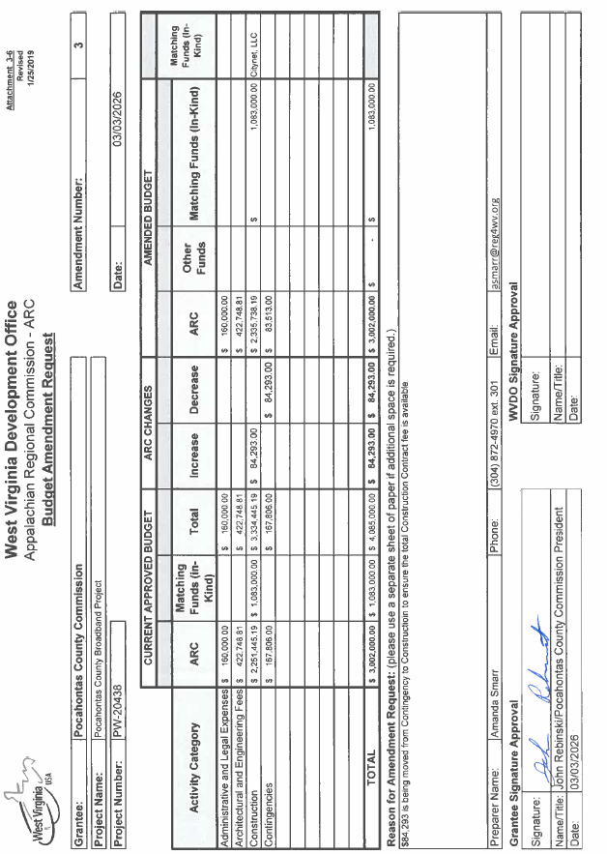

A motion was made by Commissioner Walker to approve the Pocahontas County ARC Broadband Project Draw Request #27, and noting no objections motion carried.
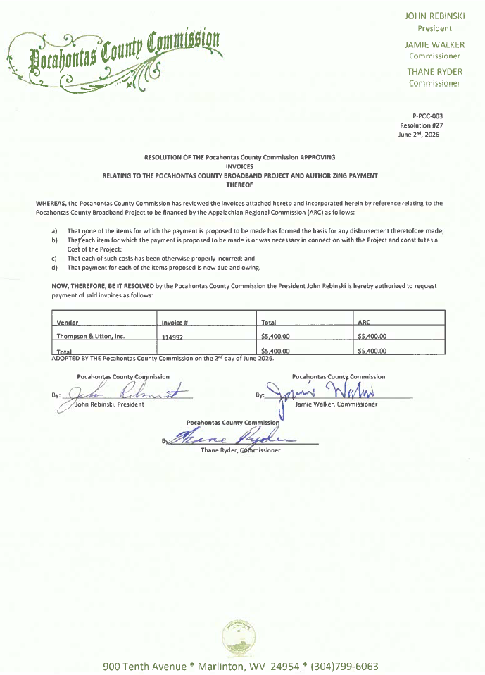
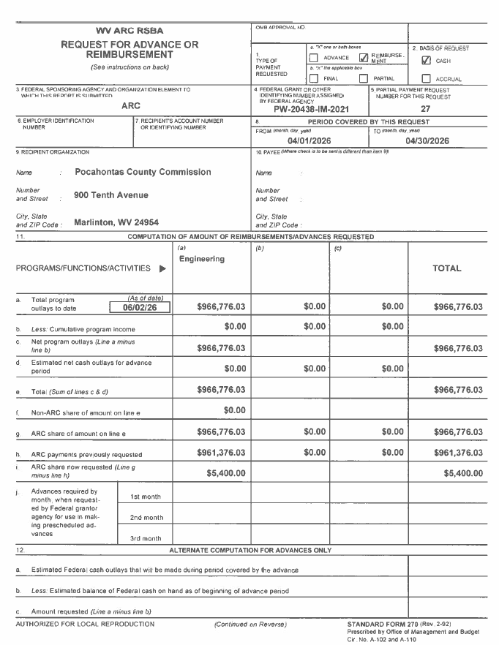
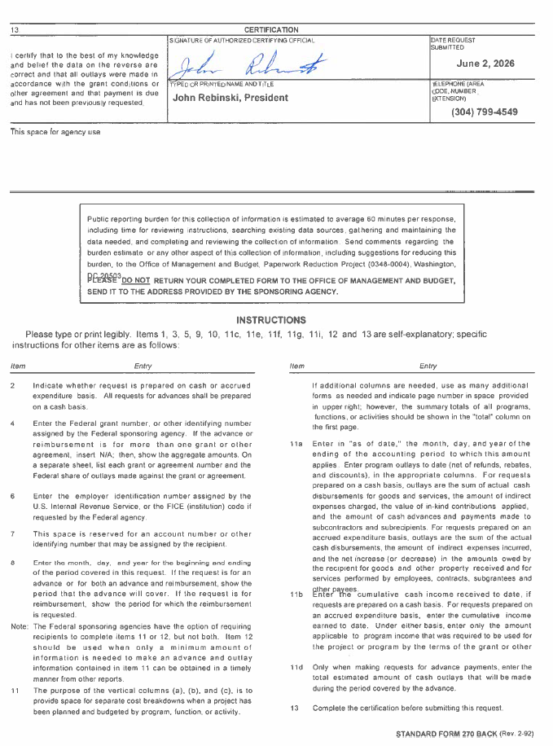
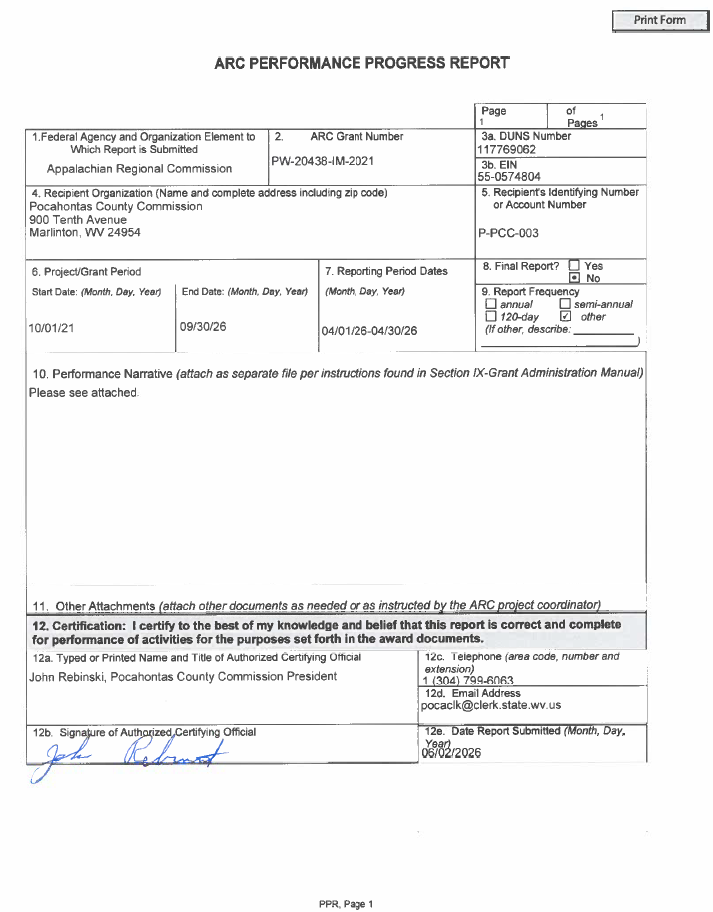

IN RE: CHARLES EVANS, SHARC – REQUEST FOR TITLE III FUNDS

A motion was made by Commissioner Rebinski to approve the request for 7% of the Title III funds approximately $29,000.00 to be given to Charles Evans with SHARC, and receipts and invoices must be submitted, and noting no objections, motion carried.

IN RE: ANIMAL SHELTER – REQUEST FOR PART-TIME EMPLOYEE

A motion was made by Commissioner Walker to approve the publication for part-time employment at the animal shelter, and noting no objections, motion carried.

IN RE: CHRIS LUSK, EMS DIRECTOR – TRANSFER PART-TIME EMPLOYEE TO FULL-TIME

A motion was made by Commissioner Walker to transfer Dylan White from part-time to full-time at his current rate of pay of $15.00 per hour and full benefits effective June 3, 2026, and noting no objections, motion carried.

IN RE: CERTIFICATION OF ASSESSOR PERSONAL PROPERTY AND LAND BOOKS 2026

A motion was made by Commissioner Walker to certify the Assessor’s Personal Property and Land Books for 2026, and noting no objections, motion carried.

IN RE: PURCHASE OF MOWER FOR POCAHONTAS CAMPGROUND AT HANDLEY

Commissioner Walker would like to put a hold on purchasing a mower for the Pocahontas Campground at Handley, to see if the old courthouse mower could be utilized at the Pocahontas Campground at Handley. No action was taken on this matter.

IN RE: PUBLICATION OF “NOTICE TO BID” FOR A UTILITY TRACTOR FOR COURTHOUSE MAINTENANCE

A motion was made by Commissioner Walker to publish a notice to bid, and bids will be opened at the special meeting on the 30th day of June, 2026, and noting no objections, motion carried.

IN RE: AMBULANCE FUNDING

Commissioner Rebinski requested to move money from the Hotel/Motel excess budget into the Ambulance Fund after discussion, no action was taken on this matter.

IN RE: JODI ZICKEFOOSE, DAY REPORT DIRECTOR – APPROVAL OF MINDEASE CONTRACT

A motion was made by Commissioner Waker to approve the MindEase Contract as presented, and noting no objections, motion carried.


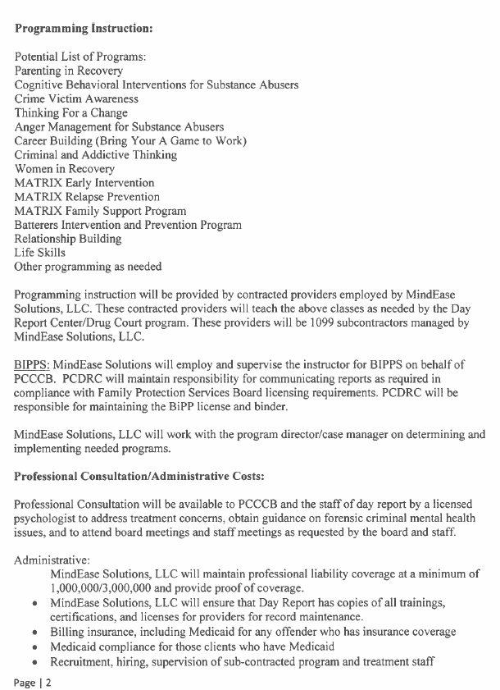
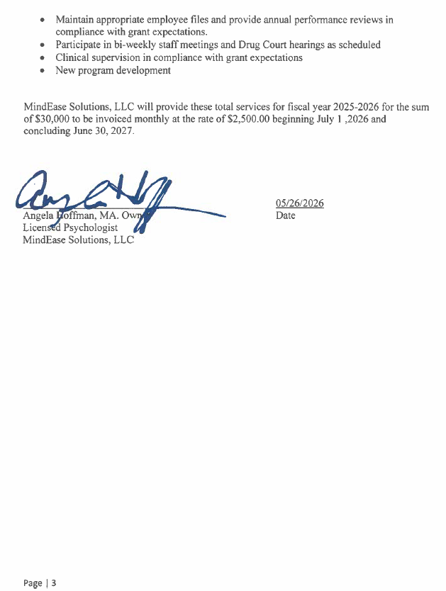
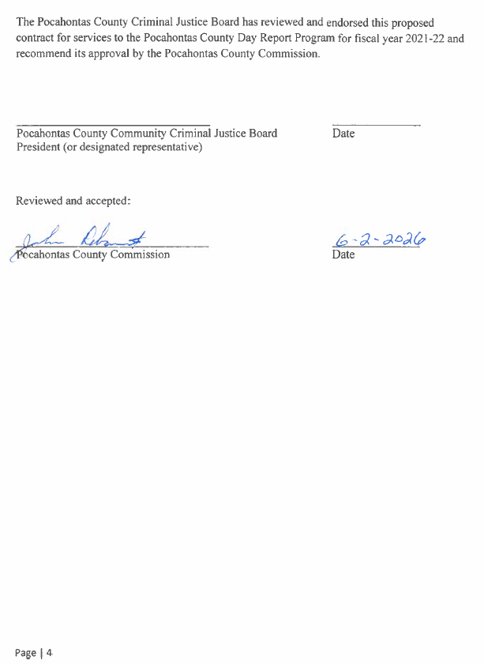

IN RE; GENERAL COUNTY BUDGET REVISIONS AND IN-HOUSE BUDGET REVISIONS AND RESOLUTIONS – VARIOUS DEPARTMENTS

A motion was made by Commissioner Walker to approve the In-house budget revisions and resolutions – various departments, a General County Budget Revision was not needed, and noting no objections, motion carried.
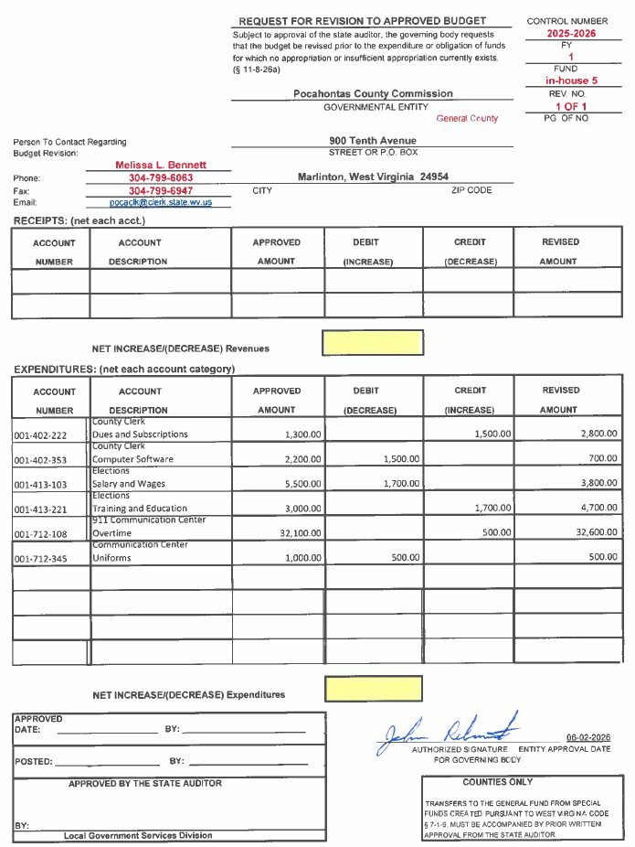

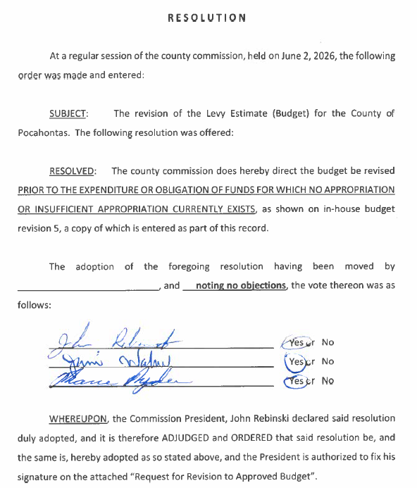

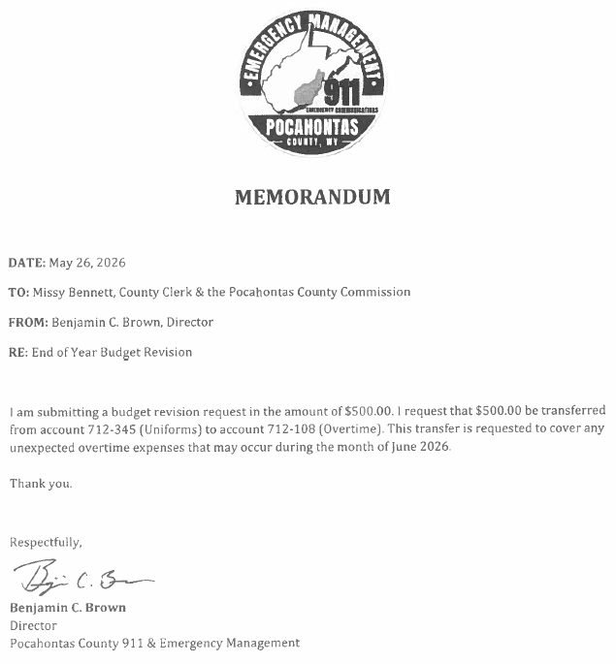
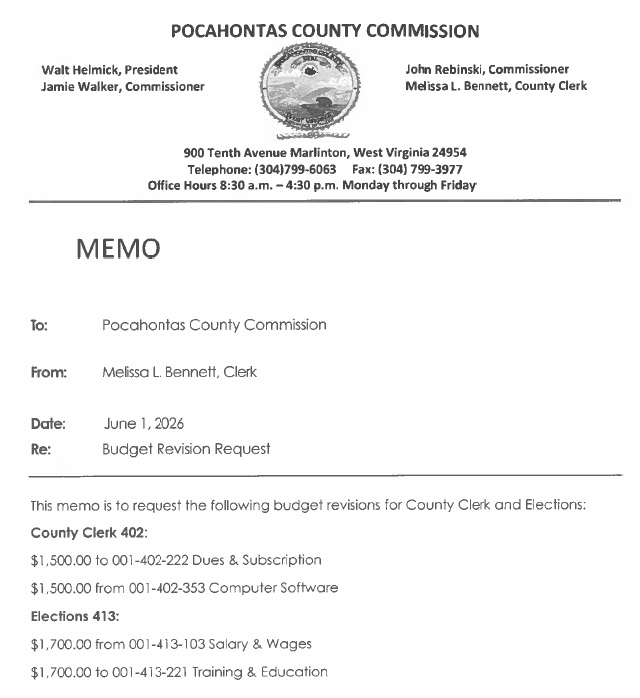
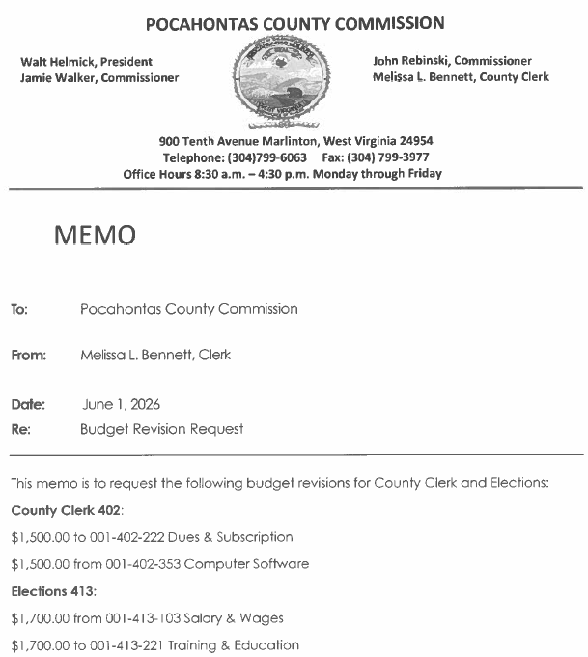

IN RE: APPROVAL OF WVCORP WORKER’S COMPENSATION/INSURANCE PROPOSAL 2026-2027

A motion was made by Commissioner Walker to approve the WV Corp Worker’s Compensation/Insurance Proposal for 2026-2027, and noting no objections, motion carried.
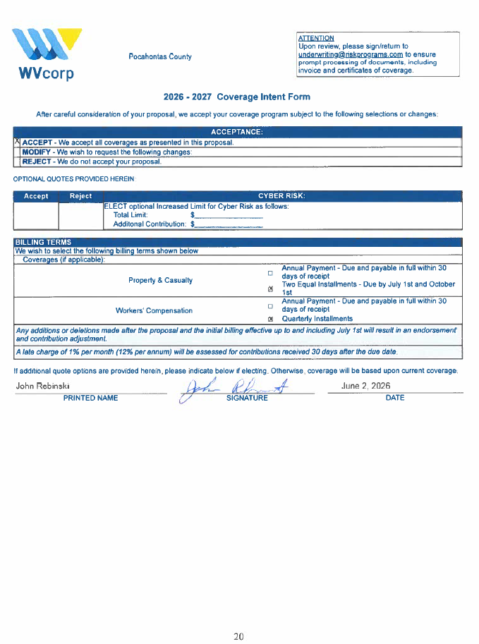

IN RE: ARC BROADBAND PROJECT ISSUES

No action was taken on this matter.

IN RE: INVOICES

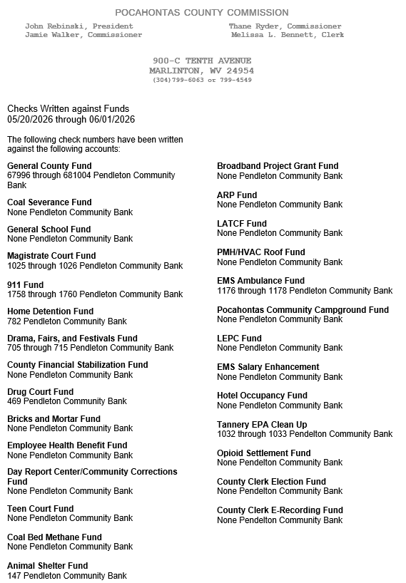

ORDERED THIS MEETING BE ADJOURNED, SINE DIE.



