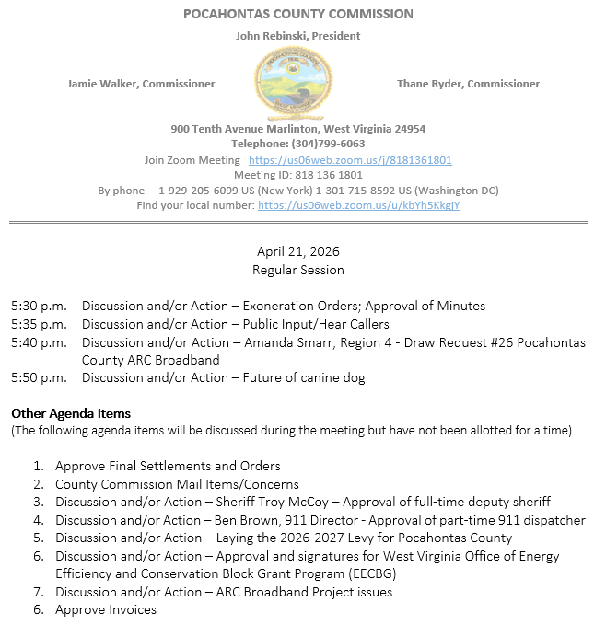
At a Regular Session of the Pocahontas County Commission held at the Courthouse situate in Marlinton, West Virginia, on the 21st day of April, 2026.

PRESENT: John Rebinski, President
Jamie Walker, Commissioner
Thane Ryder, Commissioner

Prior to the beginning of today’s session, the Commission invited all individuals in attendance to stand and recite the Pledge of Allegiance.

IN RE: EXONERATION/APPORTIONED ORDERS APPROVED

None

IN RE: MINUTES APPROVED

A motion was made by Commissioner Ryder to approve the minutes of the last regular session of the Commission held on the 7th day of April, 2026, and noting no objections, motion carried.

IN RE: FINAL SETTLEMENTS AND ORDERS APPROVED

Commission President John Rebinski reviewed several final settlements and orders pertaining to estates as presented by the County Clerk’s Office and, thereafter, approved same by placing his signature thereto.

IN RE: COUNTY COMMISSION MAIL ITEMS/CONCERNS

Post card – Pocahontas County Tourism - Summit Invitation Thursday May 7, 2026
Letter – State of West Virginia State Auditor – Notice of Approval of the Levy Estimate (Budget)

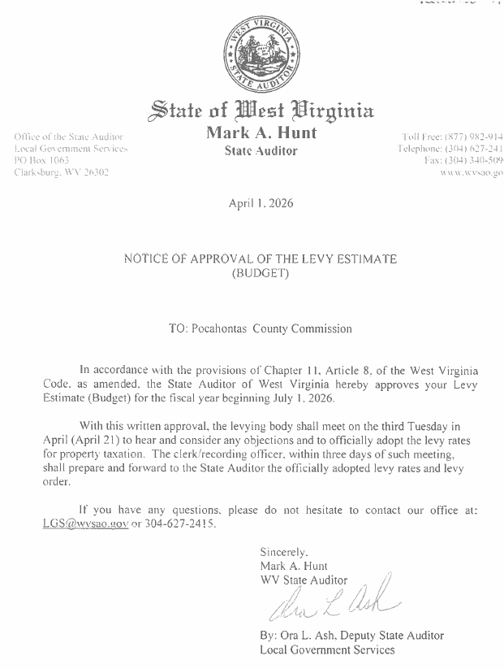
IN RE: APPROVAL OF PART-TIME 911 DISPATCHER

A motion was made by Commissioner Walker to approve Austin Rider as parttime 911 Dispatcher at $14.00 per hour with no benefits, effective April 25, 2026 and noting no objections motion carried.

IN RE: SIGN IN SHEET/HEAR CALLERS

None

IN RE: LAYING THE 2026-2027 LEVY FOR POCAHONTAS COUNTY

A motion was made by Commissioner Ryder to approve Laying the 2026-2027 Levy for Pocahontas County, and noting no objections, motion carried.
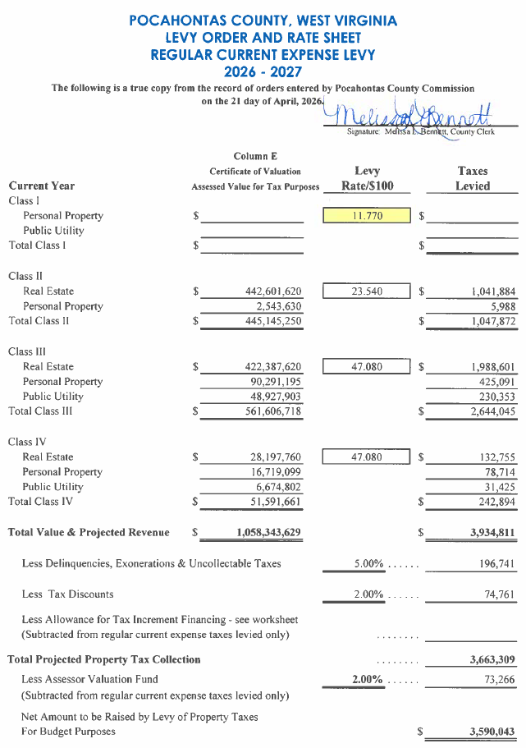

IN RE: APPROVAL AND SIGNATURES FOR WEST VIRGINIA OFFICE OF ENERGY
EFFICIENCY AND CONSERVATION BLOCK GRANT PROGRAM (EECBG)

A motion was made by Commissioner Walker to approve and sign the West Virginia Office of Energy Efficiency and Conservation Block Grant Program (EECBG), and noting no objections, motion carried.
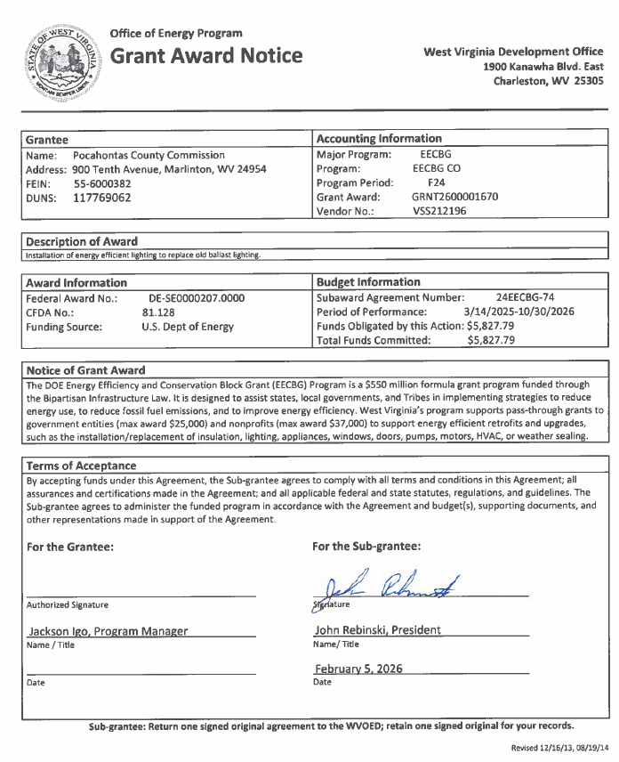
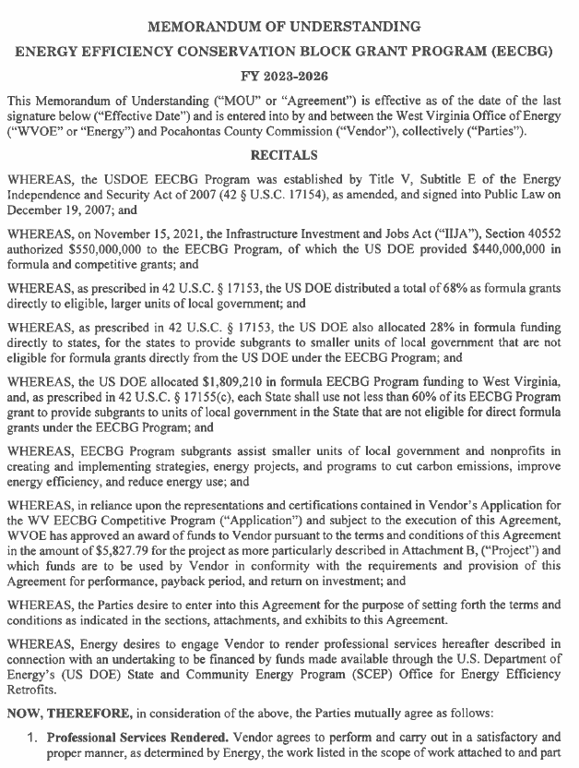
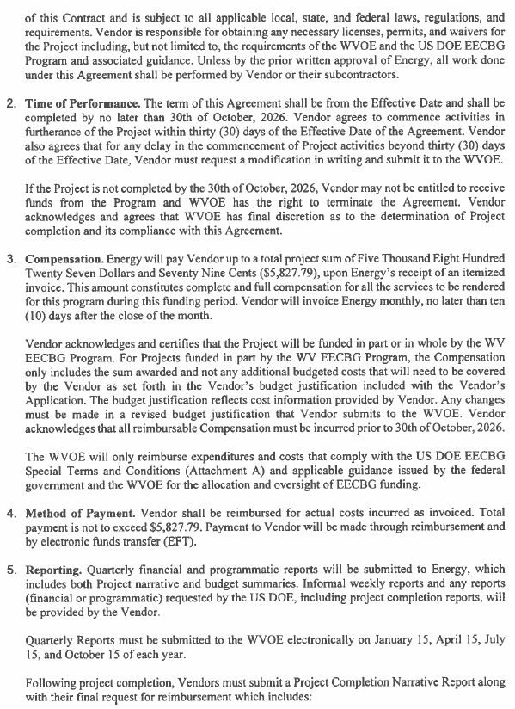
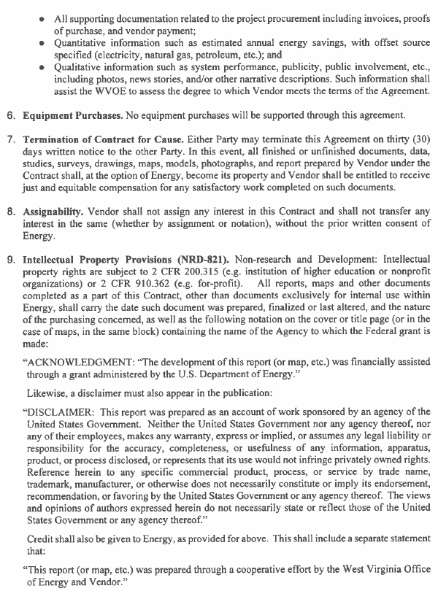
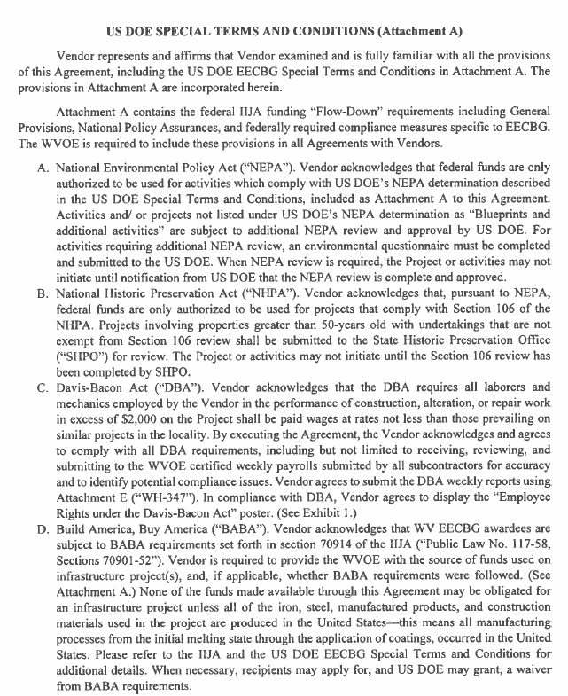

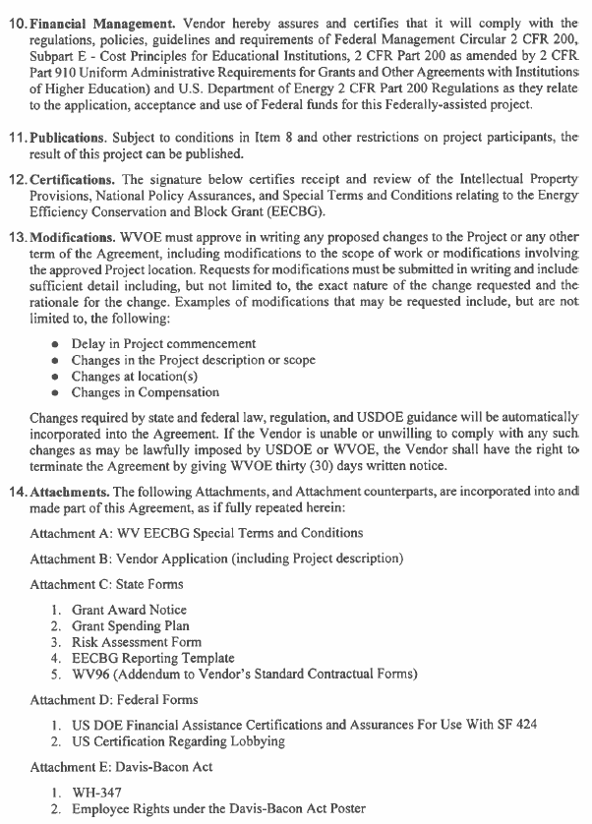
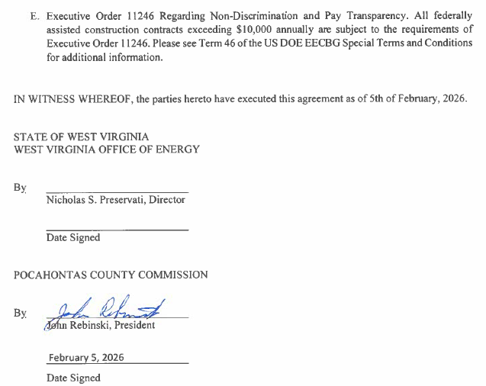

IN RE: DRAW REQUEST #26 POCAHONTAS COUNTY ARC BROADBAND

A motion was made to approve Draw Request #26 for the Pocahontas County ARC Broadband as presented by Amanda Smarr with Region 4, and noting no objections, motion carried.
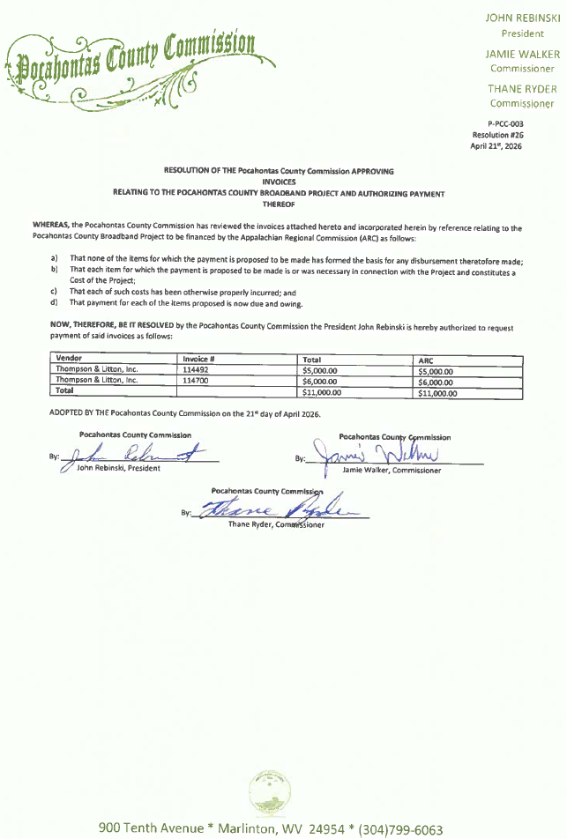
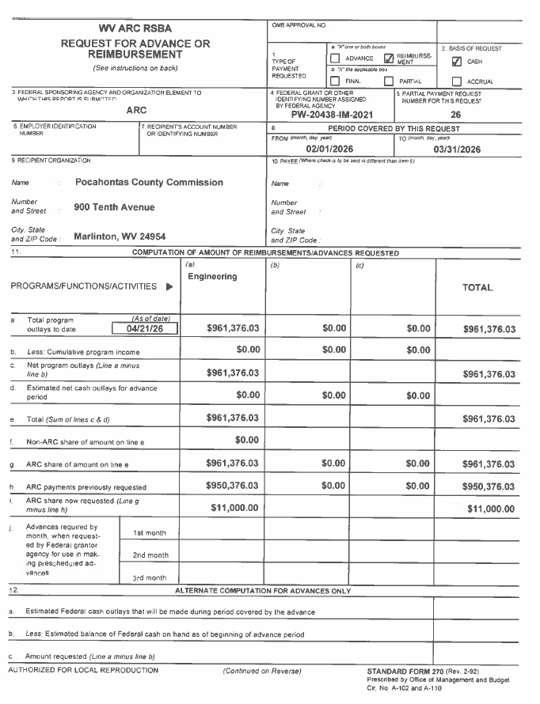
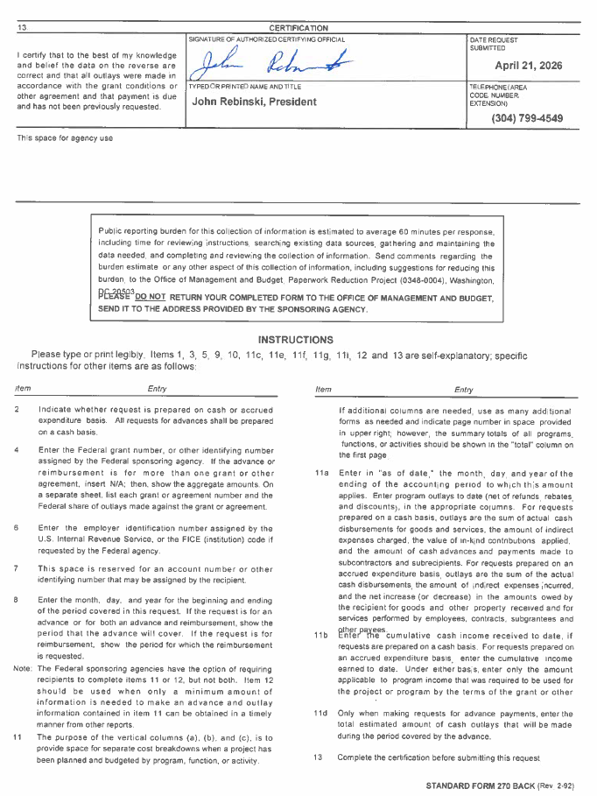
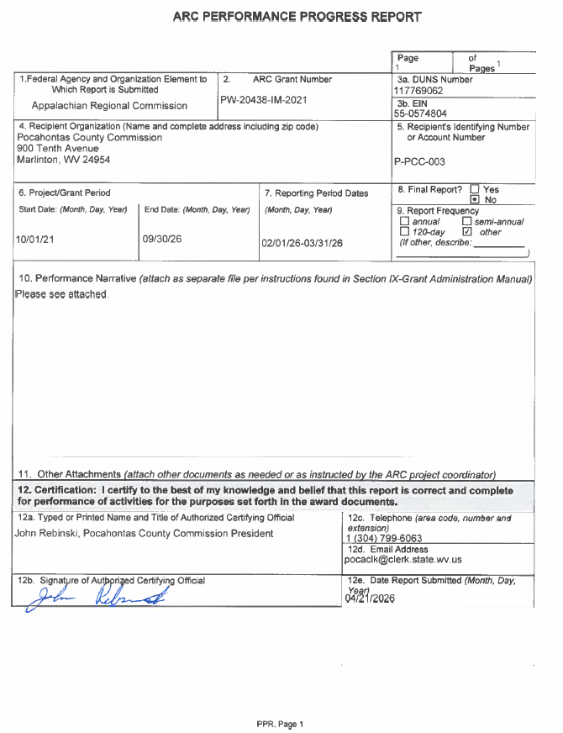
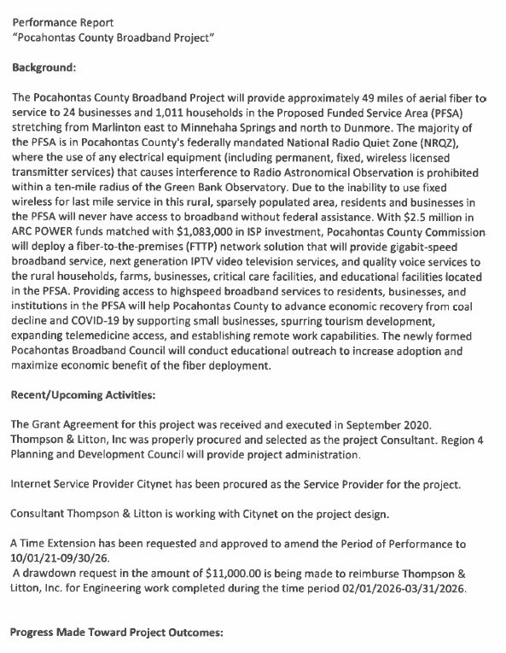
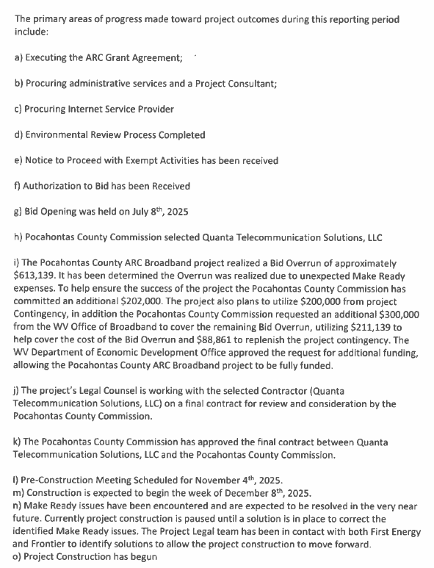
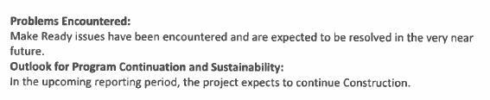
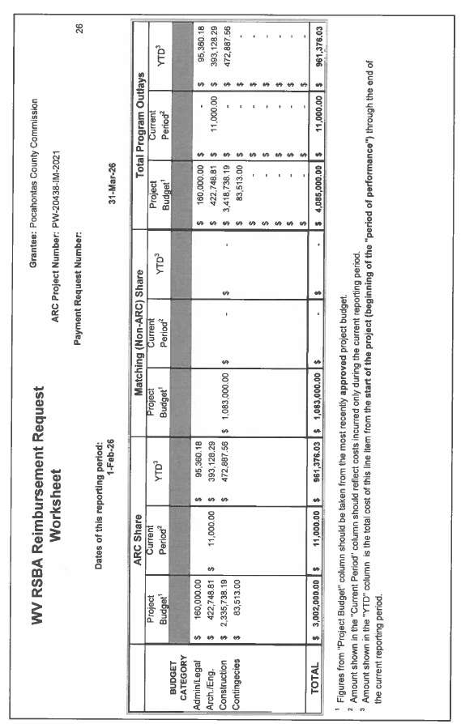
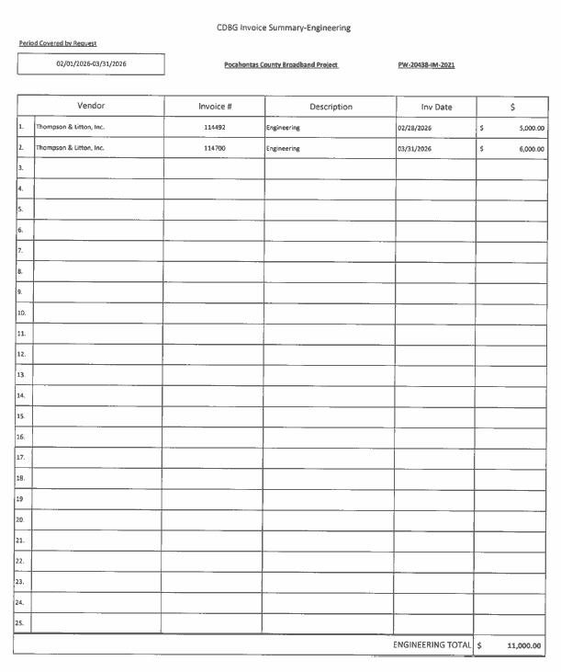
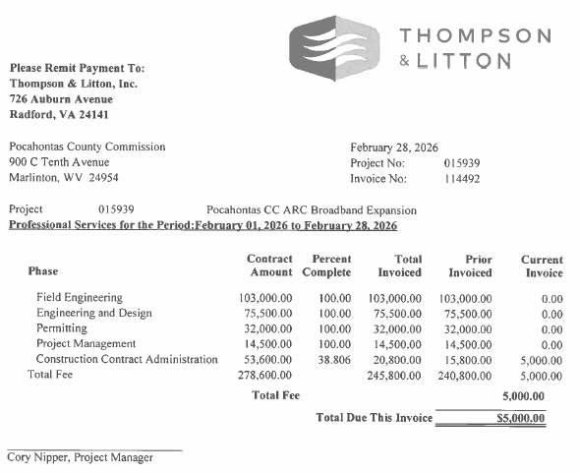
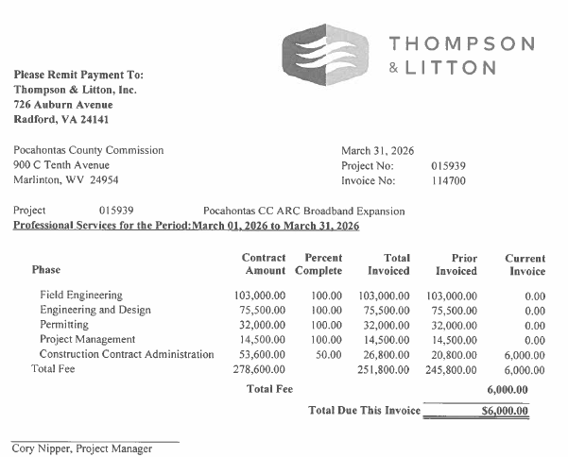

IN RE: ARC BROADBAND PROJECT ISSUES

A motion was made by Commissioner Rebinski to have Counsel send a letter to Mon Power/First Energy requesting reimbursement for cost of the make ready pole attachments that are not completed, also to pursue complaint to the public service commission, and noting no objections motion carried.

IN RE: FUTURE OF CANINE DOG

Several people from the community came to speak in support of the of keeping the Canine Dog. The Commission’s intent is to budget for fiscal year 2026-2027 for the canine dog. Personnel is the Sheriff’s department issue and will be handled by that department. No action was taken on this matter

IN RE: APPROVAL OF FULL-TIME DEPUTY SHERIFF

At the request of the Pocahontas County Sheriff to enter into executive Session per the Open Meetings Act 2B, a motion was made by Commissioner Walker to enter into executive session, and noting no objections, motion carried. At the end of the executive session a motion was made by Commissioner Walker to end the same, and noting no objections, motion carried.

A motion was made by Commissioner Walker to approve Mark Walton as Deputy Sheriff at $55,000.00 per year with full benefits effective date April 27, 2026, and noting no objections, motion carried.

IN RE: INVOICES

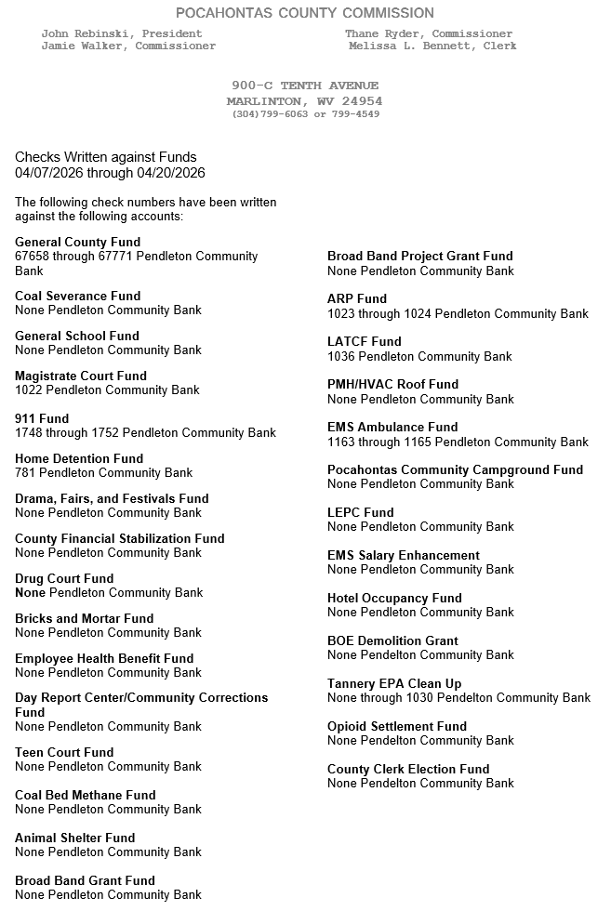

ORDERED THIS MEETING BE ADJOURNED, SINE DIE.
