POCAHONTAS COUNTY COMMISSION

John Rebinski, President


Jamie Walker, Commissioner Thane Ryder, Commissioner

900 Tenth Avenue Marlinton, West Virginia 24954
Telephone: (304)799-6063

Join Zoom Meeting https://us06web.zoom.us/j/8181361801
Meeting ID: 818 136 1801
By phone 1-929-205-6099 US (New York) 1-301-715-8592 US (Washington DC)
Find your local number: https://us06web.zoom.us/u/kbYh5KkgjY

June 30, 2026
Special Session

2:00 p.m. Discussion and/or Action – Interviews for part-time employee at Pocahontas County Animal Shelter
2:30 p.m. Discussion and/or Action – Board Appointment for Pocahontas County Solid Waste Authority
3:15 p.m. Discussion and/or Action – Opening and awarding of bid for a Sub-Compact Utility Tractor

Other Agenda Items
(The following agenda items will be discussed during the meeting but have not been allotted for a time)

- Discussion and/or Action – Approval of part-time employee for Pocahontas County Animal Shelter
- Discussion and/or Action – Board Appointments:
Pocahontas County Solid Waste Authority
Pocahontas County Dramas, Fairs and Festivals: Linda Adams, Kristen Beverage and Allie Callison; three-year terms expiring 06/30/2029
Pocahontas County Building Commission: Correction to Randy Sharp’s appointment on June 16, 2026 from a three-year term to a five-year term expiring on June 30, 2031
- Discussion and/or Action –Designation of County Depositories 2026-2027. (West Virginia Code 7-6-1).
- Approve Invoices

At a Special Session of the Pocahontas County Commission held at the Courthouse situate in Marlinton, West Virginia, on Tuesday, the 30th day of June, 2026.

PRESENT: John Rebinski, President
Jamie Walker, Commissioner
Thane Ryder, Commissioner

Prior to the beginning of today’s session, the Commission invited all individuals in attendance to stand and recite the Pledge of Allegiance.

IN RE: INTERVIEWS FOR PART-TIME EMPLOYEE AT POCAHONTAS COUNTY ANIMAL SHELTER

A motion was made by Commissioner Walker to enter into executive session to conduct interviews for a part-time employee at the Pocahontas County Animal Shelter per WV Open Meetings Act Exception 2A and noting no objections, motion carried.

A motion was made by Commissioner Walker to end the executive session and noting no objections, motion carried.

IN RE: INTERVIEWS FOR BOARD APPOINTMENT FOR POCAHONTAS COUNTY SOLID WASTE AUTHORITY

A motion was made by Commissioner Ryder to enter into executive session to conduct interviews for board appointment to the Pocahontas County Solid Waste Authority per WV Open Meetings Act Exception 2A and noting no objections, motion carried.

The following interviews were conducted in executive session: David McLaughlin, Gail Siers, Sam Collins and June Taylor

A motion was made by Commissioner Walker to end the executive session and noting no objections, motion carried.

IN RE: OPENING AND AWARDING OF BID FOR A SUB-COMPACT UTILITY TRACTOR

The commission received 4 sealed bids for a sub-compact utility tractor from the following
vendors:
James River Equipment $59,978.00
(Snow Plow) 6,200.00
TOTAL $66,178.00

Boone Tractor $5,885.00
Varner’s Outdoor Power Equipment $43,671.00
Varner’s Outdoor Power Equipment $36,600.00 (no cab)

A motion was made by Commissioner Walker to award the bid to Varner’s Outdoor Power Equipment in the amount of $43,671.00 and noting no objections, motion carried.

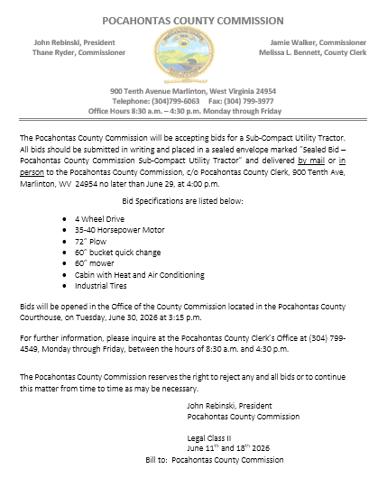

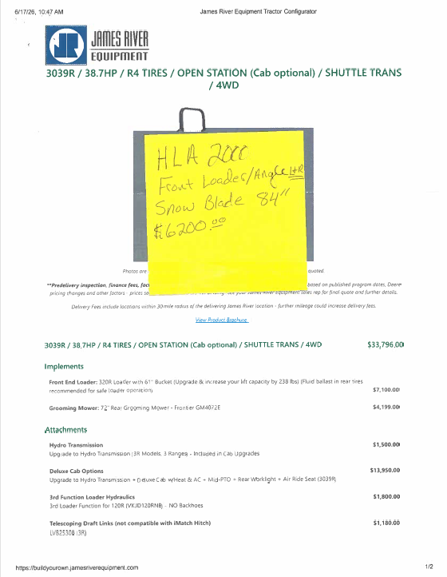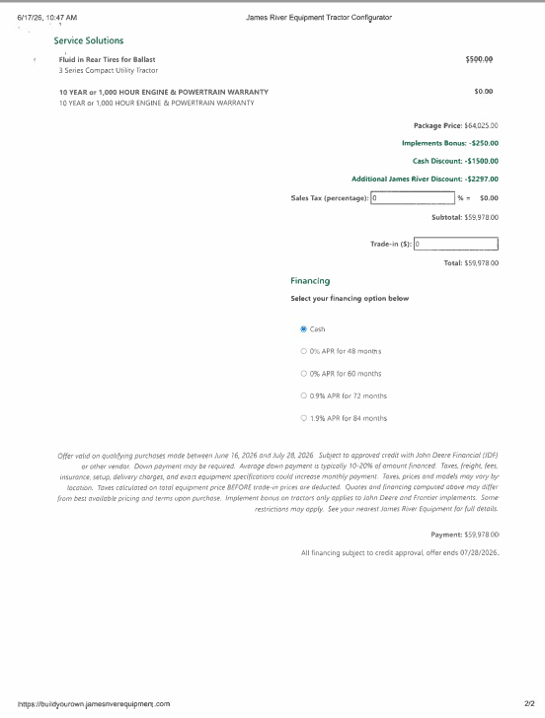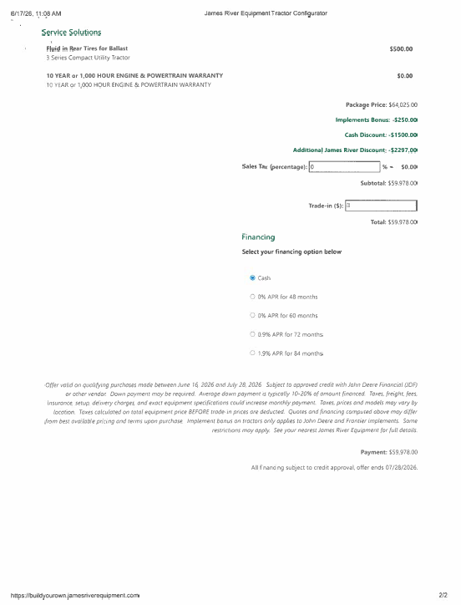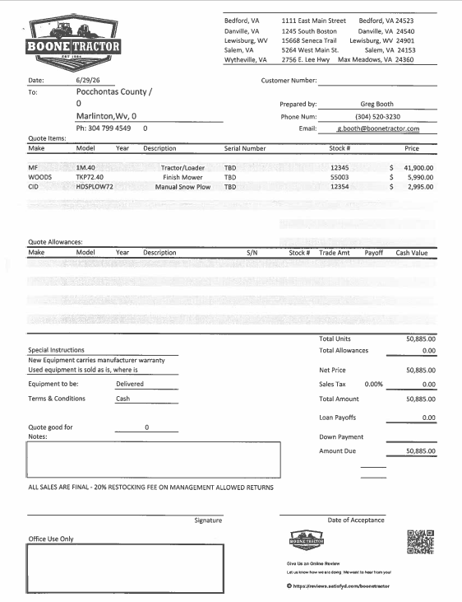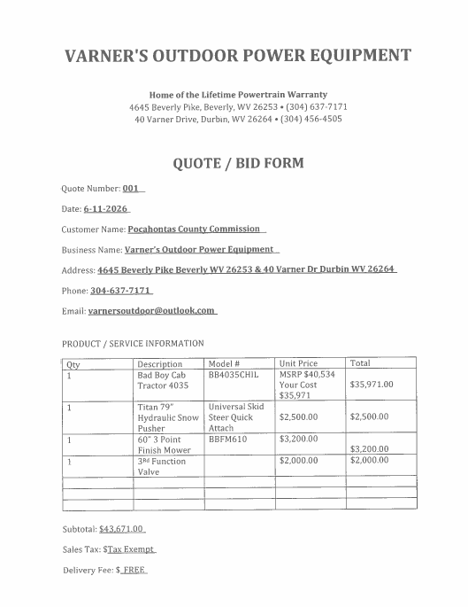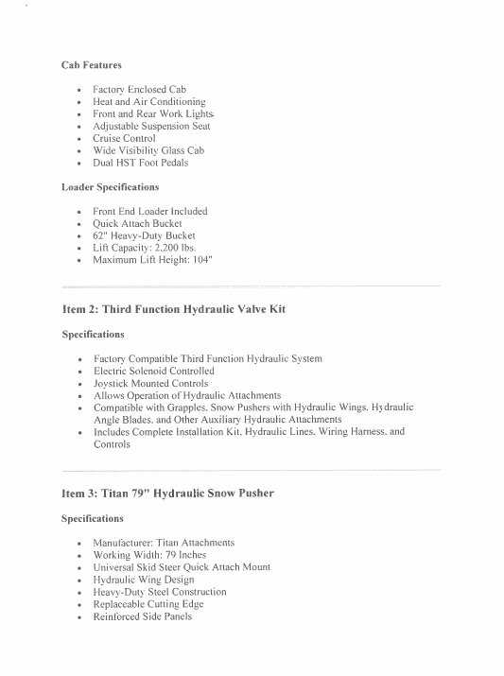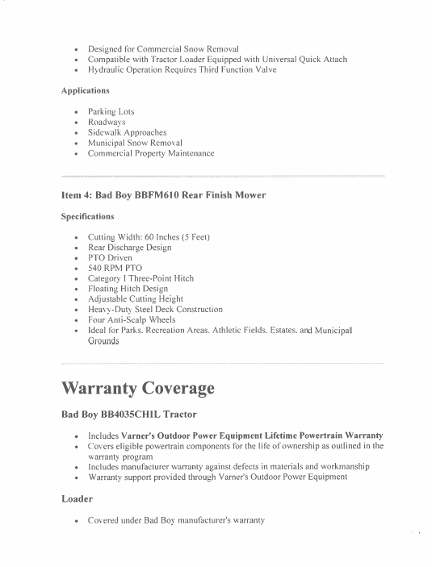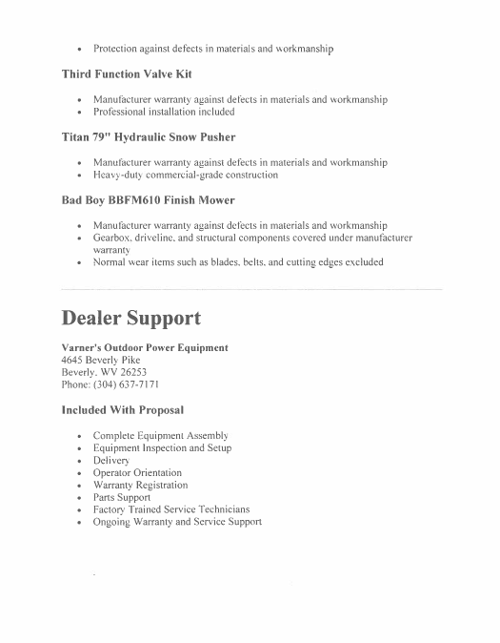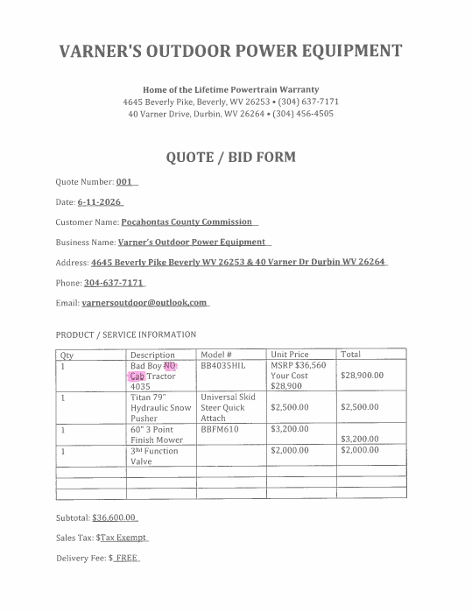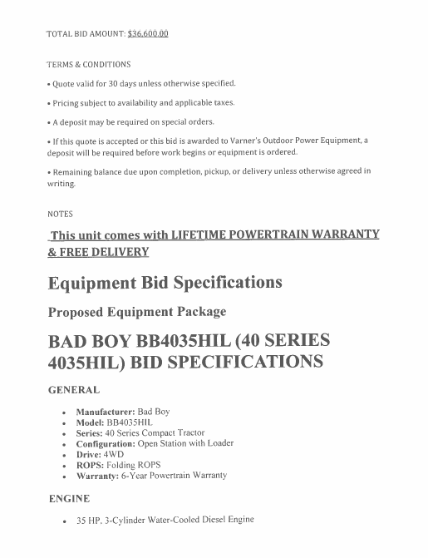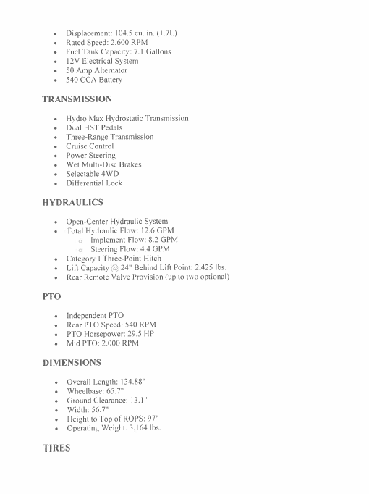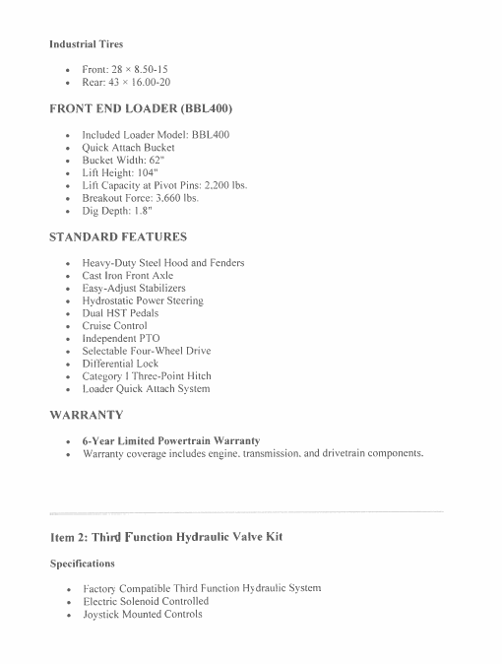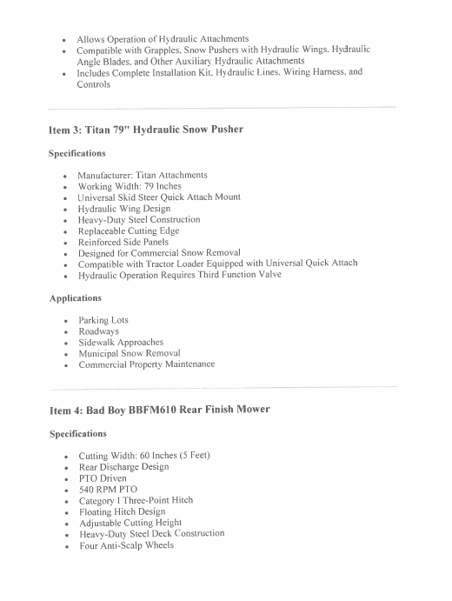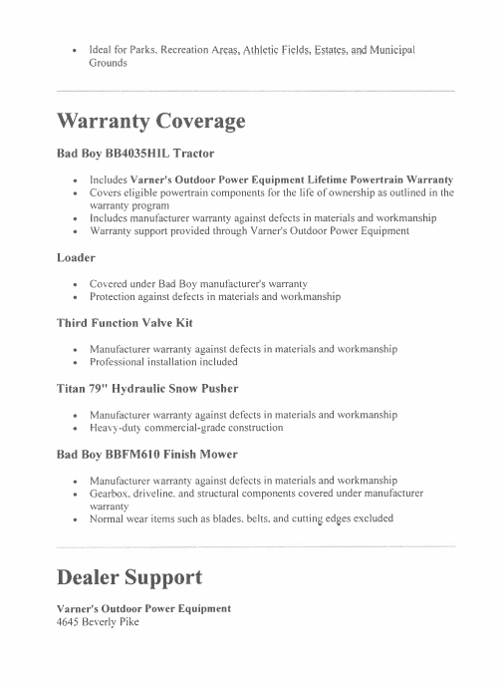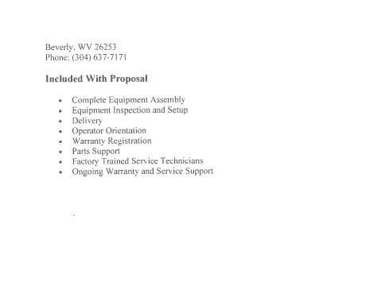

IN RE: APPROVAL OF PART-TIME EMPLOYEE FOR POCAHONTAS COUNTY ANIMAL SHELTER

A motion was made by Commissioner Walker to approve Amy Copley as a part-time employee at the Animal Shelter for 1039 hours per year to be paid at $12.00 per hour with no benefits, and noting no objections, motion carried. The start date will be determined by Mia Friel, Animal Shelter Manager.

IN RE: BOARD APPOINTMENTS:

Pocahontas County Solid Waste Authority:

A motion was made by Commissioner Ryder to appoint Gail Siers to the Pocahontas County Solid Waste Authority for a four-year term expiring June 30, 2030 and noting no objections, motion carried.

Pocahontas County Dramas, Fairs and Festivals:

A motion was made by Commissioner Walker to appoint Linda Adams, Kristen Beverage and Allie Callison to three-year terms expiring June 30, 2029 and noting no objections, motion carried.

Pocahontas County Building Commission:

A motion was made by Commissioner Walker to correct Randy Sharp’s appointment from a three-year term to a five-year term expiring on June 30, 2031 and noting no objections, motion carried.

IN RE: DESIGNATION OF COUNTY DEPOSITORIES 2026-2027. (WEST VIRGINIA CODE 7-6-1).

In accordance with West Virginia Code §7-6-1 a motion was made by Commissioner Walker to designate Citizens Bank of West Virginia, Pendleton Community Bank, First Citizens Bank and City National Bank as Pocahontas County depositories for the fiscal year 2026-2027 and noting no objections, motion carried.

IN RE: INVOICES APPROVED

ORDERED THIS MEETING BE ADJOURNED, SINE DIE.

