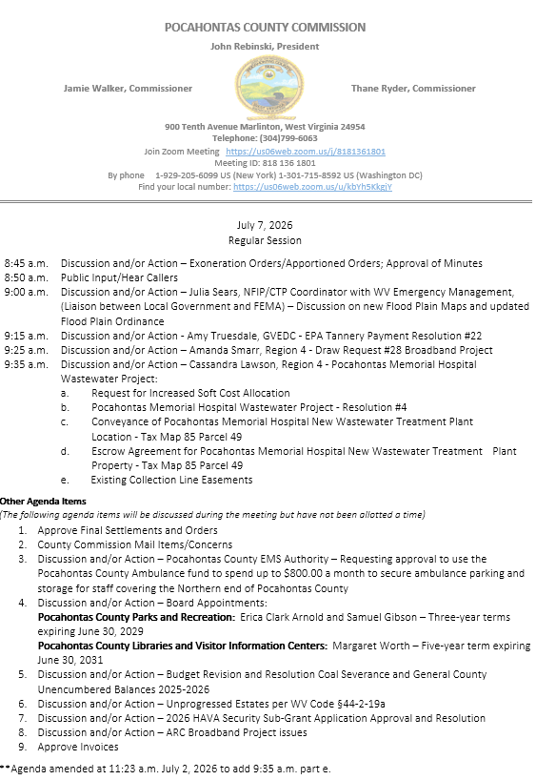

At a Regular Session of the Pocahontas County Commission held at the Courthouse situate in Marlinton, West Virginia, on the 7th day of July, 2026.

PRESENT: John Rebinski, President
Jamie Walker, Commissioner
Thane Ryder, Commissioner

Prior to the beginning of today’s session, the Commission invited all individuals in attendance to stand and recite the Pledge of Allegiance.

IN RE: EXONERATION/APPORTIONED ORDERS APPROVED

A motion was made by Commissioner Walker to approve the notice of apportionment of Jointly owned motor vehicles for Randy and Beth Wilfong, and noting no objections, motion carried.

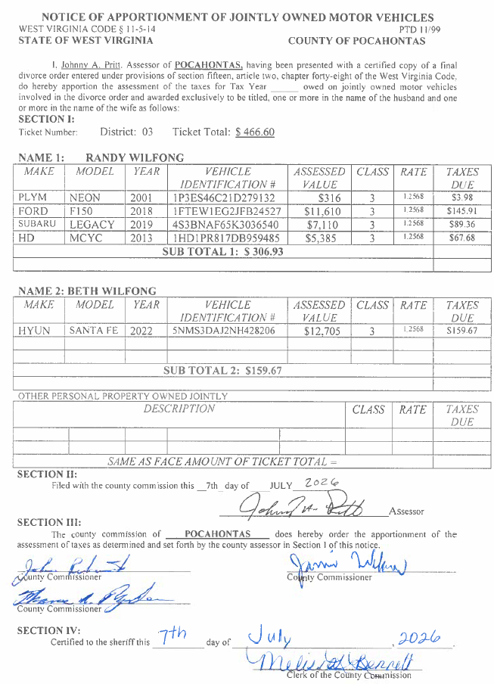

IN RE: MINUTES APPROVED

A motion was made by Commissioner Walker to approve the minutes of the last regular session of the Commission held on the 16th day of June, 2026 and special session June 30, 2026 as presented, and noting no objections, motion carried.

IN RE: FINAL SETTLEMENTS AND ORDERS APPROVED

Commission President John Rebinski reviewed several final settlements and orders pertaining to estates as presented by the County Clerk’s Office and, thereafter, approved same by placing his signature thereto.

IN RE: COUNTY COMMISSION MAIL ITEMS/CONCERNS

Letter – Spilman Thomas & Battle - Reimbursement Check $62,850.00 Pocahontas Co Broadband Project
Letter – Secretary of the Interior - 2026 PILT payment $1,104,029.00

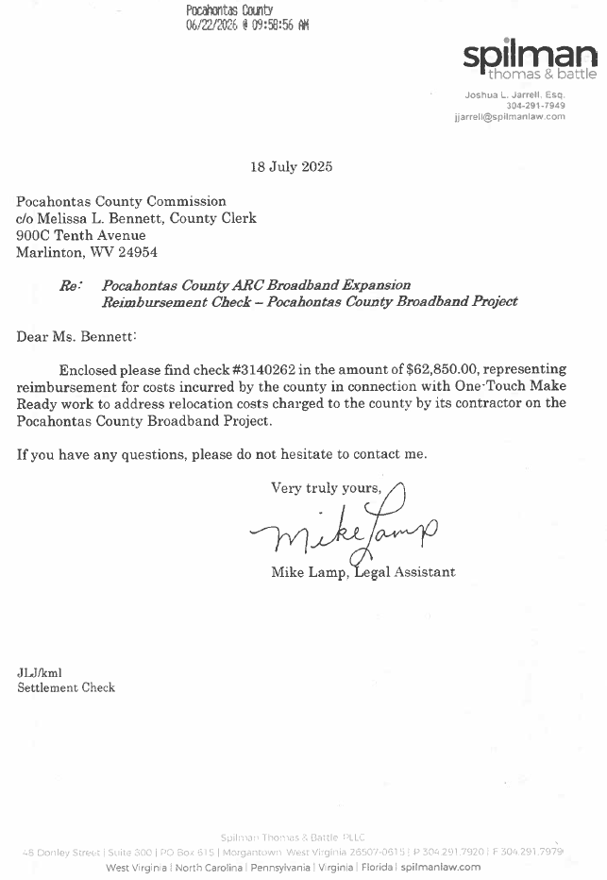

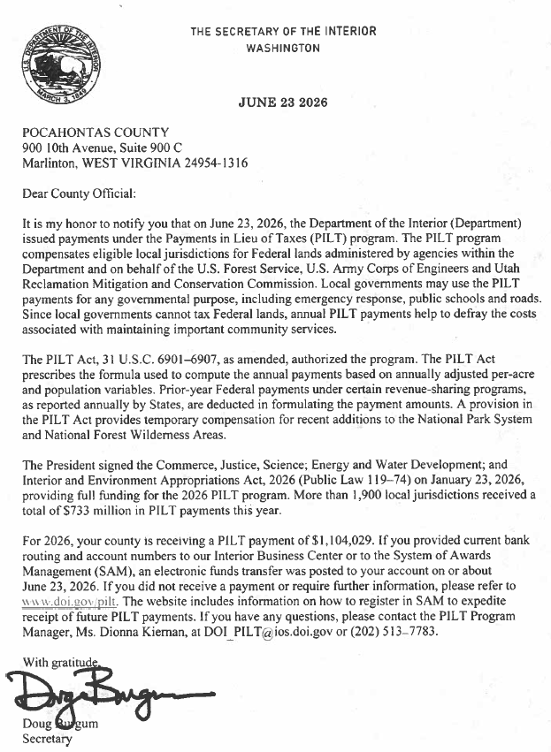

IN RE: SIGN IN SHEET/HEAR CALLERS

None

IN RE: POCAHONTAS COUNTY EMS AUTHORITY – REQUESTING APPROVAL TO USE THE POCAHONTAS COUNTY AMBULANCE FUND TO SPEND UP TO $800.00 A MONTH TO SECURE AMBULANCE PARKING AND STORAGE FOR STAFF COVERING THE NORTHERN END OF POCAHONTAS COUNTY

This will be put on the agenda for July 21, 2026. No action was taken on this matter.

IN RE: JULIA SEARS, NFIP/CTP COORDINATOR WITH WV EMERGENCY MANAGEMENT, (LIAISON BETWEEN LOCAL GOVERNMENT AND FEMA) – DISCUSSION ON NEW FLOOD PLAIN MAPS AND UPDATED FLOOD PLAIN ORDINANCE

A motion was made by Commissioner Ryder to approve the New Flood Plain Maps and the first reading by title of the Pocahontas County Flood Plain Ordinance, and noting no objections, motion carried

IN RE: AMY TRUESDALE, GVEDC - EPA TANNERY PAYMENT RESOLUTION #22

A motion was made by Commissioner Ryder to approve the Greenbrier Valley Economic Development Corporation - EPA Tannery payment resolution #22, and noting no objections, motion carried.
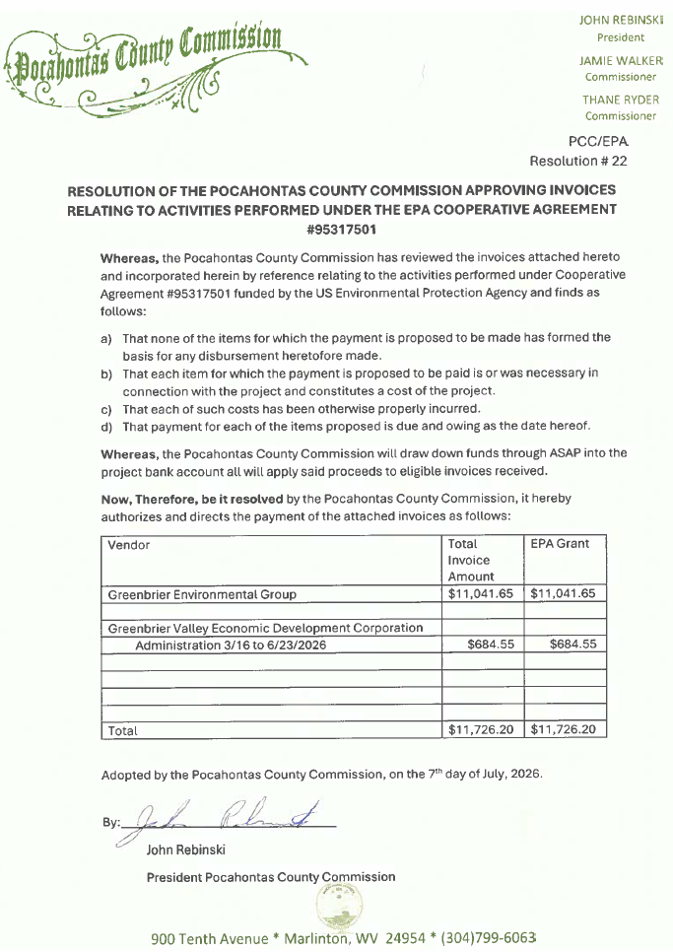
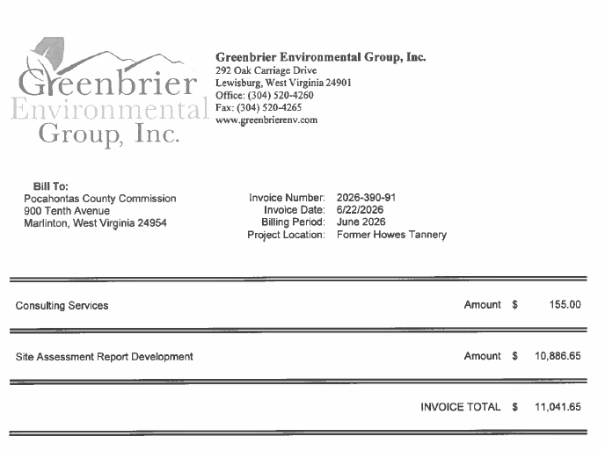
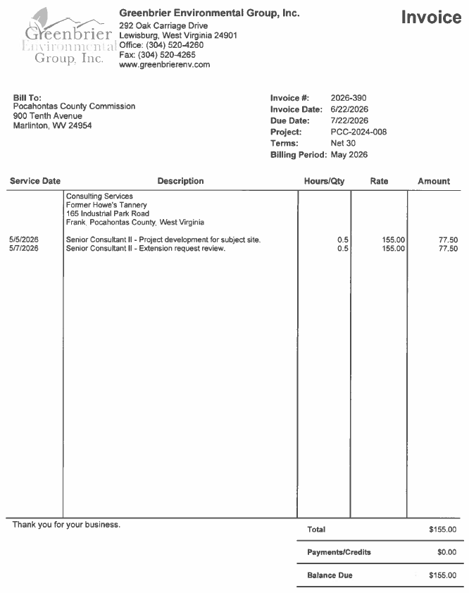
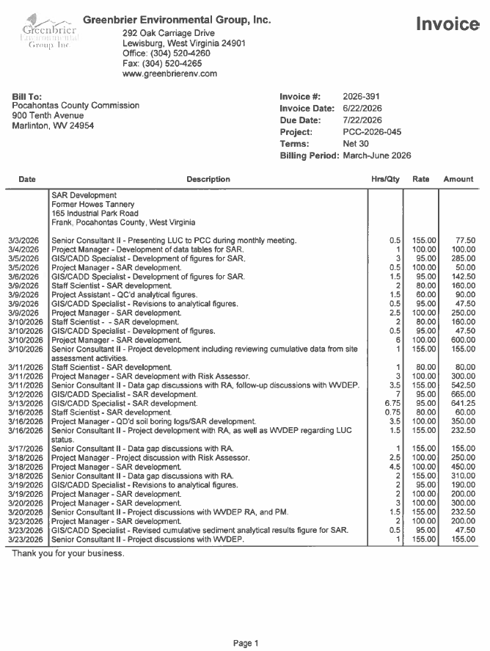
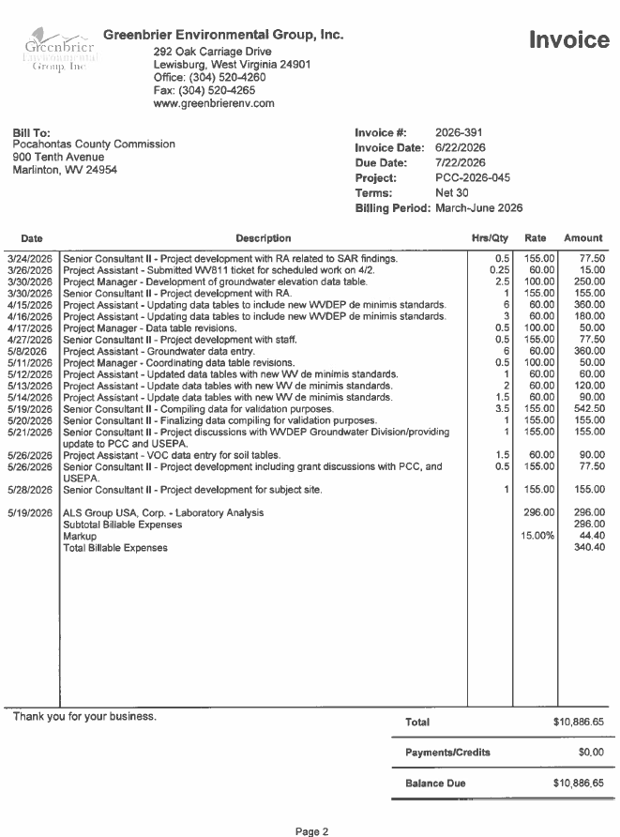


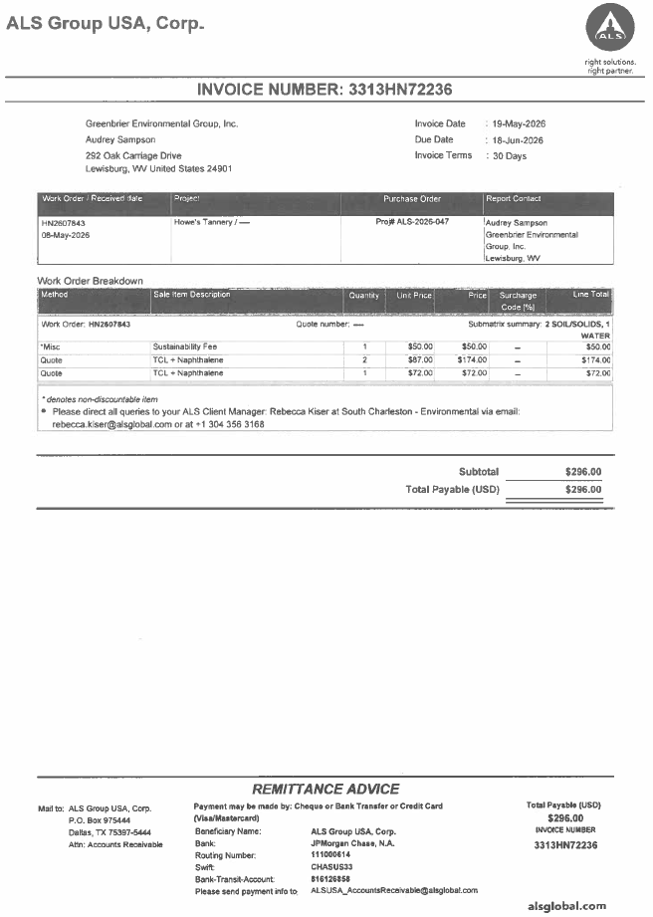
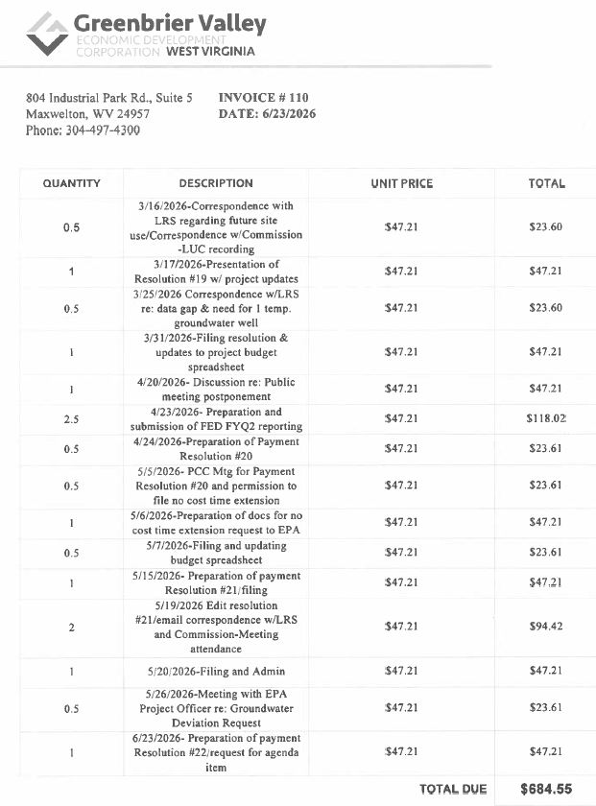
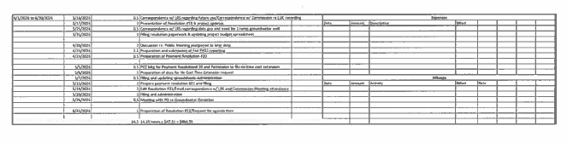

IN RE: AMANDA SMARR, REGION 4 - DRAW REQUEST #28 BROADBAND PROJECT
Region 4 – had nothing to present for Draw request #28 Broadband Project at this. No action was taken on this matter.
IN RE: CASSANDRA LAWSON, REGION 4 - POCAHONTAS MEMORIAL HOSPITAL WASTEWATER PROJECT:

a. REQUEST FOR INCREASED SOFT COST ALLOCATION
b. POCAHONTAS MEMORIAL HOSPITAL WASTEWATER PROJECT - RESOLUTION #4
c. CONVEYANCE OF POCAHONTAS MEMORIAL HOSPITAL NEW WASTEWATER TREATMENT PLANT LOCATION - TAX MAP 85 PARCEL 49
d. ESCROW AGREEMENT FOR POCAHONTAS MEMORIAL HOSPITAL NEW WASTEWATER TREATMENT PLANT PROPERTY - TAX MAP 85 PARCEL 49
e . EXISTING COLLECTION LINE EASEMENTS

A motion was made by Commissioner Ryder to approve the request for increased soft cost allocation and the Pocahontas Memorial Hospital wastewater project Resolution #4, and noting no objections, motion carried.

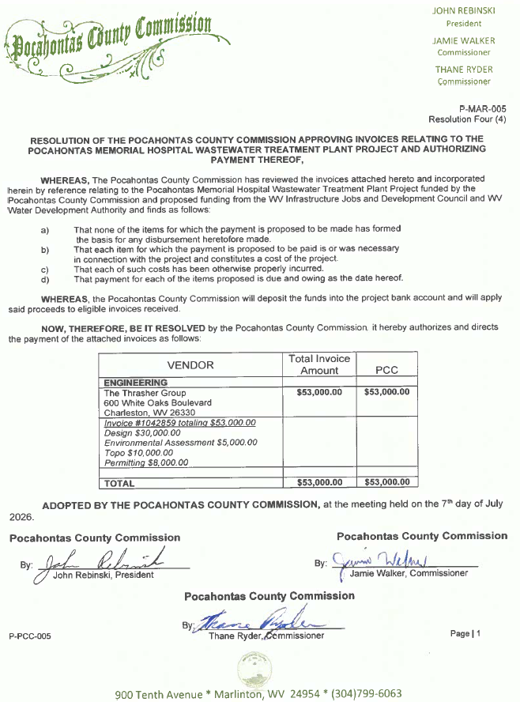
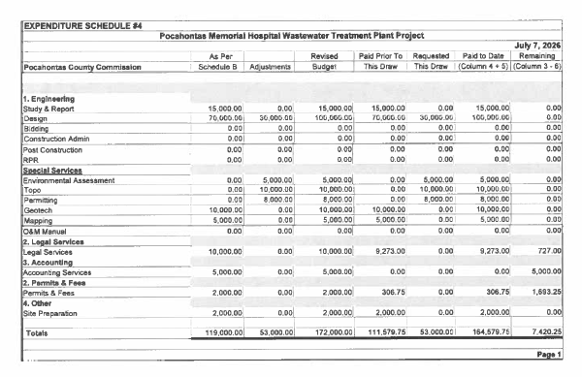

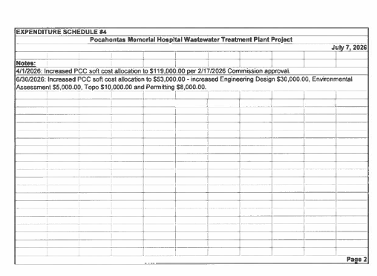
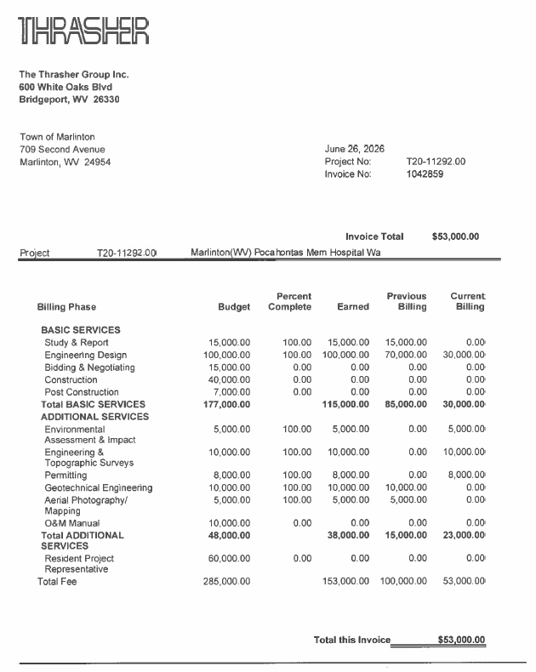



A motion was made by Commissioner Walker to approve the Conveyance of Pocahontas Memorial Hospital new wastewater treatment plant location tax map 85 parcel 49 and escrow agreement for Pocahontas Memorial new wastewater treatment plant property tax map 85 parcel 49. and noting no objections, motion carried.
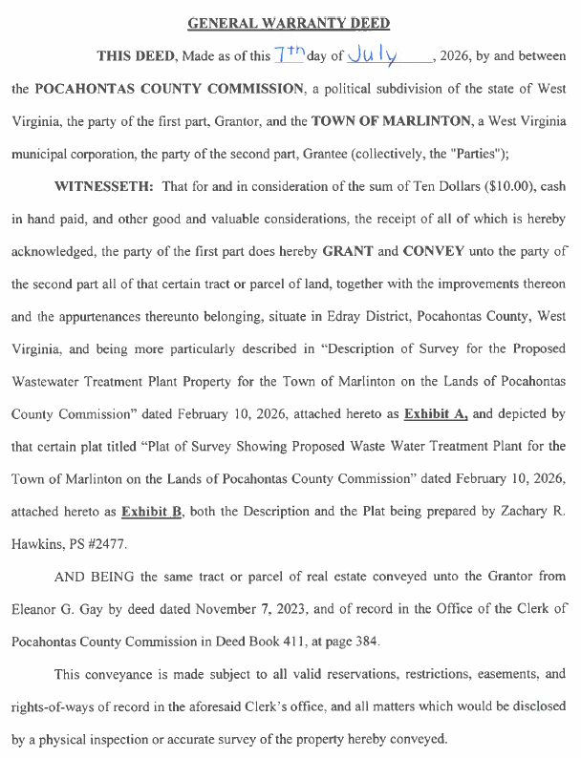
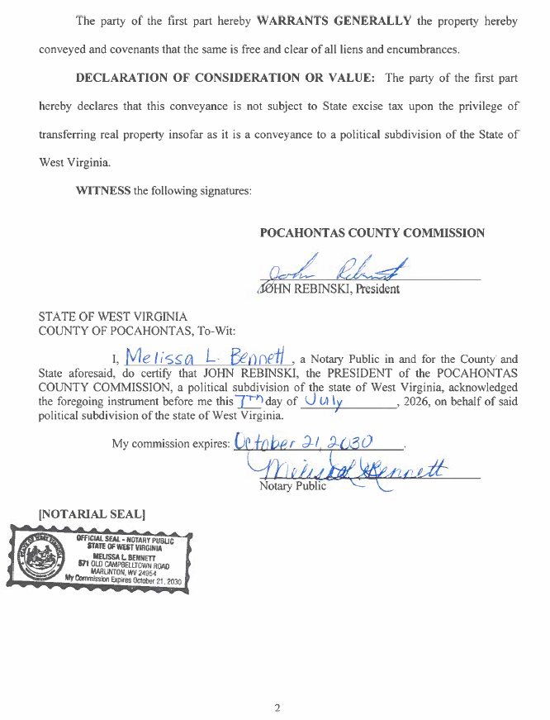
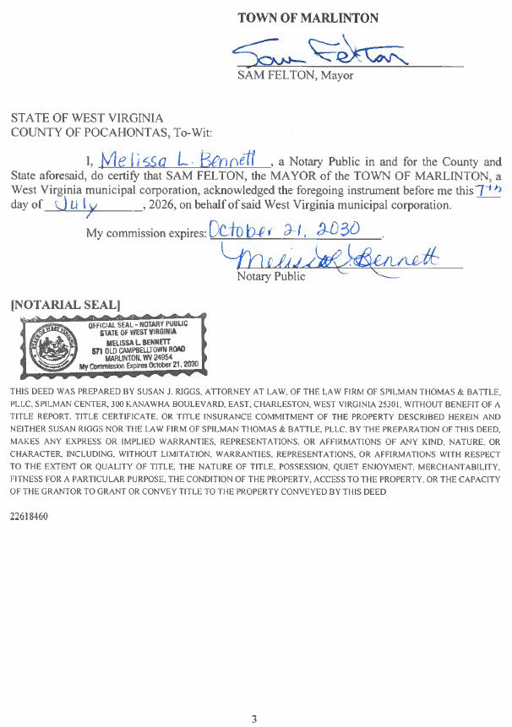
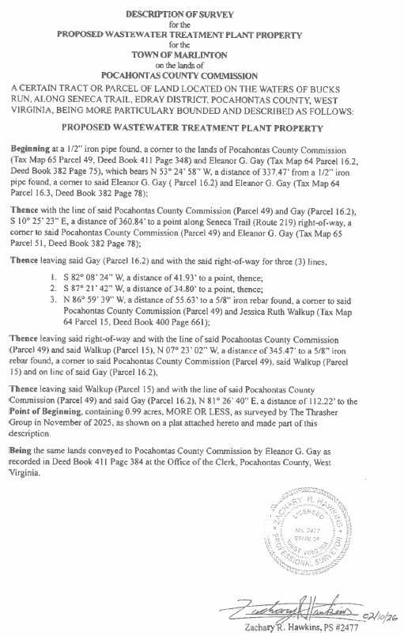

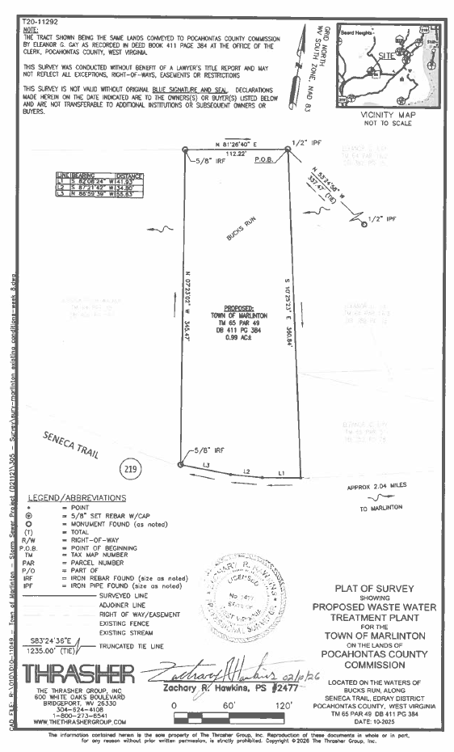

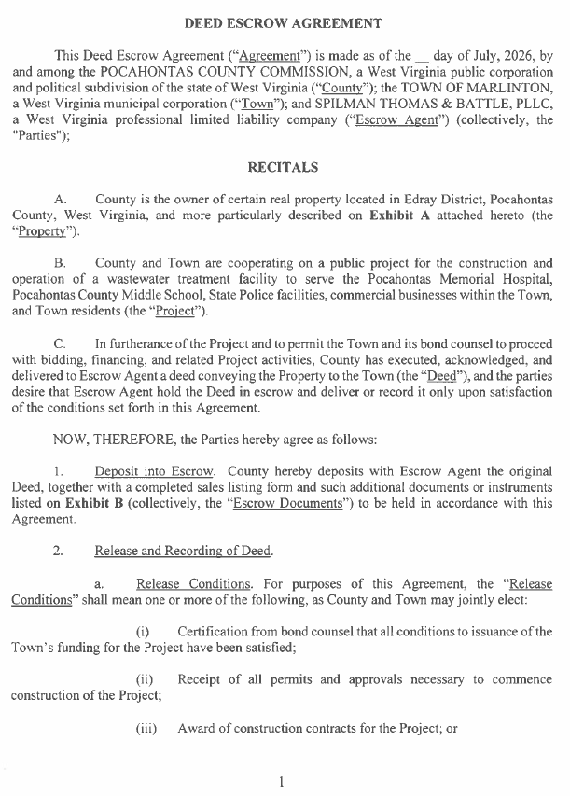
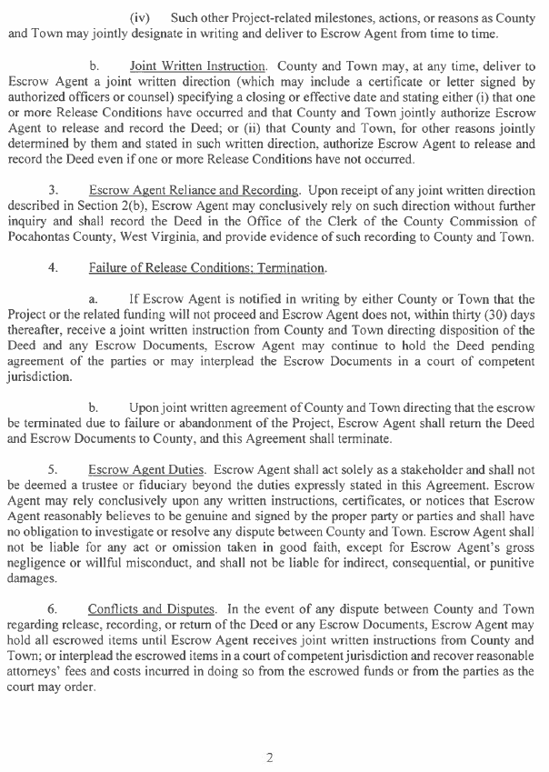

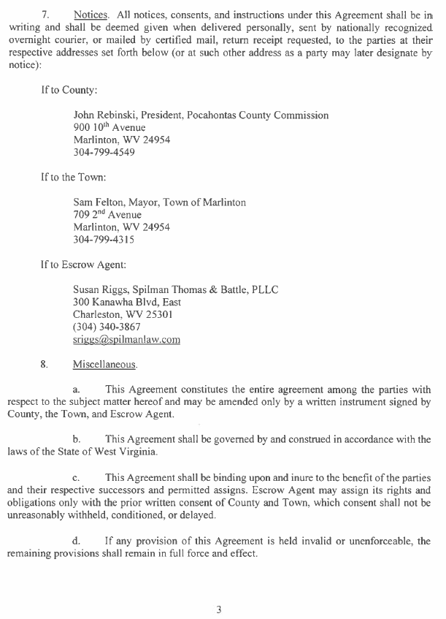
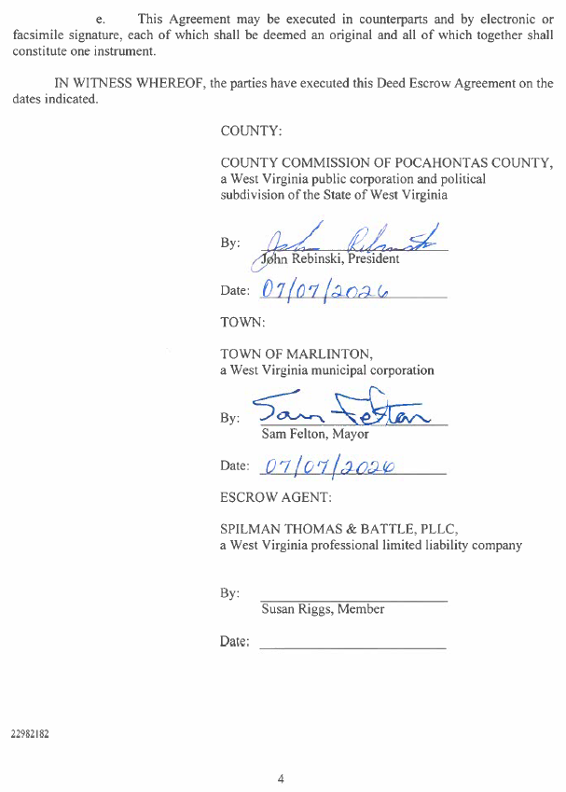

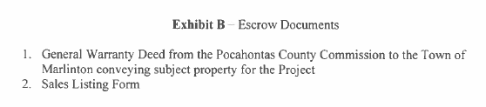

A motion was made by Commissioner Walker to approve the existing Sanitary Sewer Easements for Tax Map 15 Parcel 1 and Tax Map 15 Parcel 11 easements, and noting no objections, motion carried.

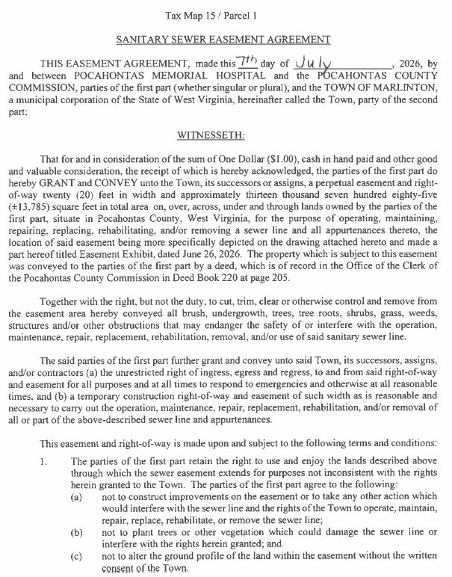

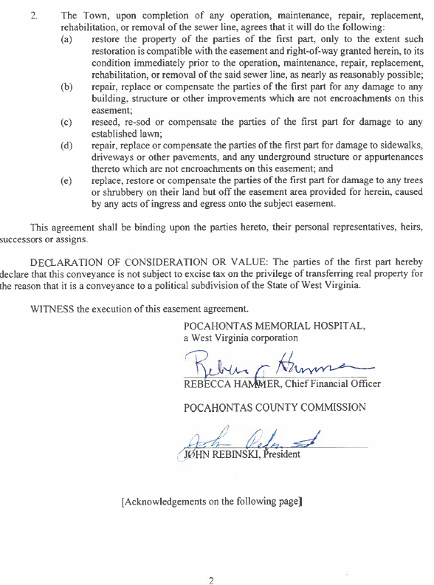

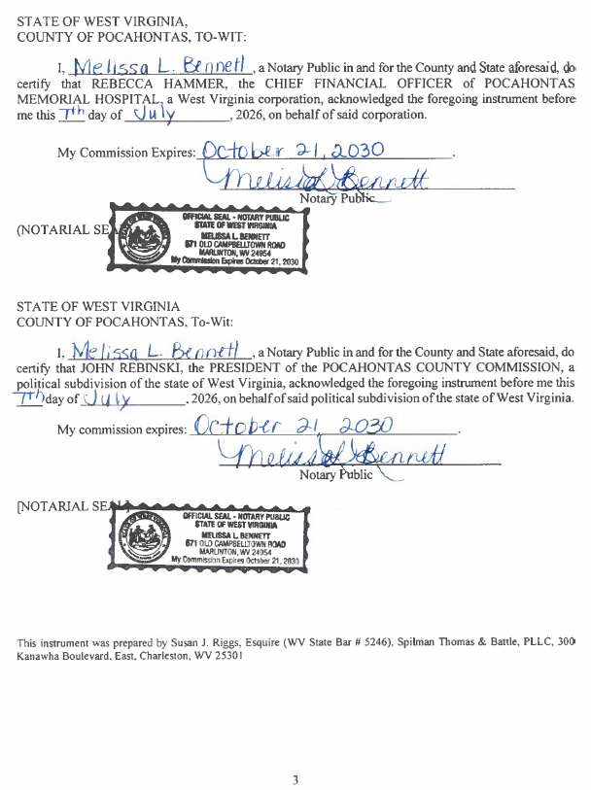
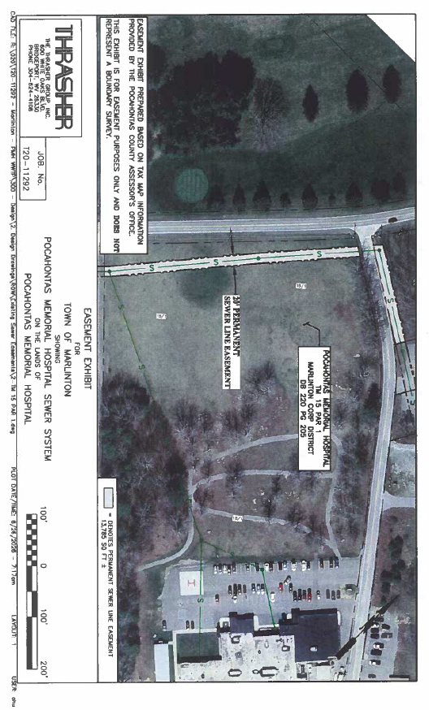
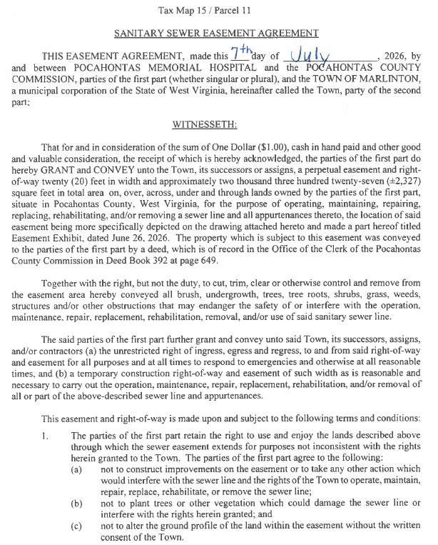

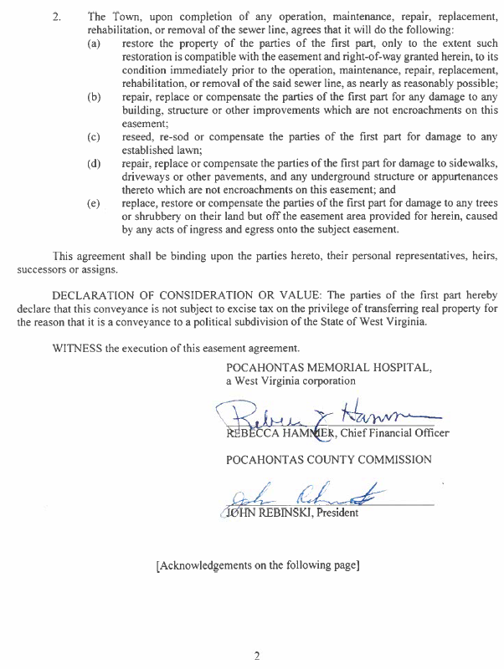
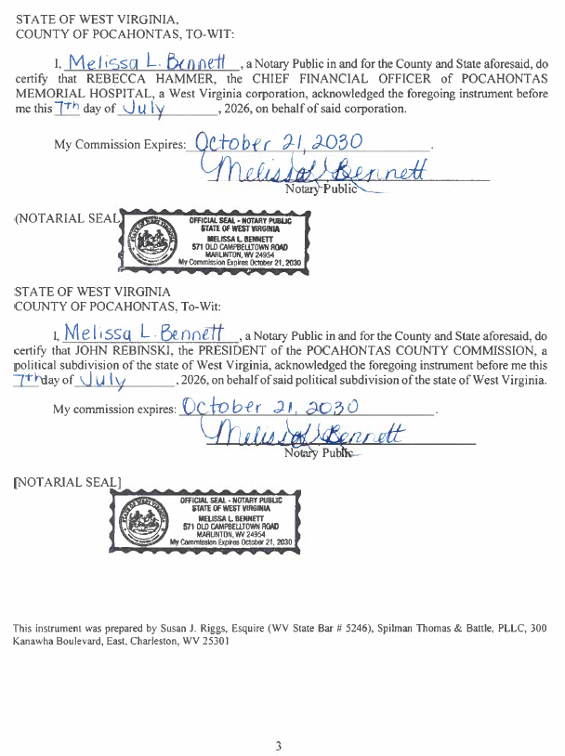

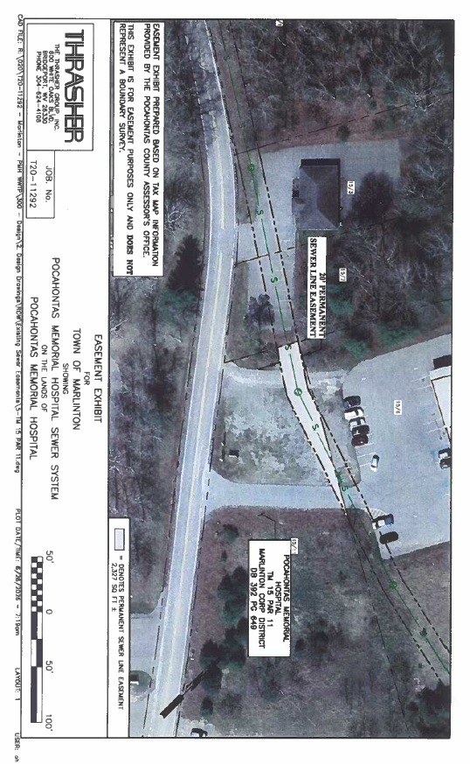

IN RE: BOARD APPOINTMENTS

POCAHONTAS COUNTY PARKS AND RECREATION: Erica Clark Arnold and Samuel Gibson – Three-year terms expiring June 30, 2029

POCAHONTAS COUNTY LIBRARIES AND VISITOR INFORMATION CENTERS: Margaret Worth – Five-year term expiring June 30, 2031

A motion was made by Commissioner Walker to approve Erica Clark Arnold and Samuel Gibson to three-year terms expiring 06/30/2029 to the Pocahontas County Parks and Recreation, and noting no objections, motion carried.

A motion was made by Commissioner Walker to approve Margaret Worth to a five-year term expiring 06/30/2031 to the Pocahontas County Libraries and Visitor Information Centers, and noting no objections, motion carried.

IN RE; BUDGET REVISION AND RESOLUTION COAL SEVERANCE AND GENERAL COUNTY UNENCUMBERED BALANCES 2025-2026

A motion was made by Commissioner Ryder to approve the Budget Revision and Resolution for Coal Severance unencumbered balance 2025-2026, and noting no objections, motion carried.
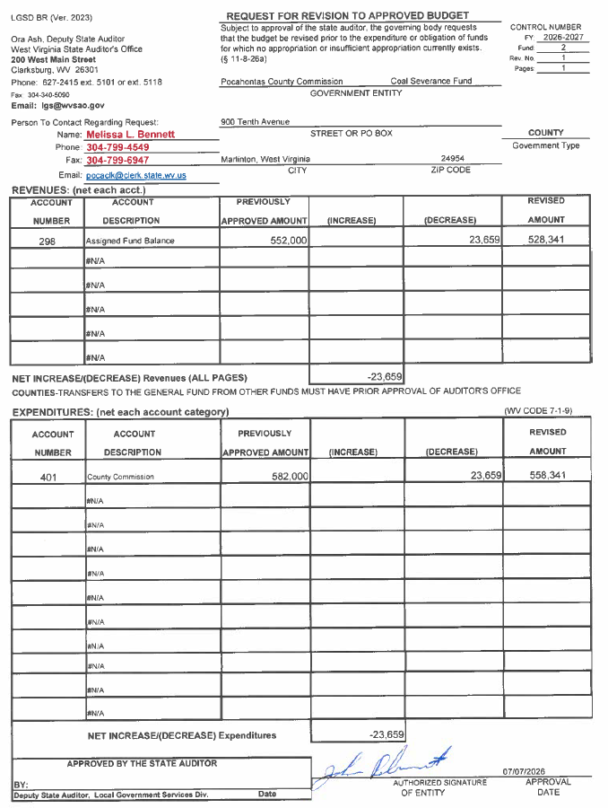
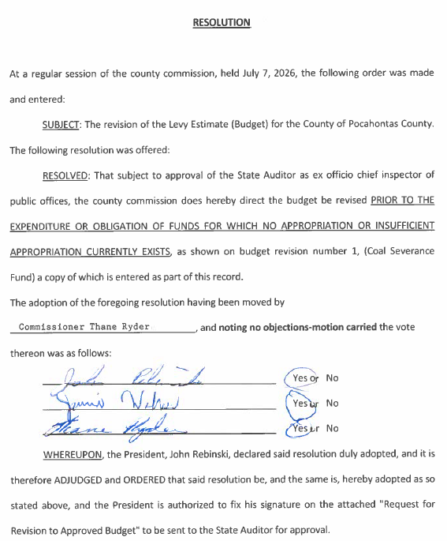

No action was taken on the Budget Revision and Resolution for General County unencumbered balance 2025-2026.

IN RE: UNPROGRESSED ESTATES PER WV CODE §44-2-19A

A motion was made by Commissioner Walker to approve the closing process for unprogressed Estates per WV Code 44-2-19A, and noting no objections, motion carried.

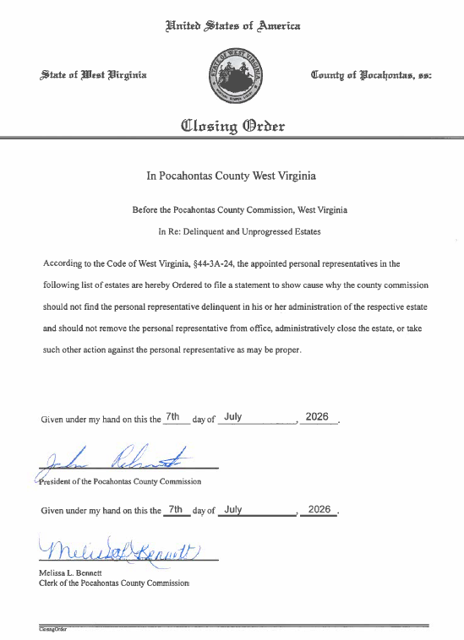
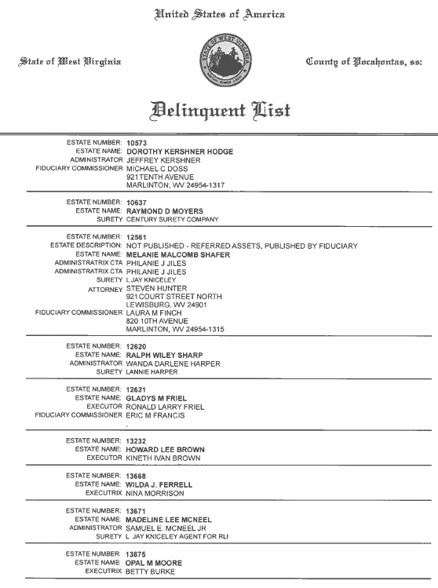

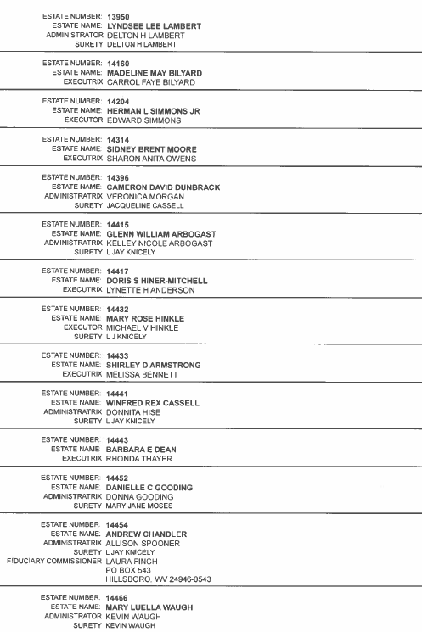
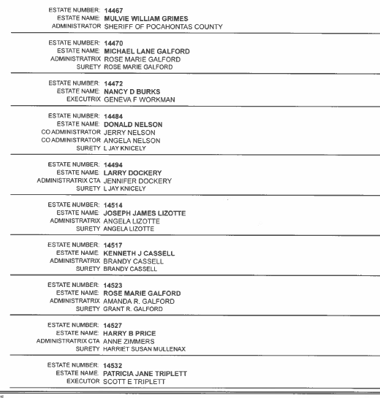

IN RE: 2026 HAVA SECURITY SUB-GRANT APPLICATION APPROVAL AND RESOLUTION

A motion was made by Commissioner Ryder to approve the 2026 HAVA Security Sub-Grant Application and Resolution as presented by County Clerk Melissa Bennett, and noting no objections, motion carried.
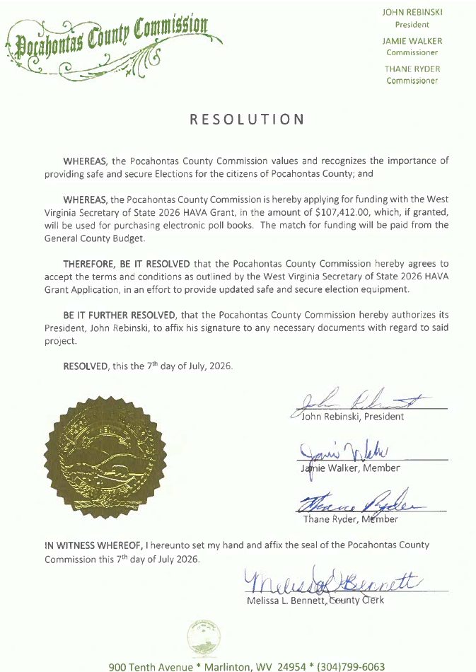
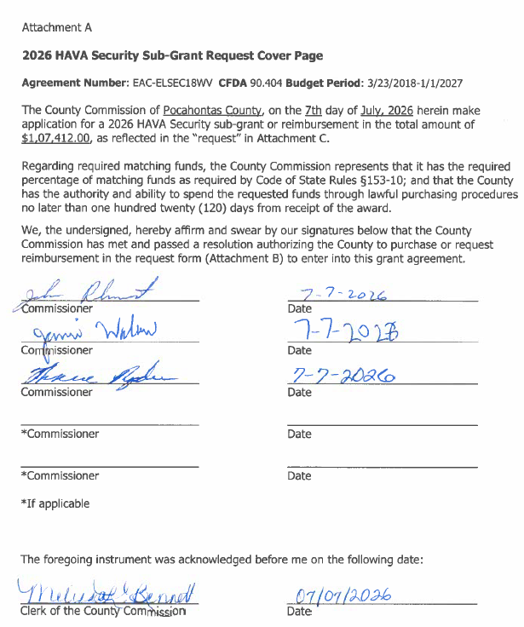
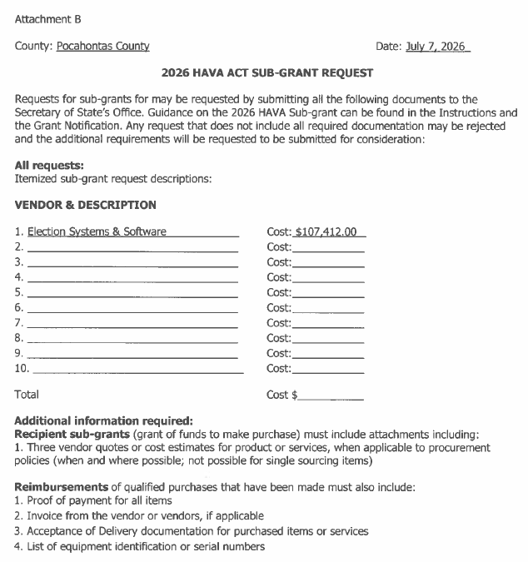

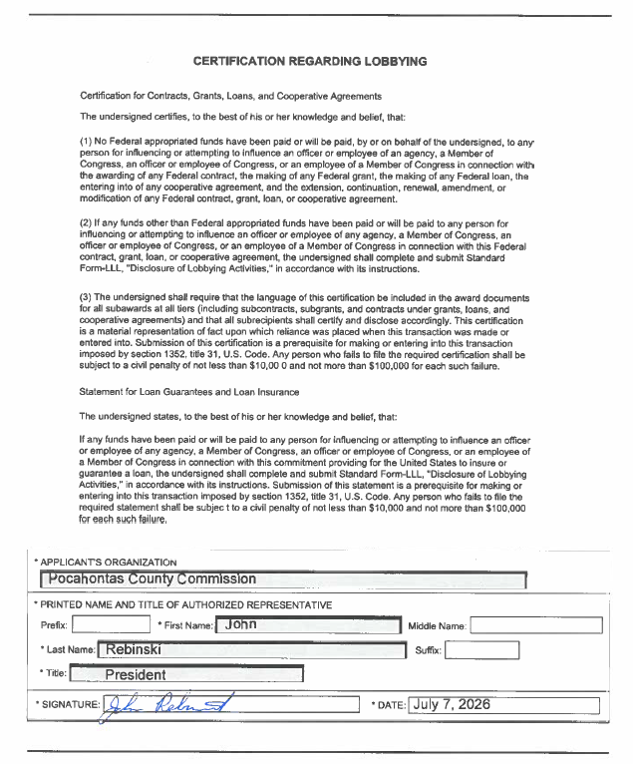
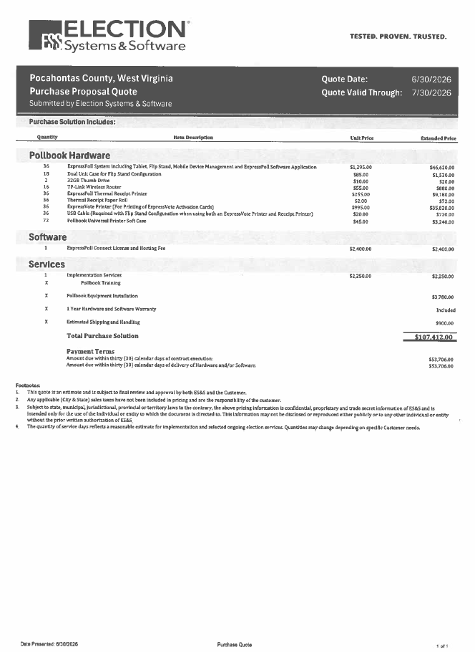

IN RE: ARC BROADBAND PROJECT ISSUES

No action was taken on this matter.

IN RE: INVOICES

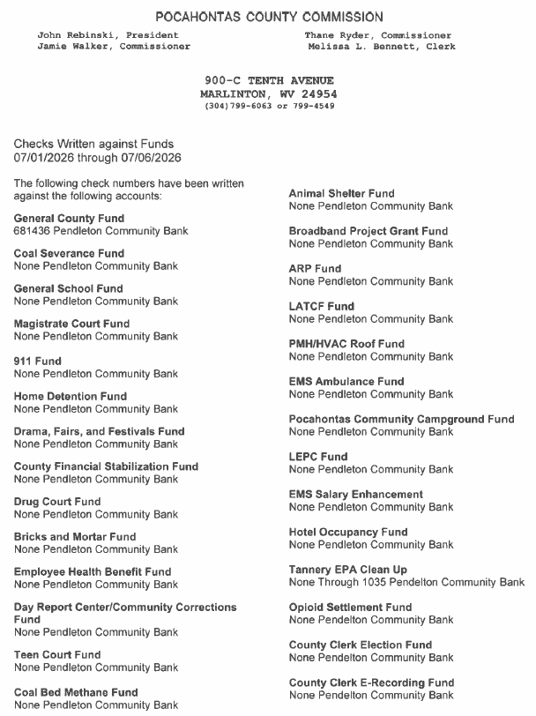

ORDERED THIS MEETING BE ADJOURNED, SINE DIE.



