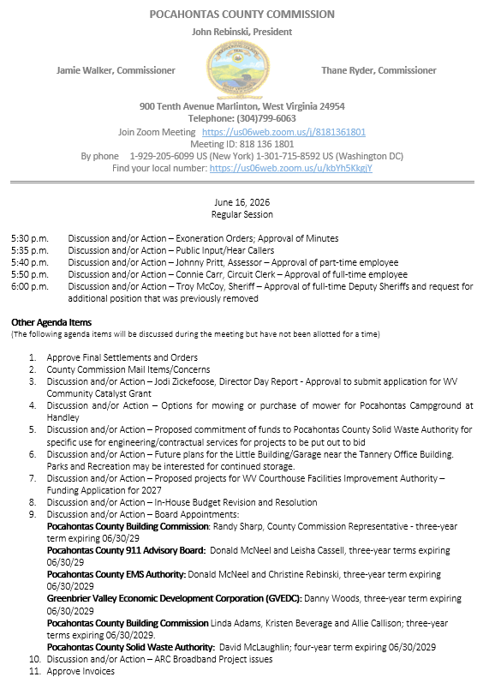

At a Regular Session of the Pocahontas County Commission held at the Courthouse situate in Marlinton, West Virginia, on the 16th day of June, 2026.

PRESENT: John Rebinski, President
Jamie Walker, Commissioner
Thane Ryder, Commissioner

Prior to the beginning of today’s session, the Commission invited all individuals in attendance to stand and recite the Pledge of Allegiance.

IN RE: EXONERATION/APPORTIONED ORDERS APPROVED

None

IN RE: MINUTES APPROVED

A motion was made by Commissioner Walker to approve the minutes of the last regular session of the Commission held on the 2nd day of June, 2026 as presented, and noting no objections, motion carried.

IN RE: SIGN IN SHEET/HEAR CALLERS

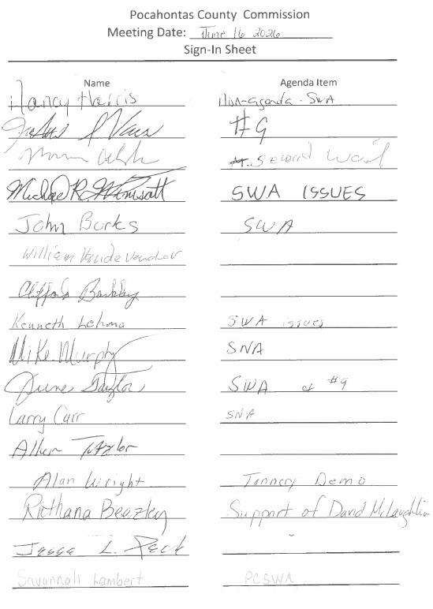

See Attached for public input concerning the SWA and the County Commission Board appointment to the SWA.
Alan Wright spoke concerning the Tannery Demo the commission advised there was no grant money received yet.

IN RE: APPROVAL OF PART-TIME EMPLOYEE

Johnny Pritt, Pocahontas County Asessor, came before commission to ask for approval of Shelly Hartman as part-time employee effective July 1, 2026 with a starting pay of $14.50 per hour, and noting no objections, motion carried.

IN RE: CONNIE CARR, CIRCUIT CLERK – APPROVAL OF FULL-TIME EMPLOYEE

A motion was made by Commissioner Ryder per request from Circuit Clerk Connie Carr and Sheriff Troy McCoy per open meetings act 2A, and noting no objections, motion carried.

Following the conclusion of the executive session, Commissioner Walker made a motion to end executive session and approve the hiring of Rebecca Puffenbarger as a full-time Deputy Circuit Clerk, effective July 1, 2026, at a starting rate of pay of $15.86 per hour with full benefits, and noting no objections, motion carried.

IN RE: TROY MCCOY, SHERIFF – APPROVAL OF FULL-TIME DEPUTY SHERIFFS AND REQUEST FOR ADDITIONAL POSITION THAT WAS PREVIOUSLY REMOVED

A motion was made by Commissioner Walker after the end of the executive session to approve Aleea Carr, Stephen Simmons, and Sean Sharp full-time deputy sheriffs effective date July 5, 2026 with a starting pay of $26.44 and full benefits, and noting no objections, motion carried.

IN RE: ALYSSA VICKERS, DIRECTOR, PARKS AND RECREATION – STRUCTURE OF PARKS & RECREATION, CURRENT FUNDING SITUATION AND FOLLOW-PU TO JANUARY MEETING
Alyssa Vickers met with the Commission regarding funding concerns, noting that hotel/motel funds are capped for the remainder of the fiscal year and that Parks and Recreation will not receive funding for several months.
The Commission agreed to explore the possibility of providing funding for a mower.
Commissioner Rebinski inquired about the use of the building at the former Tannery in Frank. Ms. Vickers stated that Parks and Recreation is interested in retaining the building for storage purposes. Commission will address the asbestos in roof. No action was taken.

IN RE: FINAL SETTLEMENTS AND ORDERS APPROVED

Commission President John Rebinski reviewed several final settlements and orders pertaining to estates as presented by the County Clerk’s Office and, thereafter, approved same by placing his signature thereto.

IN RE: COUNTY COMMISSION MAIL ITEMS/CONCERNS

Email – Gail Siers – No Transfer Station, Board Members, Lawyer removed
Email – Kenney Shinaberry – Solid Waste, Board Appointment
Email – Vic Herbster – Agenda Items 5 and 9 Solid Waste Authority Board Appointments
Email - James Rexrode – Transfer Station and the use of County Commission Funds
Email – Susan Lane – PCSWA Transfer Station.
Copy – Pocahontas County Sheriff Monthly Financial Statement May 2026

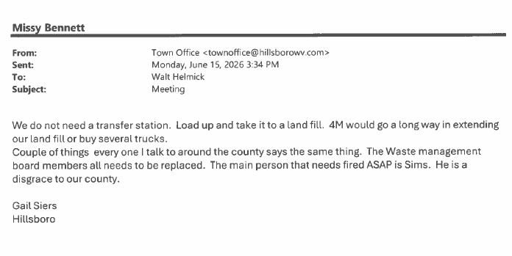
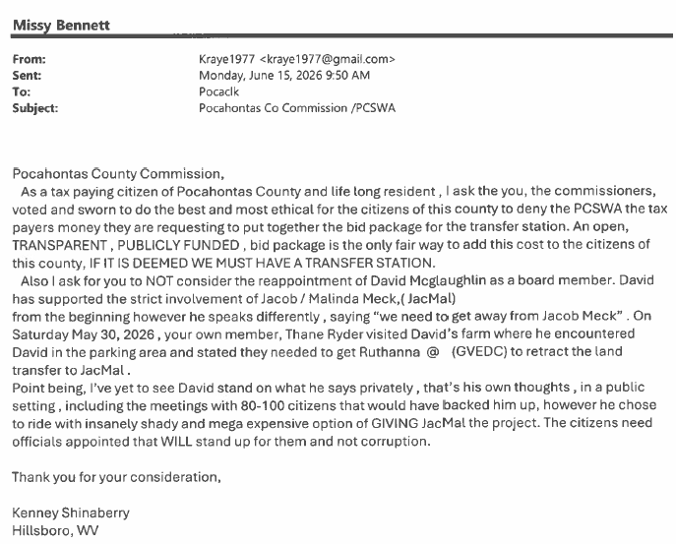
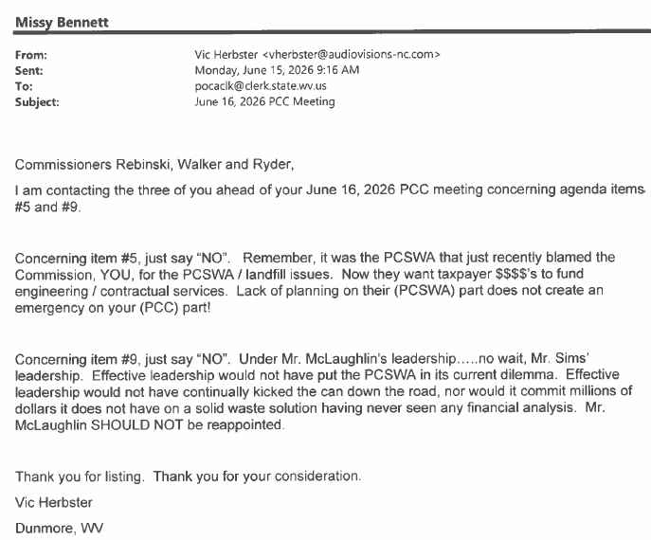
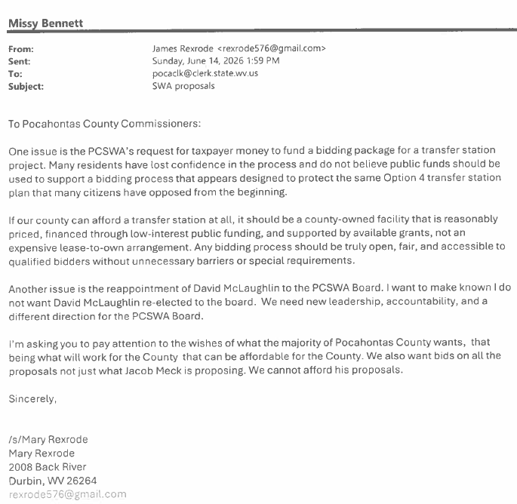

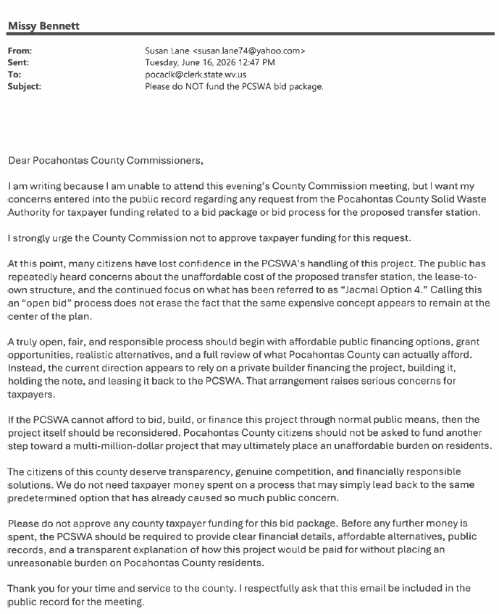

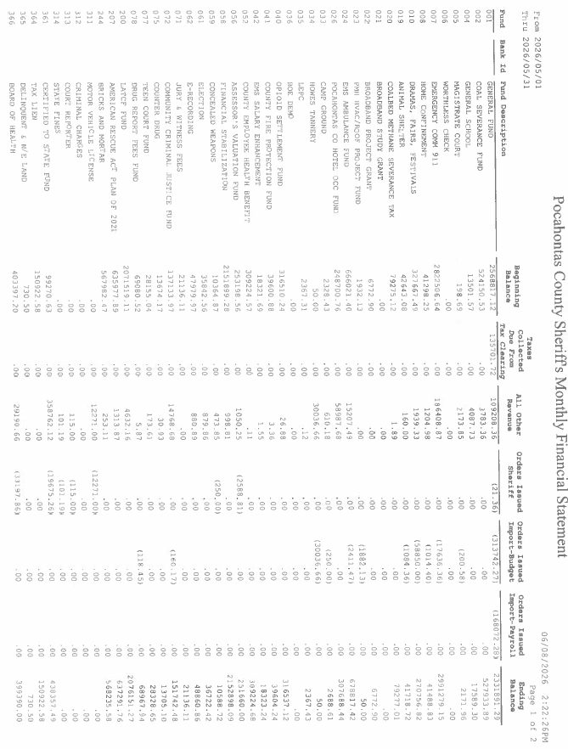
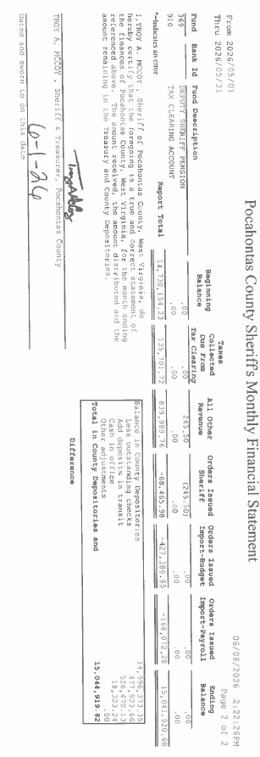

IN RE: JODI ZICKEFOOSE, DIRECTOR DAY REPORT - APPROVAL TO SUBMIT APPLICATION FOR WV COMMUNITY CATALYST GRANT

A motion was made by Commissioner Ryder to approve to submit application for WV Community Catalyst Grant, and noting no objections, motion carried.

IN RE: OPTIONS FOR MOWING OR PURCHASE OF MOWER FOR POCAHONTAS CAMPGROUND AT HANDLEY

Commissioner Rebinski spoke with Mr. Johnson from the DNR on storing the lawn mower in one of the buildings at Handley, and that the DNR is very pleased with the upkeep that Ethan Burgess is doing. Commissioner Rebinski spoke with Ehtan Burgess about his resignation, and he will stay on if the County can provide a mower for Handley. The transfer of the Courthouse mower is contingent on the approve of the purchase of a new utility tractor by the Commission. No action was taken on this matter.
IN RE: PROPOSED COMMITMENT OF FUNDS TO POCAHONTAS COUNTY SOLID WASTE AUTHORITY FOR SPECIFIC USE FOR ENGINEERING/CONTRACTUAL SERVICES FOR PROJECTS TO BE PUT OUT TO BID

The Commission herd several complaints and emails concerning the proposed commitment of funds to Pocahontas County Solid Waste Authority for specific use for engineering/contractual services for projects to be put out to bid. No action was taken on this matter.

IN RE: FUTURE PLANS FOR THE LITTLE BUILDING/GARAGE NEAR THE TANNERY OFFICE BUILDING. PARKS AND RECREATION MAY BE INTERESTED FOR CONTINUED STORAGE.

This agenda item was discussed during the 6:15 time allotment. The Parks and Recreation would like to continue the use of the building/garage near the tannery office building, with help with the asbestos removal in the roof if repairable. No action was taken on this matter.

IN RE: PROPOSED PROJECTS FOR WV COURTHOUSE FACILITIES IMPROVEMENT AUTHORITY – FUNDING APPLICATION FOR 2027

The commission discussed several proposed projects such as gutters, and handicap assessable sidewalk from the street entrance for the WV Courthouse facilities improvement authority – funding application for 2027. No action was taken on this matter.

IN RE; IN-HOUSE BUDGET REVISION AND RESOLUTION

A motion was made by Commissioner Walker to approve the In-house budget revisions and resolutions, and noting no objections, motion carried.

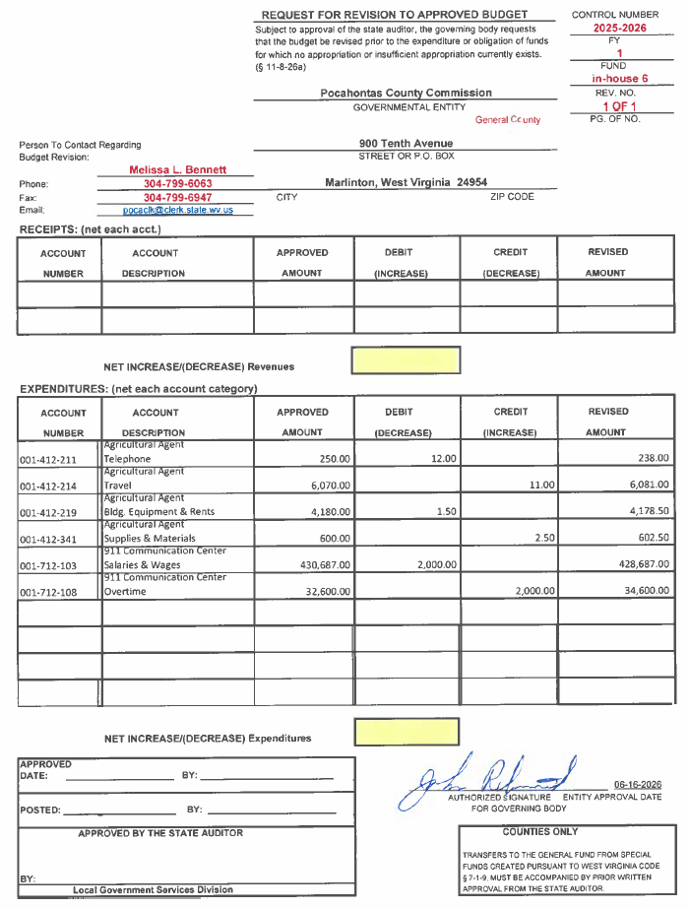
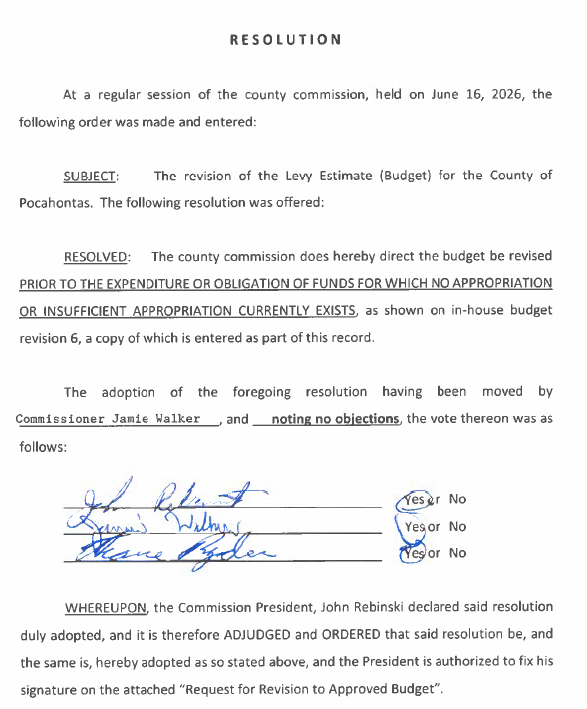
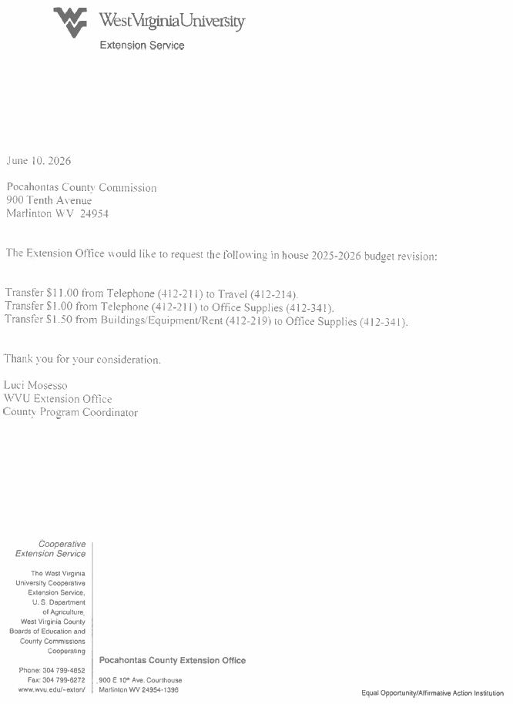

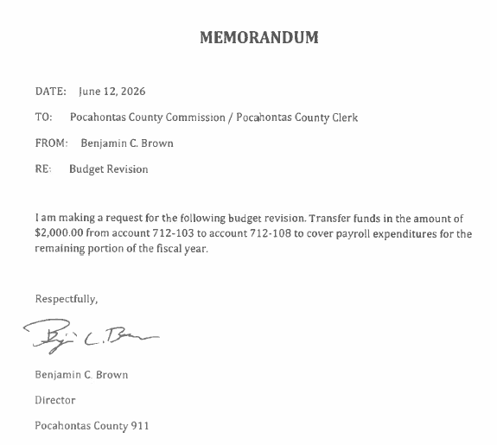
IN RE: BOARD APPOINTMENTS:

POCAHONTAS COUNTY BUILDING COMMISSION: Randy Sharp, County Commission Representative - three-year term expiring 06/30/29

POCAHONTAS COUNTY 911 ADVISORY BOARD: Donald McNeel and Leisha Cassell, three-year terms expiring 06/30/29

POCAHONTAS COUNTY EMS AUTHORITY: Donald McNeel and Christine Rebinski, three-year term expiring 06/30/2029

GREENBRIER VALLEY ECONOMIC DEVELOPMENT CORPORATION (GVEDC):
Danny Woods, three-year term expiring 06/30/2029

POCAHONTAS COUNTY BUILDING COMMISSION: Linda Adams, Kristen Beverage and Allie Callison; three-year terms expiring 06/30/2029.

POCAHONTAS COUNTY SOLID WASTE AUTHORITY: David McLaughlin; four-year term expiring 06/30/2029

A motion was made by Commissioner Walker to approve Randy Sharp to a three-year term expiring 06/30/2029 to the Pocahontas County Building Commission, and noting no objections, motion carried.

A motion was made by Commissioner Ryder to appoint Donald McNeel and Leisha Cassell, to a three-year terms expiring 06/30/29 to the Pocahontas County 911 Advisory Board, and noting no objections, motion carried.

A motion was made by Commissioner Walker to appoint Donald McNeel and Christine Rebinski, to a three-year term expiring 06/30/2029 to the Pocahontas County EMS Authority, with Commissioner Rebinski recusing himself from voting, and noting no objections, motion carried.

A motion was made by Commissioner Ryder to appoint Danny Woods, to a three-year term expiring 06/30/2029 to the Greenbrier Valley Economic Development Corporation (GVEDC), and noting no objections, motion carried.

The Commissioners did not approve the Pocahontas County Solid Waste Authority appointment; they will evaluate letters of interest at the June 30, 2026, meeting. No action was taken on this matter.

No action was taken on the Dramas Fairs and Festivals board appoints were incorrectly entered as Pocahontas County Building Commission Board Appointments. This will be placed on the next meeting agenda for July 7, 2026.
IN RE: ARC BROADBAND PROJECT ISSUES

No action was taken on this matter.

IN RE: INVOICES

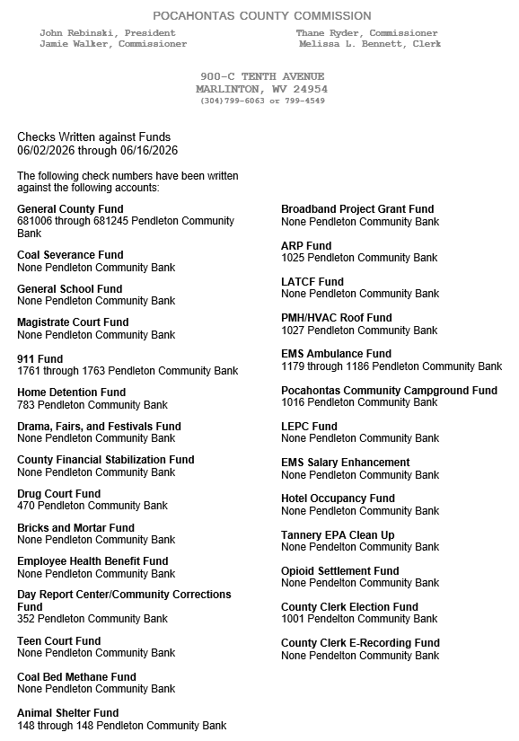

ORDERED THIS MEETING BE ADJOURNED, SINE DIE.



