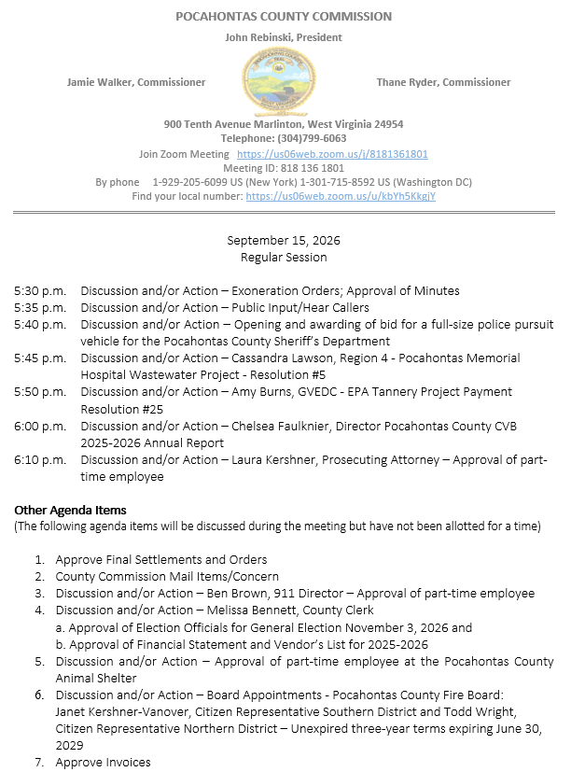

At a Regular Session of the Pocahontas County Commission held at the Courthouse situate in Marlinton, West Virginia, on the 15th day of September, 2026.

PRESENT: John Rebinski, President
Jamie Walker, Commissioner
Thane Ryder, Commissioner

Prior to the beginning of today’s session, the Commission invited all individuals in attendance to stand and recite the Pledge of Allegiance.

IN RE: EXONERATION/APPORTIONED ORDERS APPROVED

None

IN RE: MINUTES APPROVED

A motion was made by Commissioner Walker to approve the minutes of the last regular session of the Commission held on the 1st day of September, as presented, and noting no objections, motion carried.

IN RE: FINAL SETTLEMENTS AND ORDERS APPROVED

Commission President John Rebinski reviewed several final settlements and orders pertaining to estates as presented by the County Clerk’s Office and, thereafter, approved same by placing his signature thereto.

IN RE: COUNTY COMMISSION MAIL ITEMS/CONCERNS

Copy – Pocahontas County Sheriff - Monthly Financial Statement August 2026
Copy – West Virginia Department of Highways - Letter of Support response
Copy – Pocahontas County Library and Visitors Center - 2026-2027 Budget
Copy – Lease Agreement from Greenbrier County (FEMA)
Copy – West Virginia State Auditor Training Seminar – Forwarded to all board appointment as
requested by Auditor
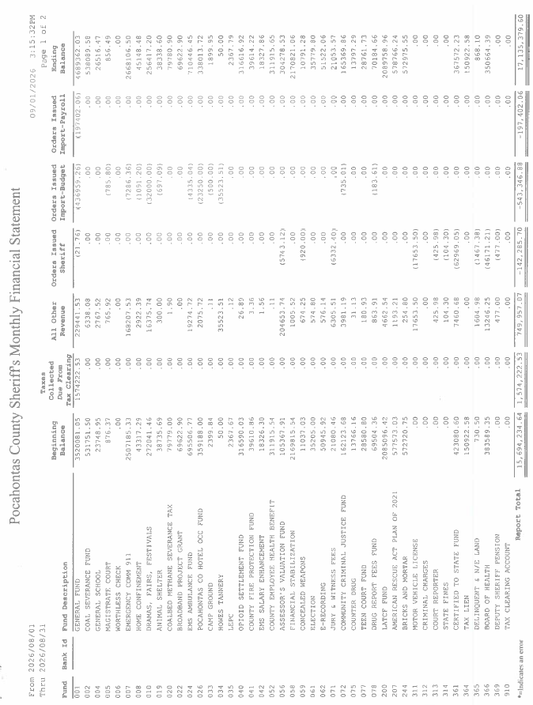
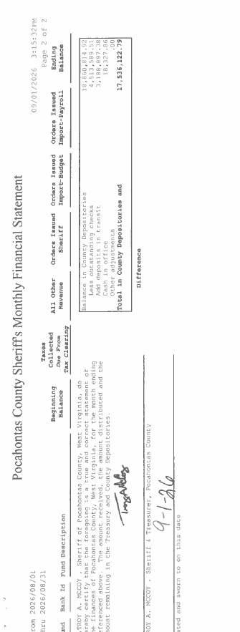
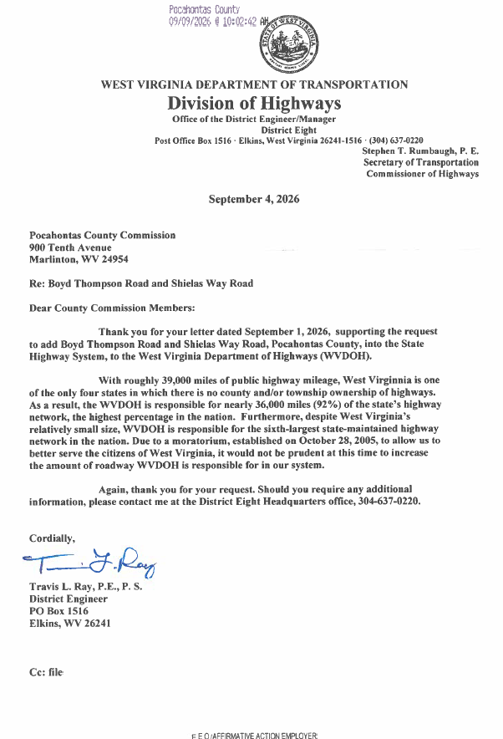

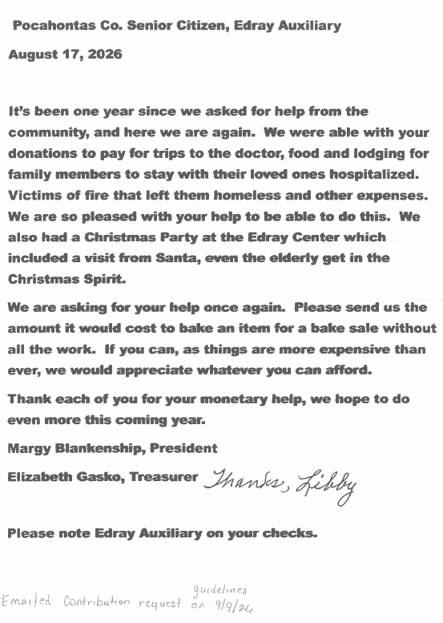
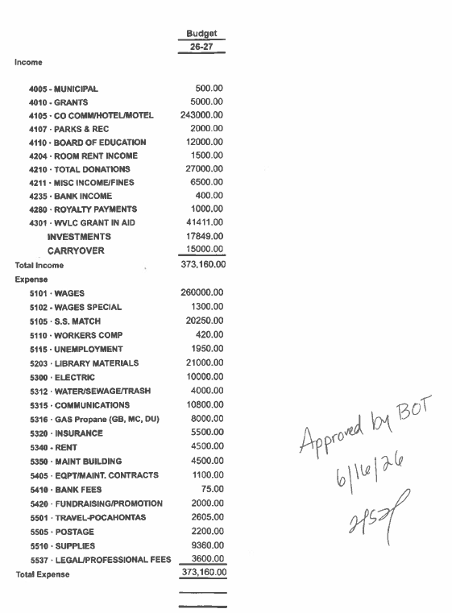
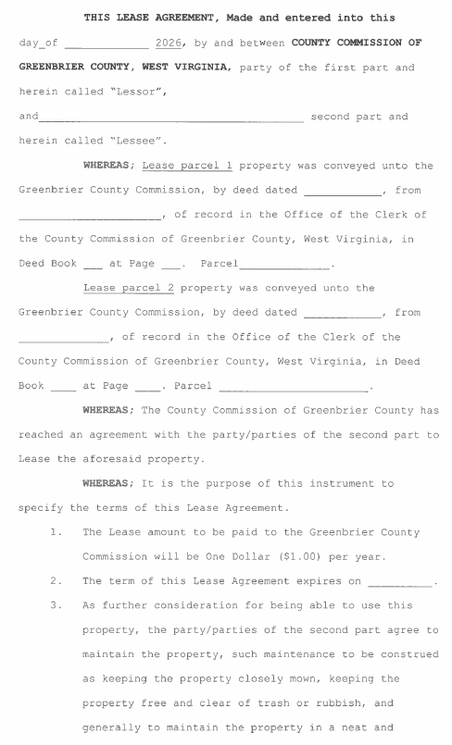
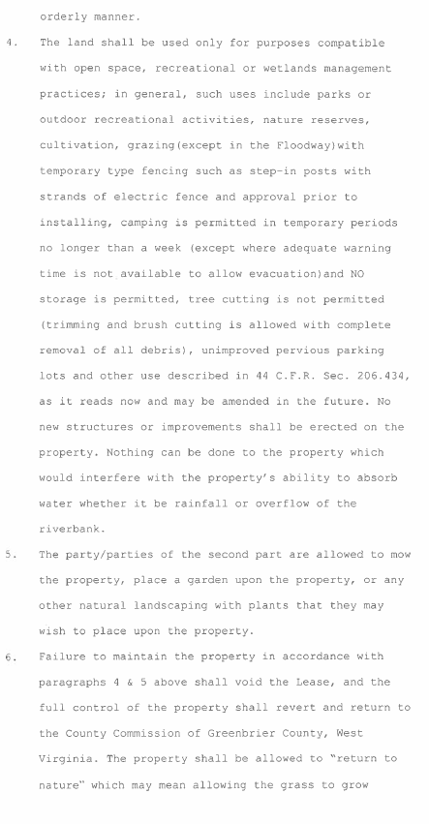
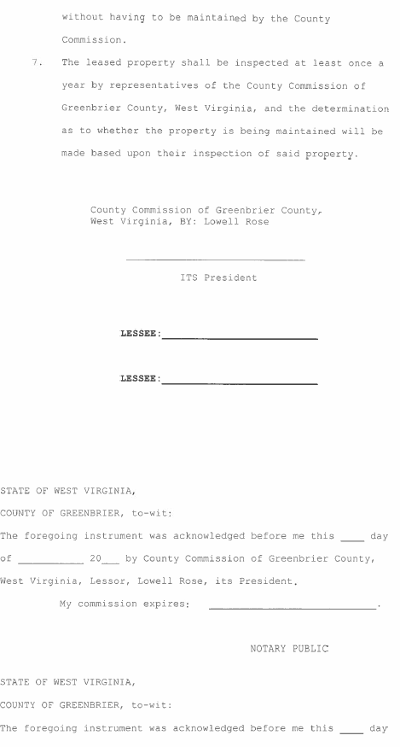
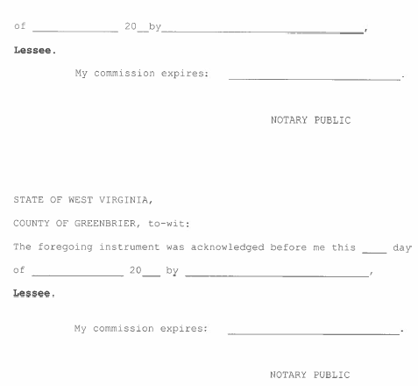
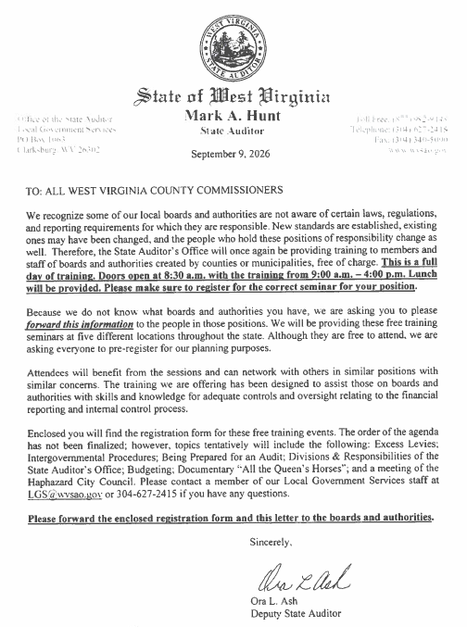
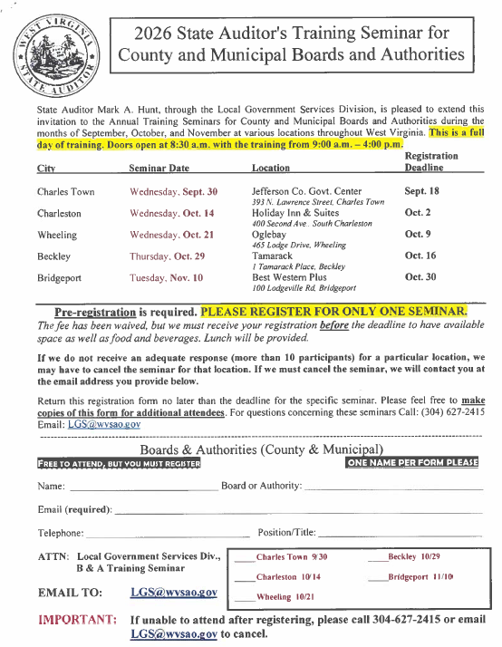
IN RE: SIGN IN SHEET/HEAR CALLERS

Amanda Smarr – Broad Band update
Nancy Harris –
Brianna Rexrode –

Amanda Smarr - Met with the commission with Broadband updates. No action was taken on this matter.

Nancy Harris – Attended the meeting by zoom and addressed the County Commission on comments made by Melissa Bennett at a public meeting of the Pocahontas County Solid Waste Authority. No action taken.

Brianna Rexrode – Addressed concerns of a private conversation being brought up in a public meeting, and how she felt some of the information was inconsistent with what she said.

IN RE: OPENING AND AWARDING OF BID FOR A FULL-SIZE POLICE PURSUIT VEHICLE FOR THE POCAHONTAS COUNTY SHERIFF’S DEPARTMENT

A motion was made by Commissioner Walker to accept the only bid received from Mid-State Chevrolet for a 2026 Chevrolet Tahoe for $58,814.76, and noting no objections, motion carried.

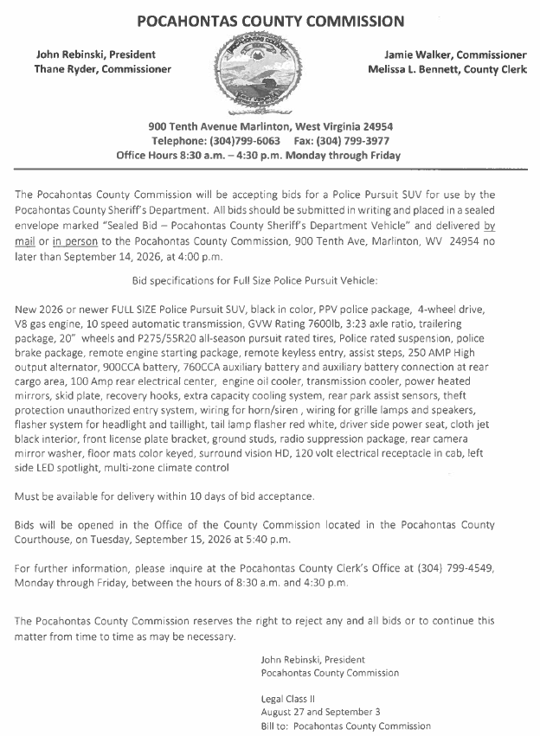
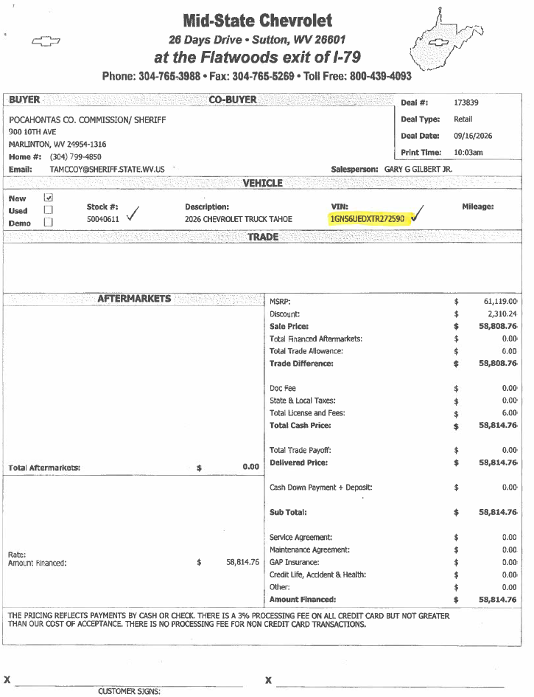
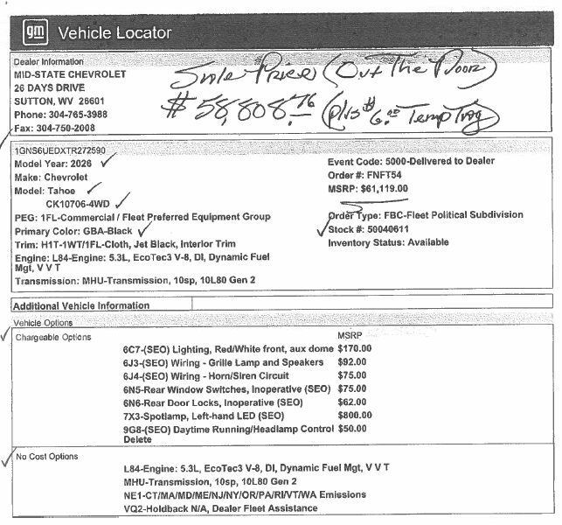
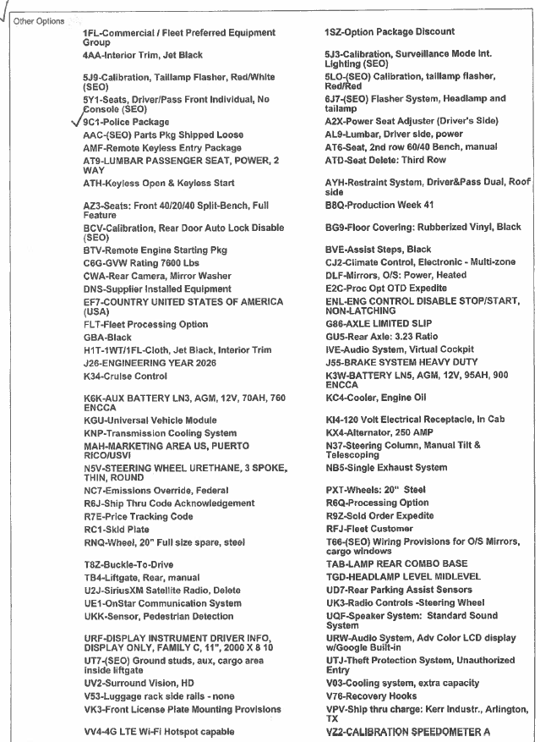
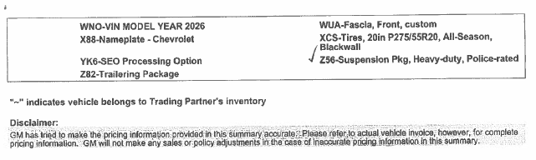

IN RE: REGION 4 - POCAHONTAS MEMORIAL HOSPITAL WASTEWATER PROJECT - RESOLUTION #5

A motion was made by Commissioner Ryder to approve Region 4 Pocahontas Memorial Hospital Wastewater Project Resolution #5, and noting no objections, motion carried.
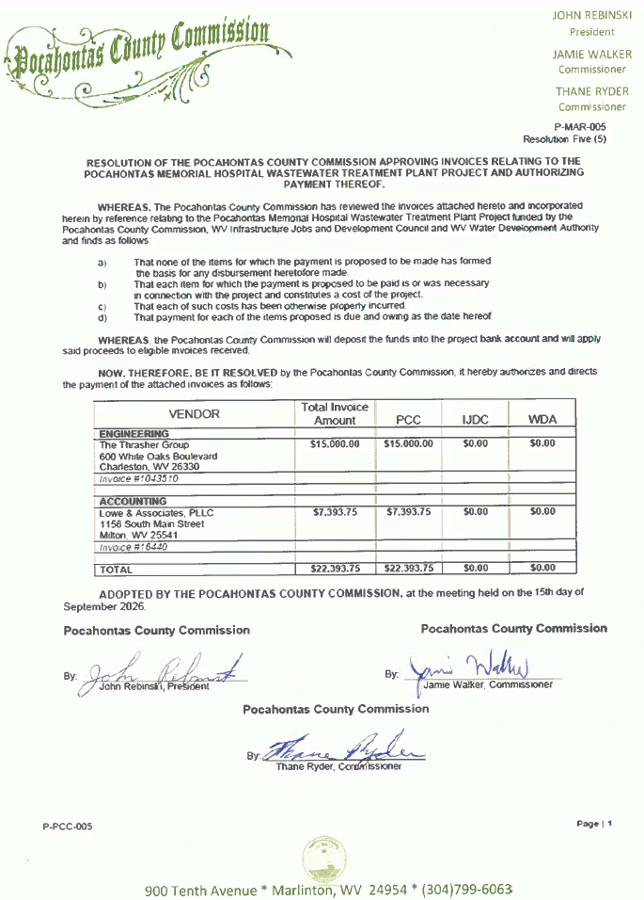

IN RE: GVEDC - EPA TANNERY PROJECT PAYMENT RESOLUTION #25

A motion was made by Commissioner Walker to approve the GVEDC – EPA Tannery Project Payment Resolution #25, and noting no objections, motion carried.

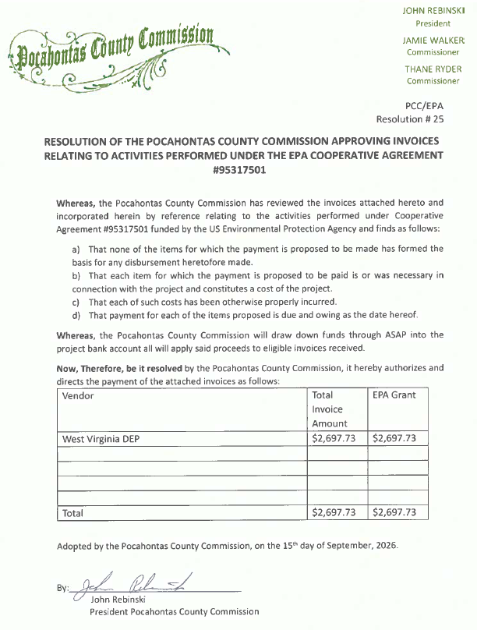
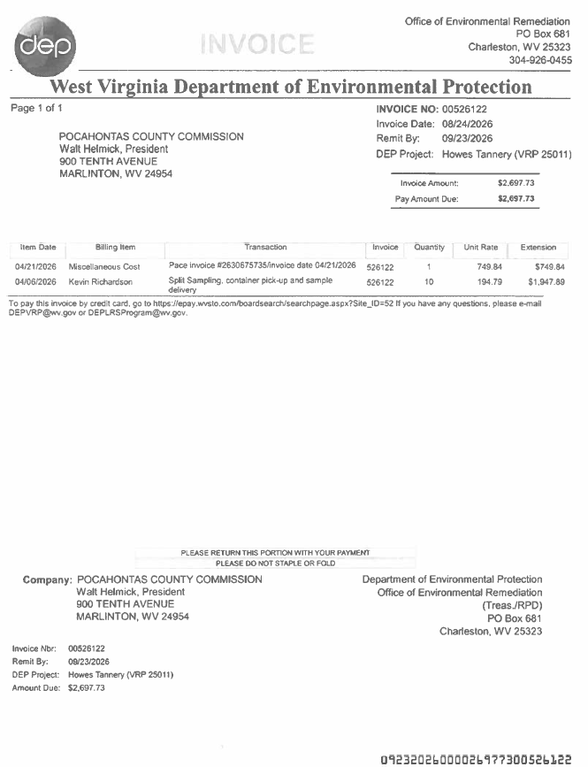

IN RE: CHELSEA FAULKNIER, DIRECTOR POCAHONTAS COUNTY CVB 2025-2026 ANNUAL REPORT

Chelsea Faulknier, Director of the Pocahontas County CVB met with the commission by zoom with the 2025-2026 Annual Report for the CVB. No action was taken on this matter

IN RE: LAURA KERSHNER, PROSECUTING ATTORNEY – APPROVAL OF PART-TIME EMPLOYEE

No action was taken on this matter.

IN RE: BEN BROWN, 911 DIRECTOR – APPROVAL OF PART-TIME EMPLOYEE

A motion was made by Commissioner Walker to approve Jacob Lee Paul as part-time dispatcher effective September 29, 2026 at $14.00 per hour with no benefits, and noting no objections, motion carried.

IN RE: MELISSA BENNETT, COUNTY CLERK

A. APPROVAL OF ELECTION OFFICIALS FOR GENERAL ELECTION NOVEMBER 3, 2026

B. APPROVAL OF FINANCIAL STATEMENT AND VENDOR’S LIST FOR 2025-2026

A motion was made by Commissioner Walker to approve the Election Officials for the General Election on November 3, 2026, and noting no objections, motion carried.

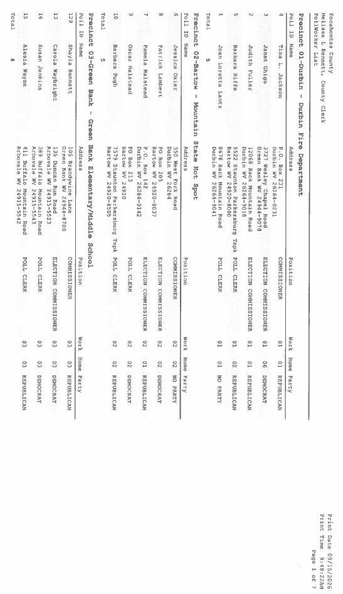
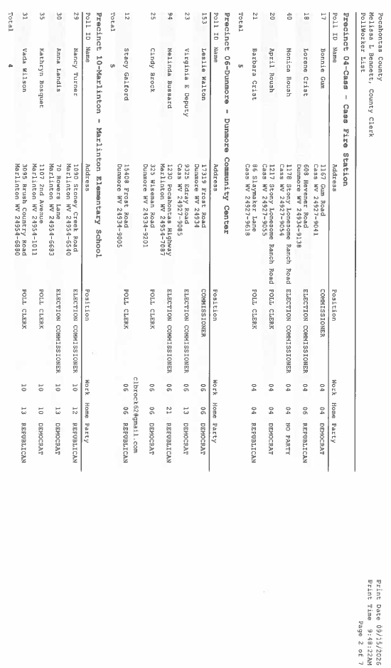

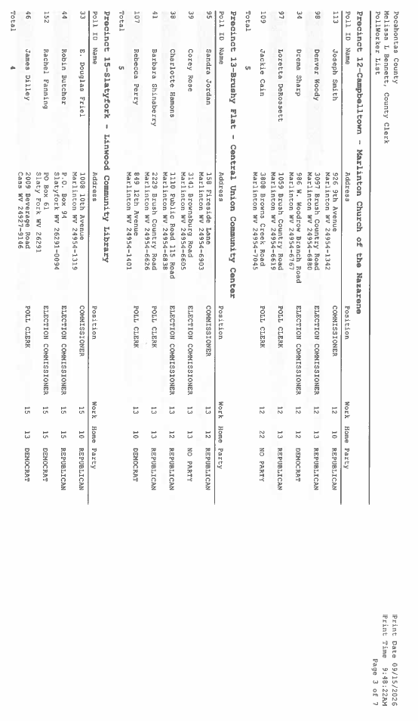
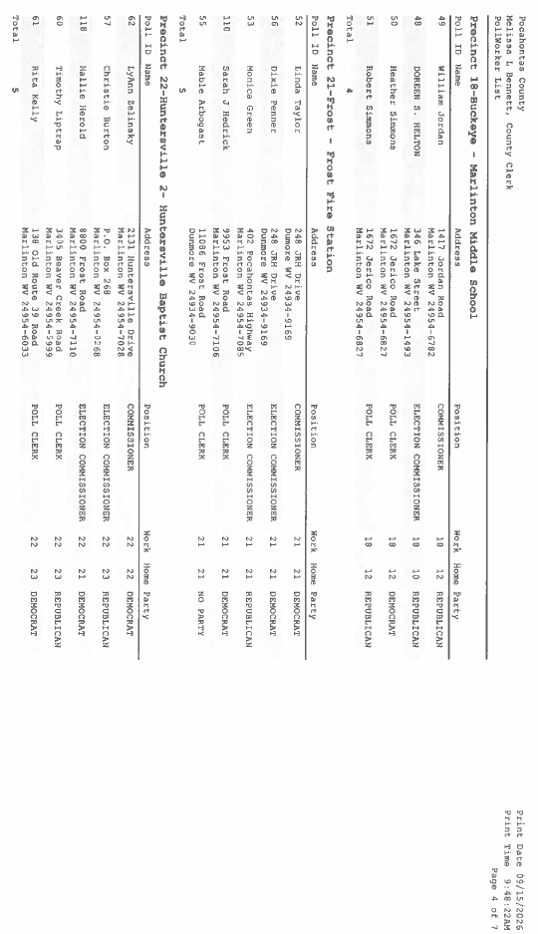
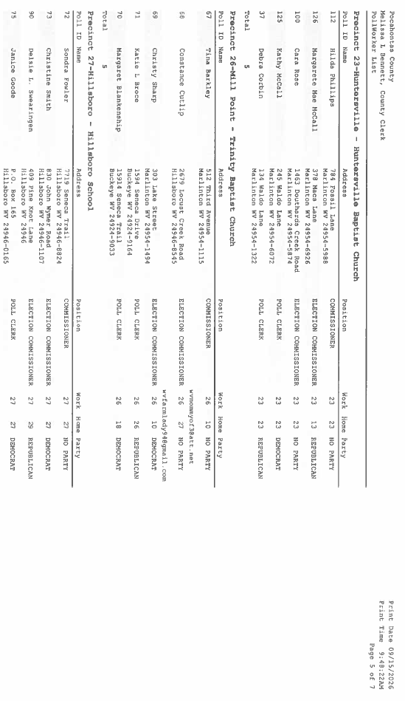

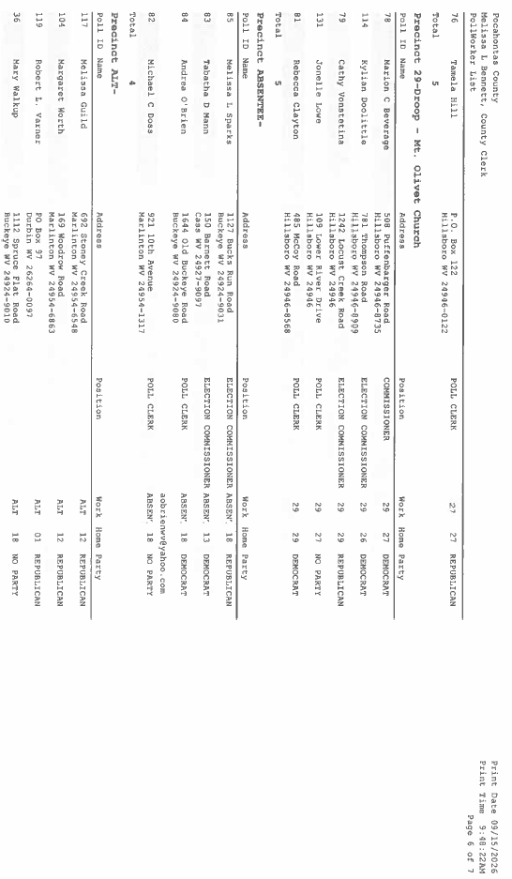
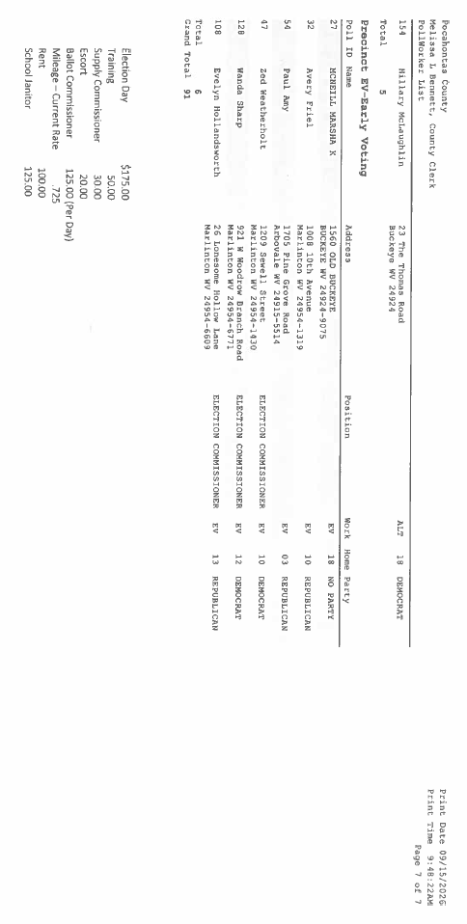

A motion was made by Commissioner Walker to approve the 2025-2026 Financial Statement and Vendor’s List, and noting no objections, motion carried.

IN RE: APPROVAL OF PART-TIME EMPLOYEE AT THE POCAHONTAS COUNTY ANIMAL SHELTER

A motion was made by Commissioner Ryder to approve Carrie Jo Branch as a part-time employee at the Pocahontas County Animal Shelter at $12.00 per hour and effective after completion of drug testing, and noting no objections, motion carried.

IN RE: BOARD APPOINTMENTS - POCAHONTAS COUNTY FIRE BOARD:
JANET KERSHNER-VANOVER, CITIZEN REPRESENTATIVE SOUTHERN DISTRICT AND TODD WRIGHT, CITIZEN REPRESENTATIVE NORTHERN DISTRICT – UNEXPIRED THREE-YEAR TERMS EXPIRING JUNE 30, 2029

A motion was by Commissioner Walker to approve Janet Kershner-Vanover, as citizen representative for the southern district and Todd Wright, as citizen representative for the northern district – each to unexpired three-year terms expiring June 30, 2029, to the Pocahontas County Fire Board and noting no objections, motion carried.

IN RE: INVOICES

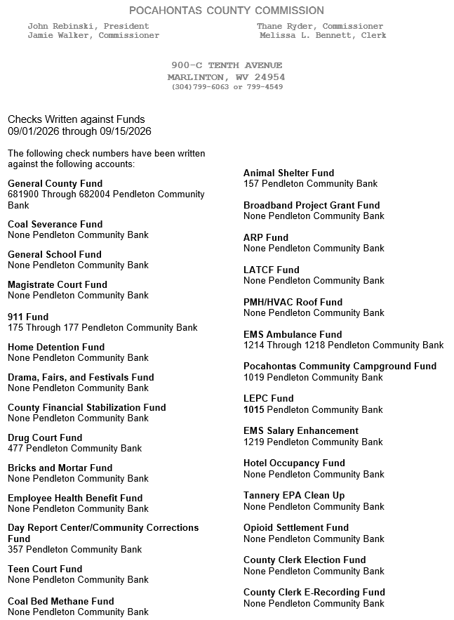

ORDERED THIS MEETING BE ADJOURNED, SINE DIE.



