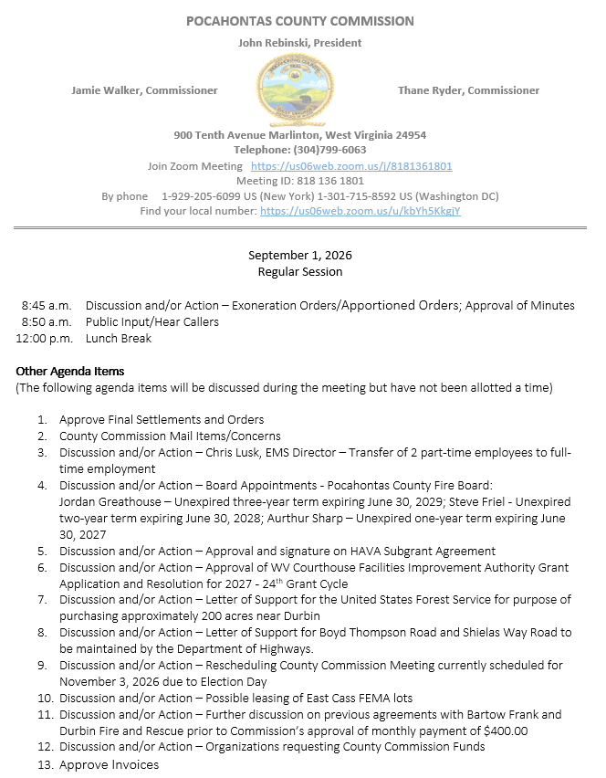

At a Regular Session of the Pocahontas County Commission held at the Courthouse situate in Marlinton, West Virginia, on the 6th day of August, 2026.

PRESENT: John Rebinski, President
Jamie Walker, Commissioner
Thane Ryder, Commissioner

Prior to the beginning of today’s session, the Commission invited all individuals in attendance to stand and recite the Pledge of Allegiance.

IN RE: EXONERATION/APPORTIONED ORDERS APPROVED

None

IN RE: MINUTES APPROVED

A motion was made by Commissioner Walker to approve the minutes of the last regular session of the Commission held on the 18th day of August, as presented, and noting no objections, motion carried.
IN RE: FINAL SETTLEMENTS AND ORDERS APPROVED

Commission President John Rebinski reviewed several final settlements and orders pertaining to estates as presented by the County Clerk’s Office and, thereafter, approved same by placing his signature thereto.

IN RE: COUNTY COMMISSION MAIL ITEMS/CONCERNS

None

IN RE: CHRIS LUSK, EMS DIRECTOR – TRANSFER OF 2 PART-TIME EMPLOYEES TO FULL-TIME EMPLOYMENT

A motion was made by Commissioner Ryder to approve the transfer of Jordan Greathouse at $14.75 per hour and Angela Lewis at $13.75 per hour to full time as drivers effective September 1, 2026, and noting no objections, motion carried.

IN RE: SIGN IN SHEET/HEAR CALLERS

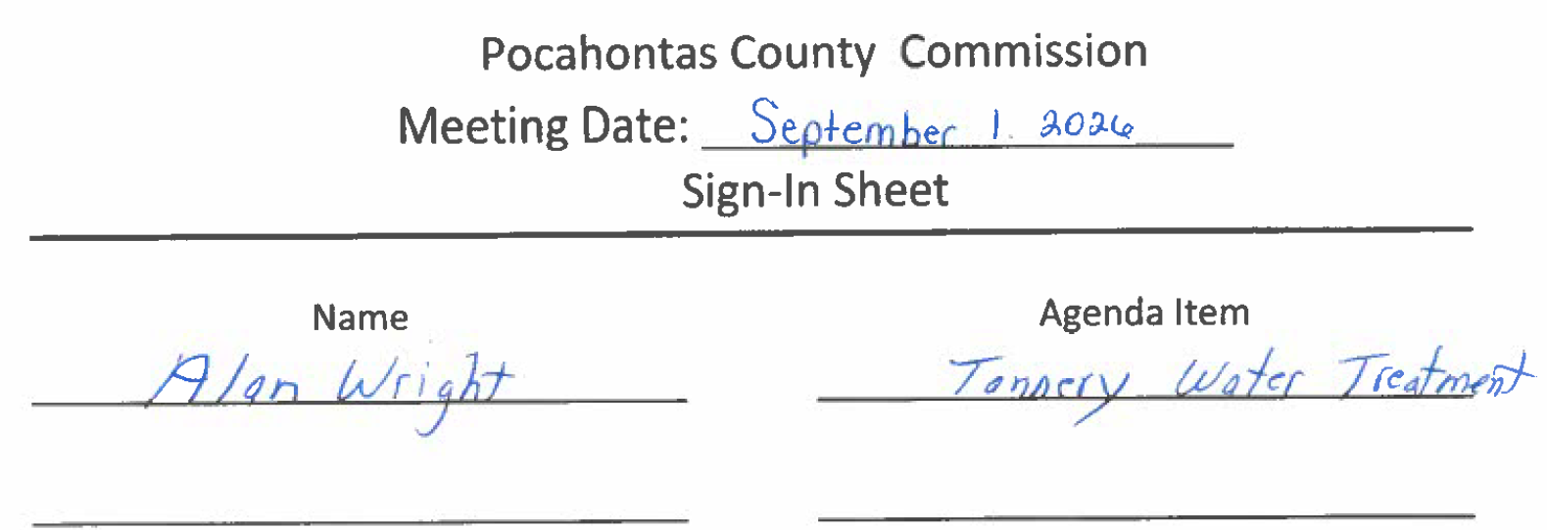

Alan Wright – Inquired about the quarterly water samples for the tannery and the expense involved in the testing, and if there will ever be an end to that expense. No action was taken on this matter.

IN RE: POSSIBLE LEASING OF EAST CASS FEMA LOTS

A motion was made by Commissioner Ryder to move forward with findings on the legalities for the possibilities for leasing the East Cass Fema Lots, and noting no objections, motion carried.

IN RE: FURTHER DISCUSSION ON PREVIOUS AGREEMENTS WITH BARTOW FRANK AND DURBIN FIRE AND RESCUE PRIOR TO COMMISSION’S APPROVAL OF MONTHLY PAYMENT OF $400.00

Commissioner Rebinski wanted to discuss the use of idle time at the Bartow Frank and Durbin Fire and Rescue since they are now receiving a monthly payment. Commissioner Rebinski believes they should not use idle time to offset the cost of using the space. A motion was made by Commission Walker to put no restrictions on what could be done with idle time and the payment to be written as rent, and noting no objections, motion carried.

IN RE: BOARD APPOINTMENTS - POCAHONTAS COUNTY FIRE BOARD:
JORDAN GREATHOUSE – UNEXPIRED THREE-YEAR TERM EXPIRING JUNE 30, 2029; STEVE FRIEL - UNEXPIRED TWO-YEAR TERM EXPIRING JUNE 30, 2028; AURTHUR SHARP – UNEXPIRED ONE-YEAR TERM EXPIRING JUNE 30, 2027

A motion was made by Commissioner Walker to approve Jordan Greathouse to an unexpired three-year term expiring June 30, 2029, Steve Friel to an unexpired two-year term expiring June 30th 2028 and Aurthur Sharp to an unexpired one-year term expiring June 30, 2027, and noting no objections, motion carried.

IN RE: APPROVAL OF WV COURTHOUSE FACILITIES IMPROVEMENT AUTHORITY GRANT APPLICATION AND RESOLUTION FOR 2027 - 24TH GRANT CYCLE

A motion was made by Commissioner Walker to approve the WV Courthouse Facilities Improvement Authority Grant Application and Resolution for 2027 - 24th Grant Cycle, and noting no objections motion carried.
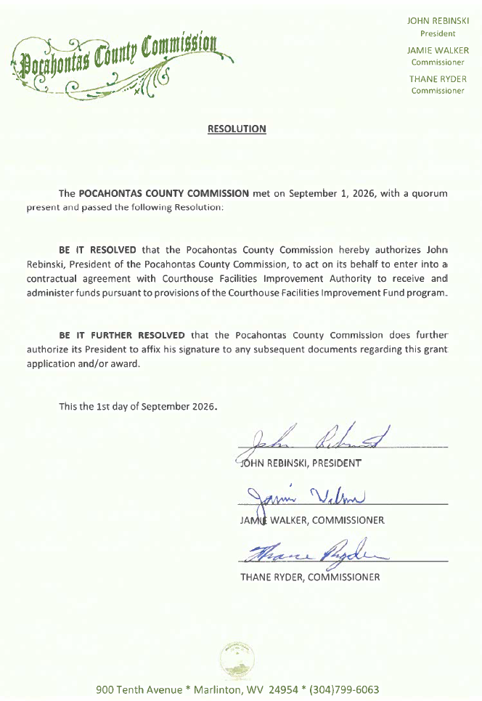

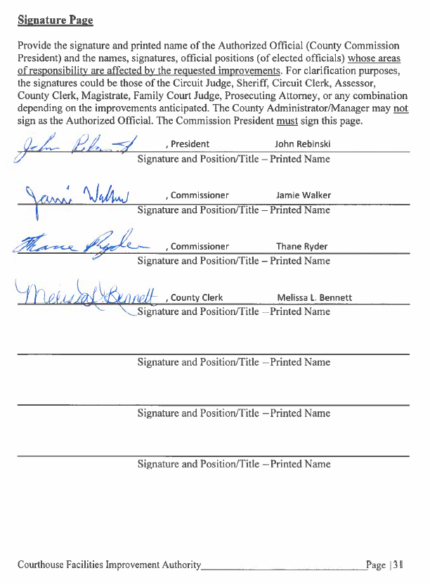

IN RE: LETTER OF SUPPORT FOR THE UNITED STATES FOREST SERVICE FOR PURPOSE OF PURCHASING APPROXIMATELY 200 ACRES NEAR DURBIN

A motion was made by Commissioner Walker to approve the letter of support for the United States Forest Service for the purpose of purchasing approximately 200 acres near Durbin, and noting no objections, motion carried.
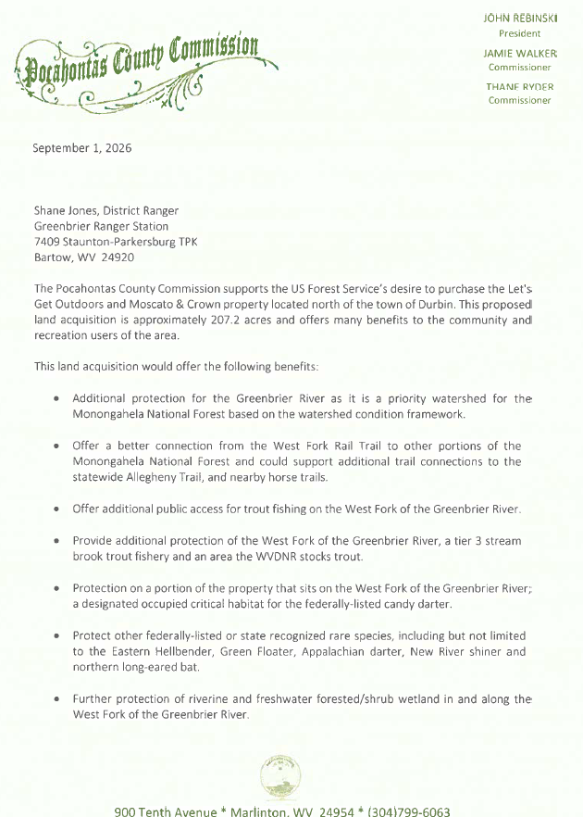
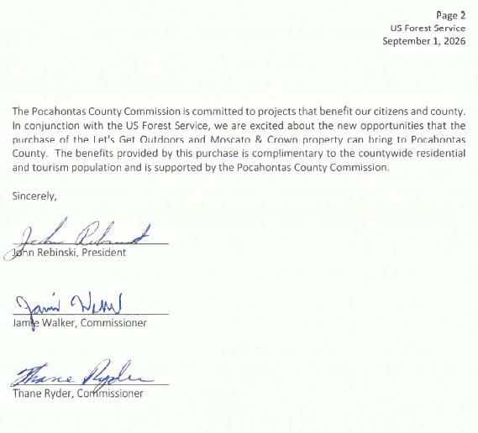
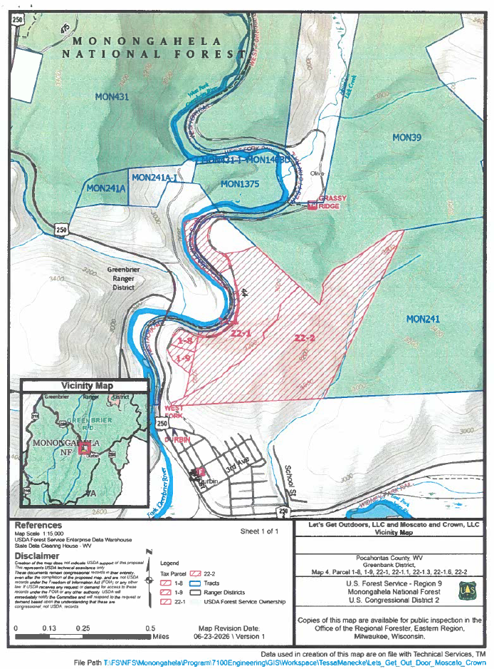
IN RE: LETTER OF SUPPORT FOR BOYD THOMPSON ROAD AND SHIELAS WAY ROAD TO BE MAINTAINED BY THE DEPARTMENT OF HIGHWAYS

A motion was made by Commissioner Walker to approve the letter of support for Boyd Thompson Road and Shielas Way Road to be maintained by the Department of Highways, and noting no objections, motion carried.

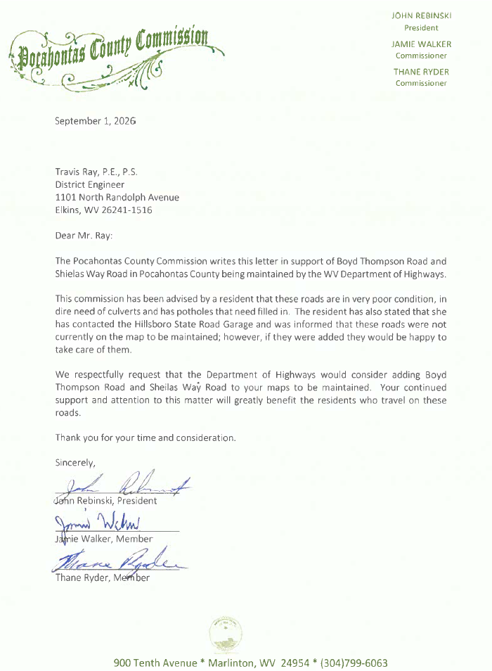

IN RE: RESCHEDULING COUNTY COMMISSION MEETING CURRENTLY SCHEDULED FOR NOVEMBER 3, 2026 DUE TO ELECTION DAY

A motion was made by Commissioner Walker to reschedule the county commission meeting to November 4, 2026, that is currently scheduled for November 3, 2026 due to Election Day, and noting no objections, motion carried.
IN RE: ORGANIZATIONS REQUESTING COUNTY COMMISSION FUNDS

Commissioner Rebinski discussed issues with organizations requesting funds when they still have money in their budgets and asking for Hotel/Motel funds and the misuse of the funds. No Action was taken on this matter.

IN RE: INVOICES

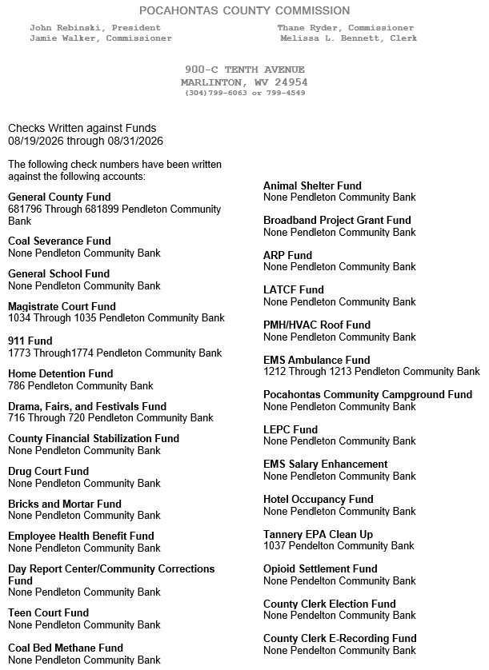

ORDERED THIS MEETING BE ADJOURNED, SINE DIE.



