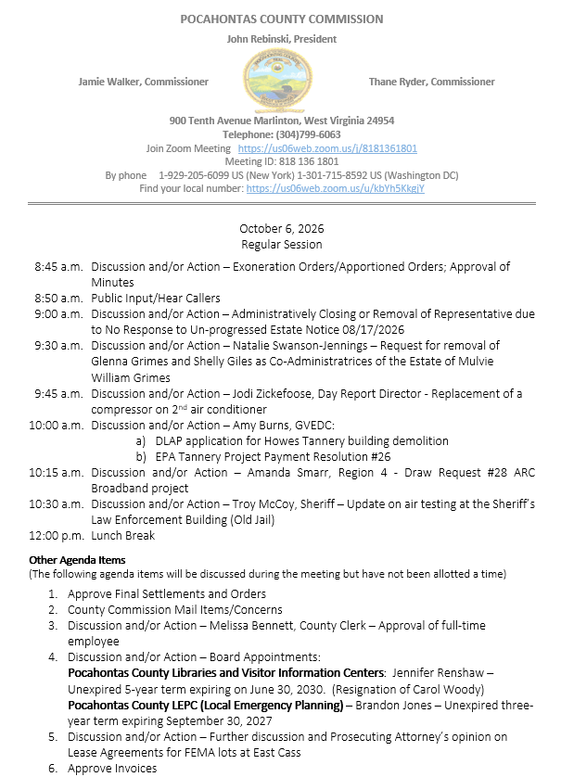

At a Regular Session of the Pocahontas County Commission held at the Courthouse situate in Marlinton, West Virginia, on the 6th day of October, 2026.

PRESENT: John Rebinski, President
Jamie Walker, Commissioner
Thane Ryder, Commissioner

Prior to the beginning of today’s session, the Commission invited all individuals in attendance to stand and recite the Pledge of Allegiance.

IN RE: EXONERATION/APPORTIONED ORDERS APPROVED

None

IN RE: MINUTES APPROVED

A motion was made by Commissioner Ryder to approve the minutes of the last regular session of the Commission held on the 15th day of September, 2026 as presented, and noting no objections, motion carried.
IN RE: FINAL SETTLEMENTS AND ORDERS APPROVED

Commission President John Rebinski reviewed several final settlements and orders pertaining to estates as presented by the County Clerk’s Office and, thereafter, approved same by placing his signature thereto.

IN RE: COUNTY COMMISSION MAIL ITEMS/CONCERNS

Copy – Pocahontas County Sheriff - Monthly Financial Statement September 2026
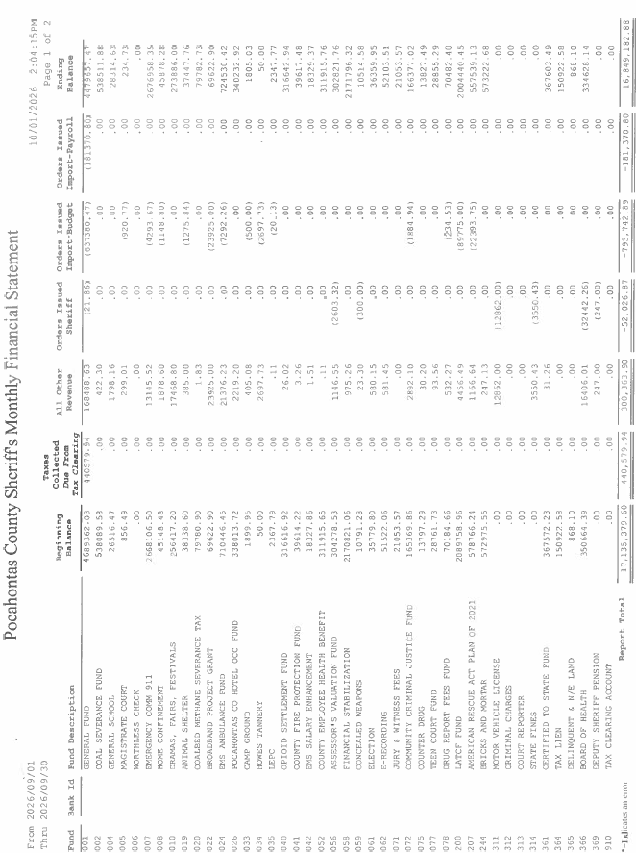

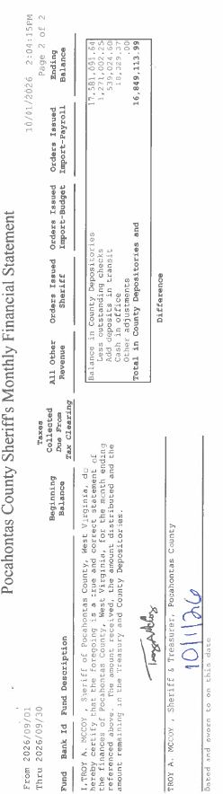

IN RE: MELISSA BENNETT, COUNTY CLERK – APPROVAL OF FULL-TIME EMPLOYEE

A motion was made by Commissioner Walker to approve Kyleen Alkire as full-time deputy clerk effective November 2, 2026, at $15.00 per hour with a 3-month probation. Hourly with wage to be paid for hours worked in October, and noting no objections, motion carried.

IN RE: SIGN IN SHEET/HEAR CALLERS

None

IN RE: BOARD APPOINTMENTS:

POCAHONTAS COUNTY LIBRARIES AND VISITOR INFORMATION CENTERS: JENNIFER RENSHAW – UNEXPIRED 5-YEAR TERM EXPIRING ON JUNE 30, 2030. (RESIGNATION OF CAROL WOODY)

POCAHONTAS COUNTY LEPC (LOCAL EMERGENCY PLANNING) – BRANDON JONES – UNEXPIRED THREE-YEAR TERM EXPIRING SEPTEMBER 30, 2027

A motion was made by Commissioner Walker to appoint Jennifer Renshaw to an unexpired 5-year term expiring on June 30, 2030, due to the resignation of Carol Woody to the Pocahontas County Libraries and Visitor Information Centers, and noting no objections, motion carried.

A motion was made by Commissioner Ryder to appoint Brandon Jones to an unexpired three-year term expiring September 30, 2027, to the Pocahontas County LEPC (Local Emergency Planning), and noting no objections, motion carried.

IN RE: FURTHER DISCUSSION AND PROSECUTING ATTORNEY’S OPINION ON LEASE AGREEMENTS FOR FEMA LOTS AT EAST CASS

A motion was made by Commissioner Ryder to approve the advertising by map and parcel for the lease interest for the East Cass FEMA Lots with a minimum bid of $1.00 per year for a 3-year lease. With an inspection from the Floodplain Coordinator once a year, and noting no objections, motion carried.

IN RE: ADMINISTRATIVELY CLOSING OR REMOVAL OF REPRESENTATIVE DUE TO NO RESPONSE TO UN-PROGRESSED ESTATE NOTICE 08/17/2026

A motion was made by Commissioner Walker to allow the Estate of Opal M. Moore to remain open for an additional 30 days to allow Executrix Betty Burke to sale said real estate. If the estate property is not sold by November 6, 2026, Betty Burke will be removed as Executrix and Dennis McCoy will be appointed, and noting no objections, motion carried.

A motion was made by Commissioner Walker to leave the attached list of estates open showing just cause from the representative as to such action, and noting no objections, motion carried.

A motion was made by Commissioner Walker to approve the attached list of administratively closing of estates, and noting no objections, motion carried.

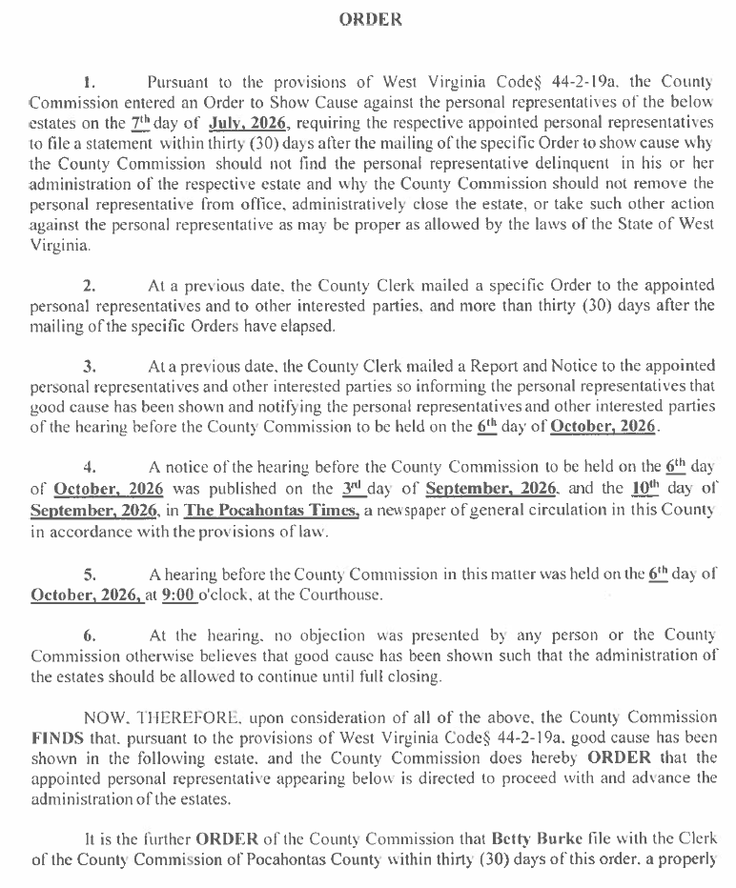
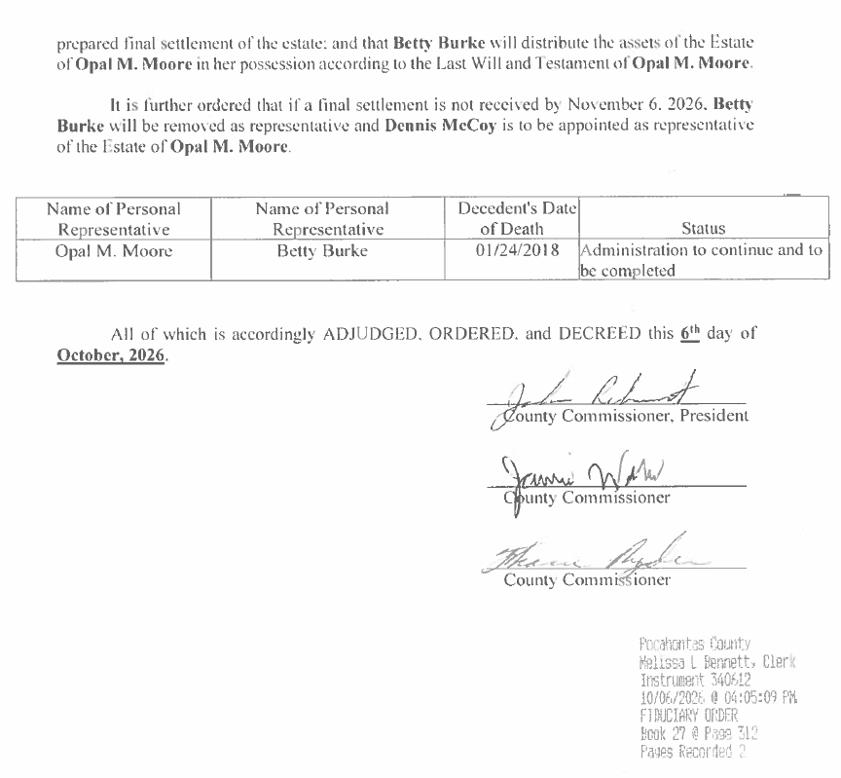
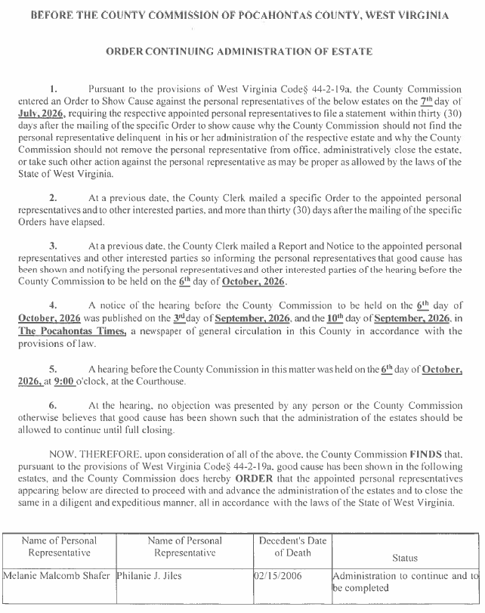

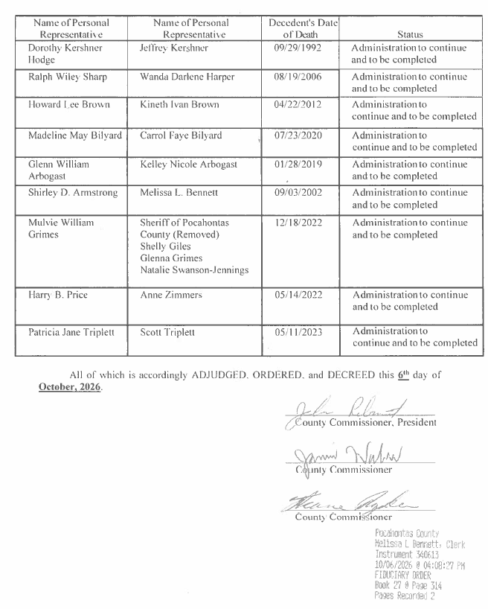
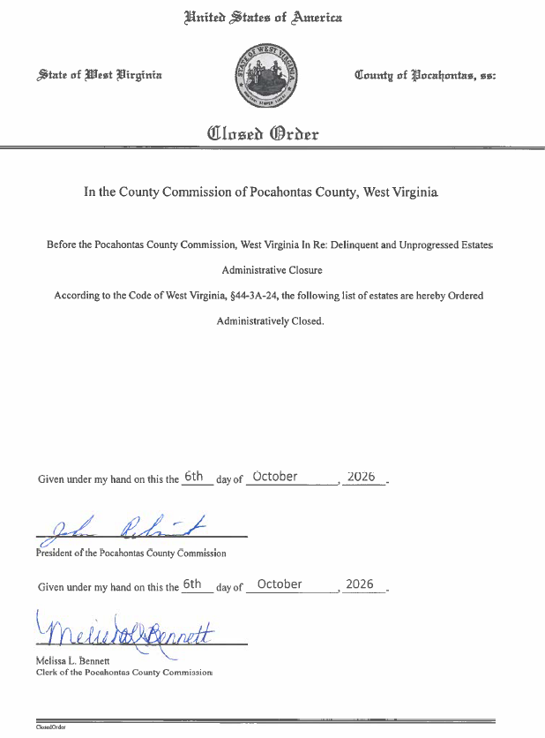

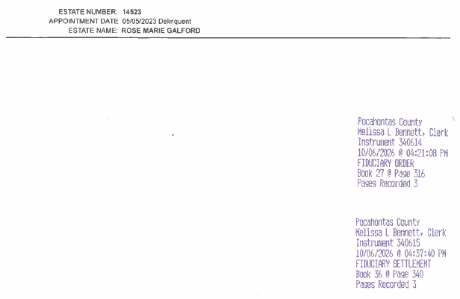
IN RE: NATALIE SWANSON-JENNINGS – REQUEST FOR REMOVAL OF GLENNA GRIMES AND SHELLY GILES AS CO-ADMINISTRATRICES OF THE ESTATE OF MULVIE WILLIAM GRIMES

After hearing concerns from the heirs on the estate of Mulvie William Grimes, on the motion from the Commission for the Sheriff to be removed and Natalie Swanson-Jennings, Glenna Grimes and Shelley Giles all to serve as Co- Administrator at a previous meeting on August 6, 2026. The commission took no action on this matter.

IN RE: JODI ZICKEFOOSE, DAY REPORT DIRECTOR - REPLACEMENT OF A COMPRESSOR ON 2ND AIR CONDITIONER

A motion was made by Commissioner Walker to approve the replacement of a compressor on the 2nd air conditioner at the ARC Building by First Call LLC in the amount of $3,963.72, and noting no objections motion carried.

IN RE: AMY BURNS, GVEDC:

- DLAP APPLICATION FOR HOWES TANNERY BUILDING DEMOLITION
- EPA TANNERY PROJECT PAYMENT RESOLUTION #26

A motion was made by Commissioner Walker to approve the DLAP application for Howes Tannery Building Demolition with the exception of the garage, and the EPA Tannery Project Payment Resolution #26, and noting no objections, motion carried.
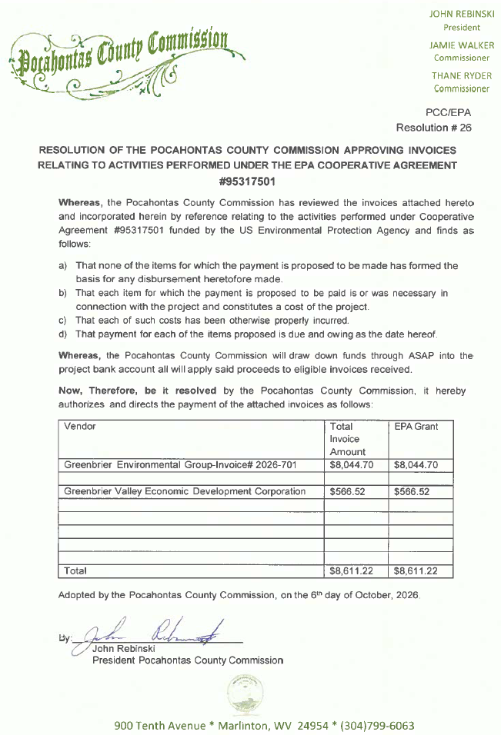
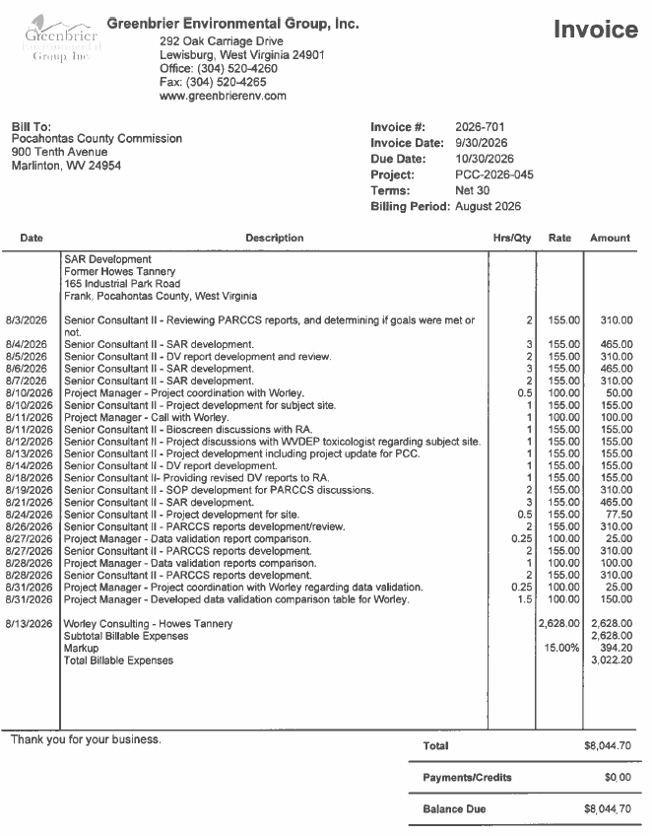

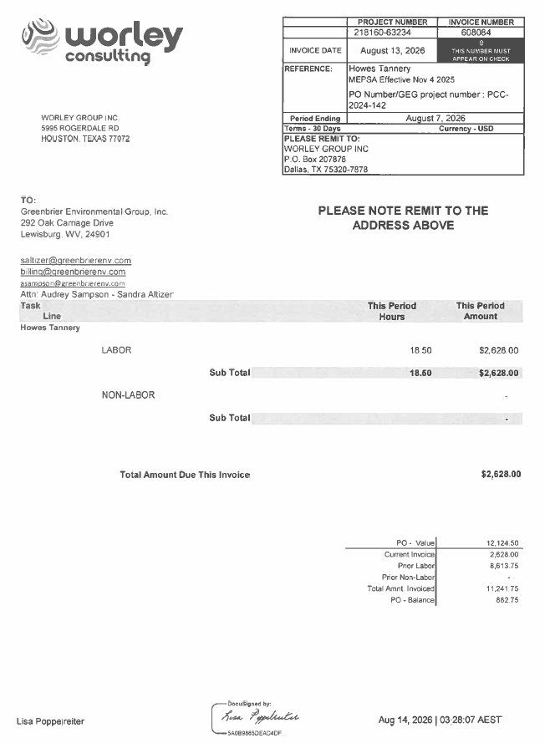
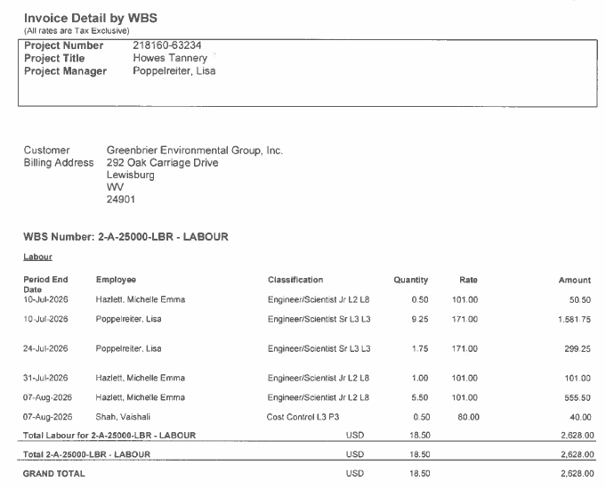

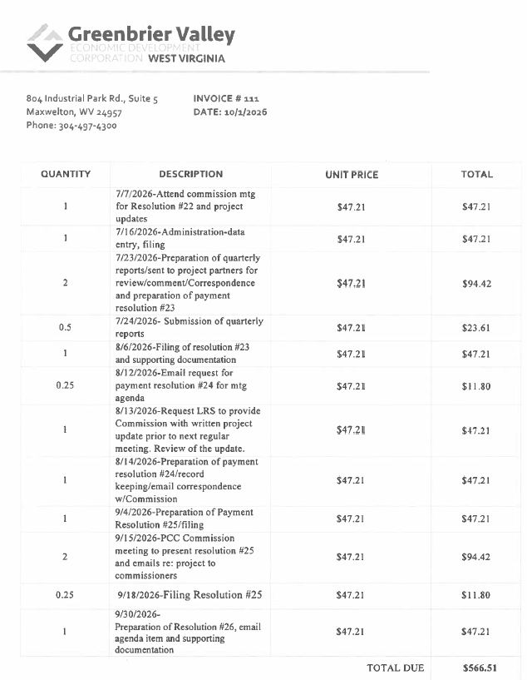
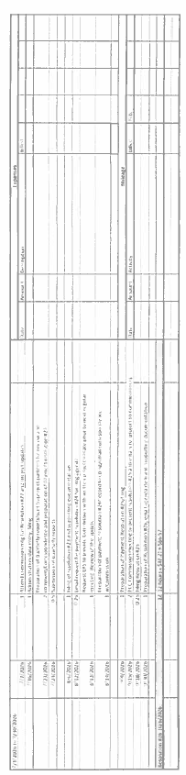

IN RE: AMANDA SMARR, REGION 4 - DRAW REQUEST #28 ARC BROADBAND PROJECT

A motion was made by Commissioner Walker to approve draw request #28 for the ARC Broadband Project, and noting no objections, motion carried.
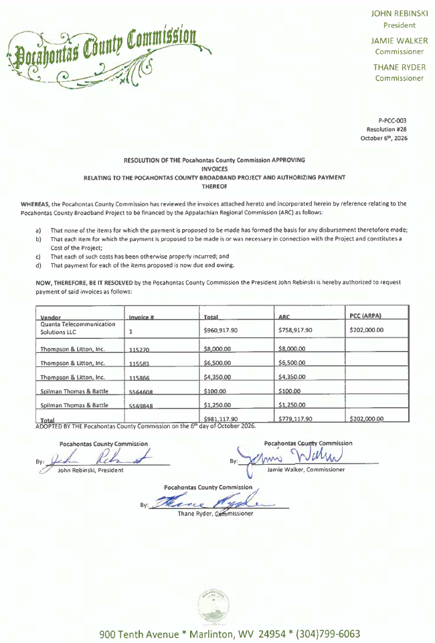
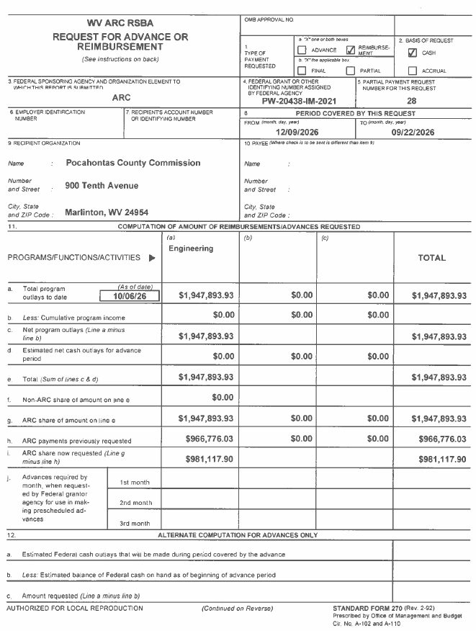
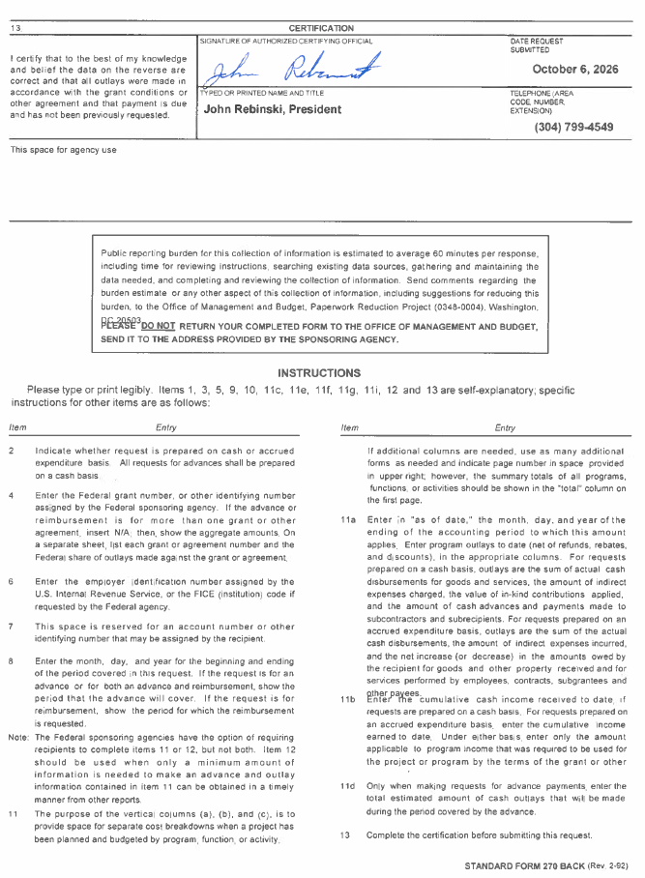
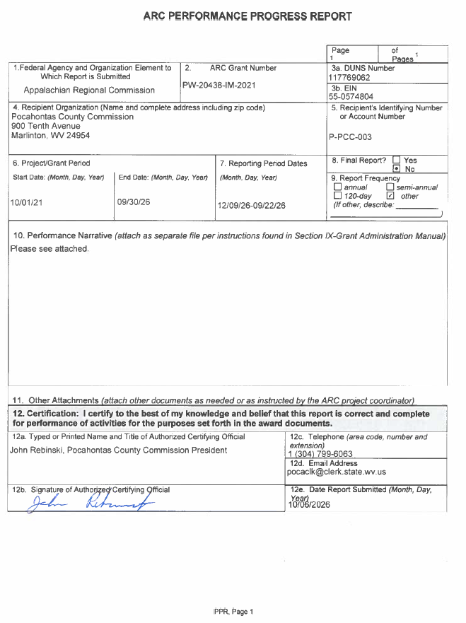

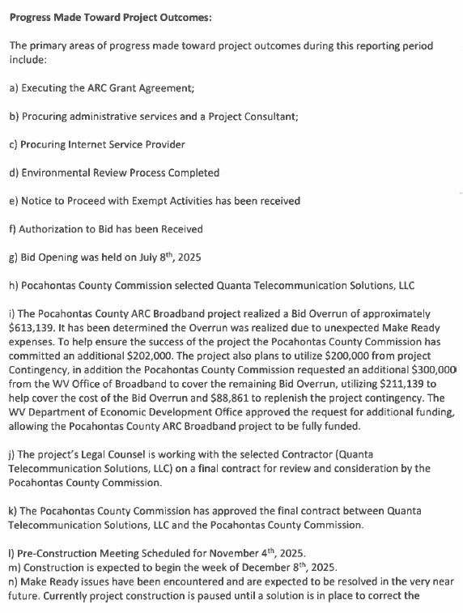
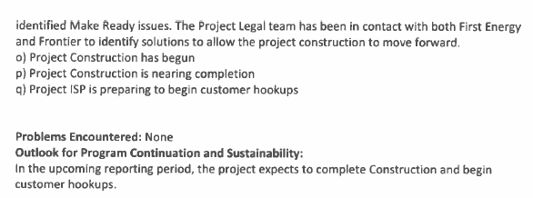

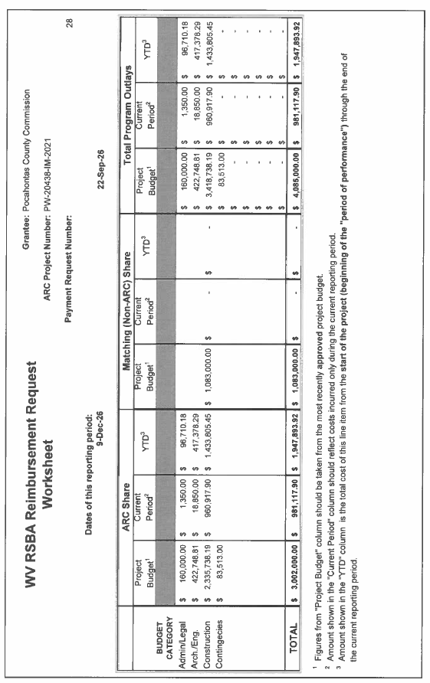
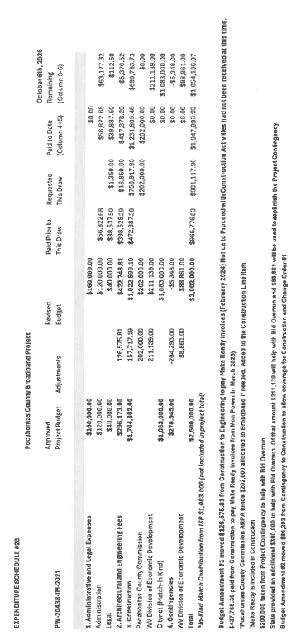
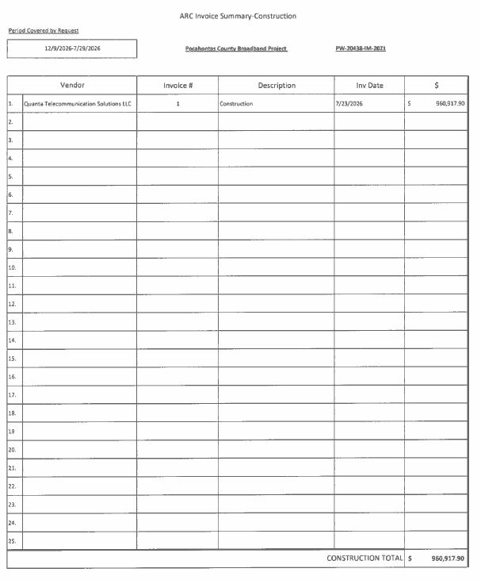

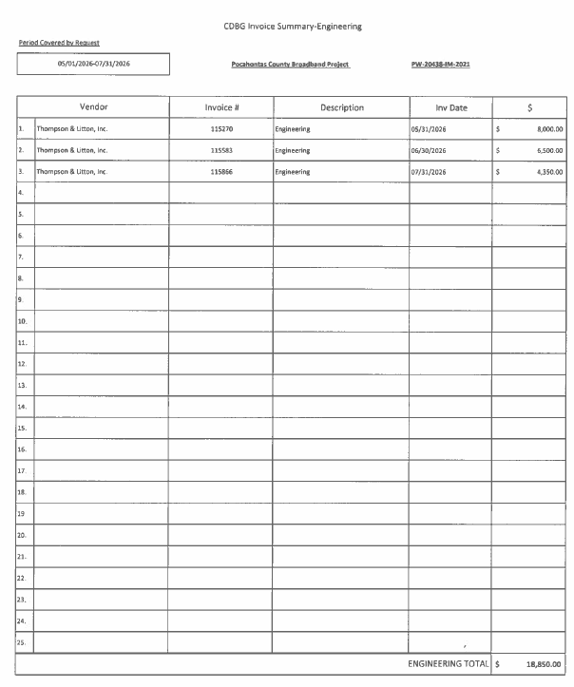
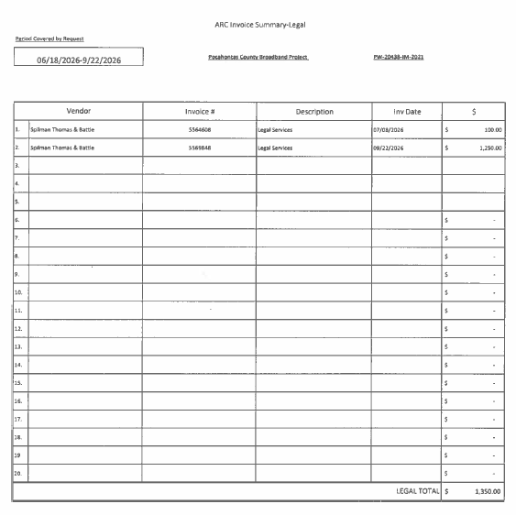
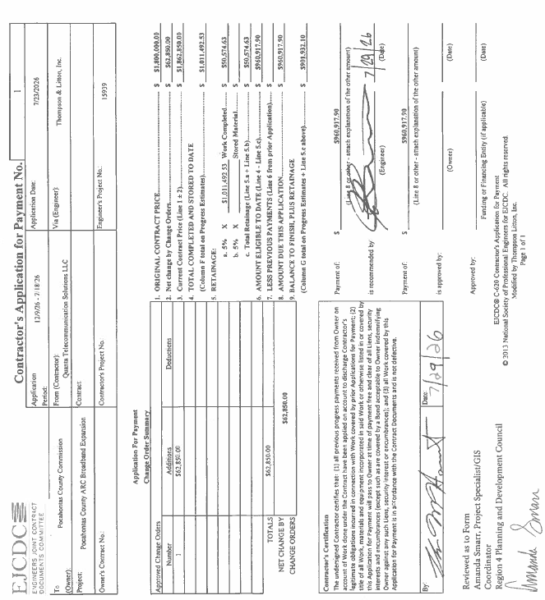
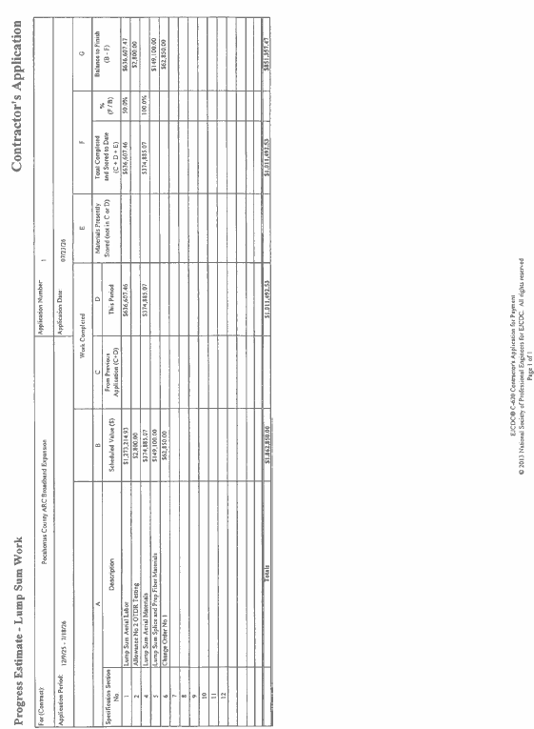



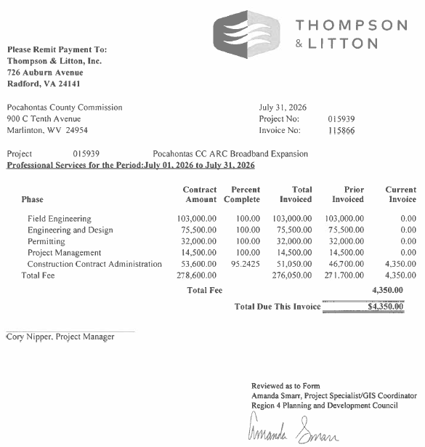
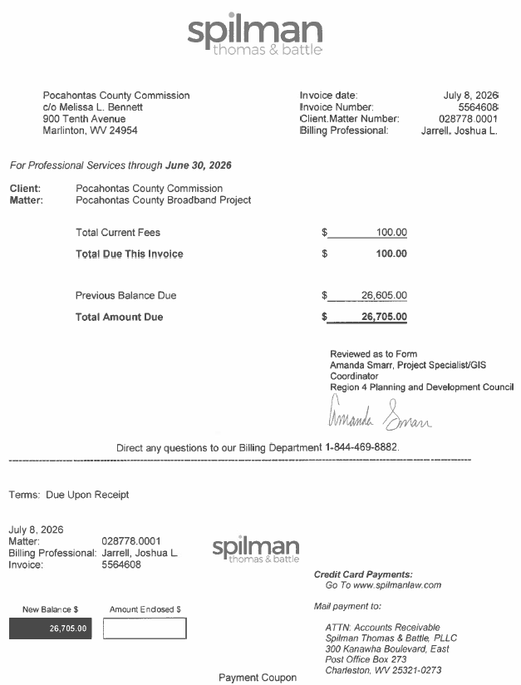
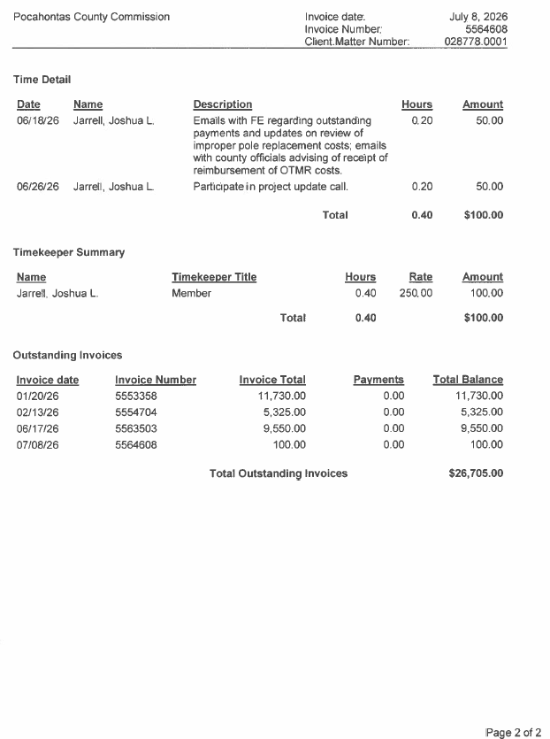
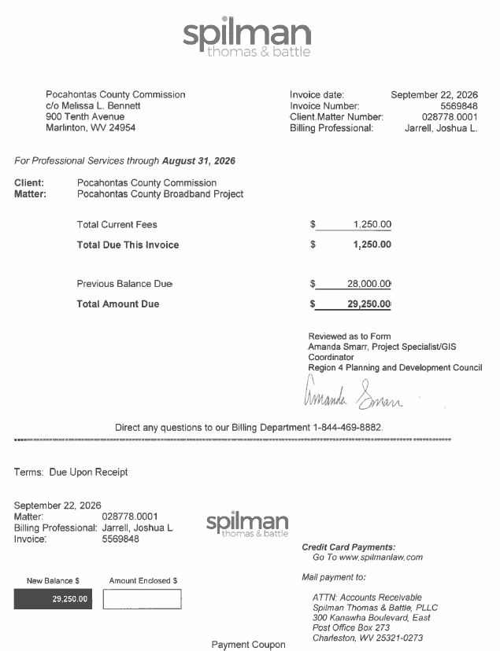
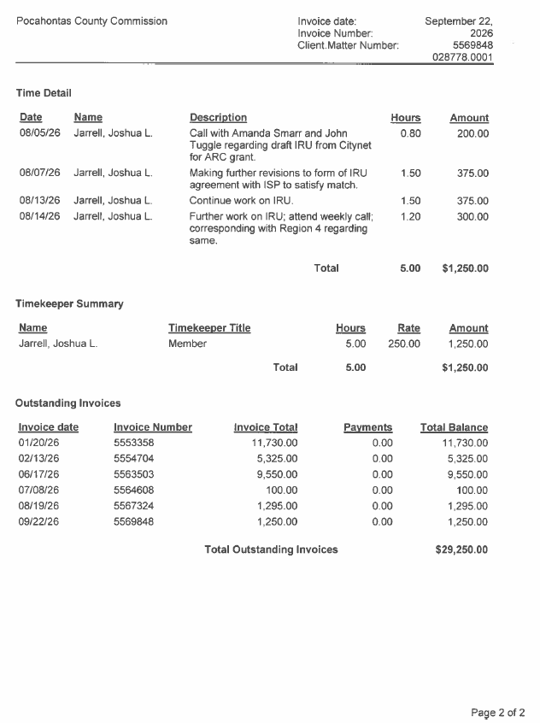

IN RE: TROY MCCOY, SHERIFF – UPDATE ON AIR TESTING AT THE SHERIFF’S LAW ENFORCEMENT BUILDING (OLD JAIL)

Sheriff, Troy McCoy met with the Commission with the update on the air testing at the Sheriff’s Law Enforcement Building (Old Jail). The sheriff has closed the building from anyone being able to enter the building due to the report filed from Appalachian Environmental Testing and Consulting. The Sheriff has asked that the bottom part of the Courthouse be vacated as a temporary solution to finding space for his department. The Commission will look into alternatives of replacing the Health Department, Solid Waste and the Extension Office.


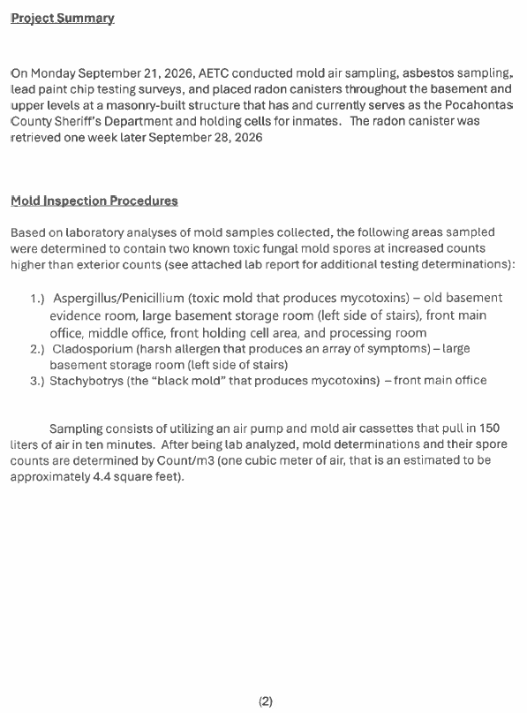
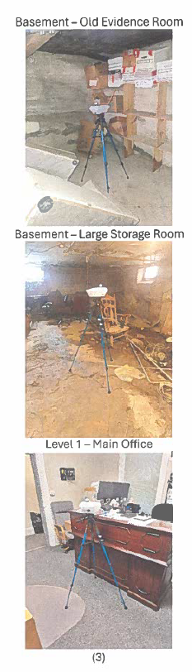
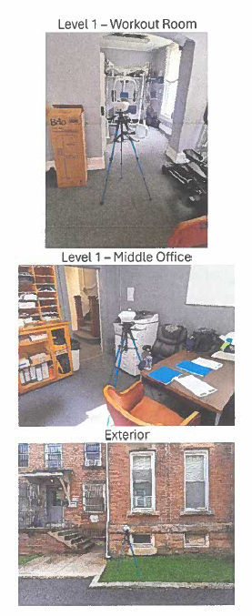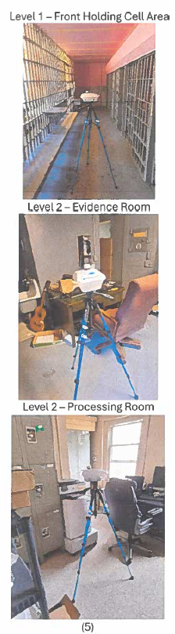
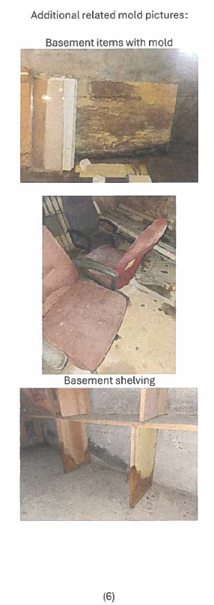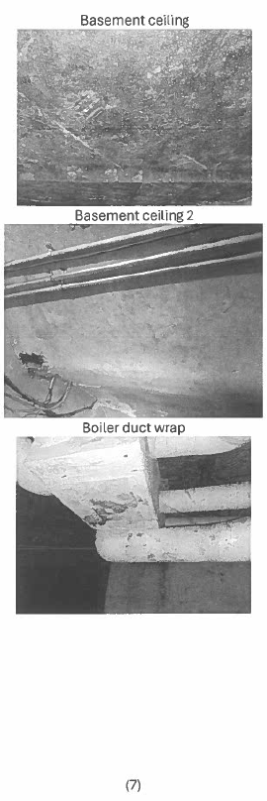

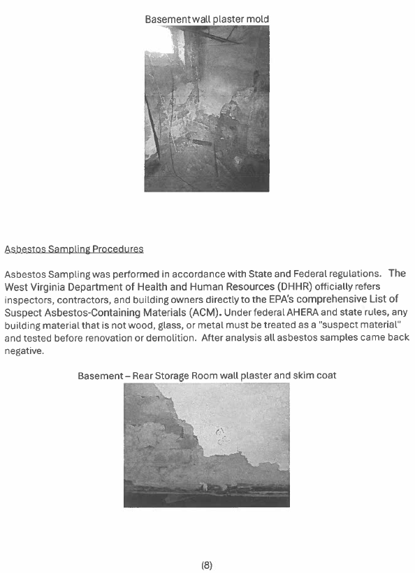
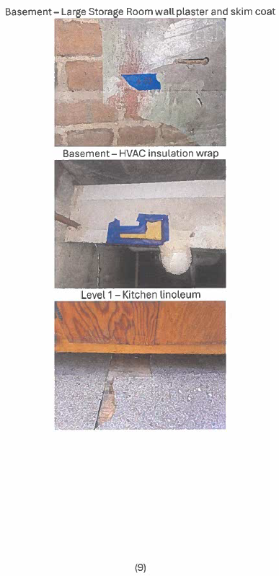
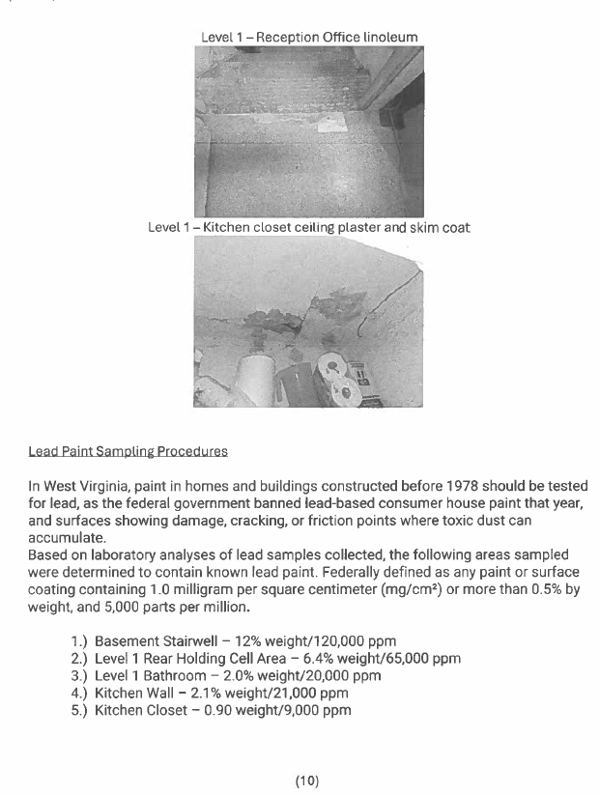
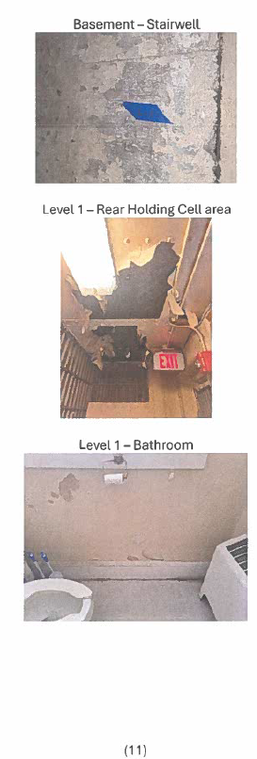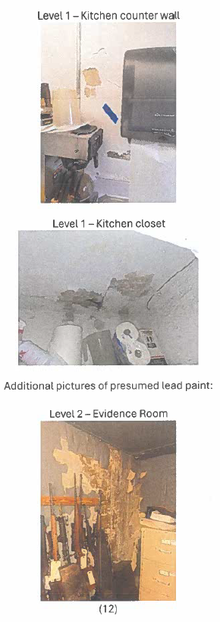

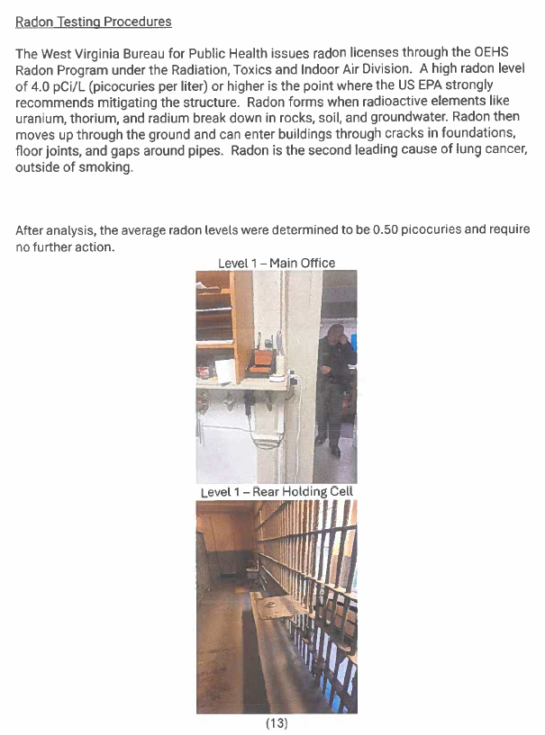

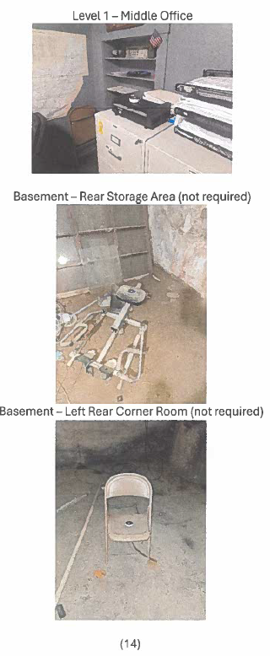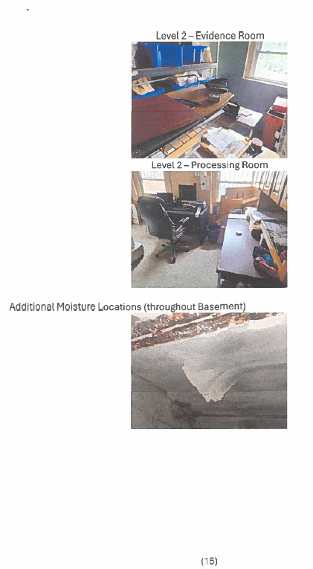
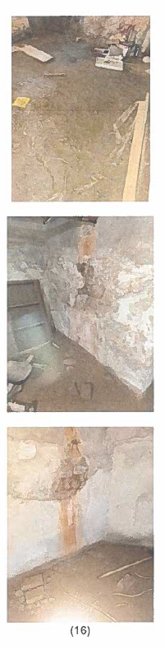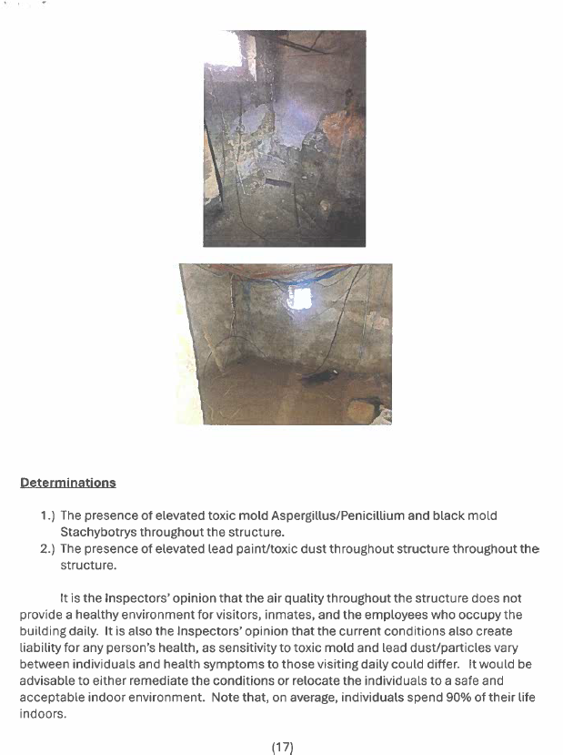

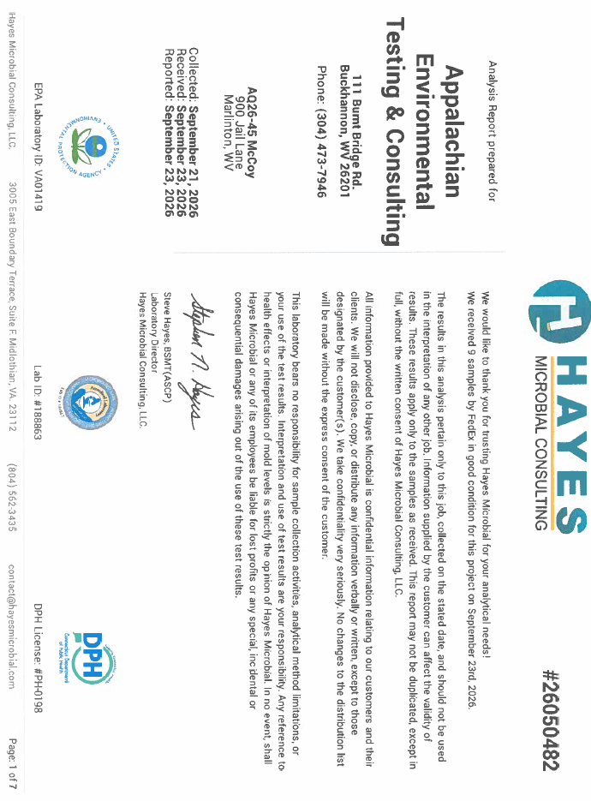
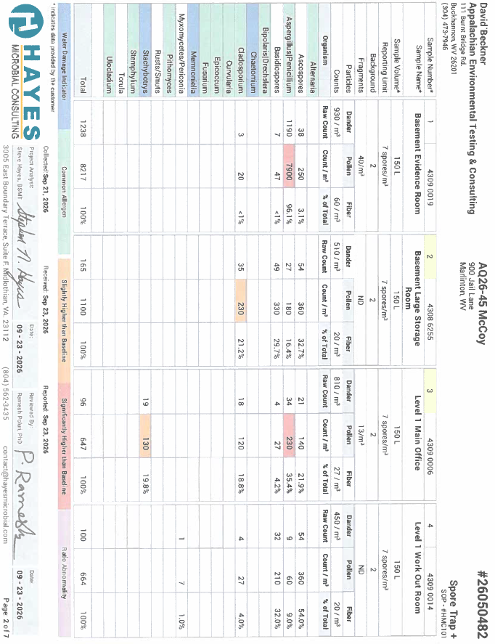

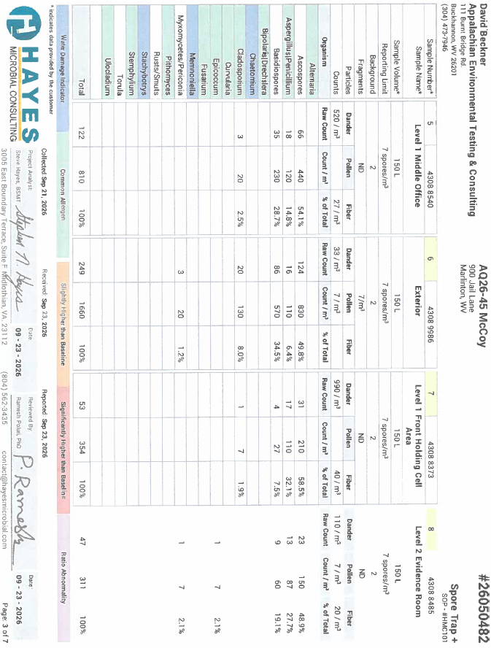
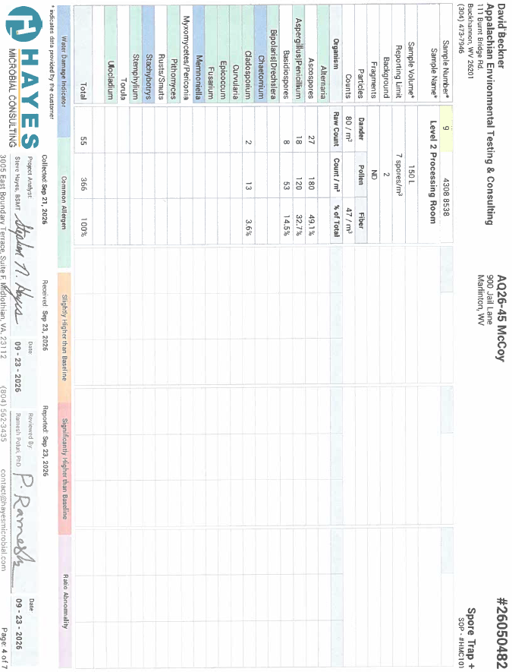
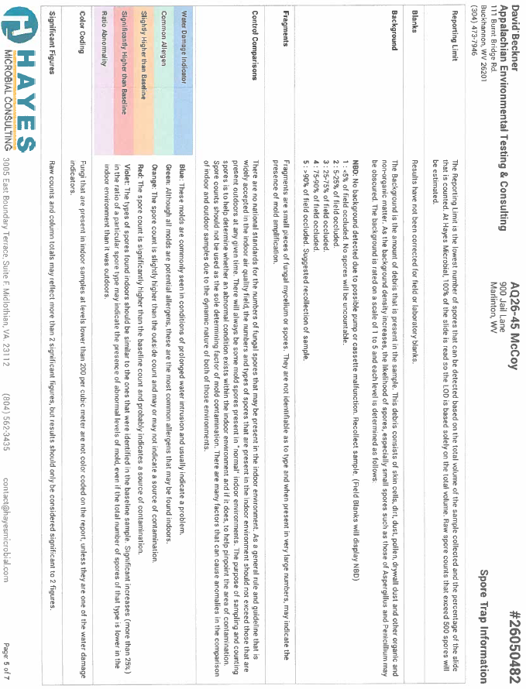
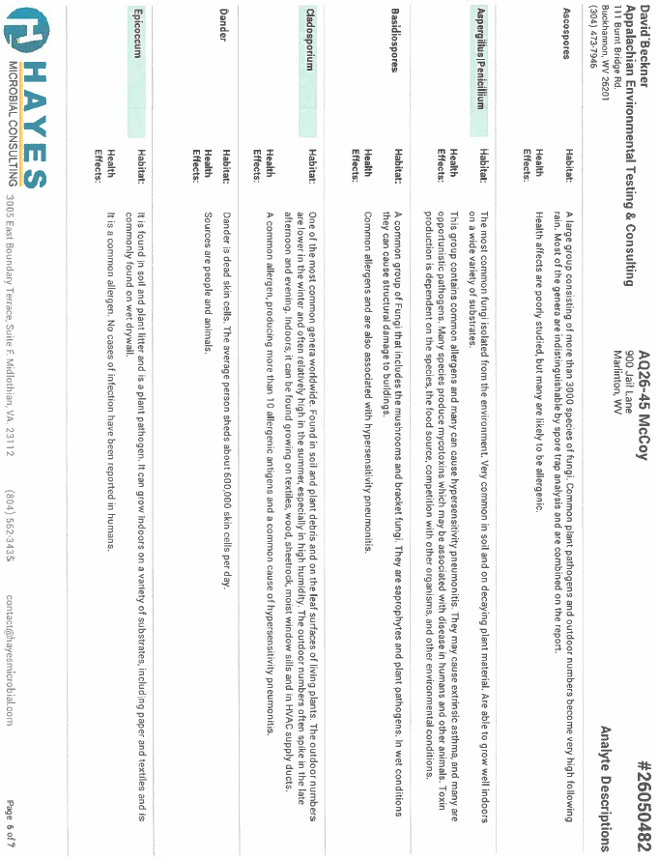
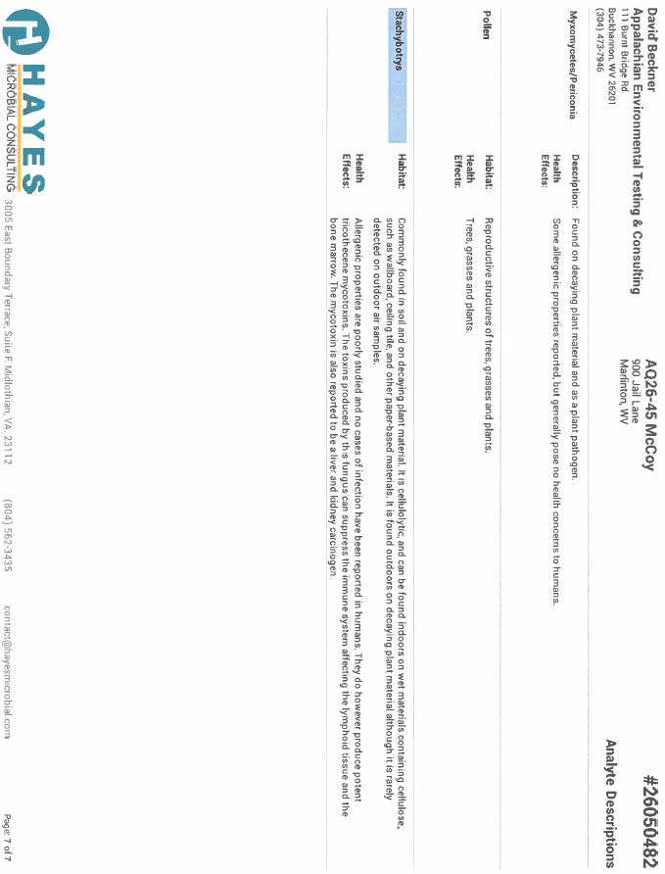
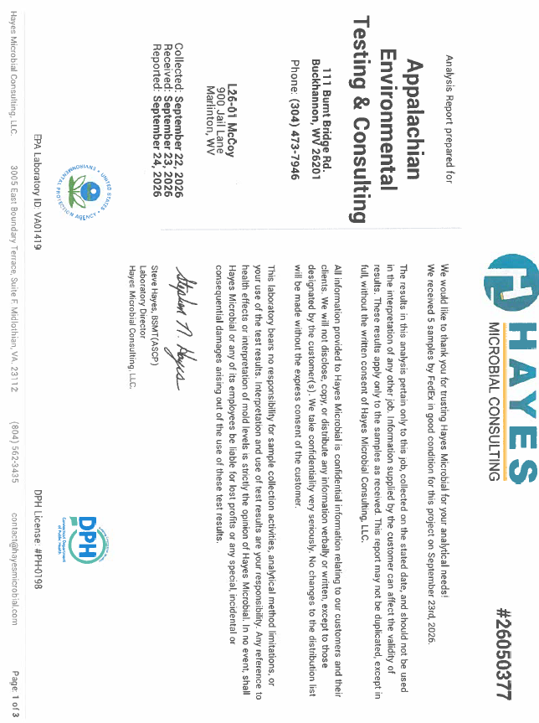

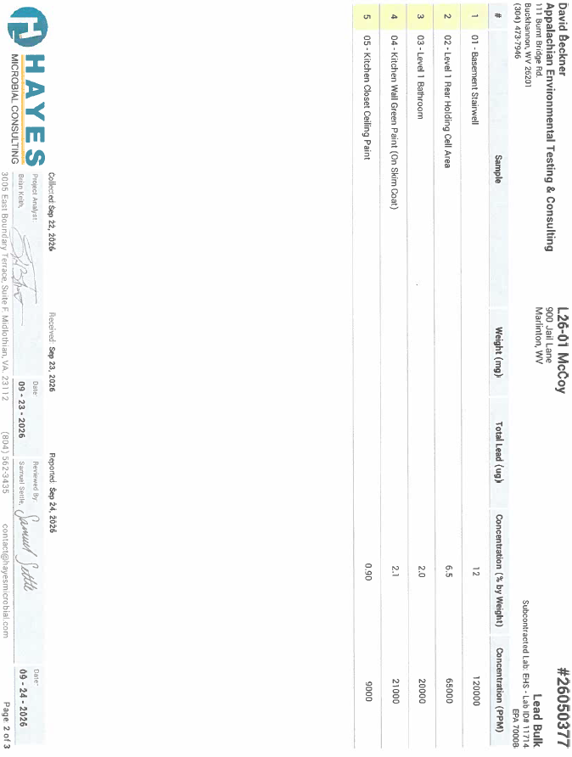
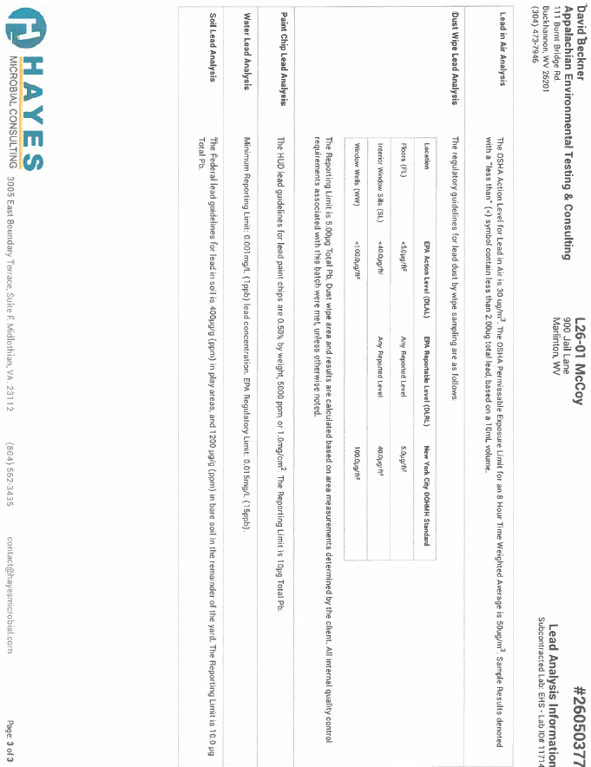

IN RE: INVOICES



ORDERED THIS MEETING BE ADJOURNED, SINE DIE.



