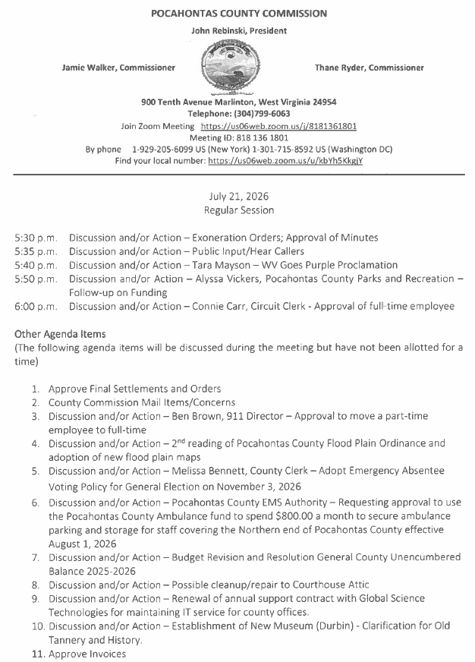

At a Regular Session of the Pocahontas County Commission held at the Courthouse situate in Marlinton, West Virginia, on the 21st day of July, 2026.

PRESENT: John Rebinski, President
Jamie Walker, Commissioner
Thane Ryder, Commissioner

Prior to the beginning of today’s session, the Commission invited all individuals in attendance to stand and recite the Pledge of Allegiance.

IN RE: EXONERATION/APPORTIONED ORDERS APPROVED

None

IN RE: MINUTES APPROVED

A motion was made by Commissioner Walker to approve the minutes of the last regular session of the Commission held on the 7th day of July, as presented, and noting no objections, motion carried.

IN RE: FINAL SETTLEMENTS AND ORDERS APPROVED

Commission President John Rebinski reviewed several final settlements and orders pertaining to estates as presented by the County Clerk’s Office and, thereafter, approved same by placing his signature thereto.

IN RE: COUNTY COMMISSION MAIL ITEMS/CONCERNS

Copy – Pocahontas County Sheriff Monthly Financial Statement June 2026

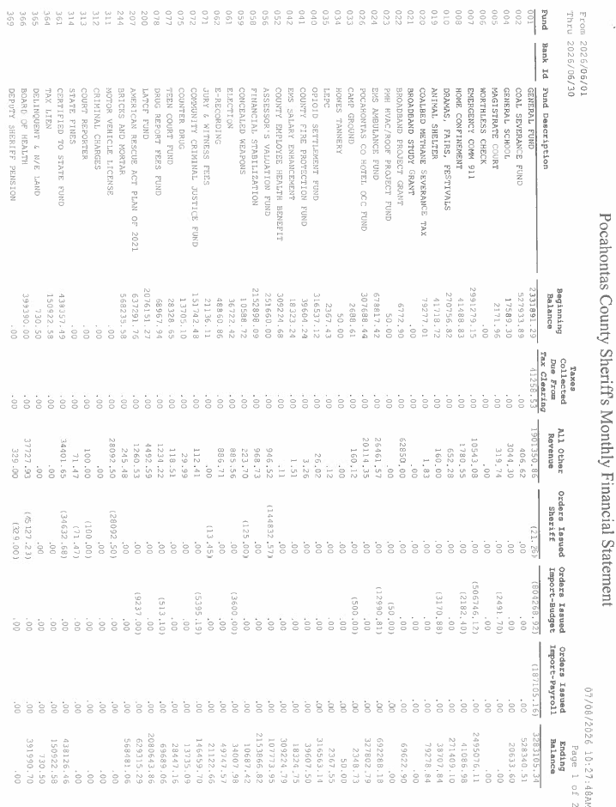

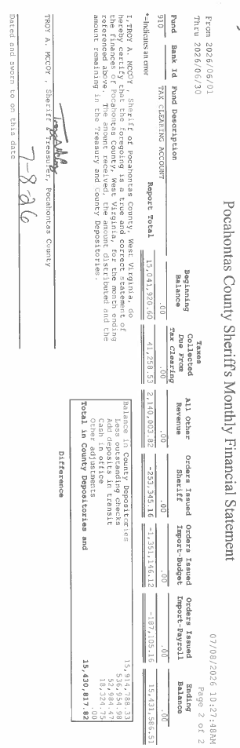

IN RE: BEN BROWN 911 DIRECTOR - APPROVAL TO MOVE A PART-TIME EMPLOYEE TO FULL-TIME

A motion was made by Commissioner Walker to move Austin Rider from part-time to full-time as 911 Dispatcher, at $15.00 per hour with full benefits, effective July 28, 2026, and noting no objections, motion carried.

IN RE: SIGN IN SHEET/HEAR CALLERS

None

IN RE: MELISSA BENNETT COUNTY CLERK - ADOPT EMERGENCY ABSENTEE VOTING POLICY FOR GENERAL ELECTIONS ON NOVEMBER 3, 2026

A motion was made by Commissioner Walker to adopt the following Emergency Absentee Voting Procedures Policy for the Pocahontas County General Election on November 3, 2026, and noting no objections, motion carried.
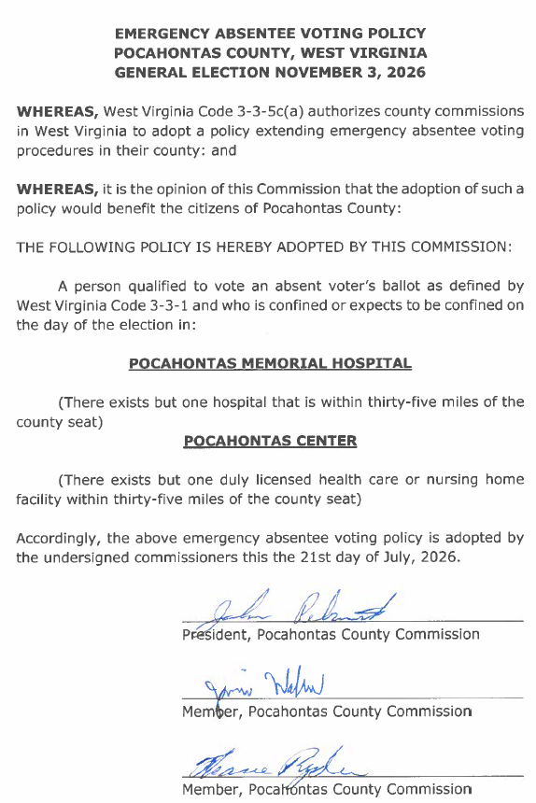

IN RE: TARA MAYSON – WV GOES PURPLE PROCLAMATION

A motion was made by Commissioner Ryder to approve the WV Goes Purple Proclamation, and noting no objections, motion carried.

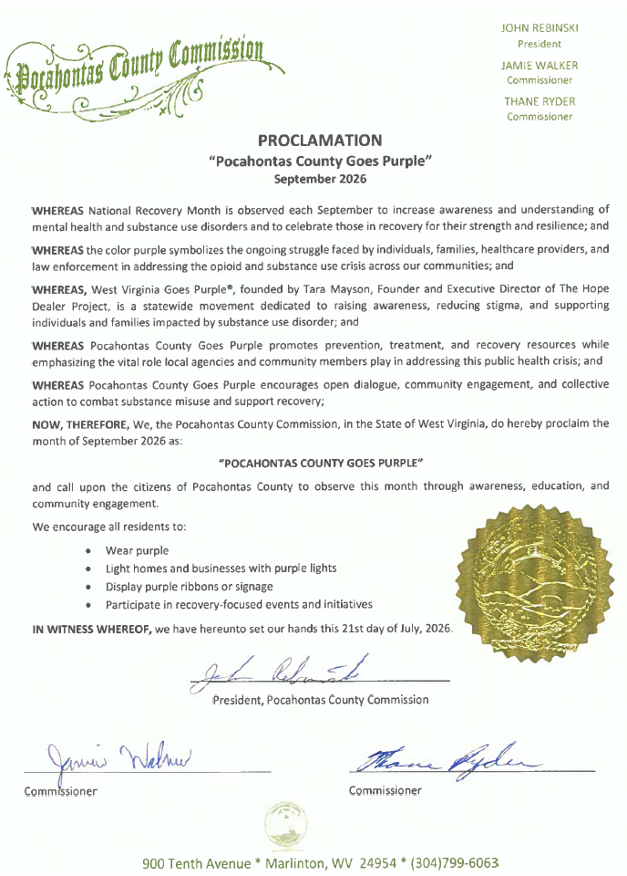

IN RE: POCAHONTAS COUNTY EMS AUTHORITY – REQUESTING APPROVAL TO USE THE POCAHONTAS COUNTY AMBULANCE FUND TO SPEND $800.00 A MONTH TO SECURE AMBULANCE PARKING AND STORAGE FOR STAFF COVERING THE NORTHERN END OF POCAHONTAS COUNTY EFFECTIVE AUGUST 1, 2026

A motion was made by Commissioner Walker seconded by Commissioner Ryder, to approve $400.00 per month to secure ambulance parking and storage for staff covering the Northern end of Pocahontas County effective August 1, 2026, and noting no objections, motion carried.

Commissioner Rebinski voted to oppose the approval.

IN RE: ALYSSA VICKERS POCAHONTAS COUNTY PARKS AND RECREATION FOLLOW-UP ON FUNDING

A motion was made by Commissioner Ryder to approve the Inspection quote of $2,750.00 from RDS for HVAC services for 3 units at the Parks and Recreation building, and noting no objections, motion carried. This agenda item was put on hold until the 6:00 P.M. agenda item could be addressed. After agenda Item #6, the commission advised Alyssa to obtain 2 to 3 estimates on a zero turn and push mower for use at Parks and Recreation, and add to the next scheduled agenda.

IN RE: CONNIE CARR CIRCUIT CLERK – APPROVAL OF FULL-TIME EMPLOYEE

At the request of Connie Carr, Circuit Clerk, a motion was made by Commissioner Walker to enter into executive session per #2A of the Open Meetings Act, and noting no objections motion carried.

A motion was made by Commissioner Walker to end executive session and a motion was made by Commissioner Walker to approve Ashley Moore as Deputy Circuit Clerk at $15.86 hour with full benefits, effective August 3, 2026, and noting no objections, motion carried.

IN RE: 2ND READING OF POCAHONTAS COUNTY FLOOD PLAIN ORDINANCE AND ADOPTION OF NEW FLOOD PLAIN MAPS

The commission asked for this agenda item to be put on the next scheduled agenda to let legal counsel to look over the ordinance. No action was taken on this matter.

IN RE: BUDGET REVISION AND RESOLUTION GENERAL COUNTY UNENCUMBERED BALANCES 2025-2026

A motion was made by Commissioner Ryder to approve the Budget Revision and Resolution for General County unencumbered balance 2025-2026, and noting no objections, motion carried.

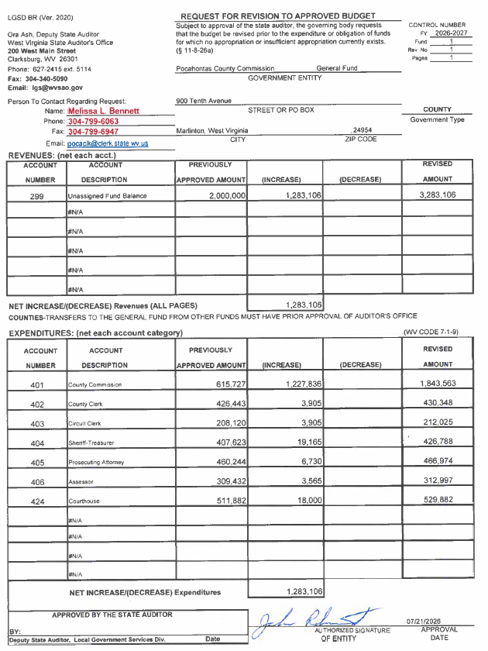
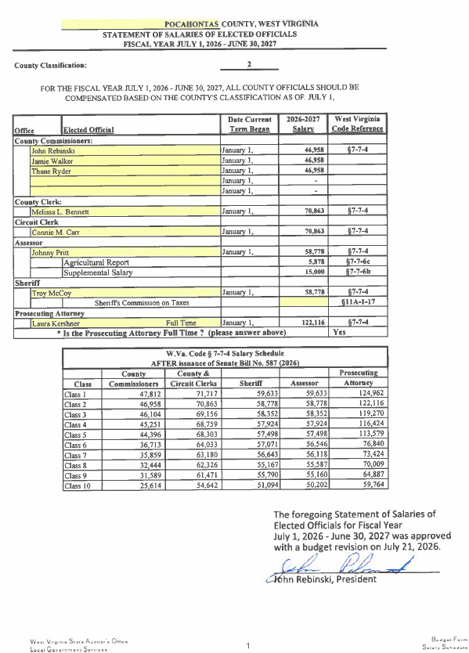

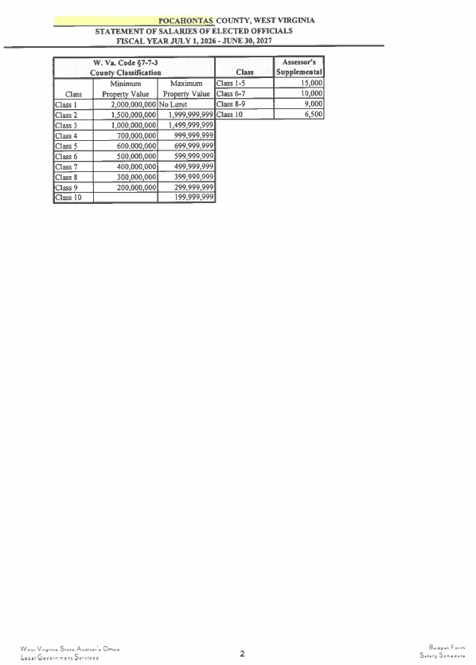

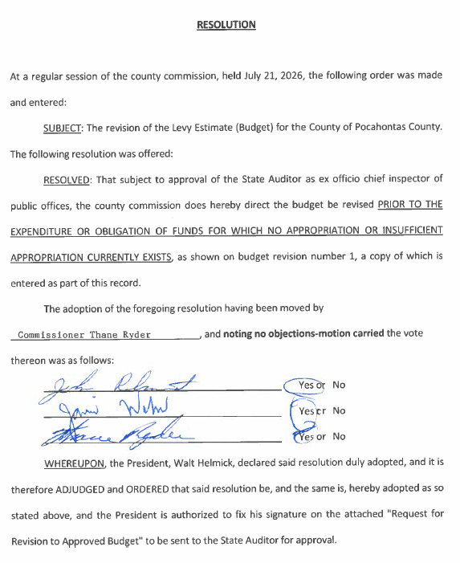

IN RE: POSSIBLE CLEANUP/REPAIR OF COURTHOUSE ATTIC

Commissioner Ryder will work on getting quotes on the cleaning and repairs of the courthouse attic. No action was taken on this matter.

IN RE: RENEWAL OF ANNUAL SUPPORT CONTRACT WITH GLOBAL SCIENCE TECHNOLOGIES FOR MAINTAINING IT SERVICE FOR COUNTY OFFICES

A motion was made by Commission Ryder to approve the renewal of annual support contract with Global Science Technologies for maintaining IT services for county offices, and noting no objections, motion carried.
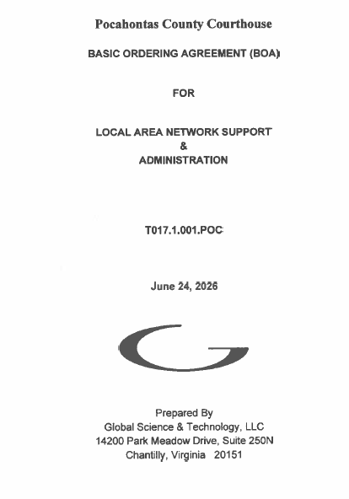
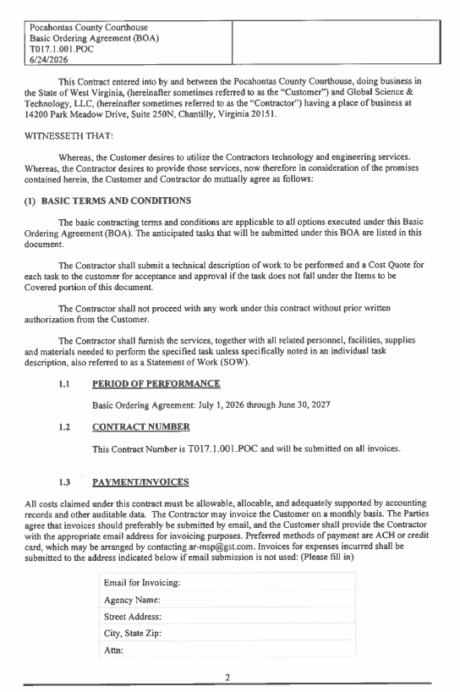
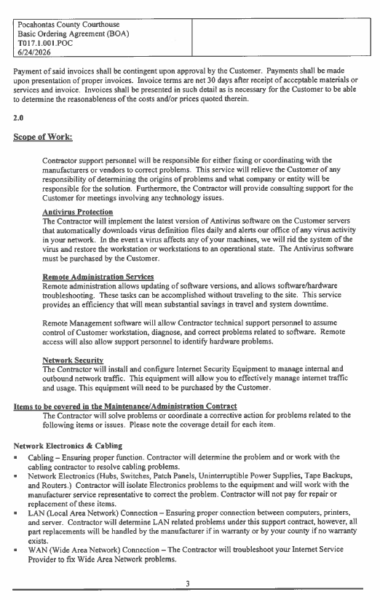
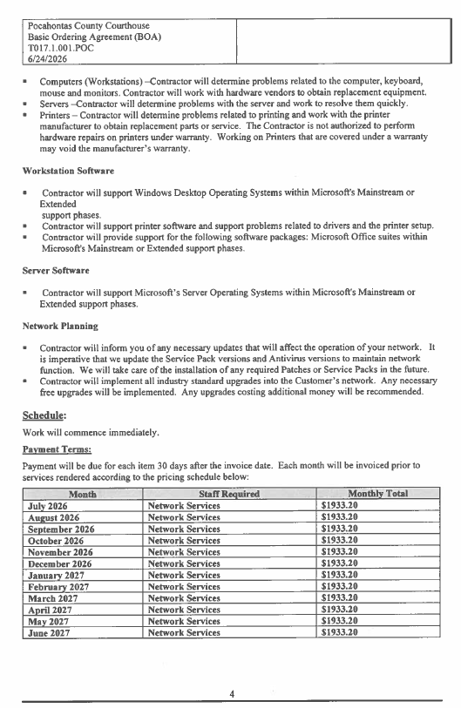
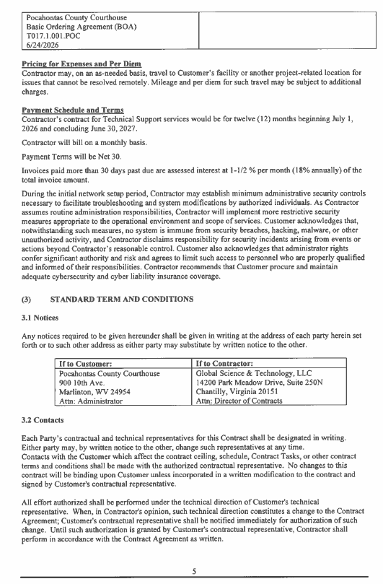
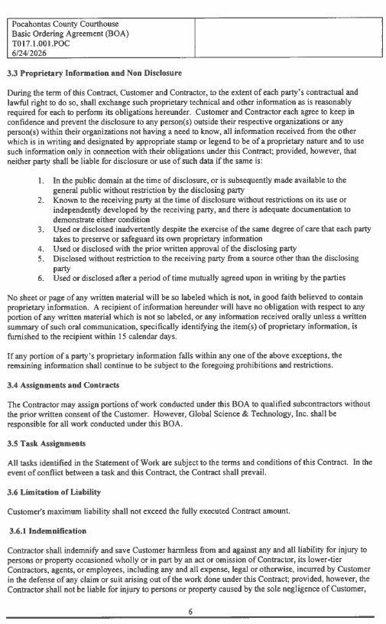
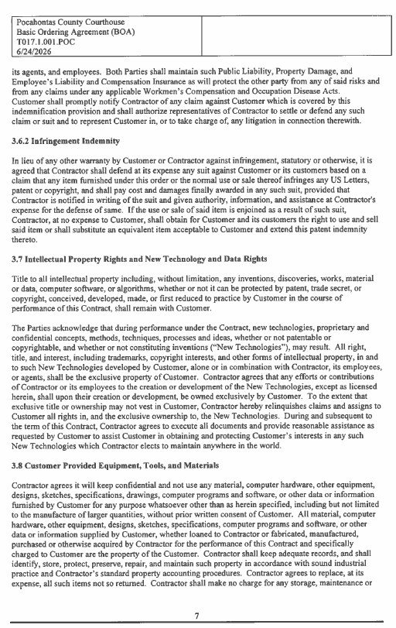
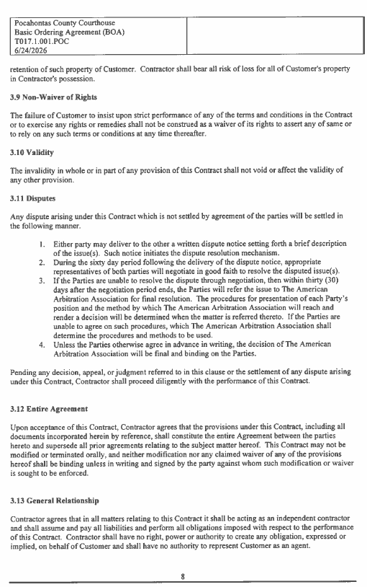

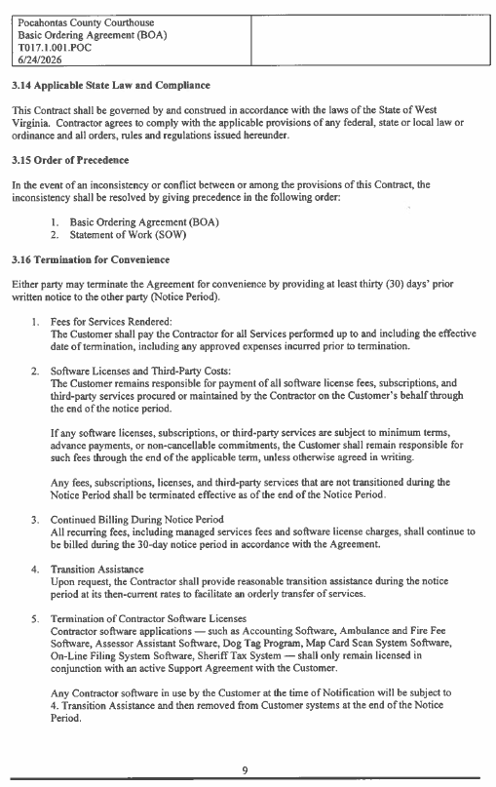
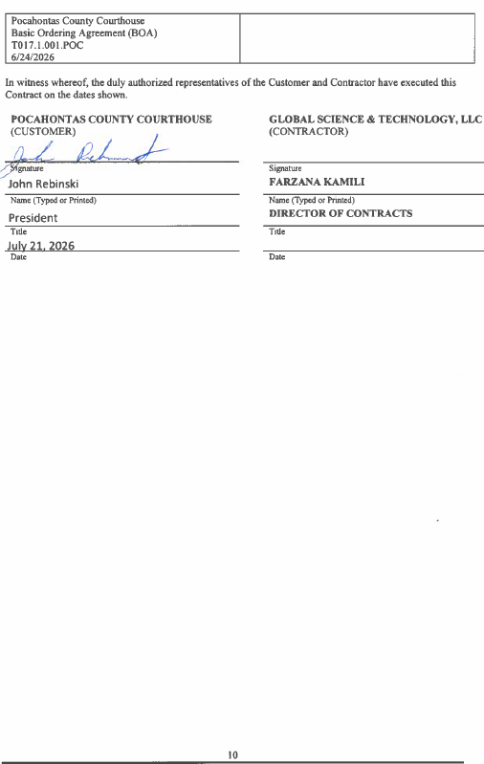

IN RE: ESTABLISHMENT OF NEW MUSEUM (DURBIN) – CLARIFICATION OF OLD TANNERY AND HISTORY

Commissioner Rebinski wanted to clarify that the museum purpose was to include the Tannery and Bruce Bosley exhibits. No action was taken on this matter.

IN RE: INVOICES

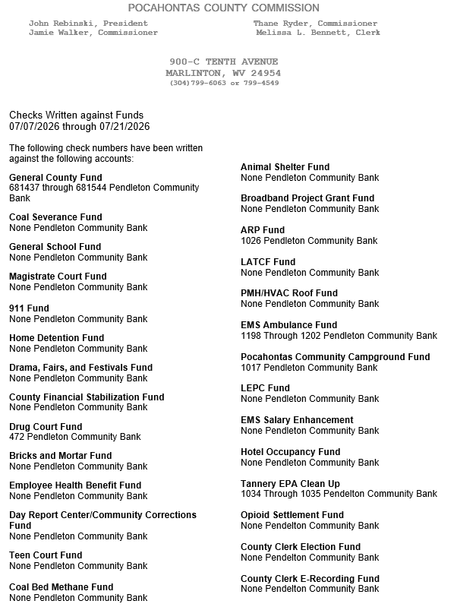

ORDERED THIS MEETING BE ADJOURNED, SINE DIE.

