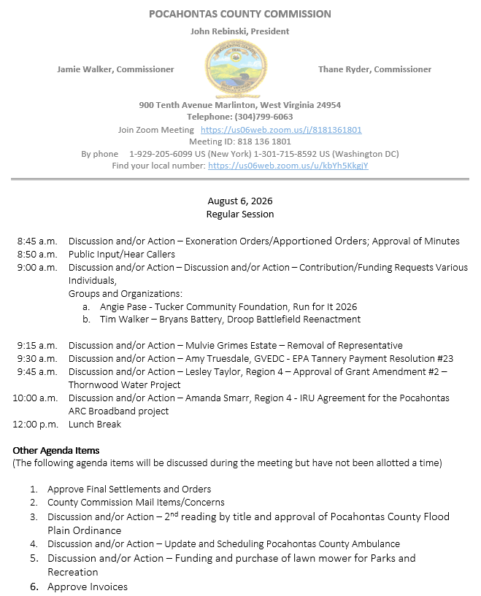

At a Regular Session of the Pocahontas County Commission held at the Courthouse situate in Marlinton, West Virginia, on the 6th day of August, 2026.

PRESENT: John Rebinski, President
Jamie Walker, Commissioner
Thane Ryder, Commissioner

Prior to the beginning of today’s session, the Commission invited all individuals in attendance to stand and recite the Pledge of Allegiance.

IN RE: EXONERATION/APPORTIONED ORDERS APPROVED

None

IN RE: MINUTES APPROVED

A motion was made by Commissioner Walker to approve the minutes of the last regular session of the Commission held on the 21st day of July, as presented, and noting no objections, motion carried.

IN RE: FINAL SETTLEMENTS AND ORDERS APPROVED

Commission President John Rebinski reviewed several final settlements and orders pertaining to estates as presented by the County Clerk’s Office and, thereafter, approved same by placing his signature thereto.

IN RE: COUNTY COMMISSION MAIL ITEMS/CONCERNS

Letter - Ethan Burgess – Rescind Termination
MTA Ridership – July 2025 – June 2026 Ridership Report
Copy – Shuman, McCuskey, Slicer PLLC - Pocahontas County PSD Service Area Notice Agreement
Letter – DEP - Nancy Harris Appointment Pocahontas County Solid Waste Authority
Copy – Preserving Pocahontas - Annual Accounting
Copy – Thompson & Litton – Engineer’s Field Report Pocahontas County ARC Broadband Project
Postcard – Country Roads Leasing LLC – Municipal Lease – Purchase Financing

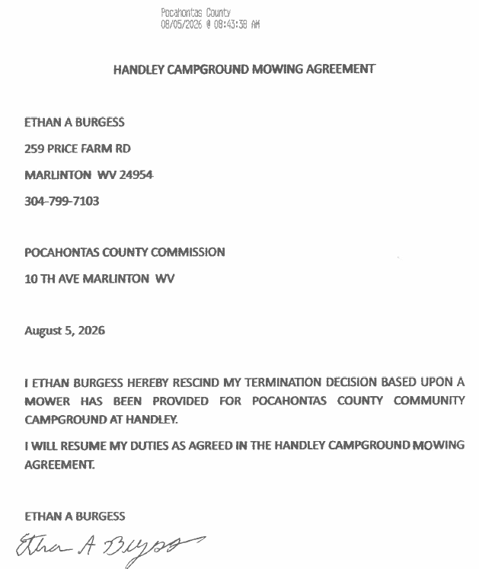

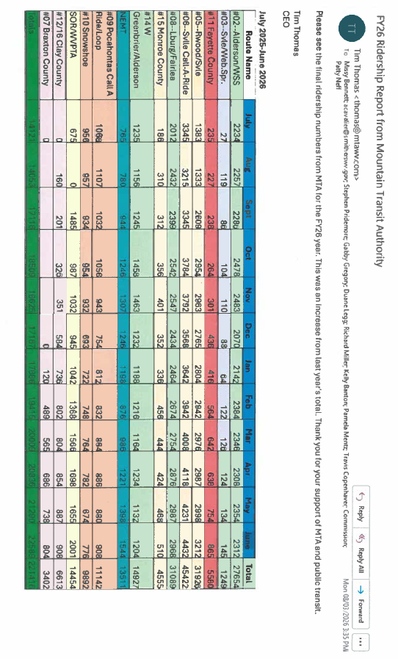
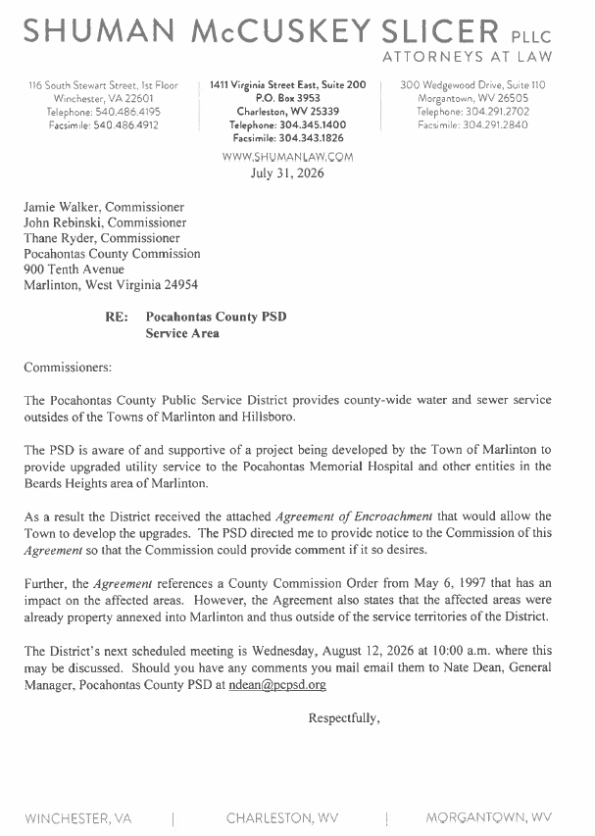

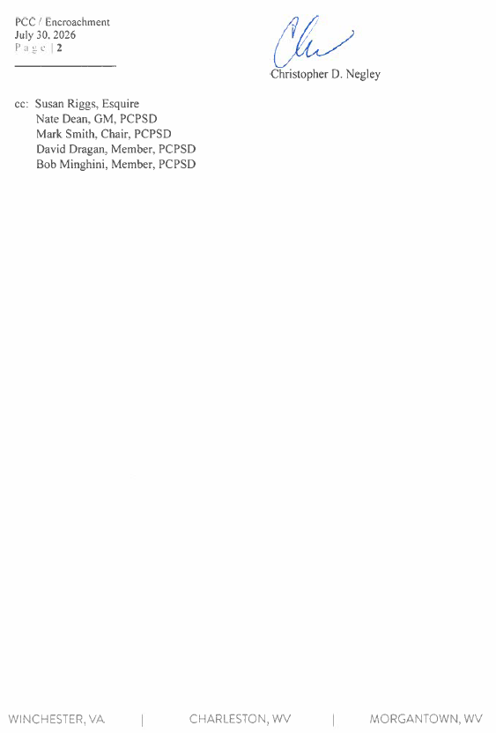
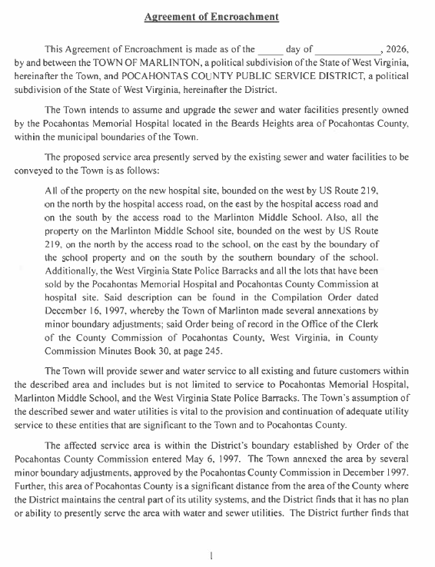

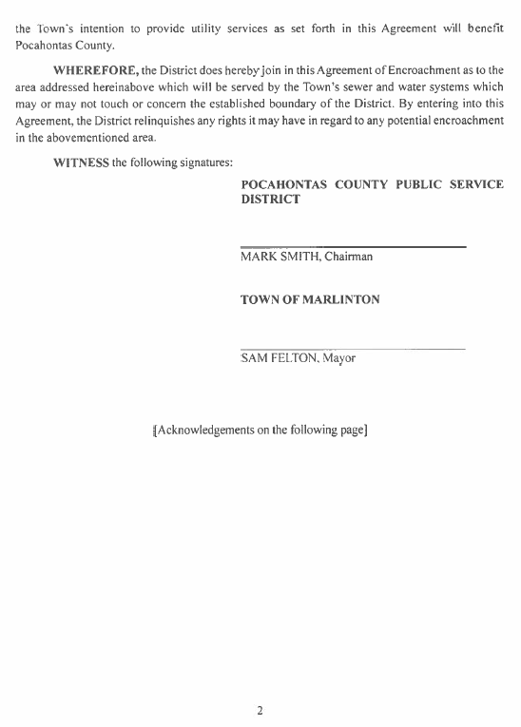
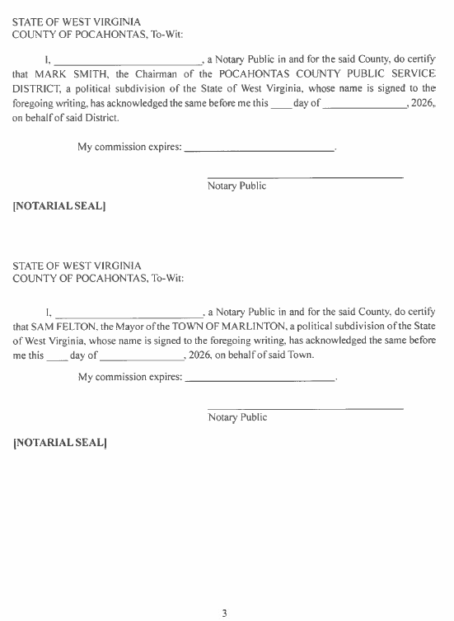

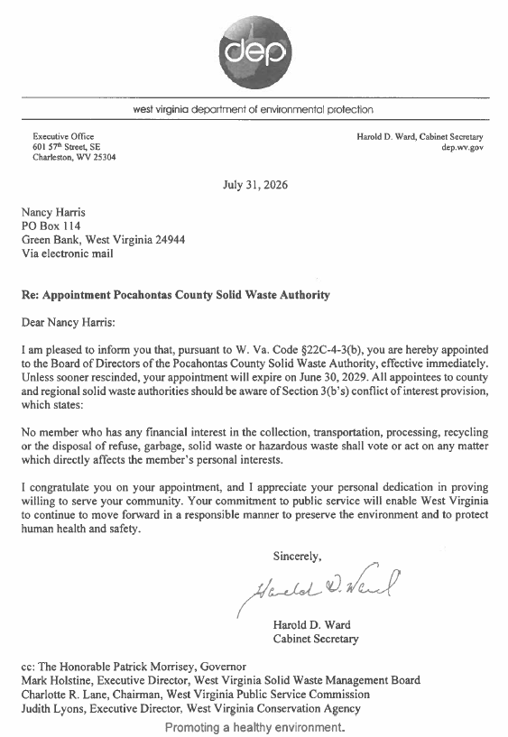
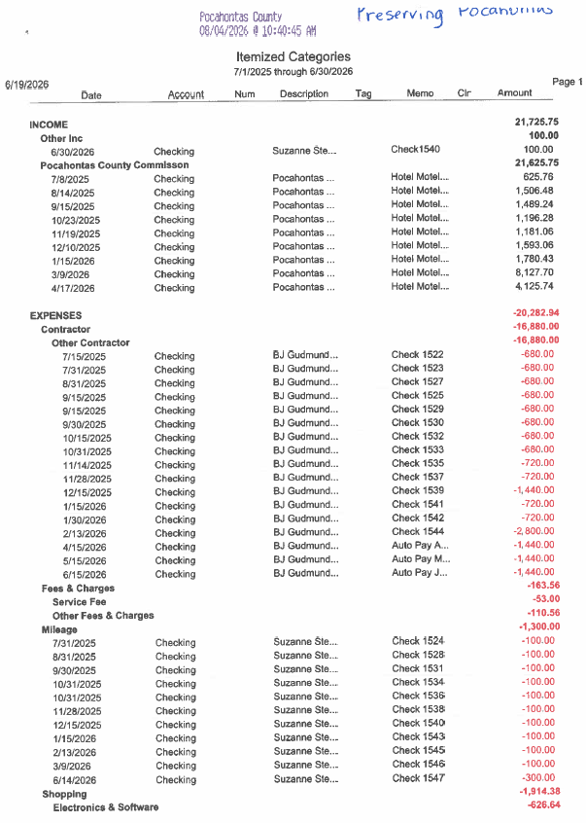
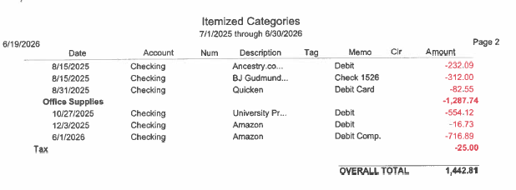

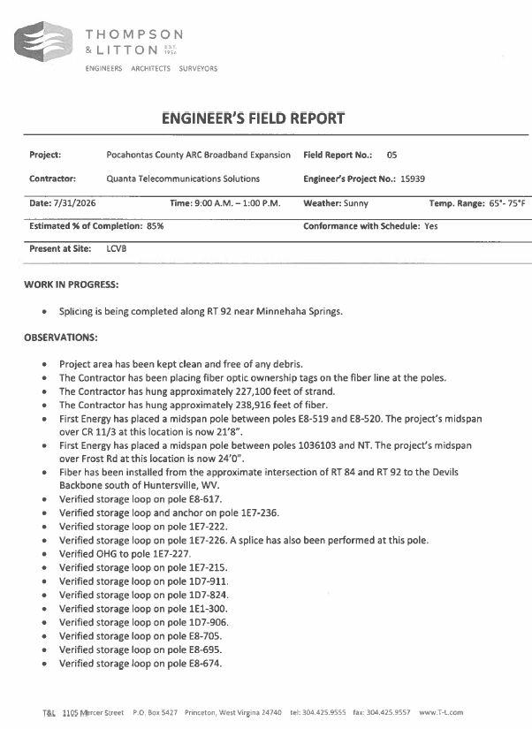
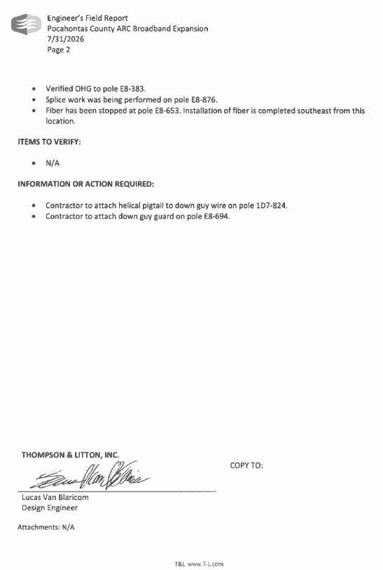

IN RE: SIGN IN SHEET/HEAR CALLERS

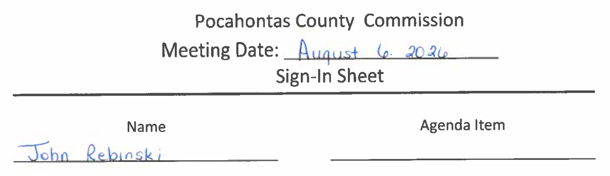
John Rebinski wanted to address overtime for the Sheriff’s Security and the evening meetings at the Courthouse.

John Rebinski wanted to address the Health Department moving and the possibility of the Sheriff’s Deputies or the County Clerk’s voting machines moving to the vacant space.
IN RE: DISCUSSION AND/OR ACTION – DISCUSSION AND/OR ACTION – CONTRIBUTION/FUNDING REQUESTS VARIOUS INDIVIDUALS,
GROUPS AND ORGANIZATIONS:

- ANGIE PASE - TUCKER COMMUNITY FOUNDATION, RUN FOR IT 2026
- TIM WALKER – BRYANS BATTERY, DROOP BATTLEFIELD REENACTMENT

A motion was made by Commissioner Walker to approve the contribution request for $2,500.00 presented by Angie Pase, to the Tucker Community Foundation, Run For It, and noting no objections, motion carried.

A motion was made by Commissioner Ryder to approve the contribution request for $2,500.00 presented by Tim Waker to Bryans Battery Droop Battlefield Reenactment, and noting no objections, motion carried.

IN RE: MULVIE GRIMES ESTATE – REMOVAL OF REPRESENTATIVE

A motion was made by Commissioner Walker to appoint Shelly Giles, Natalie Swanson Jennings and Glenna Grimes as representatives to the Mulvie Grimes estate and remove the Sheriff of Pocahontas County as representative, and noting no objections, motion carried.
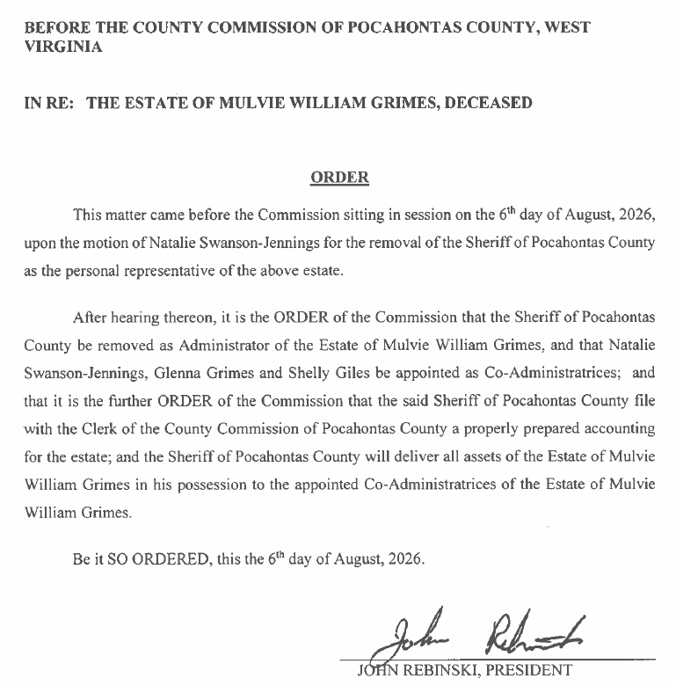

IN RE: AMY TRUESDALE, GVEDC - EPA TANNERY PAYMENT RESOLUTION #23

A motion was made by Commissioner Ryder to approve the EPA Tannery Payment Resolution #23, and noting no objections, motion carried.

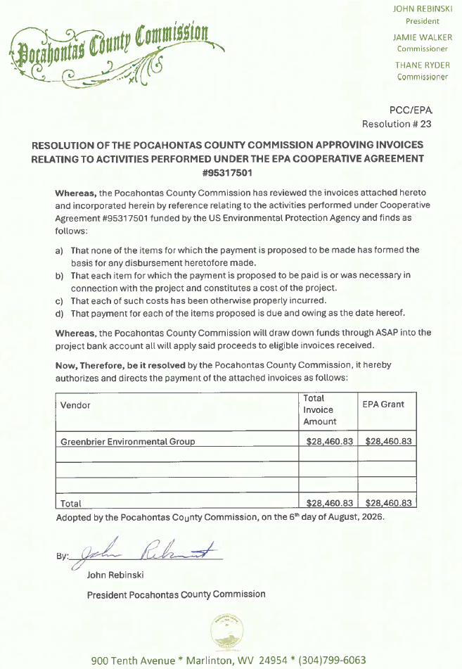
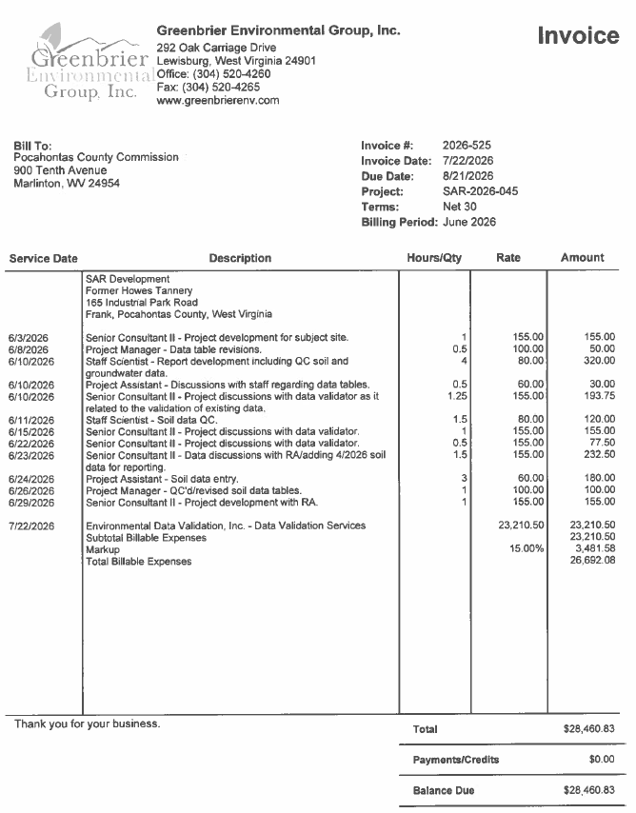

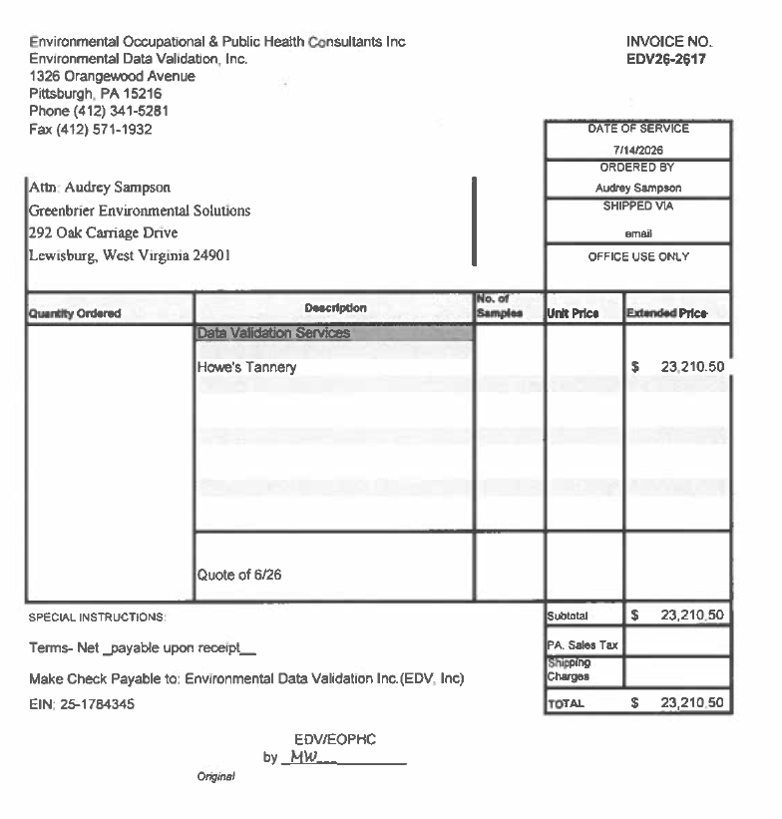
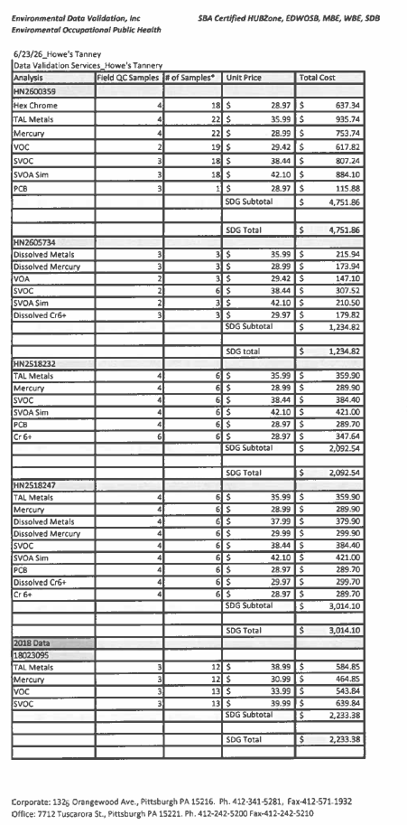

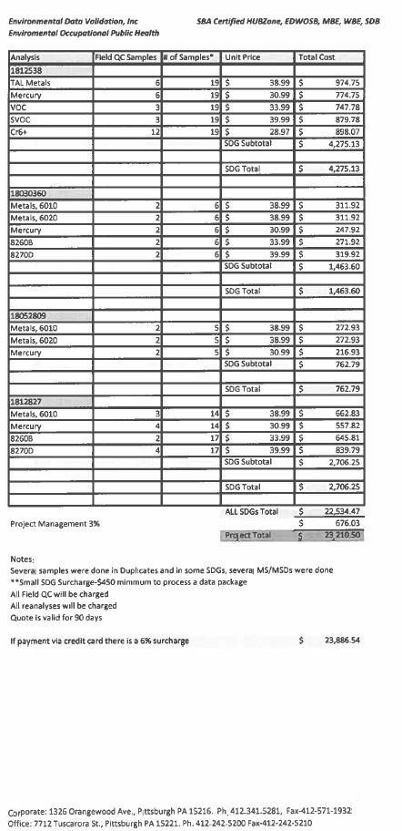
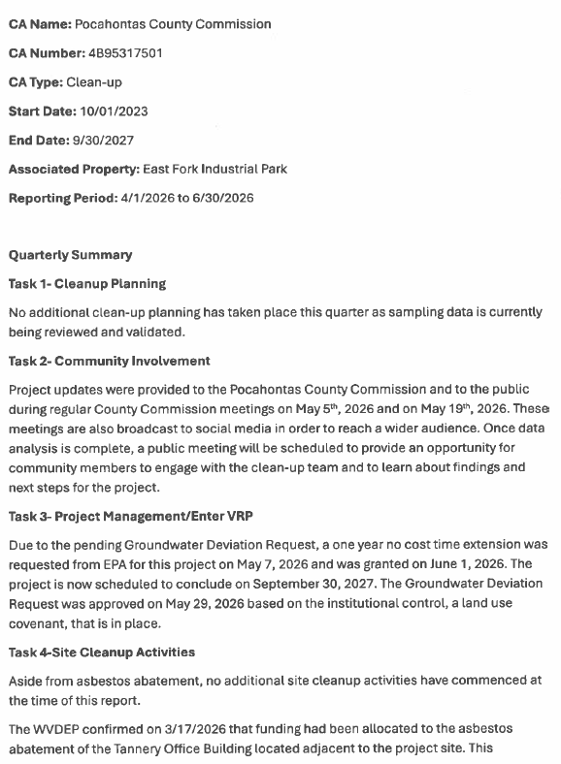
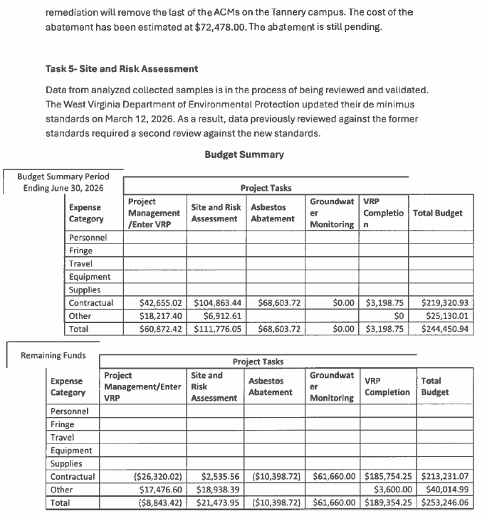

IN RE: LESLEY TAYLOR, REGION 4 – APPROVAL OF GRANT AMENDMENT #2 – THORNWOOD WATER PROJECT

A motion was made by Commissioner Ryder to approve Grant Amendment #2 for the Thornwood Water Project, and noting no objections, motion carried.
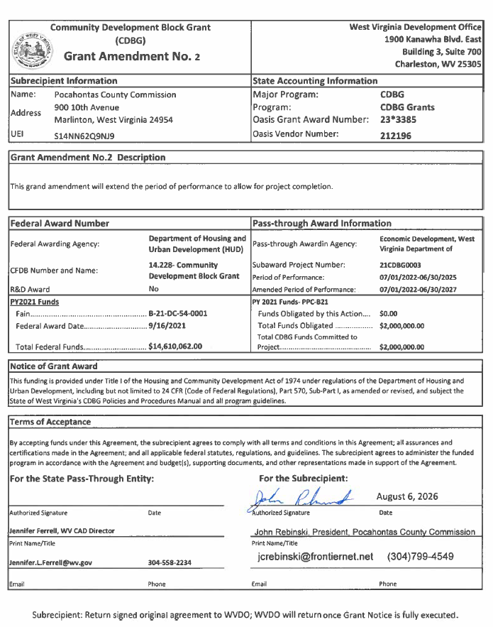

IN RE: 2ND READING OF POCAHONTAS COUNTY FLOODPLAIN ORDINANCE AND ADOPTION OF NEW FLOODPLAIN MAPS

A motion was made by Commissioner Walker to approve the 2nd reading of the Pocahontas County Floodplain Ordinance and the adoption of the New Flood Plain Maps, and noting no objections, motion carried.

Pocahontas County
Floodplain Ordinance
2026

AN ORDINANCE ESTABLISHING THAT A FLOODPLAIN EXISTS AND REQUIRING ALL CONTRACTORS, PERSONS, PARTNERSHIPS, BUSINESSES, AND CORPORATIONS TO OBTAIN A PERMIT FOR DEVELOPMENT AND THE CONSTRUCTION, SUBSTANTIAL IMPROVEMENT, OR RELOCATION OF ANY BUILDING OR STRUCTURE; PROVIDING FOR CERTAIN MINIMUM STANDARDS FOR CONSTRUCTION WITHIN THE FLOODPLAIN AREA AND SETTING FORTH SPECIAL PROCEDURES FOR SUBMISSION AND APPROVAL OF PLANS; AND ESTABLISHING PENALTIES FOR ANY PERSON WHO FAILS TO COMPLY WITH THE REQUIREMENTS OR PROVISIONS OF THIS ORDINANCE.

AUTHORITY AND PURPOSE:

THE PROVISIONS OF THIS ORDINANCE HAVE BEEN PREPARED WITH THE INTENTION OF MEETING THE REQUIREMENTS OF SECTION 60.3 (d) OF THE NATIONAL FLOOD INSURANCE PROGRAM, THE NATIONAL FLOODPLAIN INSURANCE ACT OF 1968 (PUBLIC LAW 91-152) AMENDED BY THE CONGRESS OF THE UNITED STATES THROUGH THE 15TH OF FEBRUARY 1975, WEST VIRGINIA CODE 8-12-14, §7-1-3v, 7-1-3n and 7-1-3kk.

BE IT ENACTED AND ORDAINED by the Pocahontas County Commission on the 6th day of August, 2026 as follows:

ARTICLE 1 – GENERAL PROVISIONS

Section 1.1 Intent

The intent of this Ordinance is to:

- Promote the general health, welfare and safety of the Community.

- Encourage the utilization of appropriate minimum construction practices in order to prevent or minimize flooding damage.

- Minimize danger to public health and safety by protecting the water supply and sanitary sewage disposal in cooperation with the County Sanitarian, and to protect natural drainage.

- Assure the County Assessor obtains information concerning improvement of real property as required by WV Code §11-3-3a.

- Assure all County E-911 addresses are obtained and kept current to maintain the established emergency response dispatch systems.

- Reduce financial burdens imposed on the residents, real property owners and its governmental units by preventing the unwise design and construction of development in areas subject to flooding.

Section 1.2 Abrogation and Greater Restrictions

This ordinance supersedes any other conflicting provisions which may be in effect in identified floodplain areas. However, any other ordinance provisions shall remain in full force and effect to the extent that those provisions are more restrictive. If there is any conflict between any of the provisions of this Ordinance, the more restrictive shall apply.

Section 1.3 Applicability

It shall be unlawful for any contractor, person, partnership, business, or corporation to undertake or cause to be undertaken, any development, new construction, substantial improvement, repair of substantial damage, other repairs, or the placement or relocation of any structure (including manufactured homes) in the Special Flood Hazard Area within the Pocahontas County unless a floodplain determination has been made from the Floodplain Administrator, a floodplain permit application has been completed and a permit has been obtained from the Floodplain Administrator. In addition, where land is partially or fully in the Floodplain is to be developed, subdivided, utilized for a manufactured home park or subdivision or otherwise developed, a site plan with elevation data must be submitted to, and approved by, the Floodplain Administrator prior to any development.

Provision of all other codes, ordinances, and regulations shall be applicable insofar as they are consistent with the provisions of this Ordinance and the County’s need to minimize the hazards and damage resulting from flooding.

Section 1.4 Matters not provided for specifically

Where conditions are encountered that are not specifically provided for herein, the Floodplain Administrator shall determine the applicability of the provisions of this Ordinance in accordance with its intent and shall require the applicant to take appropriate measures pursuant to such determination.

ARTICLE II - INTERPRETATIONS AND DEFINITIONS

Section 2.1 Definitions

General

Unless specifically defined below, words and phrases used in this Ordinance shall be interpreted so as to give this Ordinance its most reasonable application.

- “Adjacent Property”

Adjacent Property includes any surface tract, regardless of whether such surface tract is entirely within the Pocahontas County, so long as a portion of said surface tract is located within the county, which shares an immediate and common boundary up or down stream to the property that is the subject of the application for Floodplain Permit. Adjacent property also includes all other property that may be affected by flooding.

- Advisory Flood Height
The water surface elevation (WSEL), in feet, of the 1% annual chance (100-year) flood at a given location, as determined using hydrology and hydraulics (H&H) analysis and the best available elevation data.

- “Adversely Affect Adjacent Properties”

To adversely affect a property the increase in the elevation of the 100-year base flood elevation must be more than 1 foot at any point. Stated conversely, if the effect is that the 100-year flood base flood elevation rises 1 foot or less the property is not “affected”. This standard does not apply to the Floodway. If prior permit(s) has/have been approved in the same area of the Floodplain, the above definition would include the cumulative impact to the base flood elevation.

- Appurtenant Structure

A secondary structure on the same parcel of property as the principal structure, the use of which is incidental and shall not be habitable but shall be used only for storage in association with the principal structure on said property. This does not include a gas or liquid storage tank.

- Base Flood

Means the flood having a one percent (1%) chance of being equaled or exceeded in any given year.

- Base Flood Elevation (BFE)

The water surface elevation of the base flood in relation to the datum specified on the County’s Flood Insurance Rate Map. For the purposes of this Ordinance, the one hundred (100) year flood or 1% or greater chance of flooding in any given year. (See 100-year flood also)

- Basement

Any area of the building having its floor sub grade (below ground level) on all sides.

- Certificate of Compliance

A certification that the entire development, including the elevation of fill or the lowest floor of a structure is in compliance with all the provisions of this Ordinance.

- Compensatory storage

An artificially excavated, hydraulically equivalent volume of storage within the special flood hazard area used to balance the loss of natural flood storage when artificial fill or structures are placed within the special flood hazard area.

- Contractor – W.Va. Code §21-11-3(c)

A person who in any capacity for compensation, other than as an employee of another, undertakes, offers to undertake, purports to have the capacity to undertake, or submits a bid to construct, alter, repair, add to, subtract from, improve, move, wreck or demolish any building, highway, road, railroad, structure or excavation associated with a project, development or improvement, or to do any part thereof, including the erection of scaffolding or other structures or works in connection therewith, where the cost of undertaking is two thousand five hundred dollars or more. Contractor includes a construction manager who performs management and counseling services on a construction project for a professional fee.

Contractor does not include:

a. One who merely furnishes materials or supplies without fabricating or consuming them in the construction project;

b. A person who personally performs construction work on the site of real property which the person owns or leases whether for commercial or residential purposes;

c. A person who is licensed or registered as a professional and who functions under the control of any other licensing or regulatory board, whose primary business is real estate sales, appraisal, development, management and maintenance, who acting in his respective professional capacity and any employee of such professional, acting in the course of his employment, performs any work which may be considered to be performing contracting work;

d. A pest control operator licensed under the provisions of W.Va. Code §19-16A-7(a) to engage in the application of pesticides for hire, unless the operator also performs structural repairs exceeding one thousand dollars on property treated for insect pests; or

e. A corporation, limited liability corporation, partnership or sole proprietorship whose primary purpose is to prepare construction plans and specifications used by the contractors defined in this section and who employs a full-time registered architect licensed to practice in this State or a registered professional engineer licensed to practice in this State. Contractor also does not include employees of such corporation, partnership or sole proprietorship.

- Critical Facility

Any facility in which even a slight chance of flooding is too great a threat.

Typical critical facilities include hospitals, fire stations, police stations, storage of critical records, and similar facilities. These should be given special consideration when formulating regulatory alternatives and floodplain management plans. A critical facility should not be located in a special flood hazard area if at all possible. If a critical facility must be located in a special flood hazard area it should be provided a higher level of protection so that it can continue to function and provide services during a flood.

- Development

Any man-made change to improved or unimproved real property, including but not limited to buildings or other structure, mining, dredging, filling, grading, paving, excavation or drilling operations, oil/gas well sites, pads, pits, retention ponds or storage of equipment or materials.

- Flood

A general and temporary inundation of water in an area of normally dry land.

- Flood Insurance Rate Map (FIRM)

The official map on which the Federal Emergency Management Agency has delineated both the special flood hazard areas and the risk premium zones applicable to Pocahontas County. A FIRM that has been made available digitally is called a Digital Flood Insurance Rate Map (DFIRM).
.
- Flood Insurance Study

The official report in which the Federal Emergency Management Agency has provided flood profiles, floodway information, and water surface elevations.

- Floodplain

- A relatively flat or low land area adjoining a river, stream, or watercourse which is subject to partial or complete inundation;

- An area subject to the unusual and rapid accumulation or runoff of surface waters from any source.
- Floodplain Administrator

The Floodplain Administrator shall be a resident of West Virginia and/or a person who has completed within one year of his appointment the State/FEMA sponsored NFIP Class 273 entitled “Managing Floodplain Development” and remain current with State required continuing education training pursuant to W.Va. Code § 15-5-20(a). In the absence of a formally appointed Floodplain Administrator the duties set forth in this Ordinance for the Floodplain Administrator shall be temporarily fulfilled by the President of the County Commission if within the County’s jurisdiction or the mayor.

- Floodway

The channel of a river or other watercourse and the adjacent land area that must be reserved to discharge the base flood without increasing the water surface elevation of that flood more than one foot at any point.

- Flood Proofing (NON-RESIDENTIAL ONLY)

Any combination of structural and non-structural additions, changes or adjustments to structures which reduce or eliminate flood damage to real property or improved real property, water and sanitary facilities, structures and its contents.

- Freeboard

A factor of safety usually expressed in feet above a flood level or BFE for purposes of floodplain management. Freeboard tends to compensate for unknown factors that may contribute uncertainty to flood heights of any given flood and floodway condition, such as wave action, blockage at stream crossings, and increased runoff from urbanization of the watershed.

- Highest Adjacent Grade (HAG)

The highest natural elevation of the ground surface immediately adjacent to the development or structure foundation. This is primarily used for purposes of insurance rating in approximated floodplains.

- Historic Structure

Any structure that is:

- Listed individually in the National Register of Historic Places (a listing maintained by the Department of Interior) or preliminarily determined by the Secretary of the Interior as meeting the requirements for individual listing in the National Register;

- Certified or preliminarily determined by the Secretary of Interior as contributing to the historical significance of a registered historic district or a district preliminarily determined by the Secretary to qualify as a registered historic district;

- Individually listed on a state inventory of historic places in states with historic preservation programs which have been approved by the Secretary of the Interior; or,

- Individually listed on a local inventory of historic places in communities with historic preservation programs that have been certified either:

- By an approved state program as determined by the Secretary of the Interior; or,
- Directly by the Secretary of Interior in states without approved programs.

- Interested Person or Party

“Interested Person or Party” to include (1) the applicant; (2) the owner(s) of the subject property; (3) at least one adult residing in any residence on the subject property at the time the Floodplain Permit Application is filed; (4) owners of any adjacent property; and (5) at least one adult residing in any residence on the adjacent property at the time the Floodplain Permit Application is filed.

- Licensed Manufactured Home Dealer

A business licensed to sell manufactured homes in the State of West Virginia as set forth in the West Virginia Code.

- Licensed Manufactured Home Installer

A contractor licensed to install manufactured homes in the State of West Virginia as set forth in the West Virginia Code.

- Licensed Professional Surveyor

Any person licensed by the West Virginia State Board of Examiners of Land Surveyors to engage in the practice of land surveying as defined in the West Virginia Code.

- Lowest Adjacent Grade (LAG)

Lowest natural elevation of the ground surface immediately adjacent to the proposed development or structure foundation. The primary use of the LAG is to determine whether the structure is located within a special flood hazard area by comparing it to the base flood elevation.

- Lowest Floor

The lowest floor of the lowest enclosed area (including basement). An unfinished enclosure constructed with flood resistant materials as defined in FEMA Technical Bulletin 2-93 (FIA-TB-2) and usable solely for parking of vehicles, building access or storage in an area other than a basement area is not considered a building’s lowest floor; Provided, that such enclosure has proper flood openings and is not built so as to render the structure in violation of the applicable non-elevation design requirements of this Ordinance.

- Manufactured Home

A structure, transportable in one or more sections, which is built on a permanent chassis and is designed for use with or without a permanent foundation when connected to the required utilities. The term “manufactured home” does not include a “recreational vehicle”.

- New Construction

Structures for which the start of construction as herein defined commenced on or after October 17, 1989 and including any subsequent improvements to such structures

- One-Hundred (100) Year Flood

A flood that has one chance in one hundred or a one percent or greater chance of being equaled or exceeded in any given year. (See Base Flood Elevation also)

- Person

Any individual or group of individuals, corporation, limited liability corporation, partnership, association or other entity, including State and Local governments and agencies.

- Practice of Engineering

Any service or creative work, as described in West Virginia Code §30-13-1 et seq., the adequate performance of which requires engineering education, training and experience in the application of special knowledge of the mathematical, physical, and engineering sciences to such services or creative work as consultation, investigation, evaluation, planning and design of engineering works and systems; planning the use of land and water; teaching of advanced engineering subjects, engineering surveys and studies; and the review of construction for the purpose of assuring compliance with drawings and specifications any of which embraces such services or work, either public or private, in connection with any utilities, structures, buildings, machines, equipment, processes, work systems, projects and industrial or consumer products or equipment of a mechanical, electrical, hydraulic, pneumatic or thermal nature, insofar as they involve safeguarding life, health or property, and including such other professional services as may be necessary to the planning, progress and completion of any engineering services. Engineering surveys include all survey activities required to support the sound conception, planning, design, construction, maintenance and operation of engineered projects.

Any person who practices any branch of the profession of engineering or who, by verbal claim, sign, advertisement, letterhead, card or in any other way represents himself to be a Registered Professional Engineer, or by using another title implies that he is a Registered Professional Engineer or that he is registered under West Virginia Code, §30-13-1 et seq. or who holds himself out as able to perform, or who performs any engineering service or work or any other service designated by the practitioner which is recognized as engineering, is considered to practice or offer to practice engineering within the meaning and intent of West Virginia Code §30-13-1 et seq.

- Principally Above Ground

Where at least 51 percent of the Actual Cash Value of a structure, less land value, is above ground. [44 Code of Federal Regulations §59.1]

- Professional

Any “professional” including but not limited to a “contractor”, “developer”, “engineer”, “architect”, “hydrologist”, “land surveyor”, etc., acting in any capacity with respect to this Ordinance, must be licensed by the State of West Virginia, when certification or licensure from the State of West Virginia is so required.

- Reasonably Safe from Flooding

Means that during the base flood, or any other known flooding by the Floodplain Administrator, water should not damage structures and any subsurface waters related to the base flood and should not damage existing or proposed structures. Ways of determining Reasonably Safe from Flooding may be 3 feet above Highest Adjacent Grade, above high-water marks from historic flooding, using topographic extrapolation from contour lines or utilizing the advisory flood height data on the WV Flood Tool.

- Recreational Vehicle

A vehicle which is:

- built on a single chassis;
- 400 square feet or less when measured at the largest horizontal projection;
- Designated to be self-propelled or permanently towable by a light duty truck. and
- Designed primarily not for use as a permanent dwelling but as temporary living quarters for recreational, camping, travel, or seasonal use.

- Registered Professional Engineer

A person who has been duly registered or licensed as a registered professional engineer by the West Virginia State Board of Registration for Professional Engineers as required by W.Va. Code §30-13-13 et seq.

- Remedy a Violation

To bring a structure or other development into compliance with the requirements of this Ordinance, or if full compliance is not possible, to reduce the adverse impact of the non-compliance to the greatest extent feasible.

- Special Flood Hazard Area

The land in the Floodplain Area subject to a one percent or greater chance of flooding in any given year. Special flood hazard areas are designated by the Federal Emergency Management Agency in Flood Insurance Studies and on Flood Insurance Rate Maps as Zones A, AE, AO, A1-30, and A99. The term includes areas shown on other flood hazard maps that are specifically listed or otherwise described in this Ordinance.

- Start of Construction

(The definition for start of construction is to be used only when calculating the starting time for expiration of a Floodplain Permit.)

The date the Floodplain Permit was issued, including Floodplain Permit for substantial improvement or repair of substantial damage provided the actual start of construction, repair, reconstruction, rehabilitation, addition, placement or other improvement was within 180 days of the Floodplain Permit date. The actual start means either the first placement of permanent construction on a site, such as the pouring of slabs or footings, the installation of piles, the construction of columns, or any work beyond initial excavation, or the placement of a manufactured home on a foundation. Although a Floodplain Permit must be obtained prior to beginning, permanent construction does not include land preparation, such as clearing, grading and filling, nor does it include the installation of streets and/or walkways, nor does it include excavation for a basement, footings, piers or foundations or the erection of temporary forms, nor does it include the installation on the property of accessory buildings, such as garages or sheds not occupied as dwelling units or not part of the main structure. For an alteration, the actual start of construction means the first alteration of any wall, ceiling, floor or other structural part of a building, whether or not that alteration affects the external dimensions of the building.

- State Coordinating Office

The West Virginia Emergency Management Division.

- Stream

As defined in West Virginia Code §7-1-3u, any watercourse, whether natural or man-made, distinguishable by banks and a bed, regardless of its size, through which water flows continually or intermittently, regardless of its volume.

- Structure

A walled and roofed building, including a gas or liquid storage tank that is principally above ground, as well as a manufactured home.

- Subdivision

Development that includes the creation of individual land parcels for future sale. It does not include development where rights-of-way or easements are obtained and recorded.

- Subject Property

“Subject property” includes the surface tract(s) upon which the proposed development is planned and for which the Floodplain Permit Application is submitted.

- Substantial Damage

Damage of any origin sustained by a structure whereby the cost of restoring the structure to its before damage condition would equal or exceed 50 percent of the fair market value of the structure before the damage occurred.

Substantial Improvement

Any repair, reconstruction, rehabilitation, addition, or other improvement of a structure, the cost of which equals or exceeds 50 percent of the fair market value of the structure before the start of construction of the improvement.

This term includes structures, which have incurred “substantial damage”, as defined herein regardless of the actual repair work performed. The term does not, however, include any project for improvement of a structure to correct existing violation(s) of State or Local Health, Sanitary or Safety Code Specifications which have been identified by the Local Code Enforcement Official and which are the minimum necessary to assure safe living conditions.

Historic structures undergoing repair or rehabilitation that would constitute a substantial improvement as defined above, must comply with all Ordinance requirements that do not preclude the structure’s continued designation as a historic structure. Documentation that a specific Ordinance requirement will cause removal of the structure from the National Register of Historic Places or the State Inventory of Historic Places must be obtained from the Secretary of the Interior or the State Historic Preservation Officer. Any exemption from Ordinance requirements will be the minimum necessary to preserve the historic character and design of the structure.

For the purpose of this definition improvement is considered to occur when the first alteration of any wall, ceiling, floor or other structural part of the building commences whether or not the alteration affects the external dimensions of the structure.

- Top of Bank

The lines depicted on the FIRM maps delineating each side of a stream indicate the top of the bank. In the field a professional familiar with fluvial geomorphology should document the top of the bank. When a professional is not employed the top of the bank will be considered to be the top of the first significant slope landward of the water’s edge when it is followed by at least 50 feet of relatively flat land.

- Variance

A grant of relief by a community from the terms of a floodplain management regulation.

- Violation

The failure of any structure or development to be fully compliant with all requirements of this Ordinance. A structure or other development without the elevation certificate, other certifications, or other evidence of compliance required by this Ordinance is presumed to be in violation until such time as the documentation is provided. No future improvements or developments can be made to structures found to be in violation unless the development is to bring the structure into compliance with the current ordinance.

ARTICLE III – ESTABLISHMENT OF THE SPECIAL FLOOD HAZARD AREA

Section 3.1 Identification

  - The identified special flood hazard area shall be those areas of the Pocahontas County which are subject to a one percent or greater chance of flooding in any given year as shown on the Flood Insurance Rate Map (FIRM) and described in the Flood Insurance Study (FIS) prepared for the Pocahontas County by the Federal Emergency Management Agency (FEMA) dated July 7, 2026 or the most recent revision thereof including all digital data developed as part of the FIS.

  - The identified special flood hazard area shall also be those special flood hazard areas which have been identified as flood hazard areas by Pocahontas County by use of historic or other technical data and shown on an officially recognized “FIRM or the West Virginia Flood Hazard Determination Tool Specifically Advisory Flood Height data”. These areas shall be designated as appropriate with the level of technical data described below and shall be managed accordingly.

Section 3.2 Descriptions of Special Flood Hazard Areas

The identified special flood hazard area shall consist of the following four specific areas:

- The Floodway Area shall be those areas of AE zone identified as Floodways in the FIS and as shown on the FIRM. The term shall also include any floodway areas delineated by developers in the approximated floodplain and designated as such by the community.

- The AE Area Without Floodway shall be those areas identified as an AE Zone on the FIRM included in the FIS prepared by FEMA for which 100-year flood elevations have been provided but no Floodway has been delineated.

- The Approximated floodplain shall be those areas identified as an A Zone on the FIRM included in the FIS prepared by FEMA and for which no one hundred (100) year flood elevations have been provided.

- Advisory Flood Heights
This information is displayed on the WV Flood Hazard Determination Tool. This data may be used (when available) by the Floodplain Administrator to determine if a property is in the Special Flood Hazard Area, also to assist to determine the height in which to elevate the structure as a permitting tool. And is acceptable data to FEMA for a Letter of Map Amendment (LOMA).

- The AO and AH floodplain those areas identified as Zones AO and AH on the FIRM and in the FIS. These areas are subject to inundation by 1-percent-annual-chance shallow flooding where average depths are between one and three feet. In Zones AO and AH, drainage paths shall be established to guide floodwaters around and away from structures on slopes.

Section 3.3 Changes in Designation of Area

  - Where natural or man-made changes have occurred and/or where more detailed studies have been completed by a qualified government agency, private entity, or qualified individual who can sufficiently document the necessity for such changes; the process to revise the delineation of the identified special flood hazard area may be recommended by the floodplain manager and executed by Pocahontas County. However, prior to any such change, approval must be obtained from the Federal Emergency Management Agency.

  - A County’s base flood elevations may increase or decrease resulting from physical changes affecting flooding conditions. As soon as practical but, not later than six months from the date such information becomes available, the County shall notify FEMA of the changes by submitting technical or scientific data.

  - Pocahontas County may identify and regulate new flood hazard or ponding areas. These areas shall be delineated on a “Local Flood Hazard Map” using best available topographic data and locally derived information such as flood of record, historic high-water marks and/or approximate study methodologies.

Section 3.4 Elevations Prevail

  - If the lowest natural grade adjacent to proposed development is above the Base Flood Elevation, and the following is provided to the Floodplain Administrator:
    - elevation information certified by a Licensed Professional Surveyor or Engineer and a site plan demonstrating that all proposed development will occur above the Base Flood Elevation or,
    - a Letter of Map Amendment (LOMA) from FEMA removing the site from the SHFA
then the site shall be considered to be outside the Floodplain Area and shall not be required to conform to the provisions of this Ordinance at the discretion of the Floodplain Manager.

  - If the lowest natural grade adjacent to proposed development is below the Base Flood Elevation, the site shall be considered to be within the Floodplain Area and the proposed structure shall be required to conform to all appropriate provisions of this Ordinance.

Section 3.5 Boundary Disputes

Should a dispute concerning any Floodplain boundary arise, an initial determination shall be made by the Floodplain Administrator and any party aggrieved by this decision may appeal to the County Commission, Pocahontas County sitting as the “Floodplain Appeals Board”. The burden of proof shall be on the appellant/applicant.

ARTICLE IV – UTILIZATION OF THE SPECIAL FLOOD HAZARD AREA

Section 4.1 Floodway

Within any Floodway Area (F1), no encroachments, including fill, new construction, substantial improvements, or other development shall be permitted unless it has been demonstrated through hydrologic and hydraulic analysis performed in accordance with standard engineering practice that the proposed encroachment would not result in any increase in flood levels during the occurrence of the base flood discharge. The resultant engineering study shall include a cover letter, signed and sealed by the responsible professional, providing a statement of findings in basic terms. In addition, studies, analyses, computations, etc., shall be submitted in sufficient detail to allow a thorough technical review by the Floodplain Administrator.

Because Floodways present increased risk to human life and property due to their relatively faster and deeper flowing waters the Floodways shall be preserved to the greatest extent possible.

- New development shall not be permitted in the Floodway where reasonable alternatives exist elsewhere as determined by Floodplain Manager. In addition to the requirements below the applicant shall demonstrate that there are no reasonable alternatives other than Floodway encroachment before a permit is issued.

- When the Floodway is the only reasonable alternative the applicant shall demonstrate that the Floodway encroachment is the minimum necessary to accomplish the project.

- All permitted uses, activities, and development shall be undertaken in strict compliance with the flood proofing and related provisions contained herein, and in all other applicable Federal and State Law, Ordinances and Regulations.

- When small, single lot development (not incorporating significant amounts of fill) is proposed in a special flood hazard areas for which no regulatory floodway has been designated, a regulatory floodway may, at the discretion of the Floodplain Manager, be determined to be a width equal to the channel of the stream and the adjacent land areas to a distance of one-half the width of the special flood hazard area as measured from the top of the bank nearest the site to the upland limit of the 1% annual chance special flood hazard area boundary.

Section 4.2 AE Zone Without Floodway Area

Within any AE Zone Without Floodway Area, no new construction or development shall be allowed unless it is demonstrated that the cumulative effect of the proposed development, when combined with all other existing and anticipated development, will not increase the elevation of the 100-year flood more than one (1) foot at any point.

Section 4.3 Approximated Floodplain (Zone A)

Within any Approximated Floodplain Area:

  - The Floodplain Administrator shall use elevation and floodway information from Federal, State, or other acceptable sources when available to determine the elevation above which development will be reasonably safe from flooding.

  - When data from an acceptable source is not available, the Floodplain Administrator shall review, or shall cause to be reviewed; all proposed development to determine (1) the amount being invested and (2) the specific flood risk at the site. The Floodplain Administrator shall then require the applicant to determine the elevation above which the development and adjacent properties including but not limited to existing buildings will be reasonably safe from flooding using hydrologic and hydraulic analyses or other techniques. When hydrologic and hydraulic analyses are required, they shall only be prepared by a registered professional engineer who shall certify that the methods used correctly reflect currently accepted technical concepts. The resulting study shall include a cover letter, signed by the responsible professional, providing a statement of findings in basic terms. In addition, studies, analyses, computations, etc. shall be submitted in sufficient detail to allow a thorough technical review by the Floodplain Administrator.

  - Any development and/or use of land shall be permitted provided that all such uses, activities and/or development shall be undertaken in strict compliance with this floodplain ordinance and related provisions contained herein and in all other applicable Federal and State Laws, Ordinances and Regulations.

  - Within any approximated Floodplain Zone (Zone A) without Floodway Area, no new construction or development shall be allowed unless it is demonstrated that the cumulative impact of the proposed development, when combined with all other existing and anticipated development, will not increase the elevation of the 100-year flood more than one (1) foot at any point.

  - When Advisory Flood Height Data is available, this data will be utilized to assist in permitting and regulating development within the Special Flood Hazard Area.

Section 4.4 Alteration or relocation of a stream

  - Whenever a developer intends to alter or relocate a stream within the special flood hazard area the developer shall notify in writing, by certified mail, the Pocahontas County’s Floodplain Administrator, the State Coordinating Office, any adjacent communities and any adjacent property owners of all such intended activities prior to the alteration or relocation of the stream. Copies of all required notifications must be submitted to the Federal Emergency Management Agency. In addition, prior to issuing the local permit the Floodplain Administrator shall require copies of all necessary permits from those governmental agencies from which Federal or State Law requires approval.

  - The developer shall also assure the Pocahontas County in writing that the flood carrying capacity within the altered or relocated portion of the stream will be maintained. The Floodplain Administrator may require the applicant to demonstrate that the altered or relocated portion of stream will provide equal or greater conveyance than the original stream segment. If hydrologic and hydraulic analyses are required, they shall only be undertaken by a registered professional engineer, who shall certify that the methods used correctly reflect currently accepted technical concepts. The resulting study shall include a cover letter, signed by the responsible professional, providing a statement of findings in basic terms. In addition, studies, analyses and computations shall be submitted in sufficient detail to allow a thorough technical review by the Floodplain Administrator.

  - Alteration of a stream includes placement of temporary or permanent culverts, bridges or other stream crossings. The Floodplain Administrator may require the use of certain “best practice” techniques in the construction of bridges, culverts or stream crossings to prevent damage, loss of stream crossings and localized flooding caused by blockage. These techniques may include, but are not limited to, wing walls, trash grates or requiring openings to be of sufficient size to pass debris and/or anticipated future increases in flood heights.

  - All new and replacement bridges, culverts and other stream crossings shall adhere to the relevant anchoring requirements contained in this Ordinance.

  - The developer is required to provide the Pocahontas County a legal agreement detailing all scheduled inspections and maintenance to be performed on altered or relocated watercourses including culverts, bridges and other stream crossings. It shall be the responsibility of the applicant to transfer the agreement to the purchaser when the land associated with the watercourse alteration is transferred. A copy of all new agreements shall be provided to the Floodplain Administrator. Failure to transfer the agreement and provide a signed copy to the Floodplain Administrator shall subject the violator to the penalties set forth in Section 8.4 of this Ordinance.

  - When any watercourse alteration has occurred, the applicant must submit any maps, computations or other material required by the Federal Emergency Management Agency (FEMA) to revise the Flood Insurance Study (FIS) and/or Flood Insurance Rate Maps (FIRM), when notified by the Floodplain Administrator, and must pay any fees or other costs assessed by FEMA for this purpose.

ARTICLE V – CRITERIA FOR BUILDING AND SITE PLAN APPROVAL

Section 5.1 General

A Permit is required in order to determine whether all new construction or substantial improvements are:

- Located in an identified Floodplain, Floodway or other special flood hazard area.

- Designated (or modified) and adequately anchored to prevent flotation, collapse, or lateral movement of the structure resulting from hydrodynamic and hydrostatic loads, including the effects of buoyancy.

- Constructed with material and utility equipment resistant to flood damage as outlined in FEMA Technical Bulletin 2-93 (FIA-TB-2) or the most recent revision thereof.

- Constructed by methods and practices that minimize flood damage.

- Constructed with electrical, heating, ventilation, plumbing and air conditioning equipment and other service facilities that are designed and/or located so as to prevent water from entering or accumulating within the components during flooding.

- To comply with West Virginia Code §11-3-3a concerning County Assessor “Building or Real Property Improvement Notice”.

- Approved by County Health Department for Well, Septic and other permits to assure facilities are designed and located in compliance with the flood damage reduction requirements of this Ordinance.

Section 5.2 Basic Format

The basic format of the permit shall include the following:

- Name and address of applicant.

- Name and address of owner of land on which proposed development is to occur.

- Applicant shall provide names, addresses, and valid West Virginia license numbers of all contractors working at the building site, or affidavits stating that work is being performed by individuals exempt from contractor licensing as set forth in Title 28, Series 2, section 3.9(b) of the West Virginia Code of State Regulations or the most recent revision thereof, if known at the time the Permit Application is submitted. If not known, applicant shall provide the information within 14 days of execution of a contract with its contractor(s) prior to beginning construction.

- A description of site location sufficient to locate the proposed development including district, tax map and parcel numbers and most recent deed book and page number.

- A standard site plan showing size and location of the proposed development as well as any existing buildings or structures. The site plan shall also show all adjacent roads and watercourses with direction of flow, the lowest adjacent grade to the proposed foundation and/or toe of fill, the Base Flood Elevation and the location of the Floodway boundary when applicable.

- An acknowledgement that the applicant agrees to pay any and all fees associated with the permitting process as set forth in Article VII Sections 7.3 and 7.9 of this Ordinance.

- An acknowledgment that the applicant agrees to allow The Floodplain Administrator and authorized representatives of floodplain management programs access to the development to inspect for compliance.

- The contract required by West Virginia Code of State Regulations, Title 28, Series 4, and all addendums to the contract(s) shall be presented to the Floodplain Administrator for review within fourteen (14) business days of contract signing. The Floodplain Administrator shall keep copies of all contracts or addendums and shall file “redacted” copies of the contracts and addendums with the Clerk of the County Court in the Applicant’s Permit Application File. The Floodplain Administrator shall consult with the applicant to redact proprietary and confidential information from the contracts and addendums that are not otherwise public information. Failure to present contract(s) or addendums for review shall void the permit. If a licensed contractor is not involved, or the work is of an aggregate construction cost value of less than ten thousand dollars including material and labor, a brief written description of proposed work and the estimated value will suffice.

Section 5.3 Elevation and Flood Proofing Information

All applicants are encouraged to exceed the minimum elevation requirements contained herein. Flood insurance rates can be lowered significantly by increasing the elevation of the lowest floor above the freeboard height required by this Ordinance.

Depending on the type of structure involved, the following information shall also be included in the application for work within the Special flood hazard area:

- All structures, ductwork and electrical connections shall be elevated two feet above the Base Flood Elevation and:

  - A plan showing the size of the proposed structure and its relation to the lot where it is to be constructed.

  - A determination of elevations of the Base Flood, existing ground, proposed finished ground and lowest floor, certified by a registered professional engineer or licensed professional surveyor.

  - Plans showing the methods of elevating the proposed structure including details of proposed fills, pile structures, retaining walls, foundations, erosion protection measures, etc. When required by the Floodplain Administrator, a registered professional engineer or architect shall prepare the plans.

  - Plans showing the methods used to protect utilities (including sewer, water, telephone, electric, gas, etc.) from flooding to two feet above the Base Flood Elevation at the building site.

  - During the course of construction, as soon as the basic elements of the lowest floor are in place and before further vertical construction, it is highly recommended that the applicant check for error by obtaining elevation data completed by a registered professional engineer or licensed professional surveyor certifying the height of the lowest floor. If a mistake in elevation has been made this is the best time to correct the error.

  - A finished construction elevation certificate must be prepared by a licensed professional surveyor or others with a demonstrated qualification. The elevation certificate must confirm the structure in question together with attendant utilities are elevated in compliance with permit conditions.

  - A Non-Conversion Agreement shall be signed by the applicant whenever the Floodplain Administrator determines that the area below the first floor could be converted to a non-conforming use (generally applies to enclosed areas below base flood elevation that are 5 ft. high or more). This agreement shall state:

- The area below Base Flood Elevation shall not be converted for use other than for parking, building access or for allowable storage as detailed in this Ordinance.

- The applicant agrees to notify prospective purchasers of the existence of the Non-Conversion Agreement. It shall be the responsibility of the applicant to transfer the agreement at closing to the purchaser through notarized signature, a copy of all new Non-Conversion Agreements shall be provided to the Floodplain Administrator. Failure to transfer the Non-Conversion Agreement and provide a signed copy to the Floodplain Administrator shall subject the violator to the penalties set forth in Section 8.4 of this Ordinance.

- All structures shall be flood proofed to two feet above the Base Flood Elevation (nonresidential structures only):

All applicants shall meet or exceed the minimum flood proofing requirements contained herein. Flood insurance rates can be lowered significantly by increasing the level of flood proofing above the height required by this Ordinance. In order to obtain an “elevation credited” flood insurance rate on dry flood proofed buildings, flood proofing must extend at least one foot above the Base Flood Elevation.

  - Plans showing details of all flood proofing measures, prepared by a registered professional engineer, showing the size of the proposed structure and its relation to the lot where it is to be constructed.

  - A determination of elevations of the Base Flood, existing ground, proposed finished ground, lowest floor, and flood proofing limits, certified by a registered professional engineer or licensed professional surveyor.

  - A Flood Proofing Certificate, FEMA 81-65, as revised by FEMA, shall be prepared by the registered professional engineer who prepared the plans in (1) above, stating the structure in question, together with attendant utility and sanitary facilities are designed so that:

- The structure is watertight with walls substantially impermeable to the passage of water from the lowest structural element to two feet above the Base Flood Elevation.

- The structure will withstand the hydrostatic, hydrodynamic, buoyant, impact, and other forces resulting from the flood depths, velocities, pressures, and other factors associated with the Base Flood.

- For Appurtenant structures constructed of flood resistant materials – used solely for parking of vehicles, or limited storage (Appurtenant Structures only)

  - A site plan prepared by a licensed professional surveyor or others of demonstrated qualifications showing elevation of existing ground, proposed finished ground and lowest floor. The plan shall also show details of proposed flood resistant materials usage and the size of the proposed structure and its relation to the lot where it is to be constructed. The location of the Floodway boundary shall be represented on the plan when a Floodway is present on the site.

  - An Elevation Certificate, based on finished construction, must be prepared by a licensed professional surveyor or others of demonstrated qualifications. This certificate or report must confirm that the structure in question, together with attendant utilities is designed so that:

- Flood resistant materials as detailed in FEMA Technical Bulletin 2-93 (FIA-TB-2) are used in the construction of the structure from the lowest structural element to two feet above the Base Flood Elevation and that all utilities are located at least two feet above the Base Flood Elevation.

- Hydrostatic flood forces on exterior walls are equalized by allowing for automatic entry and exit of floodwaters. Designs for meeting this requirement must either be certified by a registered professional engineer or architect or meet or exceed the following minimum criteria:

- A minimum of two openings have a total net area of not less than one square inch for every square foot of enclosed area subject to flooding shall be provided.
- The bottom of all openings shall be no higher than one foot above grade.
- Openings may be equipped with screens, louvers, valves or other coverings or devices provided that they permit the automatic entry and exit of floodwaters.

c. In addition, the applicant shall sign a Non-Conversion Agreement and notify prospective purchasers of the existence of the Non-Conversion Agreement. It shall be the responsibility of the applicant to transfer the Non-Conversion Agreement to any purchaser at closing through notarized signature. A signed copy of the transferred Non-Conversion Agreement shall be provided to the Floodplain Administrator. Failure to transfer the Non-Conversion Agreement and provide a signed copy to the Floodplain Administrator shall subject the violator to the penalties set forth in Section 8.4 of this Ordinance.

Section 5.4 Site Plan Criteria

Site plans are required for all development, new construction and substantial improvements determined to be located in a special flood hazard area and all proposed subdivisions and manufactured home parks. These proposals shall be reviewed by the Floodplain Administrator to assure that they are consistent with the need to minimize flood damage.

The owner or developer shall submit a preliminary site plan to the Floodplain Administrator that includes the following information:

- Name of registered professional engineer, licensed professional surveyor or other qualified person responsible for providing the information required in this section.

- A map showing the location of the proposed subdivision and/or development with respect to Floodplain Areas, proposed lot sites, and fill areas.

- Where the subdivision or manufactured home park lie partially or completely in the special flood hazard areas, the plan map shall include detailed information giving the location and elevation of proposed roads, utilities and building sites. All such maps shall also show contours at intervals of two (2) or five (5) feet depending upon the slope of the land and identify accurately the boundaries of the special flood hazard areas. A registered professional engineer or licensed professional surveyor must certify the site plan.

- All subdivision proposals and other proposed new developments which are proposed to take place either fully or partially within the Approximated Floodplain Area (F4) and which are greater than ten (10) lots or two (2) acres, whichever is the lesser, shall include Base Flood Elevation data and shall delineate the Floodway.

  - When a Flood Insurance Study (FIS) is available from FEMA, the data contained in that study must be used to substantiate the Base Flood Elevation.

  - If a FEMA Flood Insurance Study is not available the required data may be available from an authoritative source, such as the U.S. Army Corps of Engineers, U.S. Geological Survey, Natural Resource Conservation Service or State and Local Water Resource Department.

  - If the required data is not available from other sources the applicant shall develop the technical data using detailed methodologies comparable to those contained in a Flood Insurance Study. This data shall be prepared and certified by a registered professional engineer, who shall certify that the methods used correctly reflect currently accepted technical concepts.

Where the subdivision or other development site lies partially in the special flood hazard area and all proposed development including fill will take place on natural grade a significant vertical distance above the Approximated Floodplain Area (Zone A) boundary depicted on the map, development of detailed Base Flood Elevation data may not be necessary. In these cases, the site plan for the proposed development must show contours at intervals of two (2) or five (5) feet depending on the slope, and clearly delineate the area to be developed and the location of the special flood hazard boundary as scaled from the FEMA map. A registered professional engineer, licensed professional surveyor or others of demonstrated qualifications must certify the site plan

Section 5.5 – Restrictions to Subdivision of land in special flood hazard areas.

Subdivision of land in the special flood hazard area shall result in lots that include a buildable portion outside of the special flood hazard area and be served by streets within the proposed subdivision having surfaces at or above the base flood elevation of the line defining the special flood hazard area limits. All new structures shall be sited on the portion of the subdivided lot that is located outside of the special flood hazard area.

ARTICLE VI – SPECIFIC REQUIREMENTS

Section 6.1 Design and Construction Standards

In order to prevent excessive damage to buildings, structures, and related utilities and facilities, the following restrictions apply to all development, subdivision proposals, manufactured home parks, new construction and to construction of substantial improvements, and the repair of substantial damage, to existing structures occurring in the Special flood hazard area.

A. Basements and Lowest Floors

  - Residential Structures – All new construction, relocation, substantial improvements, including repair of substantial damage, of residential structures must have the lowest floor, including basement, ductwork and utilities, elevated to two feet above the Base Flood Elevation.

  - Non-residential Structures – All new construction, relocation, substantial improvements, including repair of substantial damage, of non-residential structures must have the lowest floor, including basement, ductwork and utilities, elevated to two feet above the Base Flood Elevation; or, together with attendant utility and sanitary facilities, be designed so that the structure is water tight with walls substantially impermeable to the passage of water from the lowest structural element to two feet above the Base Flood Elevation.

  - Openings – For all new construction, relocation, substantial improvements, and repair of substantial damage, those fully enclosed areas below the lowest floor that are usable solely for parking of vehicles, building access or storage in an area other than a basement and which are subject to flooding shall be designed to automatically equalize hydrostatic flood forces on exterior walls by allowing for entry and exit of floodwaters. Designs for meeting this requirement must either be certified by a registered professional engineer or meet or exceed the following minimum criteria:

      - A minimum of two openings having a total net area of not less than one square inch for every square foot of enclosed area subject to flooding, shall be provided
      - The bottom of all openings shall be no higher than one foot above grade.
      - Openings may be equipped with screens, louvers, valves, or other coverings or devices provided that they permit the automatic entry and exit of floodwaters.

  - A Non-Conversion Agreement shall be signed by the applicant on all flood-proofed structures and any elevated structures when the Floodplain Administrator determines that the area below the first floor could be converted to a non-conforming use (generally applies to the enclosed areas below base flood elevation that are 5 ft. high or more). This agreement shall state:

    - The area below the Base Flood Elevation shall not be converted for use other than for parking, building access or for allowable storage as detailed in this Ordinance.
    - The applicant agrees to notify prospective purchasers of the existence of the Non-Conversion Agreement. It shall be the responsibility of the applicant to transfer the Non-Conversion Agreement at closing to the purchaser through notarized signature. A copy of a Non-Conversion Agreement shall be provided to the Floodplain Administrator. Failure to transfer the Non-Conversion Agreement and provide a signed copy to the Floodplain Administrator shall subject the violator to the penalties set forth in Section 8.4 of this Ordinance.

B. Manufactured Home Placement

Certain unique characteristics of manufactured homes installed in special flood hazard areas pose an elevated risk of substantial damage to property. Therefore, it is required that:

All manufactured homes to be installed within the special flood hazard areas of Pocahontas County shall be installed by a contractor possessing a valid West Virginia Manufactured Home Installer’s License. The installer shall use an installation design engineered to withstand flood hazards specific to the particular home site. Manufactured homes to be installed or substantially improved within the special flood hazard areas shall be installed in accordance with the following standards:

        - The lowest floor, ductwork and utilities including HVAC/heat pump shall be elevated two feet above the Base Flood Elevation.

        - Elevation shall be on reinforced piers on a permanent foundation or other foundation elements of at least equivalent strength engineered for use in a flood hazard area. Installation designs incorporating dry stacked block piers shall not be used in special flood hazard areas.

        - All manufactured homes shall be securely anchored to an adequately anchored foundation system in compliance with the requirements of 42 West Virginia Code of State Regulations, Series 19, Sections 10A and 10B as authorized by West Virginia Code § 21-9-1 et seq. The anchoring shall be adequate to resist flotation, collapse, or lateral movement. Methods of anchoring may include but are not limited to the over-the-top and frame ties, attached to permanent foundation elements. Ground anchors may not be adequate to satisfy flood specific anchoring requirements. This requirement is in addition to applicable State and Local anchoring requirements for resisting wind forces.

        - Permanently attached rigid skirts and perimeter wall skirts of brick or block must have openings to prevent collapse and damage to supporting piers. The openings must be designed to automatically equalize hydrostatic flood forces by allowing for entry and exit of floodwaters. Designs for meeting this requirement must either be certified by a registered professional engineer or meet or exceed the following minimum criteria:

      - A minimum of two openings having a total net area of not less than one square inch for every square foot of enclosed area subject to flooding shall be provided.
      - The bottom of all openings shall be no higher than one foot above grade.

        - Openings may be equipped with screens, louvers, valves, or other coverings or devices provided that they permit the automatic entry and exit of floodwaters.

        - Any additions to a manufactured home shall be similarly anchored and vented.

        - Flexible Skirting and rigid skirting not attached to frame or foundation of a manufactured home are not required to have openings.

        - The licensed West Virginia manufactured home installer installing the unit shall perform a site inspection and certify in writing that the manufactured home has been installed to the standards set forth in this Ordinance.

C. Appurtenant Structures

A. When possible, appurtenant structures shall be located out of the special flood hazard area.

B. Where appurtenant structures not connected to the principal structure are to be located on sites below the Base Flood Elevation, the following flood damage reduction provisions apply:

  - Use of the structure shall be restricted to parking or limited storage.

- Structures shall be no more than 300 square feet in size and valued at less than $7,000. (Seven thousand dollars).

- Floors shall be at or above grade on at least one side.

- Structures shall be located, oriented and constructed to minimize flood damage.

- Structures shall be designed (or modified) and adequately anchored to prevent flotation, collapse, or lateral movement of the structure resulting from hydrodynamic and hydrostatic loads, including the effects of buoyancy.

- Flood resistant materials as detailed in FEMA Technical Bulletin 2-93 (FIA-TB-2) shall be used in the construction of the structure from the lowest structural element to two feet above the Base Flood Elevation.

- Machinery, electric devices or appliances, and all utilities shall be located at least two feet above the Base Flood Elevation.

- Opening requirements:

Hydrostatic flood forces on exterior walls are equalized by allowing for automatic entry and exit of floodwaters. Designs for meeting this requirement must either be certified by a registered professional engineer or architect or meet or exceed the following minimum criteria:

  - A minimum of two openings have a total net area of not less than one square inch for every square foot of enclosed area subject to flooding shall be provided.
  - The bottom of all openings shall be no higher than one foot above grade.
  - Openings may be equipped with screens, louvers, valves or other coverings or devices provided that they permit the automatic entry and exit of floodwaters.

- In addition, a Non-Conversion Agreement shall be signed by the applicant stating that the use of the appurtenant structure or detached or attached garage shall not be changed from the use permitted, acknowledging that the structure may be subject to greater flood risk and that higher flood insurance premiums may be possible, and that a change in use may require full compliance with this Ordinance. The applicant agrees to notify prospective purchasers of the existence of the Non-Conversion Agreement. It shall be the responsibility of the applicant to transfer the Non-Conversion Agreement at closing to the purchaser through notarized signature. A copy of the Non-Conversion Agreement shall be provided to the Floodplain Administrator. Failure to transfer the Non-Conversion Agreement and provide a signed copy to the Floodplain Administrator shall subject the violator to the penalties set forth in Section 8.4 of this Ordinance.

D. Recreational Vehicle Placement

Recreational vehicles to be placed within any special flood hazard area shall either:

a) Be on site for fewer than 180 consecutive days and,

b) Be fully licensed and ready for highway use. A recreational vehicle is ready for highway use if it is on its wheels or jacking system, is attached to the site only by quick disconnected utilities, security devices, and has no permanently attached additions. Or,

c) Be installed in accordance with the manufactured home placement requirements and all other flood reduction requirements contained in this Ordinance.

E. Fill

Pocahontas County officially recognizes the beneficial functions the Floodplain Area serves in storage and transportation of water during floods. Placement of fill in the special flood hazard area is discouraged and should be minimized.
Placement of fill in other areas of the special flood hazard area shall be restricted to functional purposes such as elevating a structure. Fill shall only be permitted in the same permit with the related structure or other functional purpose. Placement of fill to dispose of spoil from excavation or to elevate yards, parking lots, or fields will not generally be considered a functional purpose. The Floodplain Administrator may require the developer to provide compensatory storage before permitting fill.

No fill shall be permitted in the Floodway unless it has been demonstrated through hydrologic and hydraulic analyses performed in accordance with currently accepted technical standards that the proposed fill will not result in any increase in the Base Flood Elevation.

All fill placed in the special flood hazard area shall meet or exceed the following standards:

  - Fill shall be used only to the extent to which it does not adversely affect the subject property and adjacent properties. The Floodplain Administrator may require the applicant to demonstrate through engineering reports that the proposed fill would not adversely affect the subject property and adjacent properties. When required, hydrologic and hydraulic analyses shall be undertaken only by a professional engineer who shall certify that the technical methods used correctly reflect currently accepted technical concepts. The resulting study shall include a cover letter, signed and sealed by the responsible professional, providing a statement of findings in basic terms. In addition, studies, analyses, computations, etc., shall be submitted in sufficient detail to allow a thorough technical review by the Floodplain Administrator. During permit review the Floodplain Administrator shall consider the following issues that have the potential to cause adverse impact to the subject property and adjacent properties:

        - Unacceptable increases in flood heights.
        - Blocking drainage from the subject property and adjacent properties.
        - Deflection of floodwaters onto adjacent existing structures.
        - Increases to stream velocity initiating or exacerbating erosion problems.
        - Other unique site conditions may be considered when determining whether fill will cause adverse impact to the subject property and adjacent properties including, but not limited to, subsidence areas, karst topography, stream blockages, and steep topography adjacent to the channel.

  - Fill shall be used only to the extent to which it does not adversely affect the capacity of channels or floodways of any tributary to the main stream, drainage ditch, or any other drainage facility or system.

  - A Fill Site must be contoured to drain properly (avoid ponding) consistent with pre-construction conditions. This provision does not apply to properly constructed impoundments which comply with the remainder of this Ordinance and which are properly permitted by the West Virginia Department of Environmental Protection.

  - Fill shall extend beyond a structure for a sufficient distance to provide acceptable access. For residential structures, fill shall extend laterally fifteen (15) feet beyond the building line from all points before the start of sloping required in subsection 5 below. For non-residential structures, fill shall be placed to provide access acceptable for intended use.

  - At grade access, with fill extending laterally fifteen (15) feet beyond the building line shall be provided to a minimum of twenty-five (25) percent of the perimeter of a non-residential structure.

  - Fill shall consist of soil or rock material only. Sanitary landfills shall not be permitted; no trash or woody debris shall be buried on site.

  - Fill material shall be compacted to provide the necessary stability and resistance to erosion, scouring or settling. Fill compaction standards must be appropriate to proposed post fill use; particular attention is necessary when fill is being used to elevate a structure.

  - Fill slopes shall be no steeper than one (1) vertical on two (2) horizontal, unless substantiating data justifying steeper slopes are submitted to and approved by the Floodplain Administrator.

  - Fill site and fill must be protected from erosion.

        - Fill slopes exposed to flood waters with expected velocities during the occurrence of the base flood of five feet per second or less will be protected from erosion by covering them with grass, vines, weeds, or similar vegetative undergrowth.
        - Fill slopes exposed to flood waters with expected velocities during the occurrence of the base flood of greater than five feet per second will be protected from erosion by armoring them with stone or rock slope protection.

  - All applicants placing fill in a special flood hazard area shall obtain a Conditional Letter of Map Revision (CLOMR-F) from FEMA when directed to do so by the Floodplain Administrator before a permit can be issued. After fill is finished the applicant shall convert the CLOMR-F to a Letter of Map Revision based on Fill (LOMR-F) before a Certificate of Compliance/Occupancy can be issued. The Floodplain Administrator is hereby appointed as the designated official to approve a request for a (CLOMR-F) or (LOMR-F), and shall cooperate with the applicant with respect to any requirements of FEMA for requesting a (CLOMR-F) or (LOMR-F), which includes, but is not necessarily limited to, approving said request and executing Form 1, “Overview & Concurrence Form” or other form as may be required by FEMA.

  - The applicant shall submit any maps, computations or other material required by the Federal Emergency Management Agency (FEMA) to revise the Flood Insurance Study (FIS) and/or Flood Insurance Rate Maps (FIRM), when notified by the Floodplain Administrator, and shall pay any fees or other costs assessed by FEMA for this purpose.

F. Placement of Structures and other development

All structures and other development shall be constructed and placed on the property so as to offer the minimum obstruction to the flow of water and shall be designed to have a minimum obstruction effect upon the flow and height of floodwater.

- Whenever possible, structures and other development shall be constructed with the longitudinal axis parallel to the direction of flood flow and,

- In so far as practicable, structures and other development shall be placed approximately on the same flood-flow lines as those of adjoining structures or development.

G. Anchoring

- All structures and other development including stream crossings shall be firmly anchored in accordance with accepted engineering practices to prevent flotation, collapse, and lateral movement, thus reducing the threat to life and property and decreasing the possibility of the blockage of bridge openings and other restricted sections of the watercourse.

- All air ducts, large pipes, swimming pools, above ground gas and storage tanks located at or below the Base Flood Elevation shall be firmly anchored to resist flotation or lateral movement.

H. Flood Protection Setback

- A Flood Protection Setback equal to twice the width of the watercourse channel measuring from the top of one bank to the top of the opposite bank of 50 feet, whichever is less, shall be maintained from the top of the banks of all watercourses. Specifically, as for oil and gas wells and well pads, no well pad may be prepared or well drilled within 100 feet from any perennial stream, natural or artificial lake, pond, reservoir or wetland. [See W.Va. Code §22-6A-12(b)]. To reduce erosion, natural vegetation shall be maintained in this area. Where natural vegetation does not exist along the watercourse and conditions for replanting are suitable, high priority shall be given to planting vegetation in the setback area to stabilize banks and enhance aquatic resources.

- Necessary public works and temporary construction may be exempted from this subsection at the discretion of the Floodplain Administrator.

- At the discretion of the Floodplain Administrator the Flood Protection Setback requirement can be waived in whole or part if the applicant demonstrates that it is impossible to allow any development without encroachment into the Flood Protection Setback Area. The conditions shall be the minimum necessary and shall be made only after due consideration is given to varying other siting standards, such as side, front and back lot line setbacks.

I. Storage

- No materials that are buoyant, flammable, explosive, or in times of flooding could be injurious to human, animal or plant life, shall be stored below Base Flood Elevation except for mineral storage properly and wholly within the ground in compliance with other State environmental agency(ies) requirements.

- Storage of other material or equipment may be allowed if not subject to substantial damage by floods and firmly anchored to prevent flotation or readily removable from the area within the time available after flood warning.

- Due to the potential of masking the natural elevation and making it more difficult to enforce this Ordinance, material that resembles “fill” material shall not be considered “storage” material for purposes of this subsection.

J. Utility and Facility Requirements

- All new or replacement water systems whether public or private, shall be designed to minimize or eliminate infiltration of floodwaters into the systems.

- All new or replacement sanitary disposal systems, whether public or private, shall be designed to minimize or eliminate infiltration of floodwaters into the systems and discharges from the systems into floodwaters.

- All other new or replacement public or private utilities and facilities shall be located and constructed to minimize or eliminate flood damage.

- Onsite waste disposal systems shall be located to avoid impairment to the system or contamination from the system during flooding.

- Drainage

Adequate drainage shall be provided to reduce exposure to flood hazard areas as well as around structures on slopes within zones AH and AO to guide floodwaters around and away from proposed structures.

- Backflow Preventers

Back flow prevention valves should be used for all enclosed structures with sewage or drainage facilities located in the special flood hazard area Floodplain Area.

ARTICLE VII – ADMINISTRATION

Section 7.1 Designation of Floodplain Administrator

The Pocahontas County Floodplain Manager is hereby appointed as Floodplain Administrator and is vested with the responsibility, authority and means to implement the commitments made. Upon appointment of a new Floodplain Administrator, the meeting minutes with the applicable Floodplain Ordinance shall be provided to The State Coordinating Office and FEMA.
Within one year of his appointment the new Floodplain Manager must attend the State/FEMA sponsored NFIP Class 273 entitled “Managing Floodplain Development” and remain current with State required continuing education annual training. (See W.Va. Code §15-5-20a) In the absence of a formally appointed Floodplain Administrator the duties set forth in this Ordinance for the Floodplain Administrator shall be temporarily fulfilled by the President of the County Commission.

The Floodplain Administrator shall administer and implement this Ordinance by granting or denying floodplain development permits in accordance with its provisions. The Floodplain Administrator shall also be responsible for submitting all required reports to FEMA concerning participation in the National Flood Insurance Program.

Section 7.2 Development Permits and Site Plan Approvals Required

It shall be unlawful for any contractor, person, partnership, business, limited liability corporation or corporation to undertake or cause to be undertaken, any development or the new construction, substantial improvement, repair of substantial damage, the placement or relocation of any structure (including manufactured homes) within Pocahontas County unless a permit application and standard site plan has been completed, and a permit has been obtained from the Floodplain Administrator. In addition, where land that is either partially or fully in the special flood hazard area is to be subdivided, utilized for a manufactured home park or subdivision or otherwise developed, a detailed site plan must be submitted to, and approved by, the Floodplain Administrator prior to any development.

Section 7.3 Approval of Permits and Plans

- The Floodplain Administrator shall review, or shall cause to be reviewed, all permit applications and plans within 90 days (from the Permit Application submission date in order to determine whether the proposed development is reasonably safe from flooding. Further, the Floodplain Administrator shall review all objections, comments, protest letters and other writings submitted in opposition of said Floodplain Permit Application and give due consideration to the same before granting or denying said Permit – (NOTE - YOU CAN NOT USE OBJECTIONS TO LEGALLY DENY A PERMIT –DENIAL HAS TO BE BECAUSE THE APPLICANT DOES NOT MEET THE STANDARDS OUTLINED IN THE ORDINANCE.)

- All permits and plans shall be approved only after it has been determined that the proposed work to be undertaken will be in conformance with the requirements of this Ordinance, State and Federal Laws, Ordinances and Regulations.

- The Floodplain Administrator shall not issue a permit to any person who does not possess a valid contractor’s license when a contractor’s license is required by West Virginia Code §21-11-7.

- The Floodplain Administrator, before issuance of the permit, shall require the applicant to furnish satisfactory proof that such person is duly licensed as a contractor under the provisions of West Virginia State Code. If the applicant is not licensed. If the applicant is not licensed under West Virginia Code §21-11-6 a written affidavit that such person is not subject to licensure as a contractor or subcontractor as defined in §21-11-6 shall be filed with the County Clerk, date/time stamped and filed in the official Floodplain Permit Application File.

- The Floodplain Administrator shall require and keep on file copies of any documentation pertaining to the permit from any other governmental agencies. Whether Federal or State or Local, that requires site approval, this shall be submitted to the County Clerk, date/time stamped and filed in the official Floodplain Permit Application File prior to final issuance of said permit and prior to the start of construction. This information shall be maintained for the life span of the development.

- The Floodplain Administrator shall provide a copy of all permits to the County Assessor as required by West Virginia Code §11-3-3a. and provide a copy of all Floodplain Permits for new structures to the County E-911 Addressing Coordinator.

After the filing of an Application for a Floodplain Permit and receiving a properly and timely filed objection to the issuance of a Floodplain Permit Application, but prior to the Floodplain Administrator’s decision to grant or deny the same, the Floodplain Administrator may, in his sole discretion, hold a public meeting wherein evidence can be taken or given by interested persons or parties. Said meeting shall have a court reporter present to record all testimony and receive all exhibits and evidence. Said meeting notice shall be mailed by certified mail return receipt requested to the Permit Applicant and the objecting person or entity and placed upon the agenda of a regularly scheduled County Commission meeting announcing the date, time and place of said meeting not prior to 10 calendar days from official announcement. The meeting transcript and exhibits presented shall be filed in the official Floodplain Application Permit File.

Section 7.4 Application Procedures

Application for a permit and/or site plan approvals shall be filed, in writing, in duplicate, on the forms supplied by Pocahontas County and shall include all information stipulated under Article V of this Ordinance.

Section 7.5 Changes

After the issuance of a Floodplain Permit or site plan approval by the Floodplain Administrator or Floodplain Appeals Board, no changes of any kind shall be made to the application, permit, or any of the plans, specification or other documents submitted with the application without the written consent and approval of the Floodplain Administrator.

Section 7.6 Permit Placards

The Floodplain Administrator shall issue a permit placard, which shall be prominently displayed on the subject property during the time development is in progress. This placard shall show the number of the permit, the date of its issuance and be signed by the Floodplain Administrator or the County Commissioners sitting as the Floodplain Appeals Board.

Section 7.7 Start of Construction

Work on the proposed development shall begin within 180 days after the date of issuance of the Floodplain Permit or the Floodplain Permit shall expire unless a time extension request made in writing to the Floodplain Administrator and filed in the official Floodplain Permit Application File by the Floodplain Manager is granted, in writing, by the Floodplain Administrator after a showing by the applicant of “justifiable delay” not caused by the negligence or lack of due diligence of the applicant. Any extension of the 180 day Start of Construction timeframe shall only be granted if the permit holder can demonstrate compliance with this Floodplain Ordinance, FIRM and/or FIS in effect at the time the extension is granted. All work on the proposed development must be completed within 18 months of permit issuance, at which time the permit shall expire, unless a time extension made in writing to the Floodplain Administrator and filed in the official Floodplain Permit File by the Floodplain Manager is granted in writing by the Floodplain Administrator. The request for a time extension shall be in writing and shall state the reasons for the extension. When considering an extension, the Floodplain Administrator shall consider the following criteria:

  - Has the applicant diligently pursued the completion of the proposed development during the 18 months?
  - Will the granting of the extension be detrimental to public safety, health, or welfare or injurious to other property?

Section 7.8 Stop Work Orders, Inspections and Revocations

A. Stop-Work Orders

- The Floodplain Administrator shall issue, or cause to be issued, a “Stop Work Order Notice” for any development found ongoing without having obtained a Floodplain Permit. Disregard of a Stop Work Order Notice shall subject the violator to the penalties described in Section 8.4 of this Ordinance.

- The Floodplain Administrator shall issue, or cause to be issued, a “Stop Work Order Notice” for any development found non-compliant with the provisions of this Ordinance and/or the conditions of the Floodplain Permit. Disregard of a Stop Work Order notice shall subject the violator to the penalties described in Section 8.4 of this Ordinance.

- In the event that the Floodplain Administrator issues a Stop Work Order Notice, the Floodplain Permit shall be stayed pending a determination of whether a violation actually occurred and/or abatement of the alleged violation, whichever occurs first.

- In the event of an Appeal on a Floodplain Permit, the Floodplain Administrator shall immediately issue a Stop Work Order Notice that shall remain in effect until a resolution is reached.

- Inspections and Revocations

  - During the development period, the Floodplain Administrator or other authorized County, State or Federal Government Officials may inspect the premises to determine that the work is progressing in compliance with the information provided on the Floodplain Permit Application, this Ordinance and with all applicable Federal, State and County laws, Regulations and Ordinances.

  - If the Floodplain Administrator discovers that the work does not comply with the Floodplain Permit Application, this Ordinance or that there has been a false statement(s) or misrepresentation(s) by any applicant in the permitting process, the Floodplain Administrator shall issue a “Stop Work Order Notice”, revoke the permit and request a temporary injunction in the Circuit or Magistrate Court of Pocahontas County. The Floodplain Administrator shall notify any appropriate agency or authority if the Floodplain Administrator finds a violation of any non-Floodplain Law, Regulation or Ordinance.

  - The Floodplain Administrator or other authorized County, State or Federal Government Officials may inspect any development covered by this or previous Floodplain Ordinances to determine whether any portion of the development has been altered to be non-compliant with the requirements of this or other Ordinances.

Section 7.9 Certificate of Compliance

- In the special flood hazard area, it shall be unlawful to occupy, or to permit the occupancy, of any building or premises, or both, or part thereof hereafter created, erected, installed, changed, converted or wholly or partly altered or enlarged in its use or structure until a Certificate of Compliance has been issued by the Floodplain Administrator stating that the building or land conforms to the requirements of this Ordinance. Occupying or using a building or premises in violation of this section shall subject the violator to the penalties described in Section 8.4 of this Ordinance.

- In the special flood hazard area, it shall be unlawful to inspect and approve a permanent utility connection to any building or premises, or both, or part thereof hereafter created, erected, installed or rebuilt until the utility inspector is in possession of a copy of the Certificate of Compliance issued by the Floodplain Administrator stating that the particular development being inspected conforms to the requirements of this Ordinance. Inspection and approval of utilities in violation of this section shall subject the violator to the penalties described in Section 8.4 of this Ordinance.

- In the special flood hazard area, it shall be unlawful to install a permanent utility connection to any building or premises, or both, or part thereof hereafter created, erected, installed or rebuilt until a Certificate of Compliance has been issued by the Floodplain Administrator stating that the development conforms to the requirements of this Ordinance. Installation of utilities in violation of this section shall subject the violator to the penalties described in Section 8.4 of this Ordinance.

- A Certificate of Compliance shall be issued by the Floodplain Administrator upon satisfactory completion of all development in the special flood hazard.

- Issuance of the Certificate of Compliance shall be based upon the inspection conducted as prescribed in this Ordinance and any finished construction elevation certificate, hydraulic data, flood proofing certificate, or encroachment analyses which may have been required as a condition of the Floodplain Permit approval process.

Section 7.10 Fees

- Floodplain Determination fee shall be assessed on all proposed development. This shall be a flat fee approved by the Pocahontas County Commission.

- Proposed development determined to be occurring in a special flood hazard area regulated by this ordinance shall be assessed an additional fee, payable to Pocahontas County based upon a set schedule approved by Pocahontas using the estimated value of the proposed construction as determined by the Floodplain Administrator.

- In addition, the applicant shall be responsible for reimbursing Pocahontas County for any additional costs for services necessary for review and/or inspection of proposed development. Services include, but are not limited to, professional engineering and surveying. The Floodplain Administrator may require a deposit towards these additional costs. Additional costs may include reimbursement for contracted services.

Due to the increased cost of processing, when any work for which a permit is required by this ordinance is started or proceeded with prior to obtaining a permit the fees above specified shall be doubled. The additional fee is intended to partially reimburse the County for the additional cost of processing permits for work already underway. To more fully recover this cost the fees above shall be tripled for every subsequent occurrence by the same person. Payment of the increased fee shall not relieve any person from complying fully with the requirements of this ordinance in the execution of the work or from other penalties prescribed herein.

ARTICLE VIII – APPEALS AND PENALTIES

Section 8.1 Appeals

Whenever a person or entity is aggrieved by a decision of the Floodplain Administrator with respect to the provisions of this Ordinance, it is the right of that person or entity to appeal to the County Commission of Pocahontas sitting as the Floodplain Appeals Board. Such an appeal must be filed with the Appeals Board or Floodplain Manager in writing, within thirty (30) days after notification of the decision of the Floodplain Administrator as announced at a regularly scheduled County Commission Meeting. Said Appeal shall be served by the aggrieved person by regular mail on all interested parties on the date that said Appeal is filed. Upon receipt of such an appeal, the Floodplain Appeals Board shall set a time, date and place not less than ten (10) nor more than sixty (60) calendar days for the purpose of hearing the appeal. Notice of the time, date and place of the hearing shall be given to all interested parties by placing an announcement of said hearing date, time and place on the agenda of the next regularly scheduled County Commission meeting notice and to announce the date, time and place of the appeal hearing not sooner than 10 calendar days from said announcement date, at which time all may appear and be heard. The determination by the Floodplain Appeals Board shall be final in all cases, subject to any Appeal to the Circuit or Magistrate Court of Pocahontas County, West Virginia, or any other Court of competent jurisdiction.

In the event an Appeal is filed wherein a Floodplain Permit grant has been ruled by the Floodplain Administrator, the Floodplain Administrator shall immediately issue a Stop Work Order Notice that shall remain in effect until a resolution of said appeal.

Section 8.2 Appeal Review Criteria

All appeals contesting only the permit fee, the cumulative substantial damage requirement, the flood protection setback requirement, or the freeboard requirements, may be handled at the discretion of the Floodplain Appeals Board.

Section 8.3 Variances

If compliance with any of the requirements of this Ordinance would result in an exceptional hardship to a prospective builder, developer or landowner, Pocahontas County may, upon request, grant relief from the strict application of the requirements.
Considerations for the issuance of Variances to this Ordinance shall adhere to the following criteria:

  - A decision granting or denying the variance request shall only be issued by the Floodplain Appeals Board upon (i) a showing of good and sufficient cause, (ii) a determination that failure to grant the permit would result in exceptional hardship to the applicant, and (iii) a determination that granting the permit will not result in increased flood heights, additional threats to public safety, extraordinary public expense, create nuisances, cause fraud on or victimization of the public or conflict with existing laws, regulations or ordinances.

  - An affirmative decision granting a variance shall be issued only upon determination that it is the minimum necessary, considering the Special Flood Hazard Area, to afford relief. Financial hardship, used as sole criteria, shall not be considered sufficient justification to grant a variance.

  - An affirmative decision granting a Floodplain variance shall be issued for the repair or rehabilitation of historic structures upon a determination that the proposed repair or rehabilitation will not preclude the structure’s continued designation as a historic structure and the variance is the minimum necessary to preserve the historic character and design of the structure.

  - The Floodplain Appeals Board shall notify the applicant in writing and signed by a majority of the Floodplain Appeals Board that (i) the issuance of a decision to allow construction of a structure below the Base Flood Elevation will result in increased premium rates for flood insurance, and (ii) such construction below the Base Flood Elevation increases risk to life and property. Such notification shall be maintained with a record of all decisions as required in this Ordinance; and

  - The Floodplain Appeals Board shall (i) maintain a record of all decisions including justification for the decisions, and (ii) report such decisions issued in its biannual report to the Federal Emergency Management Agency.

  - An affirmative decision shall not be granted for issuance of a Floodplain variance for any construction, development use or activity within any Floodway Area that would cause any increase in the Base Flood Elevation.

Section 8.4 Penalties

Any person, who fails to comply with any or all of the requirements or provisions of this Ordinance or direction or Order of the Floodplain Administrator, or any other authorized employee of, shall be unlawful and shall be referred to the Prosecuting Attorney who shall expeditiously prosecute all such violators. A violator shall, upon conviction, pay a fine to Pocahontas County of not less than fifty dollars ($50.00) or more than five hundred dollars ($500.00) plus cost of prosecution. Each day during which any violation of this Ordinance continues shall constitute a separate offense. In addition to the above penalties, all other actions are hereby reserved including an action in equity for the proper enforcement of this Ordinance. The imposition of a fine or penalty for any violation of, or non-compliance with, this Ordinance shall not excuse the violation or non-compliance with the Ordinance or permit it to continue; and all such persons shall be required to correct or remedy such violations or non-compliance within a reasonable time. Any structure constructed, reconstructed, enlarged, altered or relocated in non-compliance with this Ordinance may be declared by the Pocahontas County Commission to be a public nuisance and abated as such subject to other applicable laws and exhaustion of appellate rights.

ARTICLE IX – GOVERNMENT ACTIONS

Section 9.1 Annexation

- The County Floodplain Ordinance in effect on the date of annexation shall remain in effect and shall be enforced by the Floodplain Administrator for all annexed areas until the municipality adopts and enforces a Floodplain Ordinance which meets or exceeds the requirements for participation in the National Flood Insurance Program.

- Municipalities with existing Floodplain Ordinances shall pass a resolution acknowledging and accepting responsibility for enforcing Floodplain Ordinance Standards prior to annexation of any area containing identified Floodplain Areas.

- All plats or maps of annexation shall show the Floodplain boundaries, Base Flood Elevation and location of the Floodway where determined.

- In accordance with the Code of Federal Regulations, Title 44 Subpart (B) Section 59.22(a)(9)(v) all Federal Emergency Management Agency participating governments must notify the State Coordinating Office and Federal Insurance Administration in writing whenever the boundaries of the governments have been modified by annexation or the governments has otherwise assumed or no longer has authority to adopt and enforce floodplain management regulations for a particular area. In order that all Flood Insurance Rate Maps accurately represent the government’s boundaries, a copy of a map of the government boundaries suitable for reproduction, clearly delineating the new boundaries or new area for which the government has assumed or relinquished floodplain management regulatory authority must be included with the notification.

- NFIP participating governments must notify the State Coordinating Office in writing whenever the boundaries of the governments have been modified by annexation or the government has otherwise assumed or no longer has authority to adopt and enforce floodplain management regulations for a particular area. A copy of a map of the government boundaries suitable for reproduction, clearly delineating the new boundaries or new area for which the government has assumed or relinquished floodplain management regulatory authority must be included with the notification.

Section 9.2 Permits for Governmental Entities

Unless specifically exempted by law, all public utilities and Municipal, County, State and Federal entities are required to comply with this Ordinance and obtain all necessary permits. Any entity claiming to be exempt from the requirements of this Ordinance must provide a written statement setting forth the rationale for exemption and file the same with FEMA. In addition, the entity claiming the exemption shall provide copies of all relevant legal documentation demonstrating the exemption.

ARTICLE X – SEVERABILITY AND MUNICIPAL LIABILITY

Section 10.1 Severability

If any section, subsection, paragraph, sentence, clause, or phrase of this Ordinance shall be declared invalid for any reason whatever, such decision shall not affect the remaining portions of this Ordinance which shall remain in full force and effect and for this purpose the provisions of this Ordinance are hereby declared to be severable.

Section 10.2 Liability

The granting of a permit or approval of a subdivision, development plan in an identified Special Flood hazard Area, shall not constitute a representation, guarantee, or warranty of any kind by the Pocahontas County Commission or by any official or employee thereof of the practicability or safety of the proposed use, and shall create no liability upon the Pocahontas County Commission. This Ordinance does not create a private cause of action. All applicants proposing construction in or near a Floodplain Area are urged to locate construction as far away from, and as high above, all flooding sources as possible.

ARTICLE XI – ENACTMENT

Passed on First Reading this 7th day of July , 2026.

Passed on Second and Final Reading this 6th __ day of _ August , 2026.

As the Floodplain Ordinance OF POCAHONTAS COUNTY, all previously enacted Floodplain Ordinances are hereby null and void and vacated as replaced by this Ordinance. This Ordinance is in effect on the date signed by the Pocahontas Commission President.

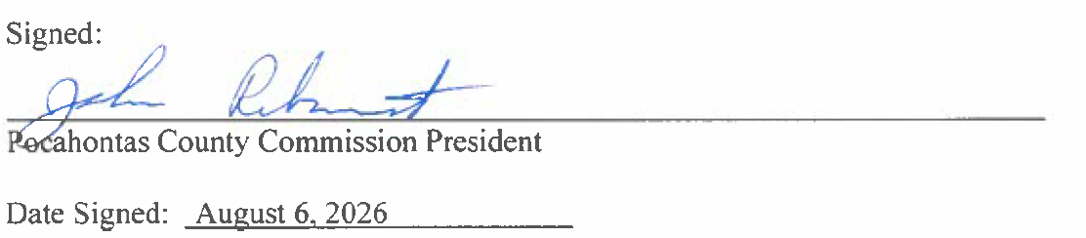

IN RE: AMANDA SMARR, REGION 4 - IRU AGREEMENT FOR THE POCAHONTAS ARC BROADBAND PROJECT

A motion was made by Commissioner Ryder to approve the IRU Agreement for the Pocahontas ARC Broadband Project, contingent upon legal review, and noting no objections, motion carried.

IN RE: UPDATE AND SCHEDULING POCAHONTAS COUNTY AMBULANCE

Chris Lusk, EMS Director gave an update on the Ambulance authority they are now doing 10-hour shifts 7 days a week. The call volume has increased from 160 last year to 371. No action was taken on this matter.

IN RE: FUNDING AND PURCHASE OF LAWN MOWER FOR PARKS AND RECREATION

A motion was made by Commissioner Ryder to approve the 5,500.00 quote from Buckeye Country Mart for Gravely ZTHD 48’ zero turn and a Ariens Razor 21’ push mower, and noting no objections, motion carried.



IN RE: INVOICES

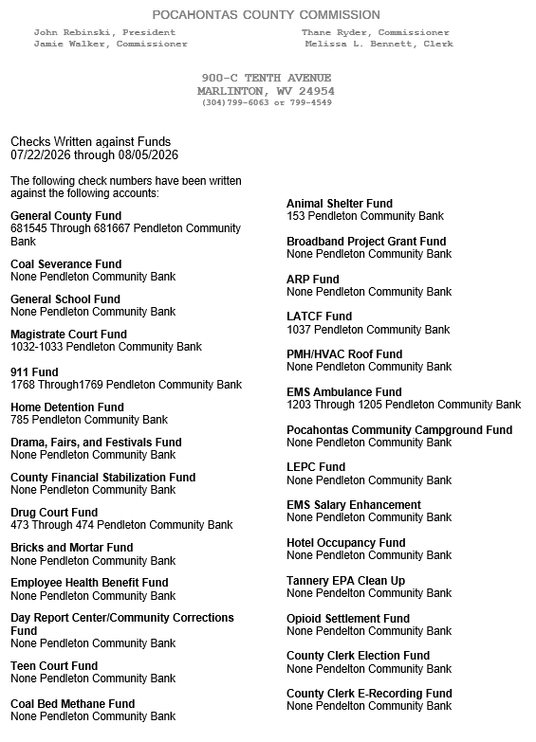

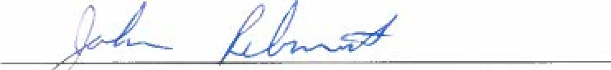
ORDERED THIS MEETING BE ADJOURNED, SINE DIE.

PRESIDENT POCAHONTAS COUNTY COMMISS28

