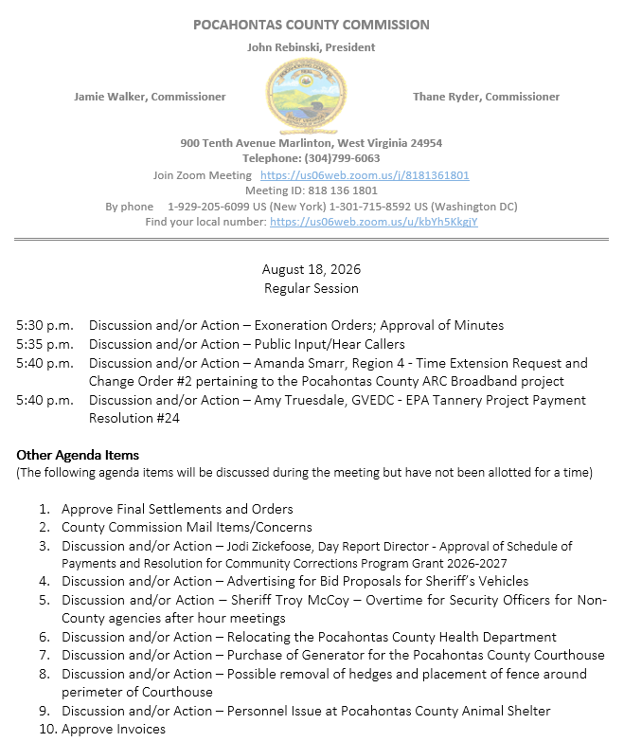

At a Regular Session of the Pocahontas County Commission held at the Courthouse situate in Marlinton, West Virginia, on the 6th day of August, 2026.

PRESENT: John Rebinski, President
Jamie Walker, Commissioner
Thane Ryder, Commissioner

Prior to the beginning of today’s session, the Commission invited all individuals in attendance to stand and recite the Pledge of Allegiance.

IN RE: EXONERATION/APPORTIONED ORDERS APPROVED

None

IN RE: MINUTES APPROVED

A motion was made by Commissioner Walker to approve the minutes of the last regular session of the Commission held on the 6th day of August, as presented, and noting no objections, motion carried.

IN RE: FINAL SETTLEMENTS AND ORDERS APPROVED

Commission President John Rebinski reviewed several final settlements and orders pertaining to estates as presented by the County Clerk’s Office and, thereafter, approved same by placing his signature thereto.
IN RE: COUNTY COMMISSION MAIL ITEMS/CONCERNS

Copy – Pocahontas County Sheriff - Monthly Financial Statement July 2026
Letter – Family Refuge Center - Request for Partnership and Capital Funding Support
Letter – Patrick Morrisey – Community Corrections Program Grant award of $54,00.00.
Email - David Cain – Leasing FEMA Floodplain Buyout Lots Card – Tucker Community Foundation - Thank you for contribution

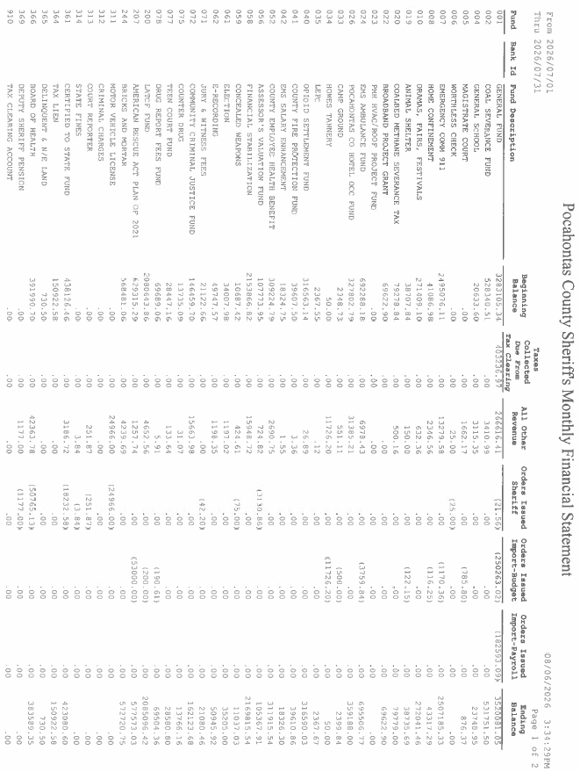

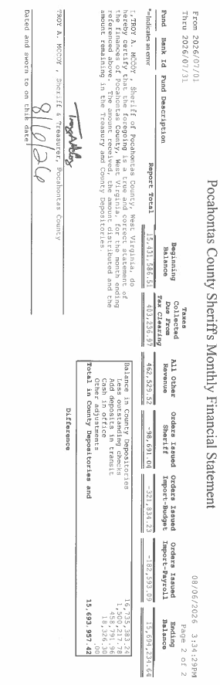



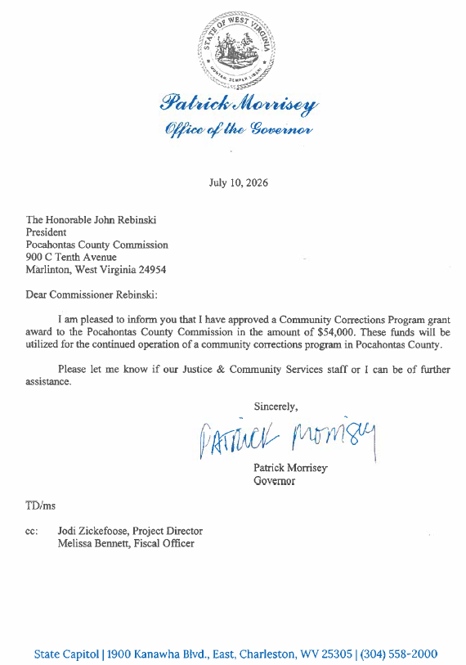

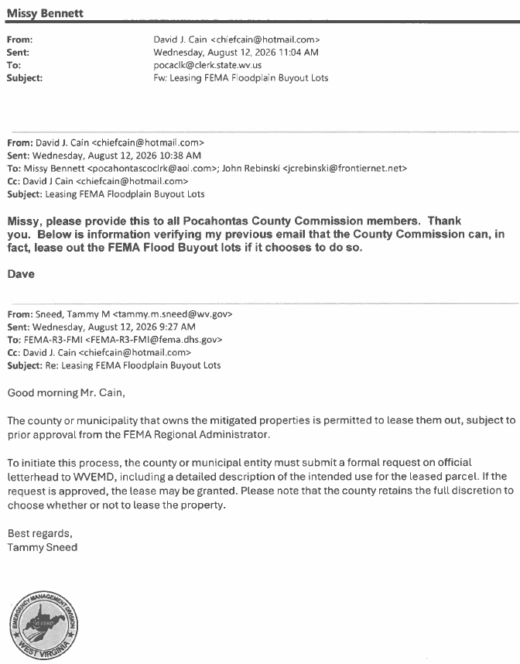

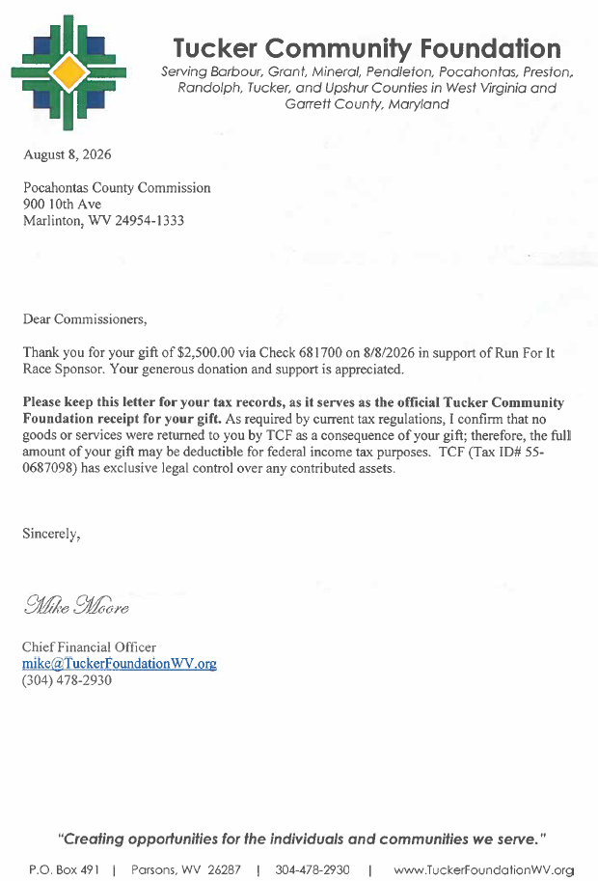

IN RE: SIGN IN SHEET/HEAR CALLERS

None

IN RE: AMANDA SMARR, REGION 4 - TIME EXTENSION REQUEST AND CHANGE ORDER #2 PERTAINING TO THE POCAHONTAS COUNTY ARC BROADBAND PROJECT

A motion was made by Commissioner Ryder to approve the time extension request pertaining to the Pocahontas County ARC Broadband project and noting no objections, motion carried.
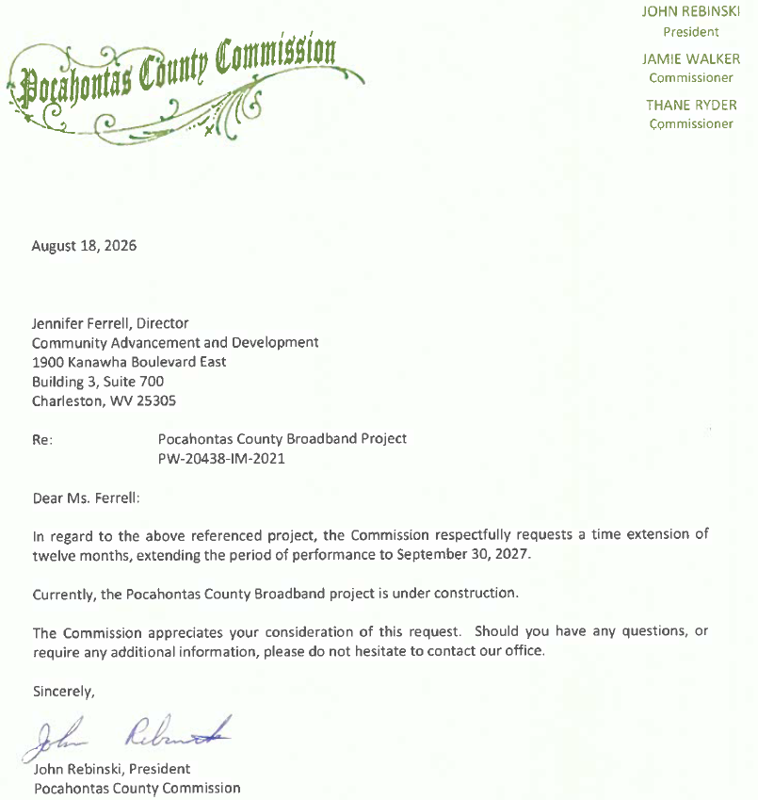

A motion was made by Commissioner Ryder to approve the change order #2 pertaining to the Pocahontas County ARC Broadband project, and noting no objections, motion carried.
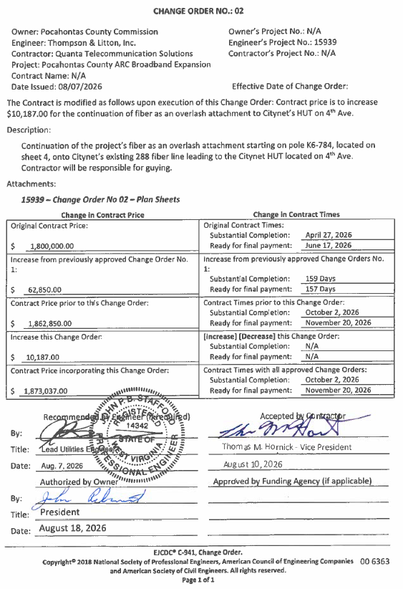
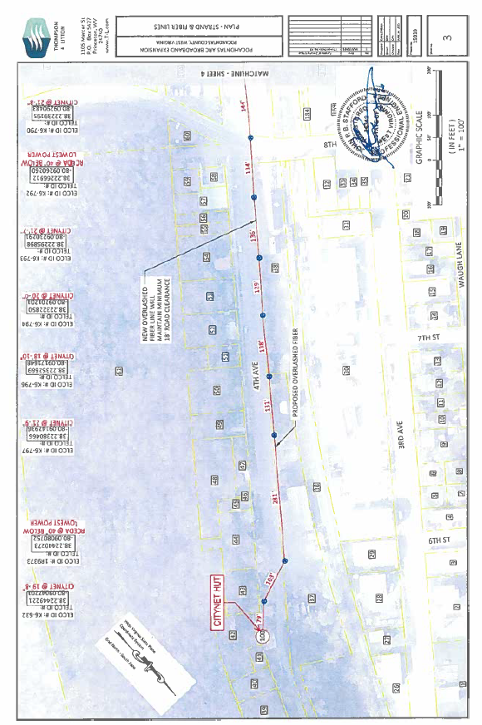
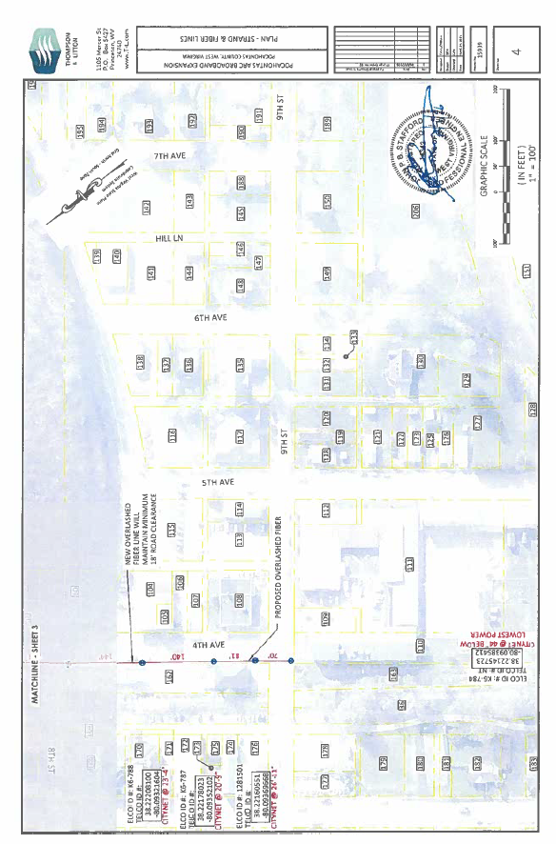

IN RE: AMY TRUESDALE, GVEDC - EPA TANNERY PROJECT PAYMENT RESOLUTION #24

A motion was made by Commissioner Walker to approve the EPA Tannery Project Payment Resolution #24, and noting no objections, motion carried.
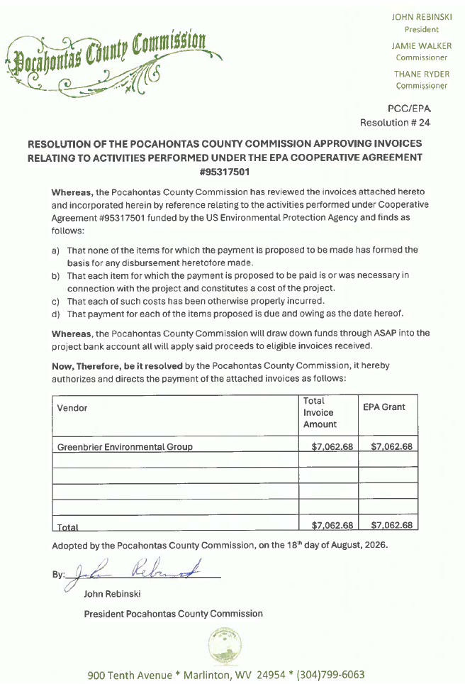
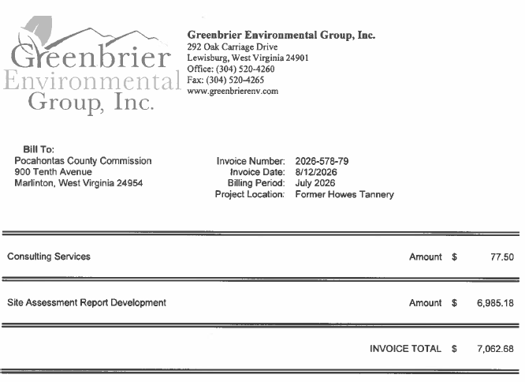
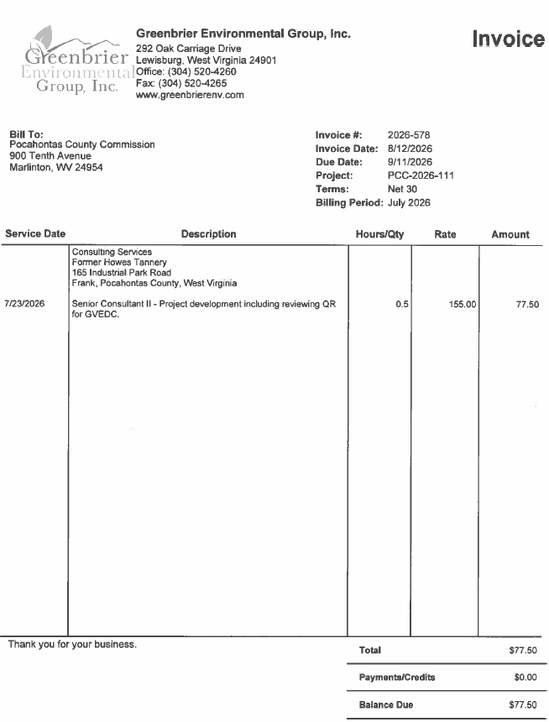
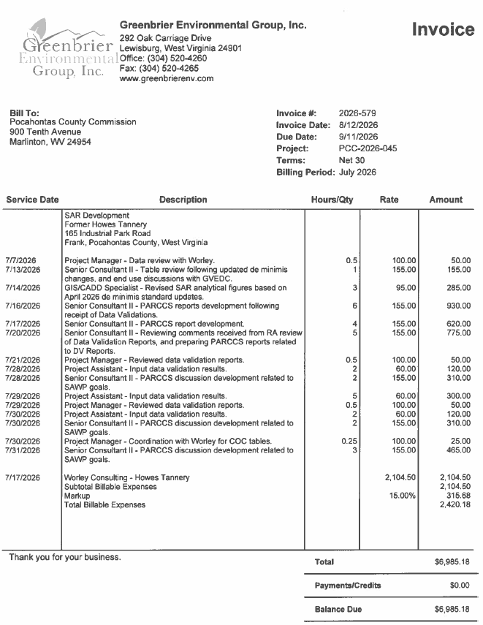


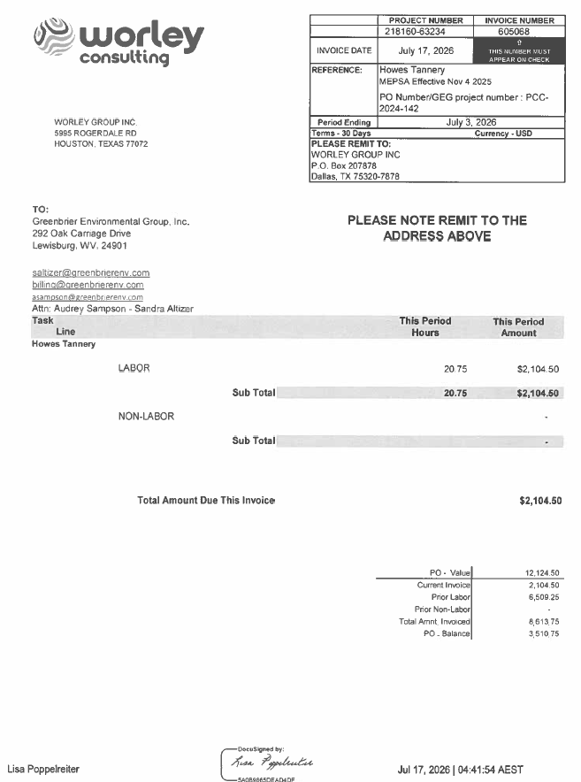

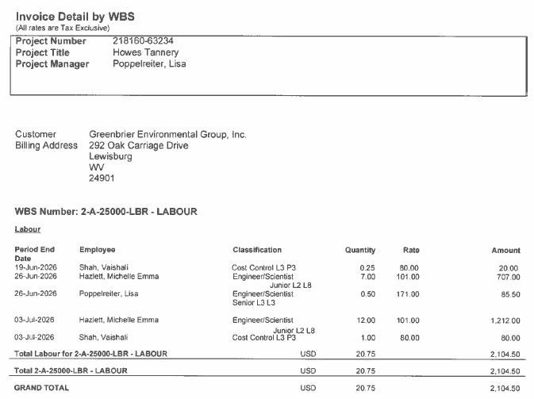

IN RE: JODI ZICKEFOOSE, DAY REPORT DIRECTOR - APPROVAL OF SCHEDULE OF PAYMENTS AND RESOLUTION FOR COMMUNITY CORRECTIONS PROGRAM GRANT 2026-2027

A motion was made by Commissioner Walker to approve the Schedule of Payments and Resolution for Community Corrections Program Grant 2026-2027, and noting no objections, motion carried.
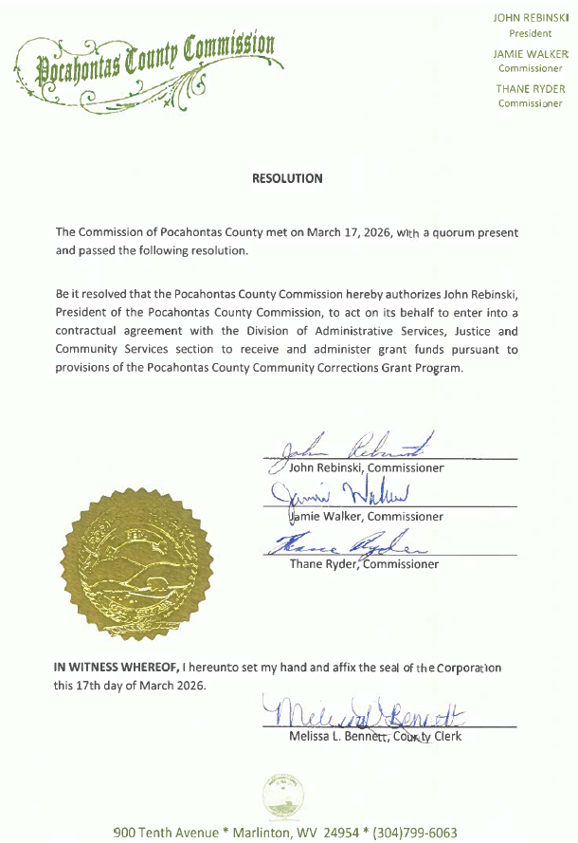
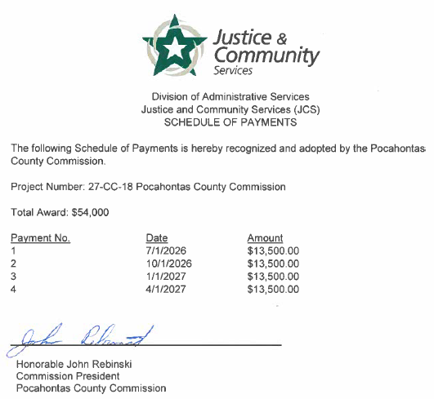

IN RE: ADVERTISING FOR BID PROPOSALS FOR SHERIFF’S VEHICLES

A motion was made by Commissioner Ryder to approve the advertising for bid proposals for Sheriff’s vehicle, and noting no objections, motion carried.

IN RE: SHERIFF TROY MCCOY – OVERTIME FOR SECURITY OFFICERS FOR NON-COUNTY AGENCIES AFTER HOUR MEETINGS

The Commission agreed to send a letter to request non-county agencies to start meetings by at least 6:00 p.m. Security would be compensated for the time until the meeting starts if they stay. No action was taken on this matter.

IN RE: RELOCATING THE POCAHONTAS COUNTY HEALTH DEPARTMENT

The Commission discussed different possibilities for relocating the Pocahontas County Health Department. No action was taken on this matter.

IN RE: PURCHASE OF GENERATOR FOR THE POCAHONTAS COUNTY COURTHOUSE

The Commissioners agreed they should pursue quotes on the purchase of a generator for the Courthouse. No action was taken on this matter.

IN RE: POSSIBLE REMOVAL OF HEDGES AND PLACEMENT OF FENCE AROUND PERIMETER OF COURTHOUSE

A motion was made by Commissioner Ryder to move forward with the removal of the hedges only, and to wait on the fence around the perimeter of the Courthouse, and noting no objections, motion carried.

IN RE: PERSONNEL ISSUE AT POCAHONTAS COUNTY ANIMAL SHELTER

A motion was made by Commissioner Ryder to enter into executive session per open meetings act 2A, and noting no objections, motion carried. At the conclusion of the executive session a motion was made by Commissioner Walker to end the executive session, and noting no objections, motion carried.

A motion was made by Commissioner Walker to send a letter to employee inviting them to attend the County Commission meeting on September 1, 2026, and noting no objections, motion carried.

IN RE: INVOICES

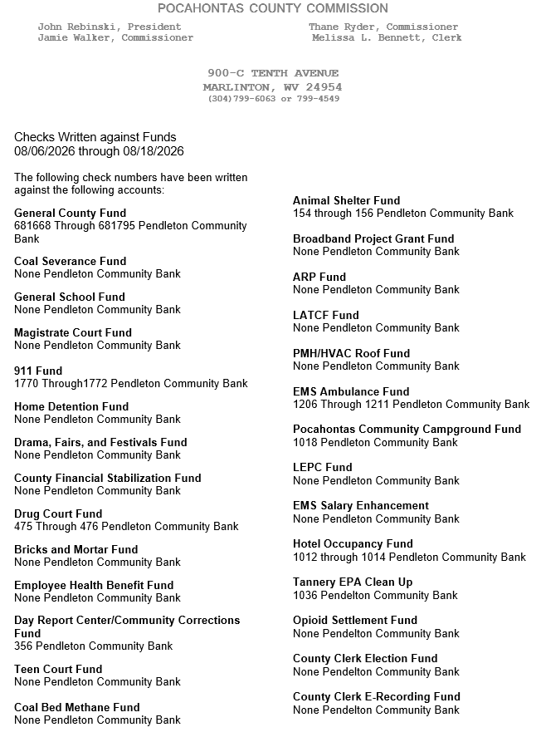

ORDERED THIS MEETING BE ADJOURNED, SINE DIE.



